Standard Operating Procedure for PEALD Operation

Machine Appearance and Main screen

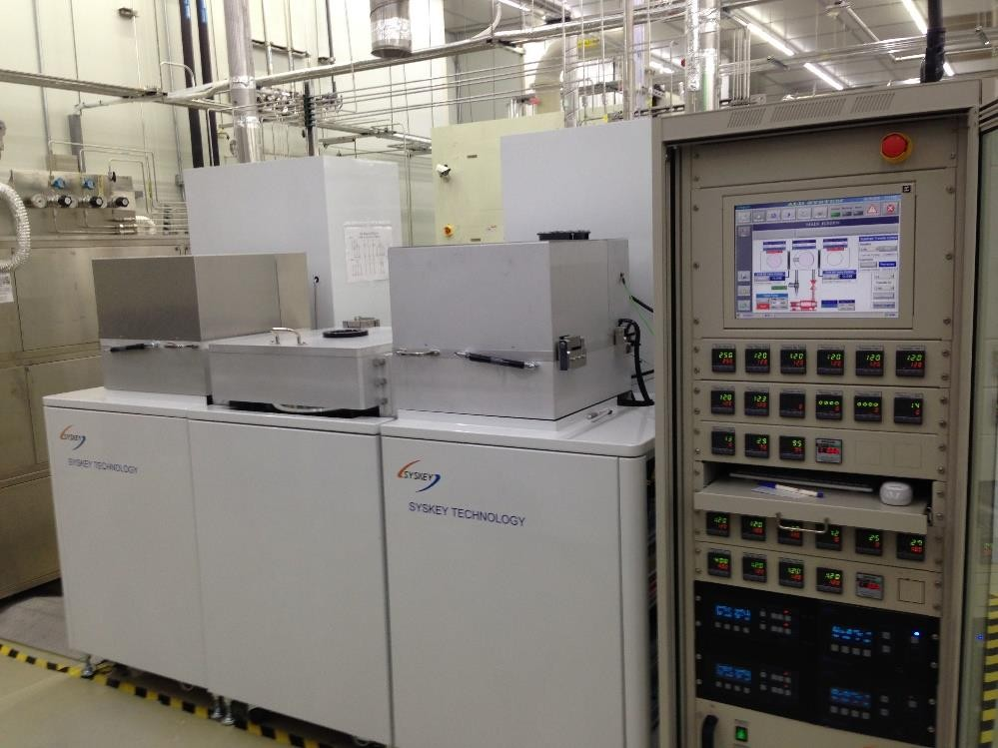
1
4
2
3
5
6 | 7

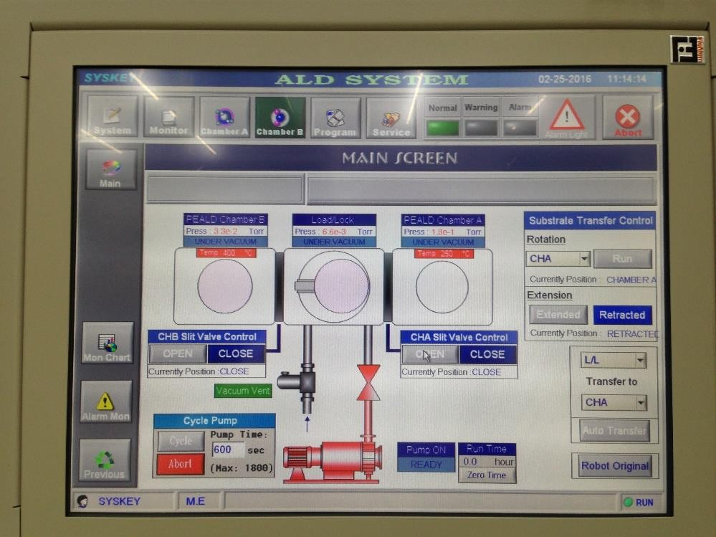
8

Machine appearance
- System control and operation area
- Load lock chamber
- Chamber A (High k)
- Chamber B (Metal)

Main screen
- Function menu
- Function submenu
- System diagram
- Load lock control options

Note before Use
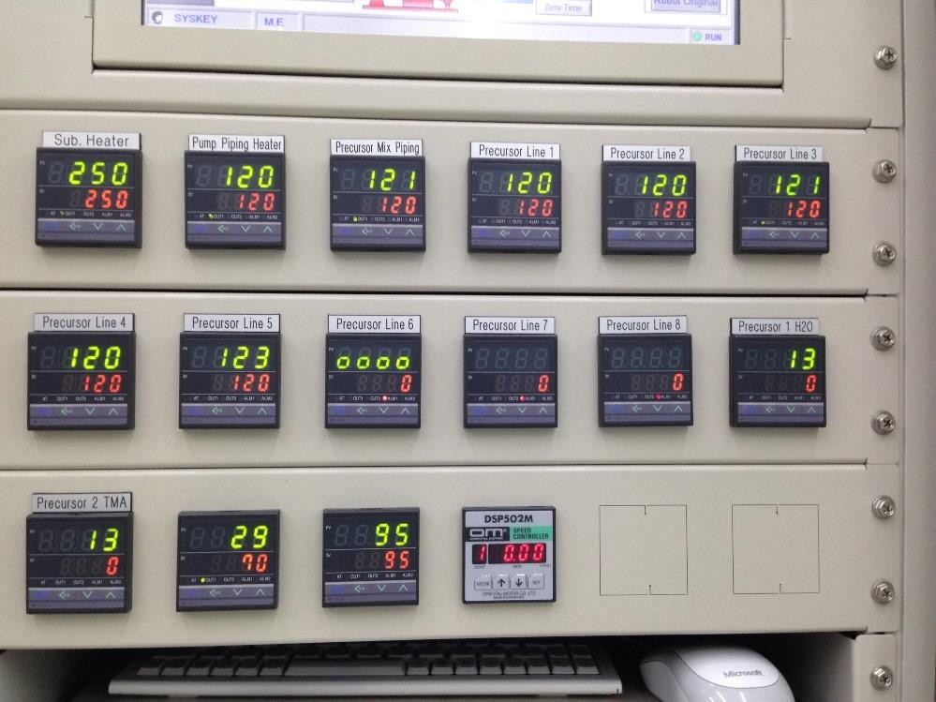
1
2 3
4

1.Check if the machine status is “Normal” and make sure that there is no alarm message.
2.Set the temperature of “Sub Heater.” (TMA:250°C, TEMAZ:250°C, TEMAH:250°C)
3.Check if the temperature of Pump/Gas line is 130°C.
4.Check the temperature of “Precursor.” (Al2O3: 20°C, HfO2: 75°C, TEMAZ: 75°C)

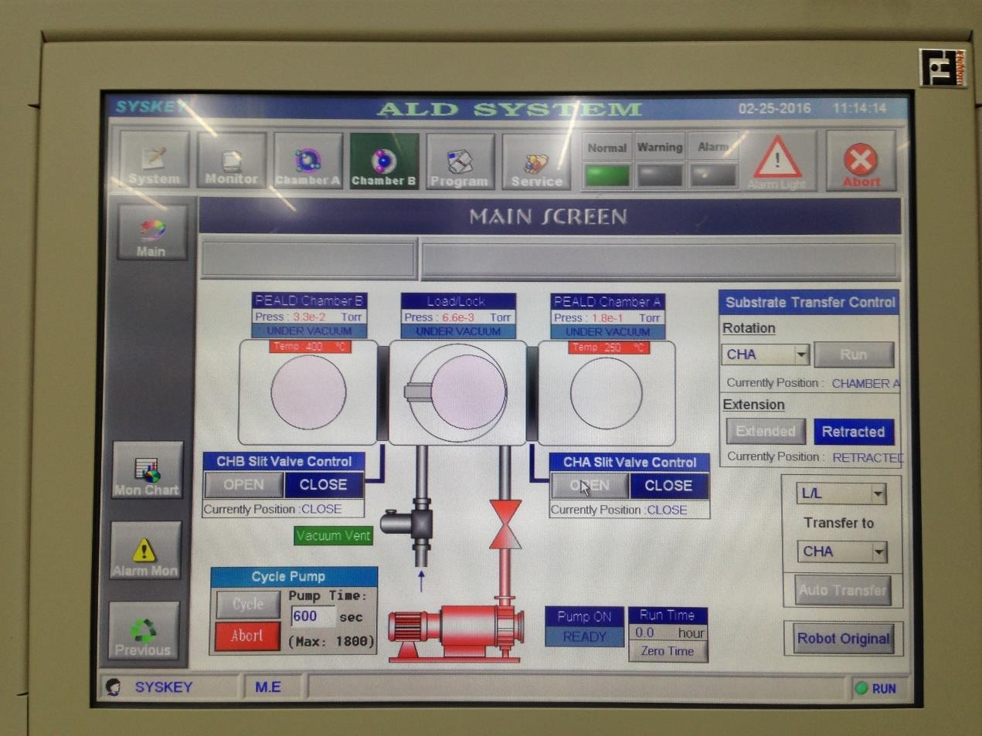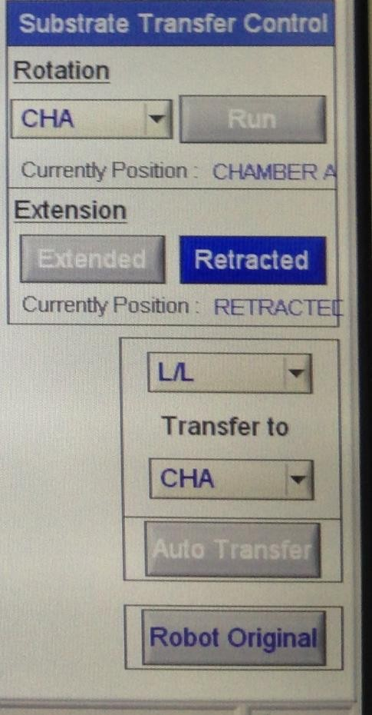Chip Placement and Transfer

3

4
2
1 5

- Tap on “Pump valve”→“Close.”
- Tap on “Vent valve”→“Open.” After making sure that the pressure is “ATM,” open the chamber and put chips in.
- Tap on Vent valve→Close and Pump valve→Open. After making sure that the pressure is “5E-3 Torr↓,” the chips can be transferred.
- Select the location to transfer the chips.
- Tap on “Auto Transfer” to start the transfer. After completion, make sure that there are no chips on the robot arm.

Process Parameter Editing
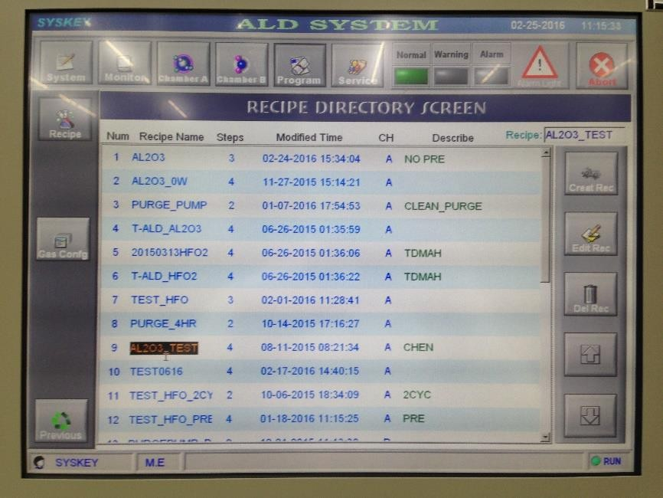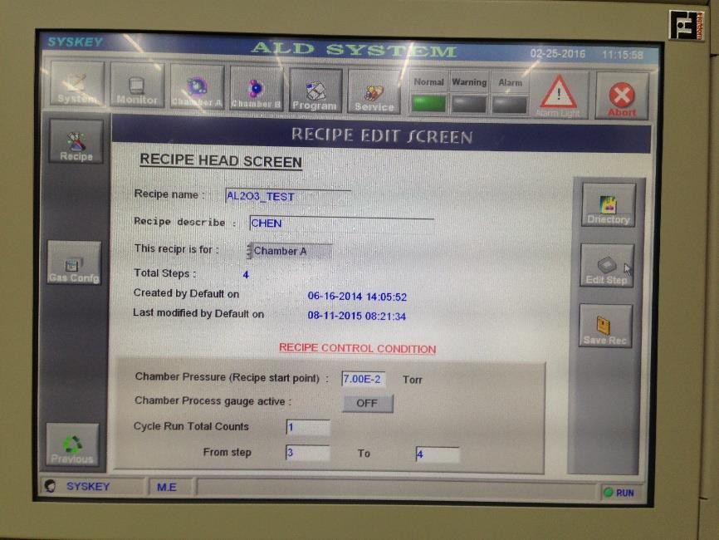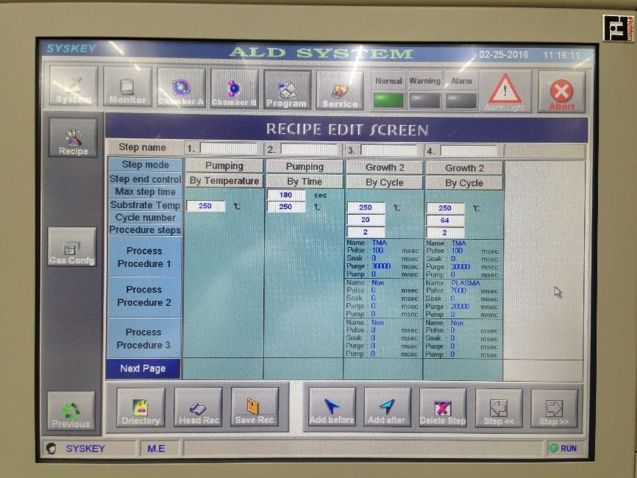

Screen1
Screen2

2
3
1

- Select the program name and make sure the name on the upper right is correct.
- Tap on “Edit Rec” to enter Screen 2.
- Tap on “Edit Step” to enter Screen 3.
- Follow the process steps for editing and leave this page after completion.
Screen3

4

Process Execution [1]

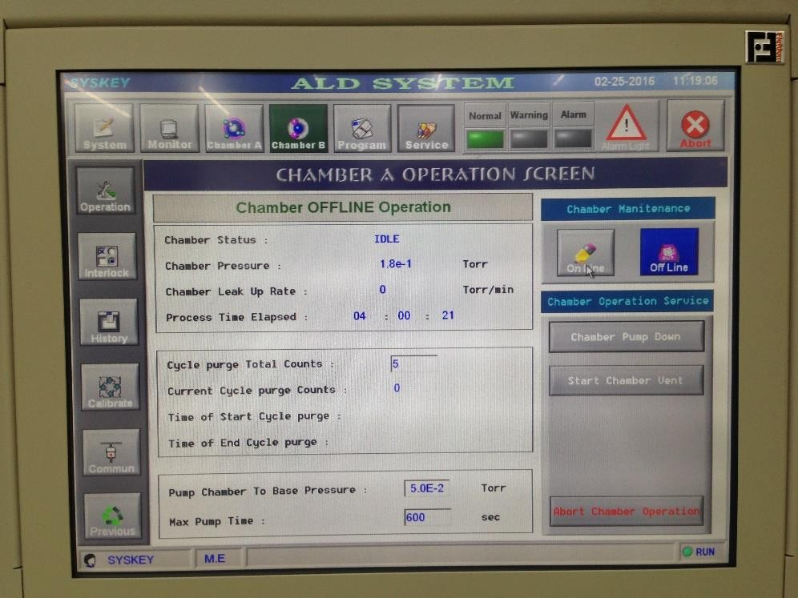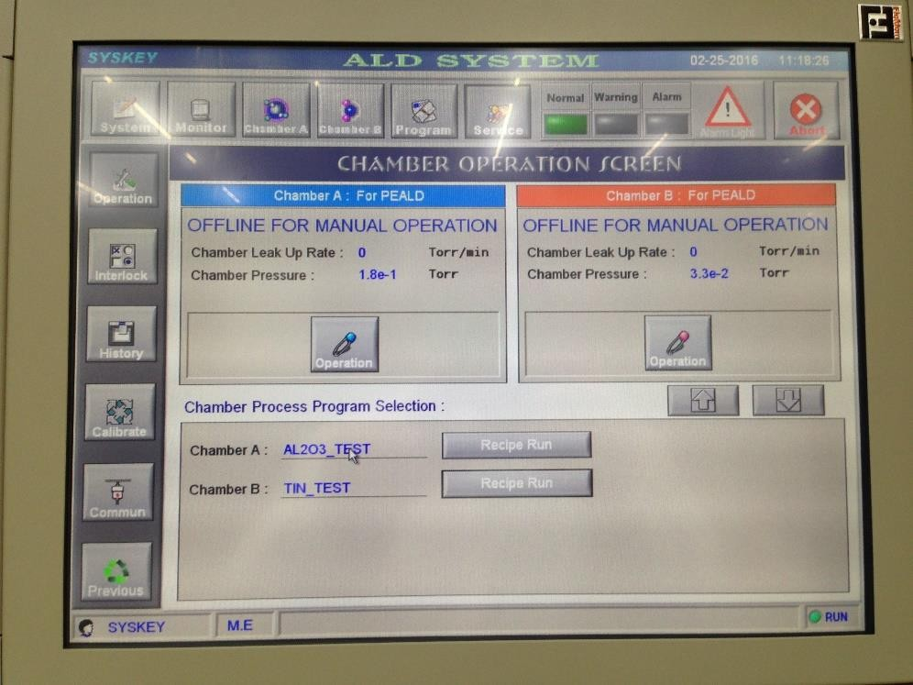
Screen2
4
5
Screen1
1
2
3
  - Tap on “Service” in the function menu
  - Tap on “Operation” in the function submenu to enter the “Chamber operation” screen.
  - Tap on “Operation” for the process chamber to enter Screen 2.
  - Tap on “Chamber Maintenance”→“On Line.”
  - Tap on “Previous” in the function submenu to return to Screen 1.

Process Execution [2]
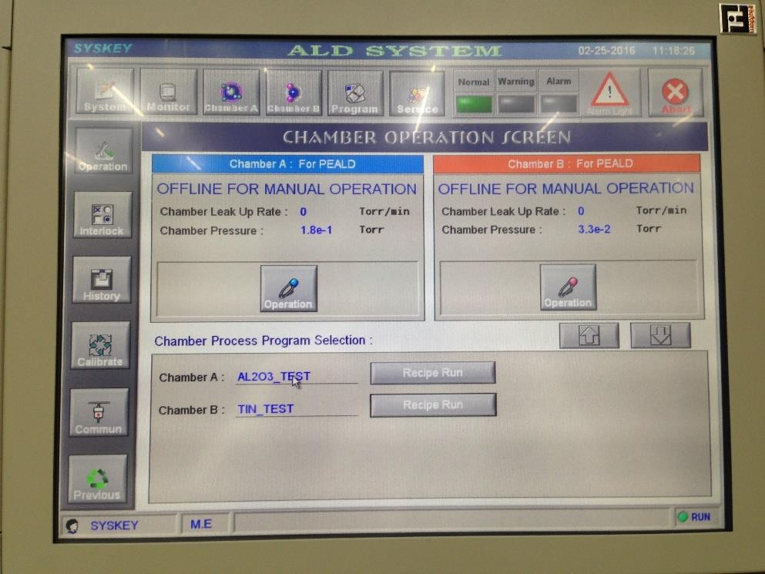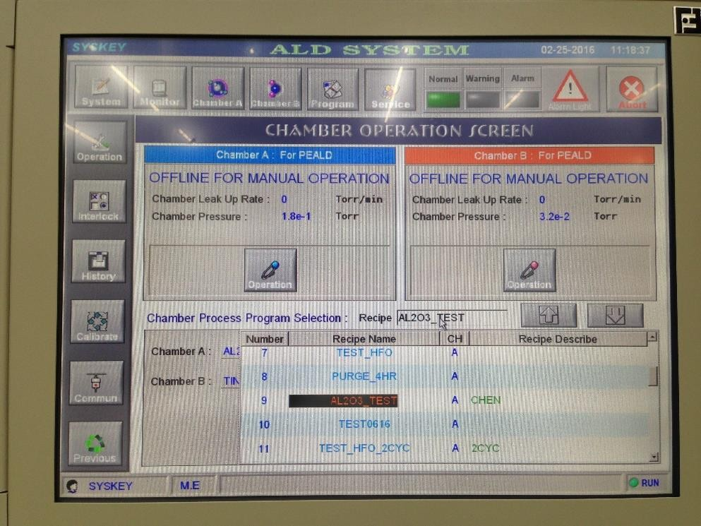
Screen1

1
4
Screen2
3
2

- Select Chamber A: in the Chamber Process Program Selection block at the bottom of Screen 1, and a drop-down program list displays in Screen 2.
- Select the name of the required program.
- Make sure that the selected program is correct and tap on Recipe to confirm.
- Tap on “Recipe Run” to execute the program.

Real-time Process Monitoring
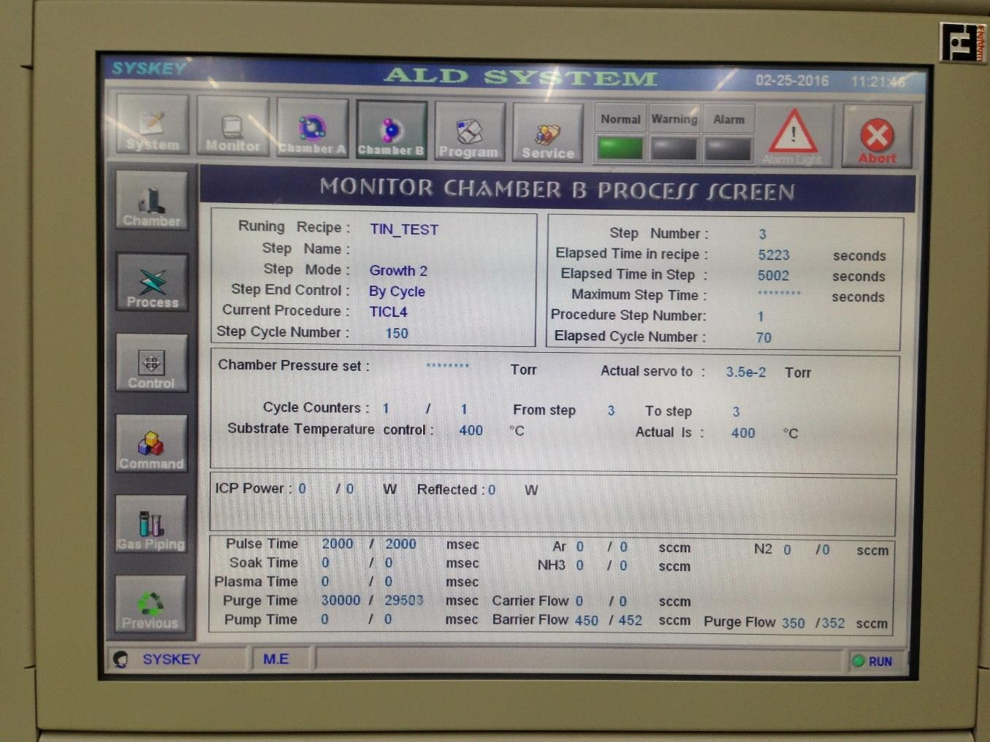

1

2

  - Tap on “Chamber A” in the function menu.
  - Tap on “Process” in the function submenu to enter the “Monitor chamber A process” screen to monitor process progress in real time.

