Four point probe (SOP)

Model No.: JandelHM21(probe:type A 40u)
(Applicable range 10m~10K ohm/□for TCO film, metal film ,implant wafer,...)
Specifications:
1. can display ohm/□ or mv, can also display the measured current value
2. 6-segment current range switching, from 100nA ~ 10mA
3. 100 batteries of calibration resistor for testing and calibration
4. provide forward current and reverse current function 5. Provide forward current and reverse current function
5. Unit accuracy: 0.5% (100mV: 99.5 ~100.5mV)
6. Provide HI Resolution (0~150 mV ) and Low Resolution (0~1250mV) modes. HI Resolution (0~150 mV) and Low Resolution (0~1250mV) modes are available.

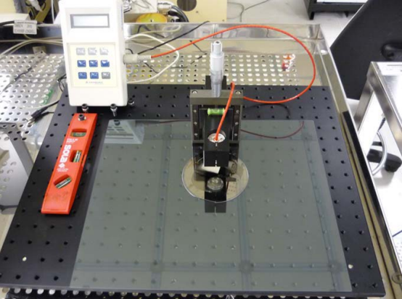

7. Standby appears on the screen, the instrument is powered on.
8. The type of test piece should not contaminate the probe.
The material should be approved by the engineer (e.g. CNT...).
If there is any abnormality of the probe (skewed or broken needle), please stop using it immediately and inform the engineer to keep the measuring platform clean
9. Lower the measuring wafer, rotate the micrometer to adjust the probe down, and then click START to start the measurement.

