Introduction to the 6” wet workstation
The front-end 6” wet workstation is a semi-automatic chemical wet etching workstation manufactured by a local manufacturer. It is divided into three stations: Cleaning station: applicable for 4” and 6” wafer cleaning before undergoing high-temperature and high-vacuum processes. Photoresist station: applicable for photomask removal, 6” wafer photoresistor removal (non-metallic layer), 6” wafer silicon dioxide etching; Wet Etching station: applicable for 6” and 8” wafer silicon dioxide etching and silicon nitride thin film removal.

This bench has a total of: 7 chemical tanks and 7 auxiliary quick rinse tanks. To prevent process contamination between different processes, the cassette, handle and vacuum pen must not be shared.

This bench is applicable for wafer cleaning of standard 4” and 6” processes and the wet etching process of photoresist remover for 6” processes. Among them,
Cleaning Station: wafers that are fragmented, metallic, organic, pure germanium, silicon germanium 18%+, glass, High K, Low K, as well as Class III/V, and processes beyond NDL FAB front-end process are strictly prohibited from entering.
Photoresist Station: wafers that are fragmented, metallic (except those which have had the photoresist removed in the photomask tank), pure germanium, silicon germanium 18%+, glass, High K, Low K, as well as Class III/V, and processes beyond NDL FAB front-end process are strictly prohibited from entering.

The chemicals in this bench are sent by the plant’s central chemical supplies system to the bench’s back-end buffer tank, and controlled by the LOAD CELL measurement method, where the chemicals are weighed and then converted into specified chemical concentrations via the principle of conservation of chemical mass. When the chemicals are prepared according to concentration requirements, they will be pre-mixed in the buffer tank in the back-end of the bench, then delivered to the process tank through the pump. Bench users must wear protective gear according to the standard SOP, and select the desired chemical tank based on the process requirement. First, select the process condition settings from the single-process tank control panel to complete the operations of said process tank and quick rinse tank according to the manual operating procedures. Then proceed to other cleaning or wafer drying procedures based on the process requirements.

Cleaning Station
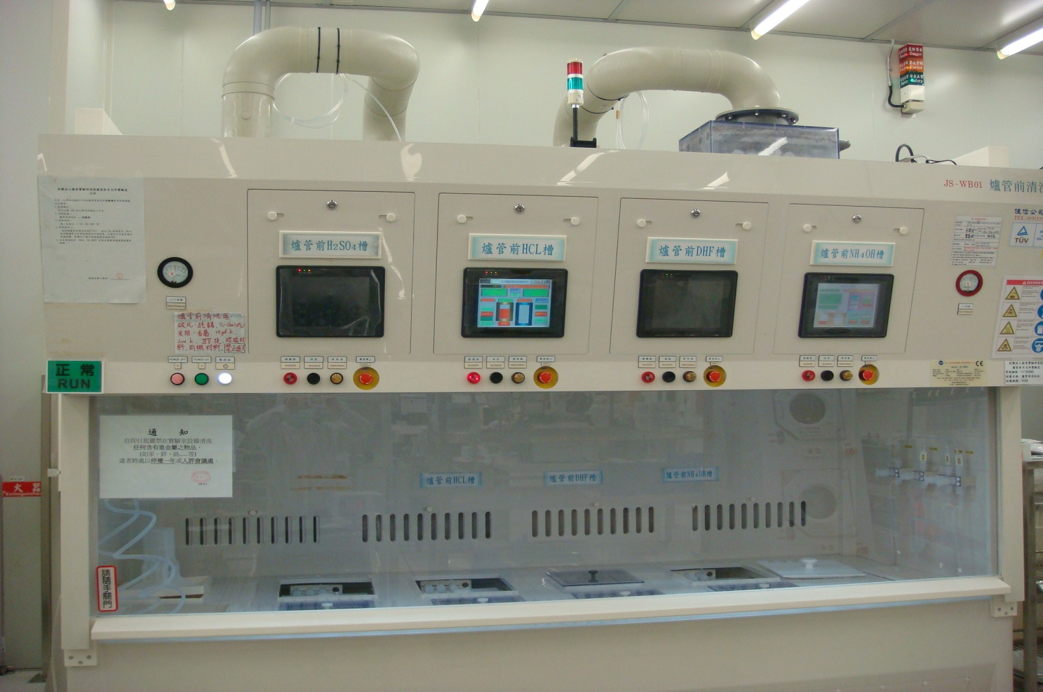
Wet etching station/spin dryer
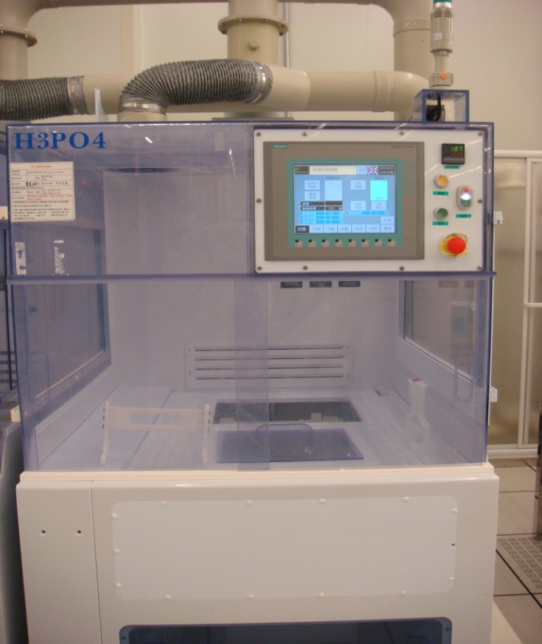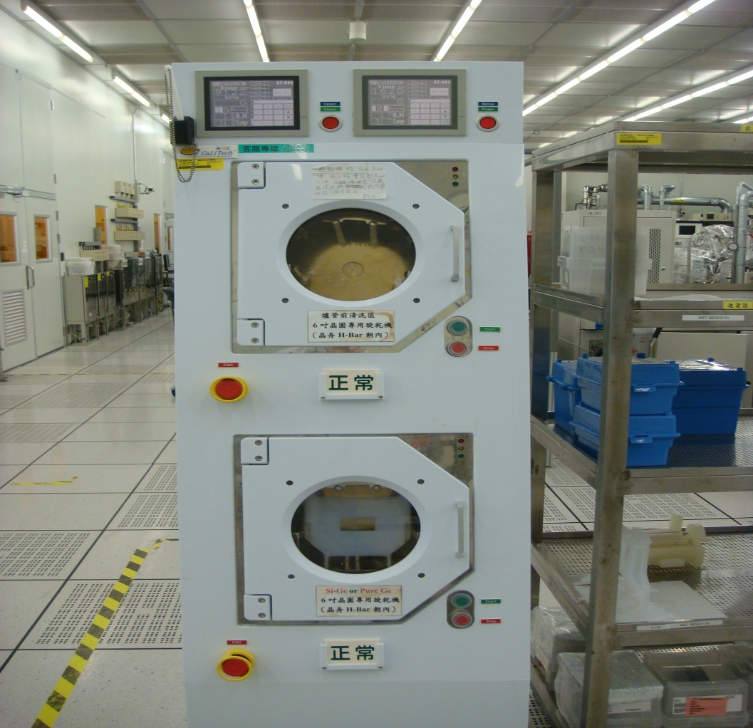

Photoresist Station
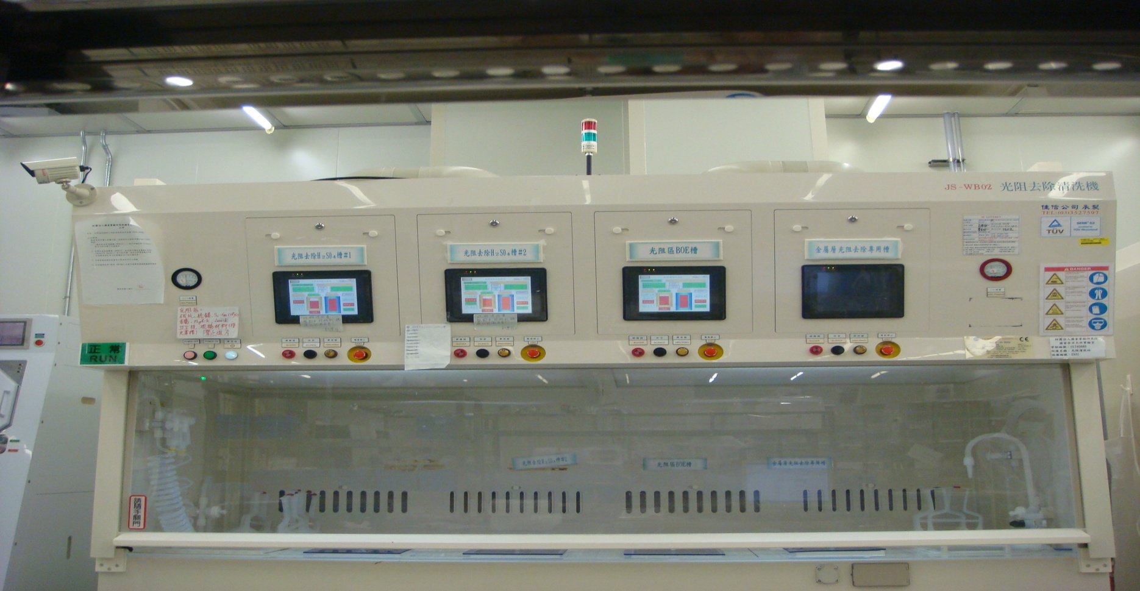
Front-end 6” chemical wet etching workstation equipment configuration:
- Chemicals that are used in this equipment are: sulfuric acid (H2SO4 96%), hydrochloric acid (HCl 31%), ammonia (NH4OH 29%), hydrogen peroxide (N2O2 36%), hydrofluoric acid (HF 49%), B.O.E.7:1, phosphoric acid (H3PO4 86%); all above chemicals are supplied by the plant’s central chemical supplies system to the equipment end, where the equipment will automatically prepare the concentration needed by the process for a safe, clean and stable process condition.
- An air intake tube is placed on top of both the Cleaning station and Photoresist station, and the air is sent to the process station after the ULPA (ultra-low penetration air) filter; the exhaust gas in the process station will be removed with the respective acid-, alkali-, and fluorine-type chemical extraction pipes which are connected to the plant’s exhaust gas handling system.
- The electronic controller system PLC panel output used for this equipment is the Chinese/English (phosphoric acid tank) HMI; users may select interfaces that are easy to operate and read process information.
- In the back-end of the equipment, there are pre-mix buffer tanks for SC-1, SC-2, DHF, B.O.E. chemicals; furthermore, to prevent exothermic reactions produced from pre-mix sulfuric acid and hydrogen peroxide from endangering the loading safety of buffer tanks, the sulfuric acid (H2SO4) and hydrogen peroxide (H2O2) are separately loaded into the process tank before mixing.
- The commands for every chemical replacement of single-chemical tanks must be given through the HMI by the operator, to send the acid-demanding signal to the acid room, then the chemicals will be sent to the equipment’s back-end buffer tanks via the pressure pumps through the pipes; the chemicals will be weighed according to the concentration ratio through the load cell weight and placed in the buffer tanks, and finally the user will send the pre-mix chemical to the process tank.
- Chemical tank selection:
SC-1 tank: | Made of quartz; a static tank, temperature is controlled via an embedded heating system in the tank body. To induce chemical reaction between the chemical directly with the pollutant on the surface of wafers, to remove particulates or polymers.
SC-2 tank: | Made of quartz; a static tank, temperature is controlled via an embedded heating system in the tank body. To induce chemical reaction between the chemical directly with the pollutant on the surface of wafers, to remove metallic pollutants.
DHF tank: | Made of PVDF; a circulation tank equipped with a membrane pump and filter material; to induce chemical reaction between the chemical directly with the native oxide layer on the surface of wafers.
SPM tank: | Made of quartz; a static tank, temperature is controlled via an embedded heating system in the tank body. To induce chemical reaction between the chemical directly with the pollutant on the surface of wafers, to remove organic pollutants.
Photoresist Station
SPM#1 tank: | Made of quartz; a static tank, temperature is controlled via an embedded heating system in the tank body. To induce chemical reaction between the chemical directly with the pollutant on the surface of wafers, to remove organic pollutants (photomask only).
SPM#2 tank: | Made of quartz; a static tank, temperature is controlled via an embedded heating system in the tank body. To induce chemical reaction between the chemical directly with the pollutant on the surface of wafers, to remove photoresist pollutants (silicon-base material only).
B.O.E. tank: | Made of PVDF; a circulation tank equipped with a membrane pump and filter material; to induce chemical reaction between the chemical directly with the silicon dioxide thin film on the surface of wafers, to complete the etching process of the silicon dioxide material.
Wet Etching station
Phosphoric acid tank: | A static tank shared by 6” and 8” processes and made of quartz; temperature is controlled via an embedded heating system in the tank body. To induce chemical reaction between the chemical directly with the silicon nitride thin film on the surface of wafers, to complete the etching process of the silicon nitride material.
B.O.E. tank: | A circulation tank shared by 6” and 8” processes and made of PVDF; to induce chemical reaction between the chemical directly with the silicon dioxide thin film on the surface of wafers, to complete the etching process of the silicon dioxide material.
QDR tank: | Made of PVDF; provides purified water with high resistivity, used to remove water-soluble pollutants after the chemical reaction and residual chemicals on the surface of wafers.
- The auxiliary equipment of this bench is: 4”/6”/8” wafer spin dryer (SPIN/RINSE Dryer), used for wafer cleaning or wafer drying after photoresist removal.
The action principle is: remove the moisture from the surface of wafers using centrifugal force produced from high-speed spinning, the static eliminator is equipped with a dryer to remove the static produced from friction between high-speed spinning and nitrogen, to prevent particulates from becoming attached to the wafer surface due to static.

