Introduction to the 8” front-end wet workstation
The front-end 8” wet workstation is a semi-automatic chemical wet etching workstation manufactured by a local manufacturer; it is configured with 5 chemical tanks and 5 auxiliary quick rinse tanks; among them, 4 chemical tanks and their auxiliary quick rinse tanks are suited for the 8” wafer cleaning operation before undergoing high-temperature and high-vacuum processes. The other chemical tank and its auxiliary quick rinse tank are suited for the photoresist removal operation after the front-end thin-film pattern etching.
This equipment is applicable to standard 8” silicon wafer cleaning and photoresist removal; among which,
Cleaning Station: | Wafers that are fragmented, metallic, organic, pure germanium, silicon germanium 18%+, glass, High K, Low K, as well as Class III/V, and processes beyond NDL FAB front-end process are strictly prohibited from entering.
Photoresist Station: | Wafers that are fragmented, metallic, pure germanium, silicon germanium 18%+, glass, High K, Low K, as well as Class III/V, and processes beyond NDL FAB front-end process are strictly prohibited from entering.
This equipment uses the robot arm as transport between the single-process tank and its auxiliary quick rinse tank; users only need to secure the wafers inside the cassette and select the required process conditions from the process control panel, then operate and control the robot arm from the arm operation station. From here, operations in the process tank and quick rinse tank will be completed according to the procedures. Then proceed to other cleaning or wafer drying procedures based on the process requirements.
The amount of chemicals is measured and fed into this machine through a quantitative pump, so that chemical concentrations can be prepared with precision; the use of robot arms for wafer transport offers an operation environment with high cleanliness and high security. Using high-efficiency PLC modules to drive the HMI enables equipment operation to become highly automated.
For the handling of residual chemicals on wafer surfaces after cleaning, it provides purified DI water with high resistivity to carry out the rinsing. Also, it is equipped with a sensitive water resistivity gauge, so it is helpful in the recycling and reuse of wastewater after wafer cleaning.
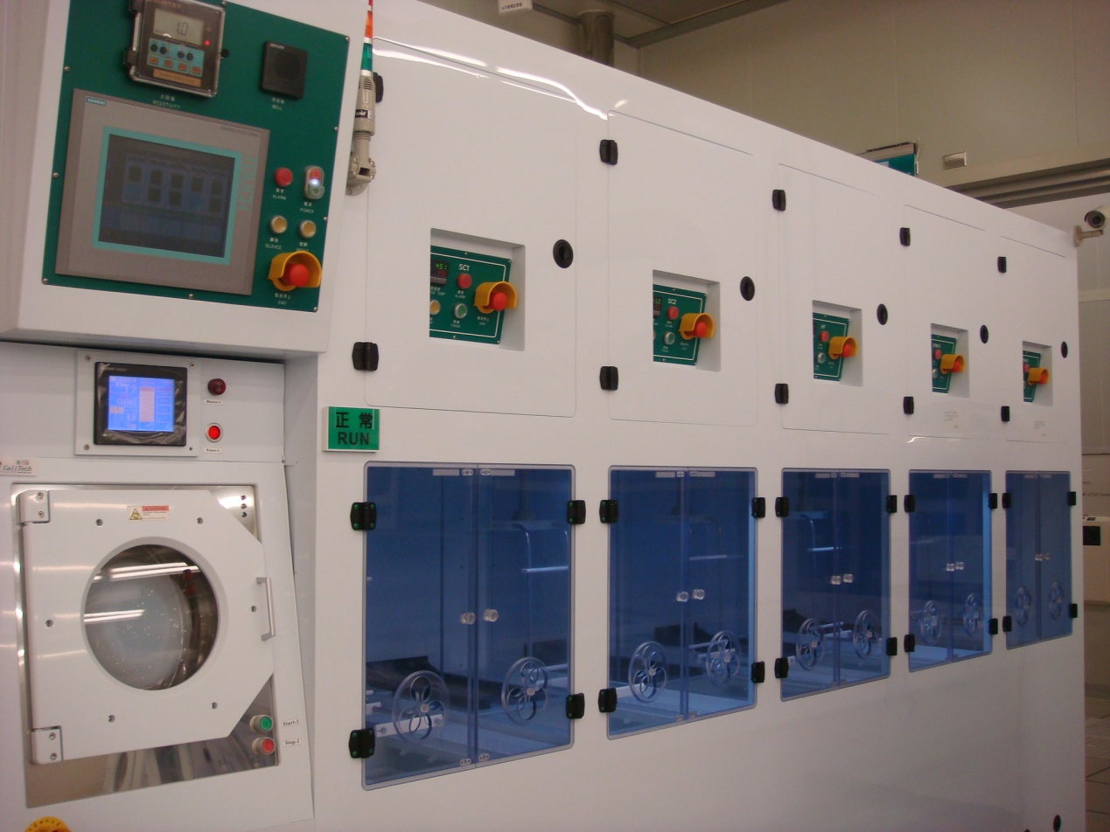
The front-end 8” chemical wet etching workstation equipment configuration:
- The chemicals that are used in this equipment are: sulfuric acid (H₂SO₄ 96%), hydrochloric acid (HCl 31%), ammonia (NH₄OH 29%), hydrogen peroxide (N₂O₂ 36%), and hydrofluoric acid (HF 49%). The above chemicals are supplied by the plant’s central chemical supplies system to the equipment end, where the equipment will automatically prepare the concentration needed by the process for a safe, clean and stable process condition.
- There are 3 air intake tubes on top of the equipment, and the air is sent to the process station after the ULPA (ultra-low penetration air) filter; the exhaust gas in the process station will be removed with the respective acid-, alkali-, and fluorine-type chemical extraction pipes which are connected to the plant’s exhaust gas handling system.
- The electronic controller system PLC panel output used for this equipment is the Chinese/English dual language HMI; users may select interfaces that are easy to operate and read process information.
- The rear end of the machine is equipped with buffer tanks for chemicals such as hydrochloric acid, ammonia, hydrogen peroxide, and hydrofluoric acid. When the chemical solution level in a buffer tank is insufficient, the machine will automatically signal the plant’s supply system to fill the buffer tank with said chemical solution to a specified height, to ensure the process tank can prepare any chemical it requires at any time.
- The chemical concentration ratio of the single-process tank is delivered from the chemical buffer tank to the process tank via a micro-volume quantitative pump; it is able to prepare chemical solutions with high precision and provide them for various process requirements.
- Chemical tank selection:
SC-1 tank: | Made of quartz; an ultra-hypersonic oscillation circulation tank equipped with an in-line heater for temperature control and tank body circulation filter design; in addition to inducing chemical reaction between the chemical directly with the pollutant on the surface of wafers, it lends assistance from the ultra-hypersonic oscillation function to obtain both cleanliness and planarization process results.
SC-2 tank: | Made of quartz; a static tank, temperature is controlled via an embedded heating system in the tank body. To induce chemical reaction between the chemical directly with the pollutant on the surface of wafers, to remove metallic pollutants.
DHF tank: | Made of PVDF; a circulation tank equipped with the BELLOWS PUMP as well as external thermostatic circulation system; to induce chemical reaction between the chemical directly with the native oxide layer on the surface of wafers, and obtain both cleanliness and uniformity (U%) process results through the circulation characteristics and filtration material of the BELLOWS PUMP.
SPM #1 tank: | Made of quartz; a static tank, temperature is controlled via an embedded heating system in the tank body. To induce chemical reaction between the chemical directly with the pollutant on the surface of wafers, to remove organic pollutants.
SPM #2 tank: | Made of quartz; a static tank, temperature is controlled via an embedded heating system in the tank body. To induce chemical reaction between the chemical directly with the pollutant on the surface of wafers, to remove photoresist pollutants.
QDR tank: | Made of PVDF, and provides purified water with high resistivity, used to remove water-soluble pollutants after the chemical reaction and residual chemicals on the surface of wafers. It is equipped with N2 Bubble and automated process; it can avoid water marks, enhance cleaning efficiency and ensure process quality.
- The auxiliary equipment of this bench is: two 8” wafer spin dryers (SPIN/RINSE Dryer), used for wafer cleaning or wafer drying after photoresist removal.
The action principle is: remove the moisture from the surface of wafers using centrifugal force produced from high-speed spinning, the static eliminator is equipped with a dryer to remove the static produced from friction between high-speed spinning and nitrogen, to prevent particulates from becoming attached to the wafer surface due to static.

