- Functions of the Machine
Mirra Mesa is an 8-inch chemical-mechanical polishing machine manufactured by AMAT (Applied Materials, Inc.). It is mainly used for front-end STI or SOI or the planarization of the channel layer (poly-Si/Oxide/Nitride) for effective isolation and for silicon-capped insulation.
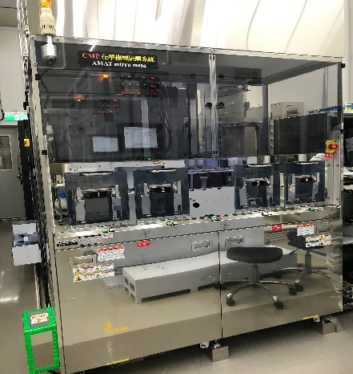  TSRI  Front view of the machine | 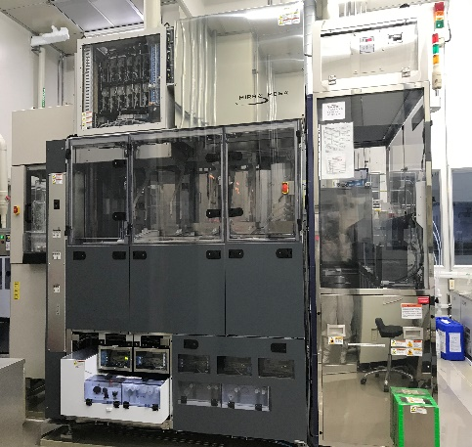  TSRI  Side view of the machine
The machine is applicable for the STI or SOI of 8-inch wafers or the planarization process of the channel layer. With automated mechanical transmission, the machine only needs to place wafers through a load port and select an appropriate process program to carry out an integrated process of polishing, cleaning and spin rinse drying, during which no manual intervention or operation is required, to avoid contamination of the process to the maximum extent. Slurry is supplied by the automated delivery system.

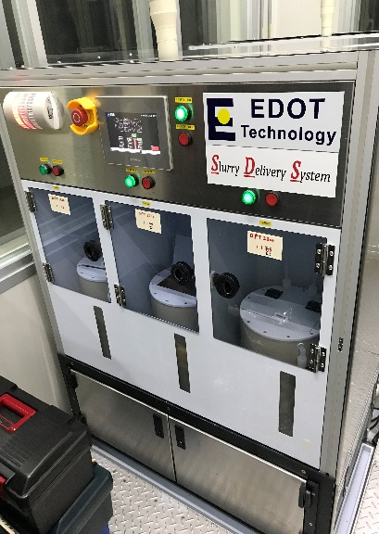  TSRI  Slurry delivery system | 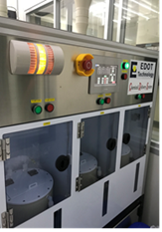  TSRI  Chemical delivery system
- Composition of the Machine
The machine is composed of the following parts: Mirra polisher: 4 polishing heads and 3 polishing pads on the polishing turntable; a Mesa cleaner: 1 Megasonics module, 2 Brush cleaners, 1 SRD (spin rinse dryer), 1 output station for flipping wafers; cassette storing and wafer transfer: 1 FABS with 4 load/unload ports, 2 robotic arms for transferring wafers. Three or more wafers can be polished simultaneously with the process ongoing.

- Operation Mode
Through the FABS (load port), a robotic arm carries a wafer to the buffer, and another robotic arm inverts the wafer and transfers it to the HCLU (Head-Cup-Load-Unload) in the Mirra polisher, where the wafer is picked by the head and moved to platen 1, 2 or 3 on the polishing turntable to be polished. After polishing is completed, a conveyor transfers the wafer to the Mesa ultrasonic cleaner, which contains chemical alkaline solution (NH4OH+DI), for cleaning. Then the wafer is sent to Brush 1 (NH4OH+DI) and Brush 2 (DI) for cleaning in sequence, following which the wafer is sent to the SRD for fast spin drying. Finally, the wafer is placed in Output and transferred by the robotic arm to the FABS (unload port).

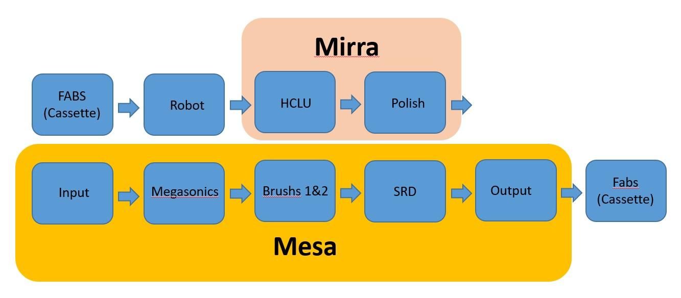
References
1. AMAT (Applied Materials, Inc.)
https://www.appliedmaterials.com/zh-hant/products/mirra-mesa-cmp-200mm
2. E-Dot Technology Inc.
http://www.e-dot.com.tw/web/front/bin/home.phtml

Oxide/Nitride process
With a proportional mixture of slurry and water, the normal polishing rate for TEOS OX with a polishing pad may be higher than 1000-3500 A/min, but the actual rate depends on the set conditions of the process.

Poly-Si process
With a proportional re-mixture of slurry and water, the normal polishing rate is approximately xxx, but the actual rate depends on the set conditions of the process.

