AMAT Mirra Mesa
8-inch CMP - Standard Operating Procedures
- Check equipment condition (check the alarm messages of the equipment)
- Swipe the card to start up the machine.
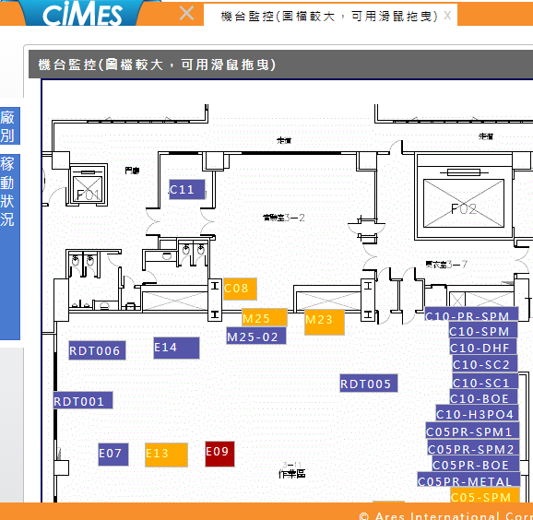

- Distribute slurry into the slurry delivery system (SDS) and switch to the chemical delivery system (CDS) mode for Si or SiO2/SiN.
--See “SOP for Switching to Mega Chemical Tank”—

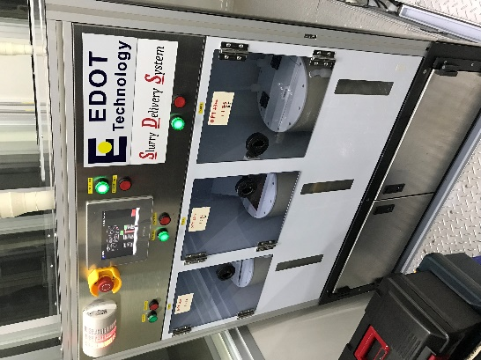
TSRI

- Pause the wet idle mode process: STOP Close
- Press Unload and insert the cassette.
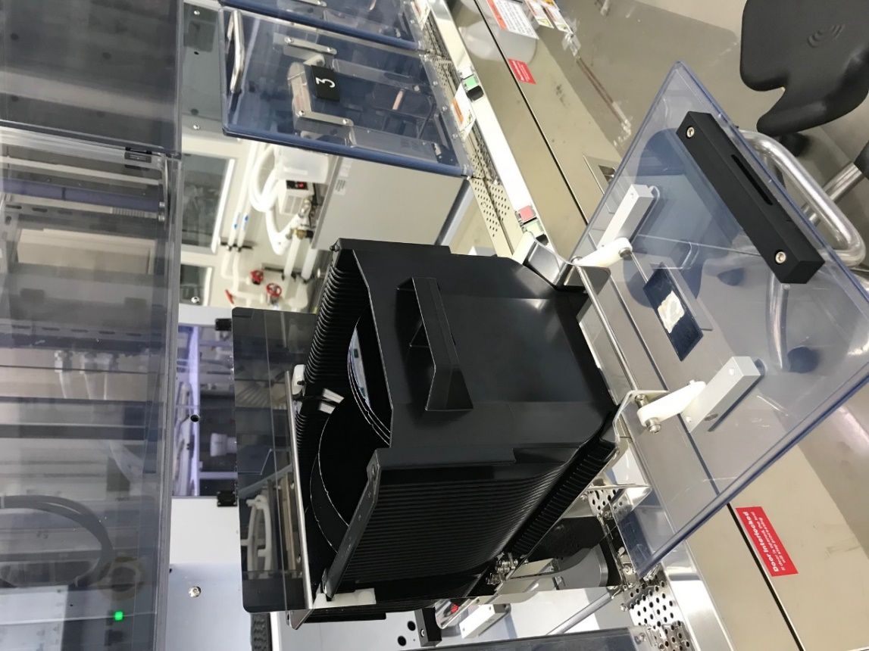

- Scan the cassette and select a program.
  - Edit new if polishing is required, and edit disable otherwise.
(Pad 1 is used for Si polishing; Pad 2 is used for SiO2/Si3N4 polishing)
  - Select a Pad Conditioner program: “Dummy Condition” is generally used.
  - Select a polishing program (newly created program)
  - OK

- Start Processing OK

References
1. AMAT (Applied Materials, Inc.)
https://www.appliedmaterials.com/zh-hant/products/mirra-mesa-cmp-200mm
2. E-Dot Technology Inc.
http://www.e-dot.com.tw/web/front/bin/home.phtml

