EBARA EPO 222A

8-inch CMP Auto Operation Process

Standard Operating Procedure

- Swipe the card to start up the machine.
- Prepare the slurry to be used and pour it into the central fluid supply system (For the OX process, the post-mix volume must be at least 20L and Slurry Line A is used) or the simple fluid supply system (For the OX process, the post-mix volume must be at least 5L and Slurry Line A is used; for the W process, the post-mix volume must be at least 5L and Slurry Line B is used). Mixed use is prohibited to avoid cross-contamination.
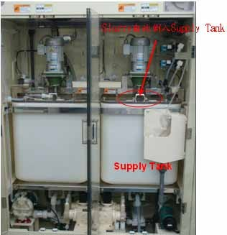 | 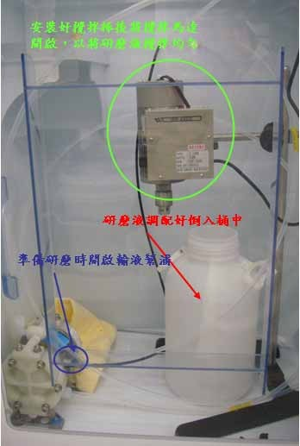
- Switch System 1 of the central fluid supply system to Auto (Tap on the Start option for System 1, with System 2 not in use). For the simple fluid supply system, switch on the stirring rod motor and pump to fully mix the slurry and water (for at least 10 minutes), increasing the uniformity of the slurry. When the process starts, the slurry will be supplied automatically.
Simple fluid supply system: The A pump is for Pipe A for the OX process; the B pump is for Pipe B for the W process.
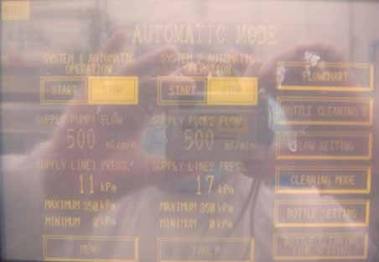
- The machine’s start operation screen is shown below: Please select the “Auto Operation Start” option to enter the process operation page.
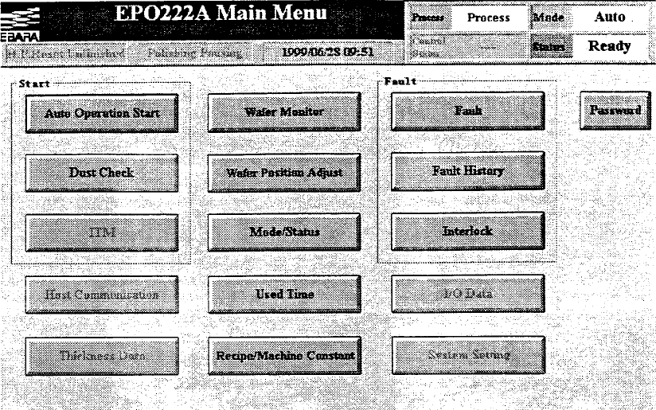
- After entering the process operation page, you will see the operation interface on the next page. The program selection section is used to enter the wafer lot ID and the number of wafers to run and to select a program for the process. The process information section is used to display the process time and route for the selected process program. The process start and stop section is used to start the process (when a process program has been selected) and stop (cancel) it midway. (The parameter highlighted with a pink box refers to polishing time. The operator can change polishing time through this parameter without modifying the program)
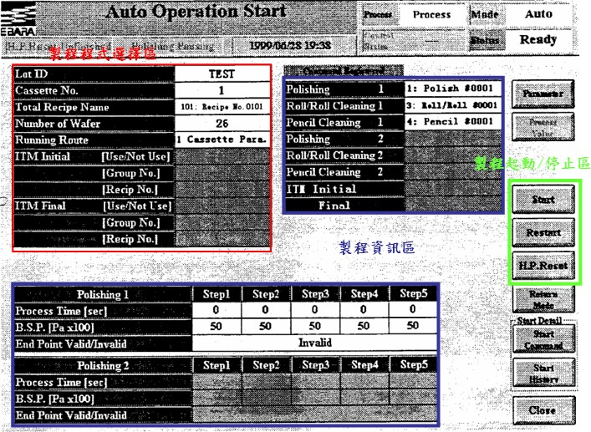
- Put the wafers to be polished into a cassette first, and then place it onto a load port. Please check if the cassette is set in place and make sure that its number is the same as the load port (Load Port/Cassette 1 is for the front-end process; Load Port/Cassette 2 is for the back-end process).
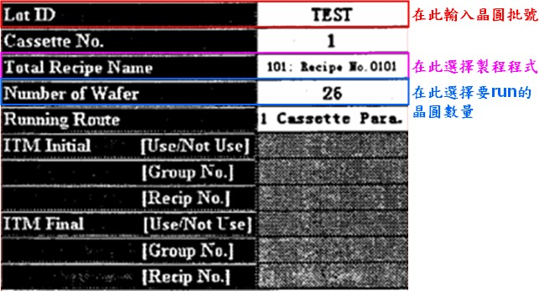
- Next, go to the process program selection section to select process-related parameters. There is no need to select Cassette No. and Running Route. Please use the default settings. (If Cassette No. and Running Route need to be changed, please notify the engineer. Since some changes must be made to the machine’s parameter settings, changes to these parameters require the engineer’s permission)
- When you select a process program, the following screen displays. On this screen, you can select a required main process program. As shown in the figure below, the 102 program named “Recipe No.0102” is used. The numbers 1, 3, 4, 5, 7, and 8 followed by the name represent Subprogram 1 of Pol.1 (Polish 1), Subprogram 3 of Roll 1, Subprogram 5 of Pen.1 (Pencil 1), and so forth that constitute the main process program. Pol.1, Roll 1, etc. provide Subprograms 1-10 for selection. The tab title “Parallel” shown above means that 1 Cassette Para. is selected as Running Route.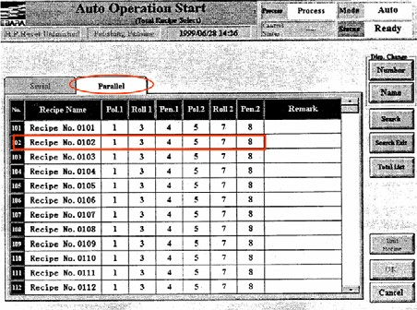
- You can select the “Unit Recipe” option on the screen above to check the parameters set for every sub-recipe. If parameters other than polishing time need to be changed, please notify the engineer for setting. (Please see Point 5 for the modification of polishing time)
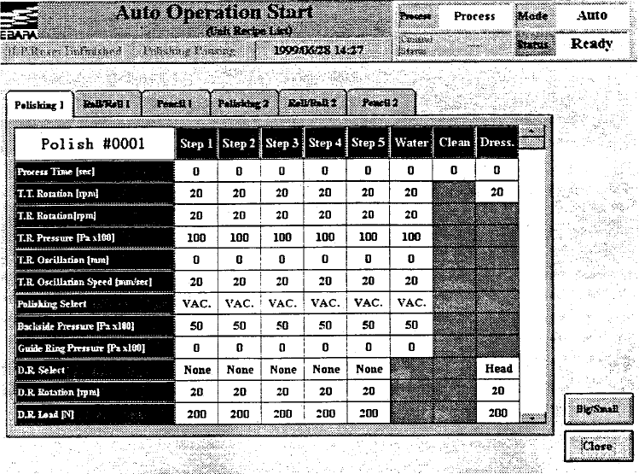 | Parameter setting table for Polish 1
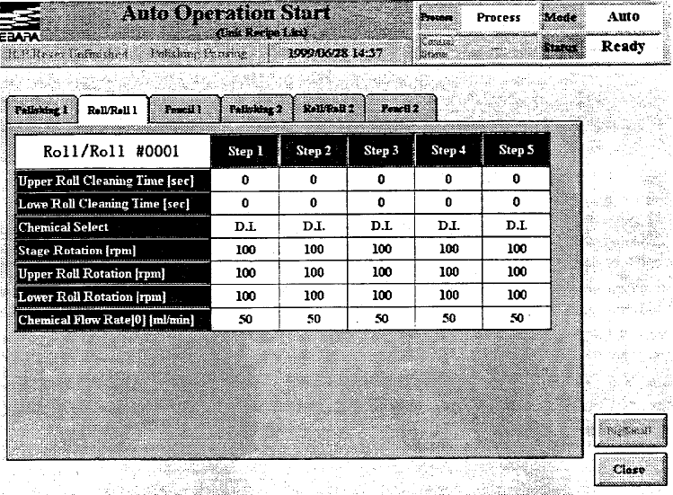 | Parameter setting table for Roll 1
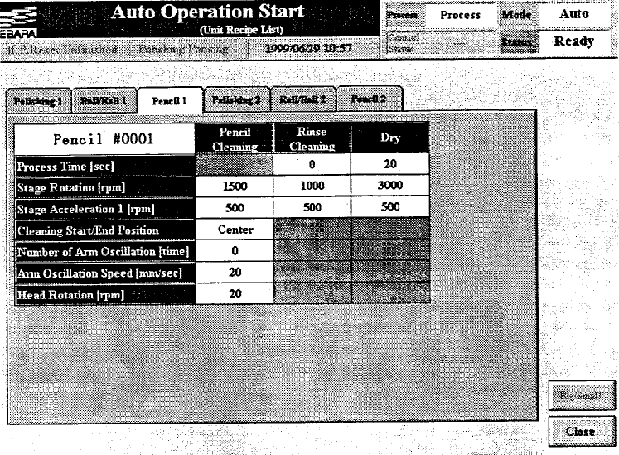 | Parameter setting table for Pen 1
- After selecting a required process program, tap on Start in the process start and stop section, and the machine will automatically start the process.
- After the process starts, wafer mapping is performed first to locate every wafer in the cassette. Generally, wafers in the cassette are picked up in bottom-up order until the value of Number of Wafer is reached; broken wafers are not counted towards the value.
- If the slurry type has been changed or a new slurry has been prepared for a new lot, please remember to conduct a dummy run for five wafers to make sure that the pipeline is filled with the new slurry; an incorrect slurry ratio will result in a drift in process accuracy.
- Do not open any machine door or window during the process. As they are equipped with a safety interlock device, this action will lead to a stoppage of the machine and process.
- After the process is fully completed, open the load port door and take out the cassette. After putting the wafers back into your personal carrier, replace the cassette on the load port and swipe the card to turn off the machine.
- If the simple fluid supply system is used, it is necessary to drain the fluid out of the pipeline, empty the fluid storage tank, wash the tank, and replace it.

