Document Title: | Machine SOP (CF-E10 8-inch front-end polysilicon/dielectric dry etching machine)
Document No.: | Q3-NL04
Draft Dept.: | Film etching division
Draft Date: | 2019-02-15

Document Revision History
Version | Edited by | Effective date | Approve document No. | Revision/change description | Revised Page
1.0 | Fu-Guo Xue | 2019-02-20 | IS108006 | New release | ---
1.1 | Fu-Guo Xue | 2019-06-05 | IS108024 | Replaced “Instrument” in the title in header with “Machine SOP” | P1-7
1.2 | Fu-Guo Xue | 2023-05-11 | IS112011 | - Updated the description in Article 3 under III. Rights and Responsibilities | P1

- Purpose:
Define 8” front-end polysilicon/dielectric dry etching machine practices to ensure production quality.
- Scope:
Applicable to 8” front-end polysilicon/dielectric etching machine.
- Rights and Responsibilities:
- Organization responsibilities: The process engineer is responsible for the drafting and revision of specifications.
- Equipment manager is responsible for handling anomalies to maintain normal operation.
- Qualified operator: Operators passing 8” front-end polysilicon/dielectric etching machine operation test.
- Relevant Documents:
Lam2300 - 8” front-end polysilicon/dielectric etching machine Operation manual.
- Introduction of Machine Parts:
Gas panel system
Polysilicon etching chamber
Dielectric etching chamber
Cassette load port module
Vacuum transfer module
Vacuum/atmosphere exchange module
Atmosphere transfer module
Ashing chamber
- Operation Content:
- Inspect machine condition and current status (green card: in use; red card: under maintenance; yellow card: under test). Only qualified operators are allowed to swipe the card to boot.
- Lay the wafer wafer in the cassette and place in Port 1 or 2 (as shown in Fig. 1). Make sure the cassette and wafer are loaded correctly.
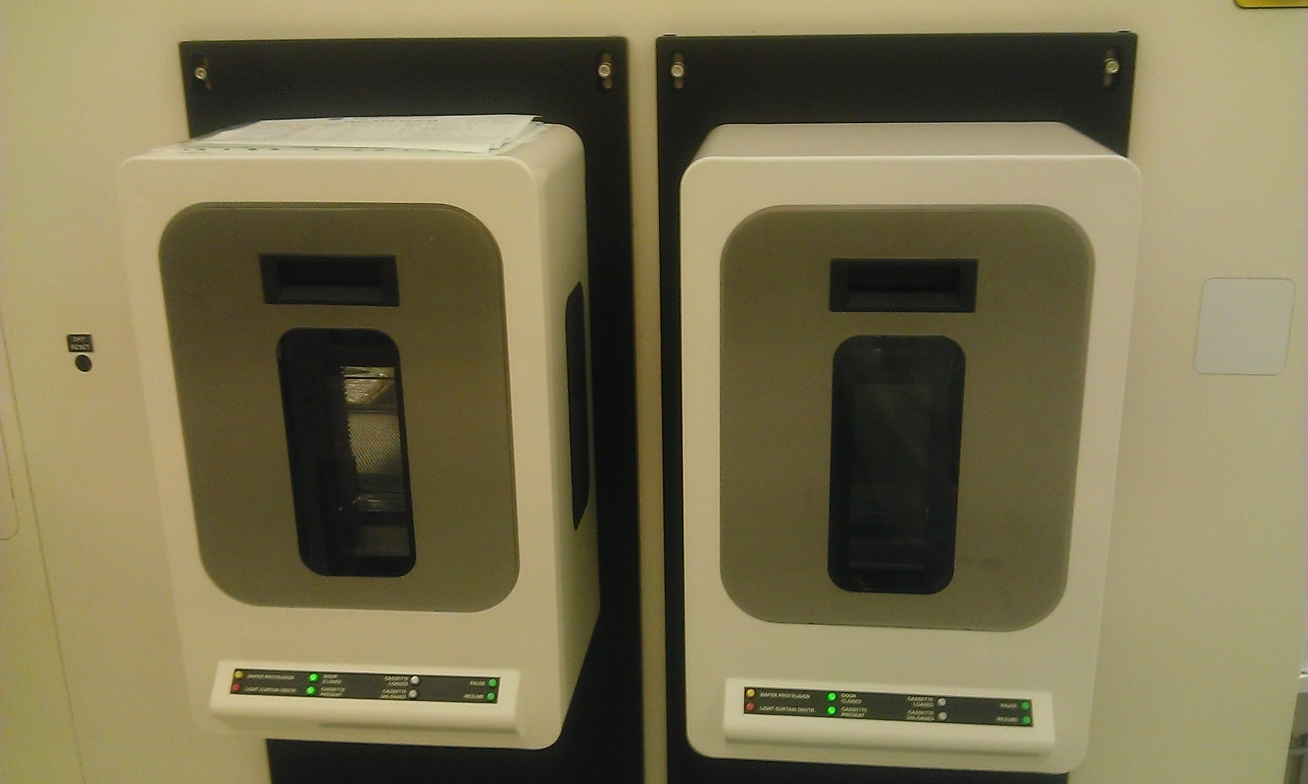

Port2
Port1

Fig. 1: Cassette load port module

- Select process parameters from Operation page (as shown in Fig. 2): (1) Enter Carrier ID and Lot ID (2) Select required parameters from Wafer flow (3) Check wafer quantity (4) Start operation.

Fig. 2: Operate mode page
(4)
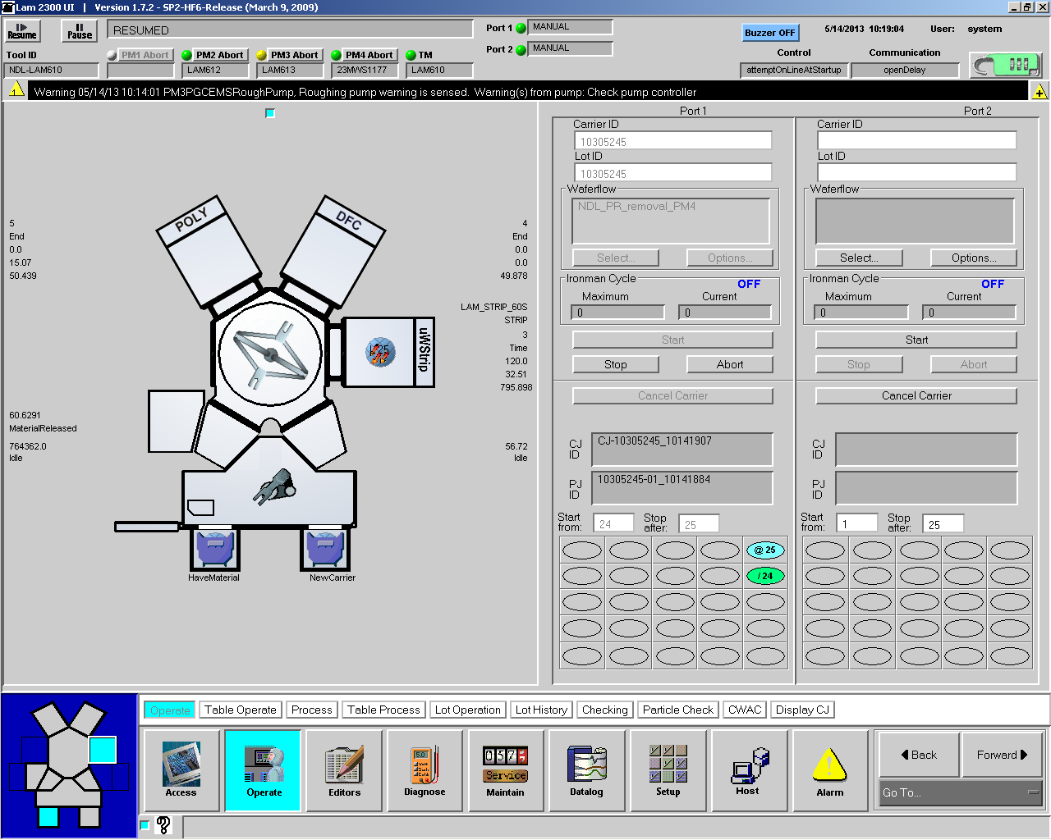
(1)
(2)
(3)
- Check wafer status in Operation page: 〔Gray: process not executed; green: process completed; blue: wafer in transfer; yellow: anomaly occurred in process〕(as shown in Fig. 3).

Fig. 3: Wafer status

- If any error occurs during the experiment, press “Abort” or “Stop” (as shown in Fig. 4) and contact machine engineer.

Fig. 4: Abort and stop page

- After the process is completed (when wafer field turns green), open Port 1 or 2 to take out the wafer.
- Alarm troubleshooting process: Check and record the message displayed on Alarm page (as shown in Fig. 5) and notify the engineer.

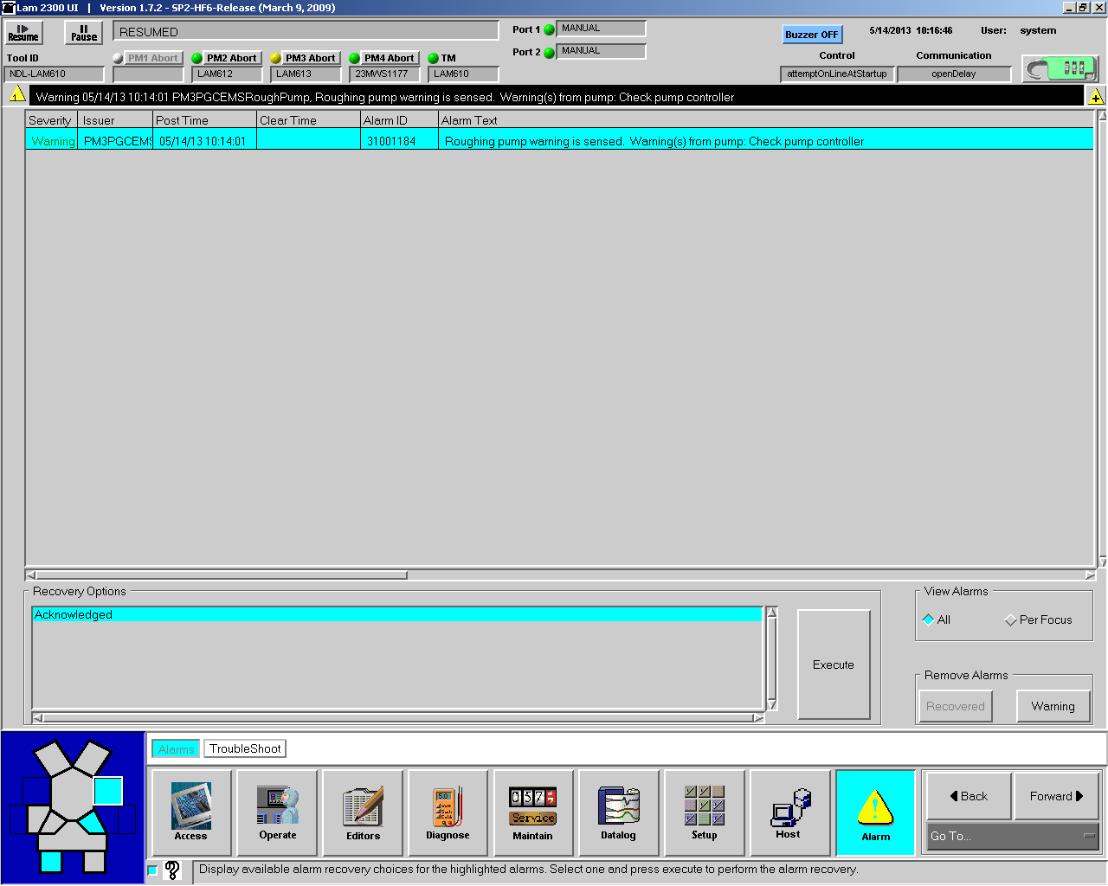

Fig. 5: Alarm page

- MES swipe to turn off the machine

- Notes:
- Please notify the person in charge when an anomaly cannot be determined and solved.
- Make sure to refer to machine SOP and follow relevant regulations when using the machine.
- Reference forms and attachments:
- Q4-NL02 Machine management card
- Q4-NL03 Machine evaluation checklist
- Q4-NL04 Machine checklist
- Q4-NL06 Anomaly and Preventive/ correction action list

