Document Title: | Machine SOP (CF-E14 8” fully automated surface profiler)
Document No.: | Q3-NL04
Draft Dept.: | Film etching division
Draft Date: | 2021-10-06

Version | Edited by | Effective date | Approve document No. | Revision/change description | Revised Page
1.0 | Po-Hao Chu |  |  | New release | ---

Purpose:
Define 8” fully automated surface profiler practices to ensure production quality

Scope:
Applicable to 8” fully automated surface profiler.

Rights and Responsibilities:
- Organization responsibilities: The process engineer is responsible for the drafting and revision of specifications.
- Equipment manager is responsible for handling anomalies to maintain normal operation.
- Qualified operator: Operators passing Tencor P-10 surface profiler operation test.

Definition of terms:
No.

Relevant Documents:
8” fully automated surface profiler user manual.

Standard Operating Procedure:
- Inspect machine condition and current status (green card: in use; red card: under maintenance; yellow card: under test). Boot the machine on the web (web on) and record the start time in machine usage log.
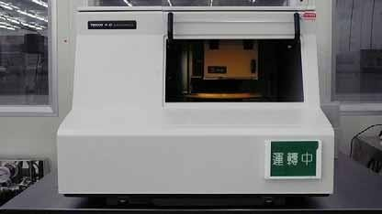

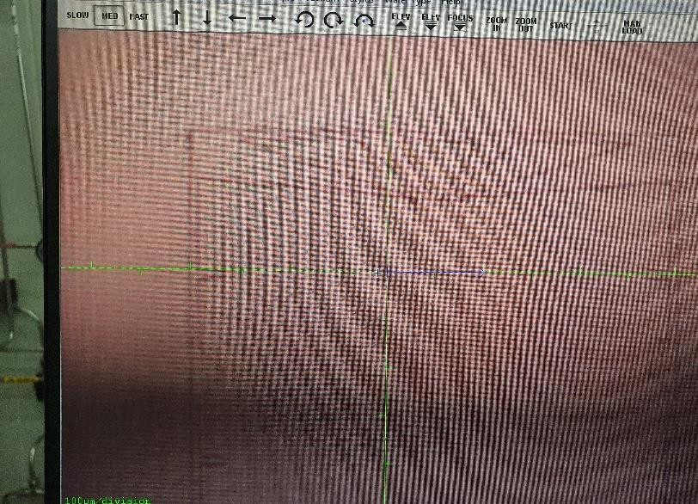
FOCUS
MAN LOAD

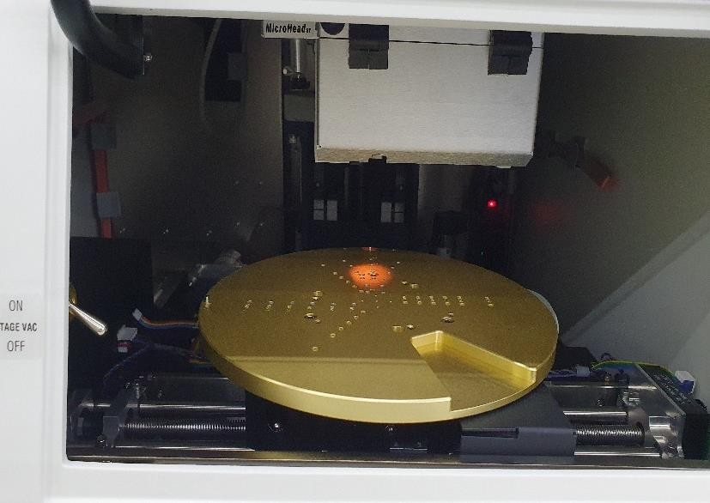

- Move out the carrier by clicking MAN LOAD.
- Open the clear door, put the wafer on the carrier (flat side outward) and turn on vacuum suction.
- Close the clear door, click MAN LOAD to move the carrier to the position for measurement (DO NOT open the clear door during operation).
- Click FOCUS to move the stylus to the sample.
- Use mouse buttons to select the scan area or the trackball to control X-Y.
- After determining the scan area, click “Cancel” to access Recipe screen and select the required recipe.
- Check or change the scanning program parameters and click “START" to start scanning. After scanning, the system will automatically jump to the screen below (Fig. 1).
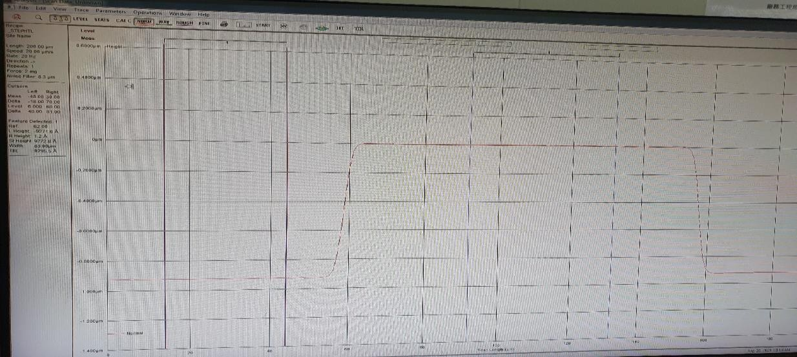
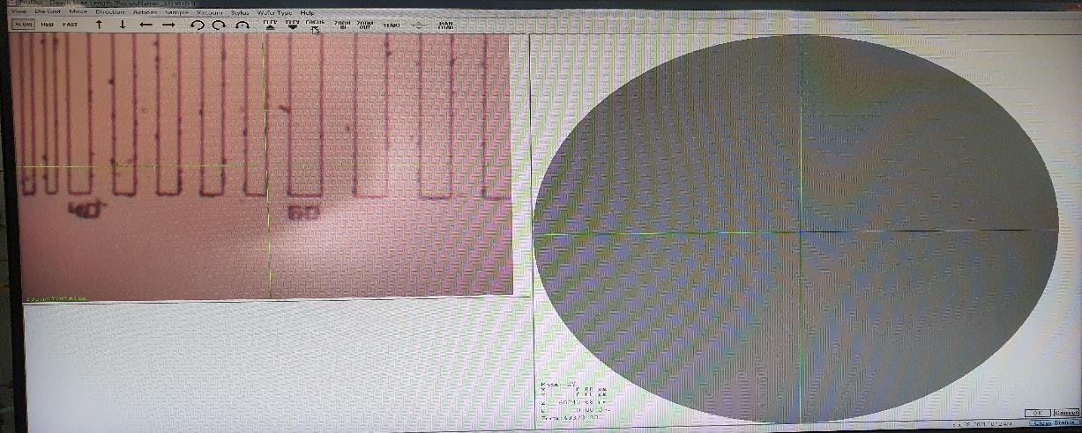
Cancel
START
Fig. 1

- If the result is skew, click Level to call L-L and R-R to level the scanned profile.
- Press 2 keys to translate and 1 key to adjust the width. Adjust L-L and R-R to the same level and leave some space to acquire the average.
- Click Level again to level the image.
- Place L-L and R-R at the height (or width) for comparison and the height (or width) difference will be displayed on the left side of screen.
- After measurement, move out the carrier by clicking MAN LOAD.
- Open the clear door, turn off vacuum suction and take out the wafer.
- Turn off the machine on the web (web off) and record the end time in machine usage log.

Reference forms and attachments:
- Q4-NL02 Machine management card
- Q4-NL03 Machine evaluation checklist
- Q4-NL04 Machine checklist
- Q4-NL06 Anomaly and Preventive/ correction action list

