

Breakage Lines of I-line Stepper-Introduction

Chin-Tsai Hsu

Jan. 9, 2020



Instructions on Use of Breakage Lines of I-line Stepper

- Scope of exposure service for breakage lines
- Instructions on use of breakage lines
- Requirements on use of breakage lines

Scope of exposure service for breakage lines - (1)

Breakage line exposure can be divided into the following two processes:
Process 1: Exposure (zero layer) starts with a small breakage, followed by the subsequent process until the component is completed.
Process 2: Exposure (zero layer) starts with a whole breakage (6” or 8”), followed by a certain process, after which it is cut into a standard sized breakage, and then the process continues until the component is completed.

<Note>
- All breakages to be aligned for exposure must initially be cut into small breakages with a cutting machine.
- If the exposure procedures go through Process 2, their details must be discussed with the engineer.

Chin-Tsai Hsu ext.: 7648 cthsu@narlabs.org.tw

Scope of exposure service for breakage lines - (2)

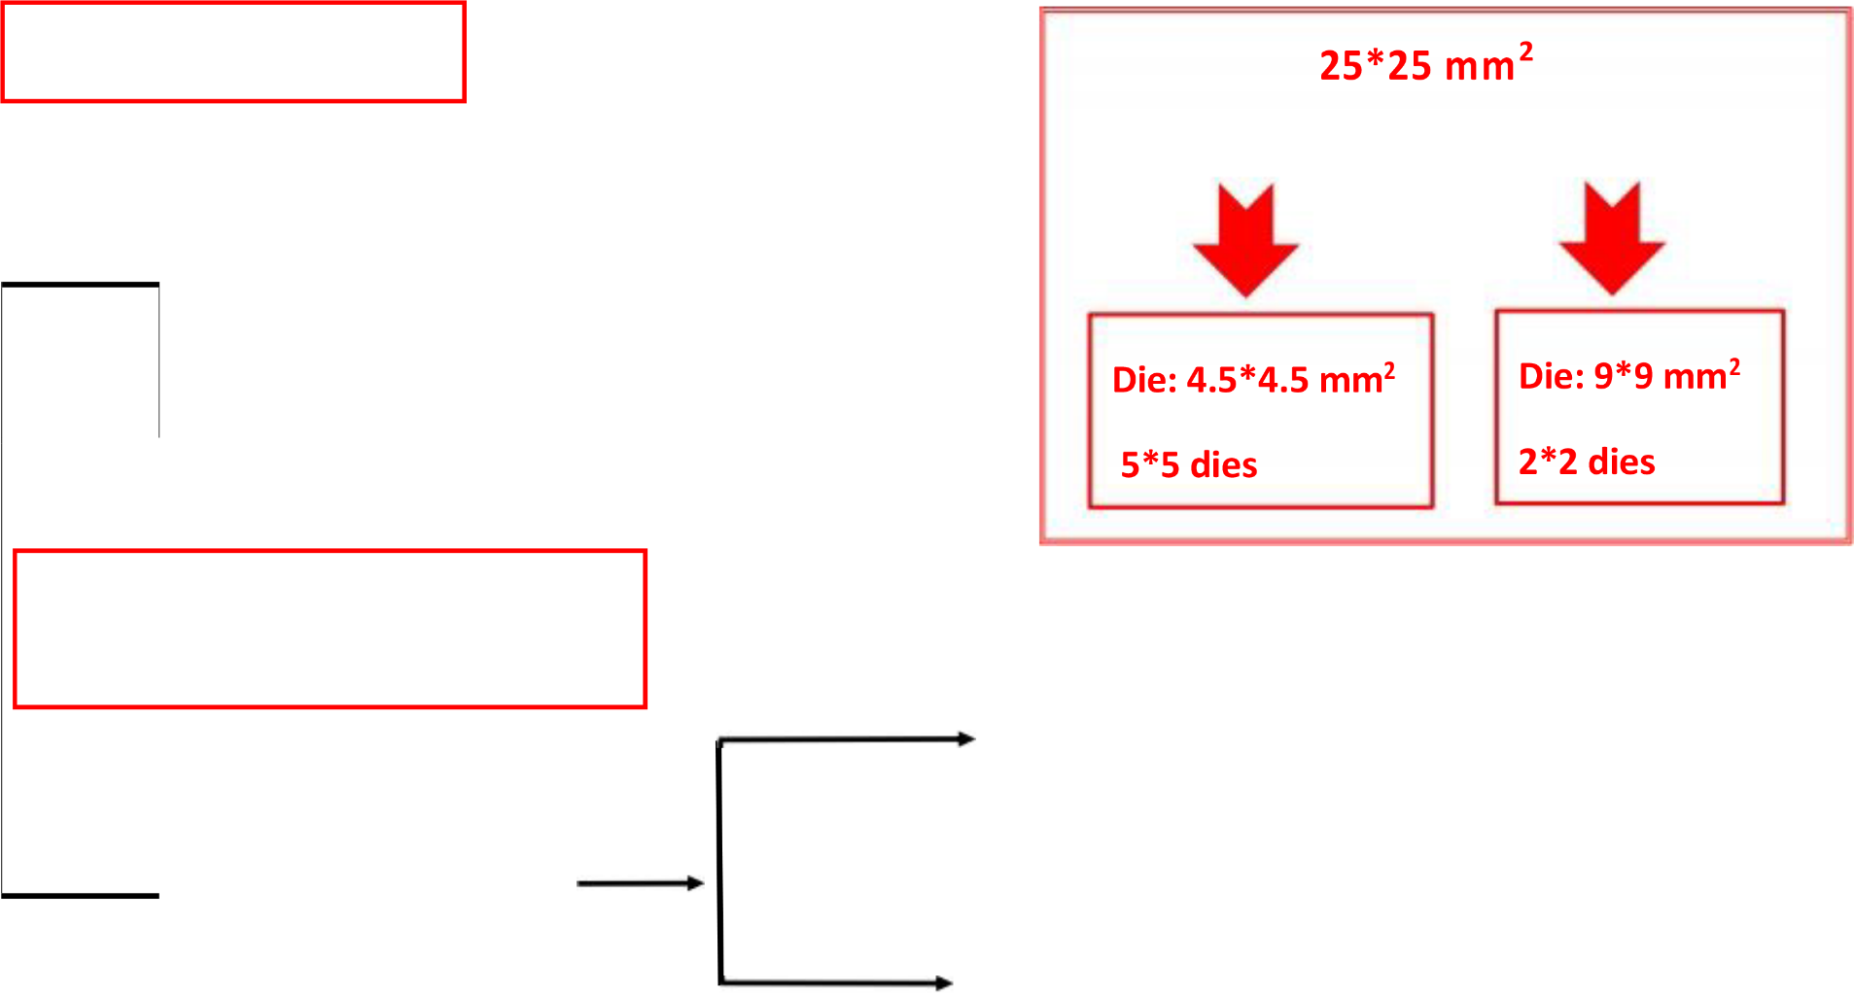
Process for breakage line exposure
9-in-1 reticle
4-in-1 reticle
Breakage
start
start
Whole breakage
Cut into breakage after certain process
Note: Exposure of 2*2 dies is required for breakage alignment at a minimum
Pure I-line
WEPRINT/ELS7500
(using 4-in-1 reticle)
Mix-Match
(must be discussed with engineer!!)
1.2*1.2, 2*2, 2.5*2.5 cm², 2”, 4”
(using standard, 9-in-1 or 4-in-1 reticle)
Mix-Match
Pure I-line
WEPRINT/ELS7500
2.5*2.5 cm² (using 4-in-1 reticle)
4*4 cm² (using standard reticle)
2*2, 2.5*2.5 cm² (using 4-in-1 reticle)
(must be discussed with engineer!!)

Scope of exposure service for breakage lines - (3)

Process 1:
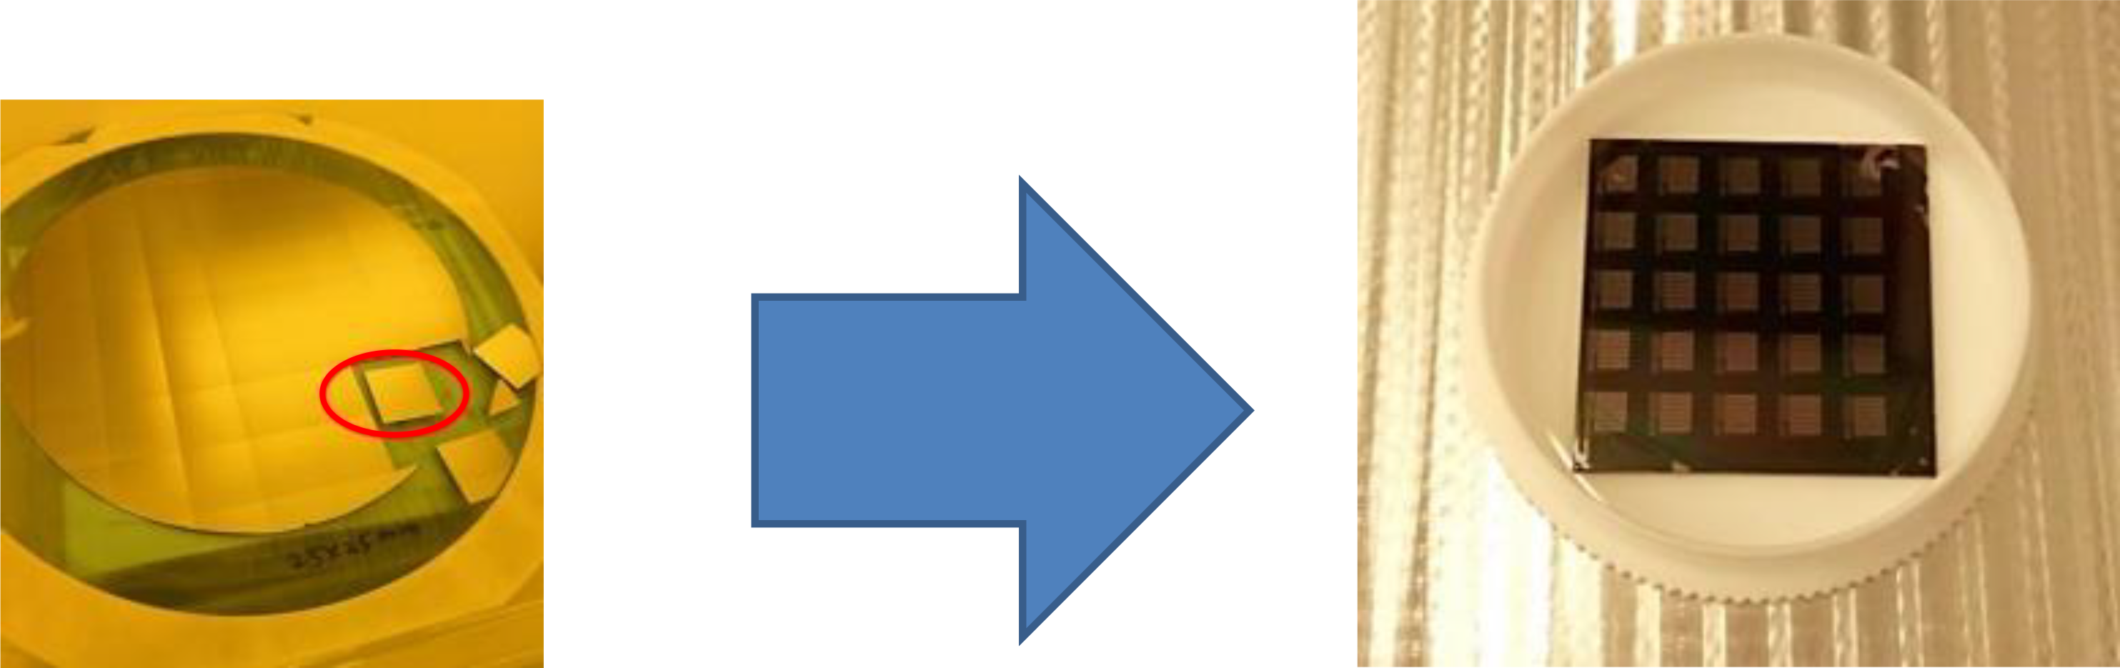
Subsequent process
Starting with small breakage of certain size |  | Component is completed

Scope of exposure service for breakage lines - (4)

Process 2:  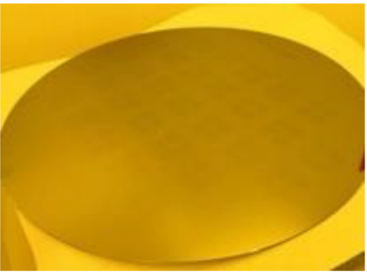  Exposure (zero layer) starts with 6” or 8” | 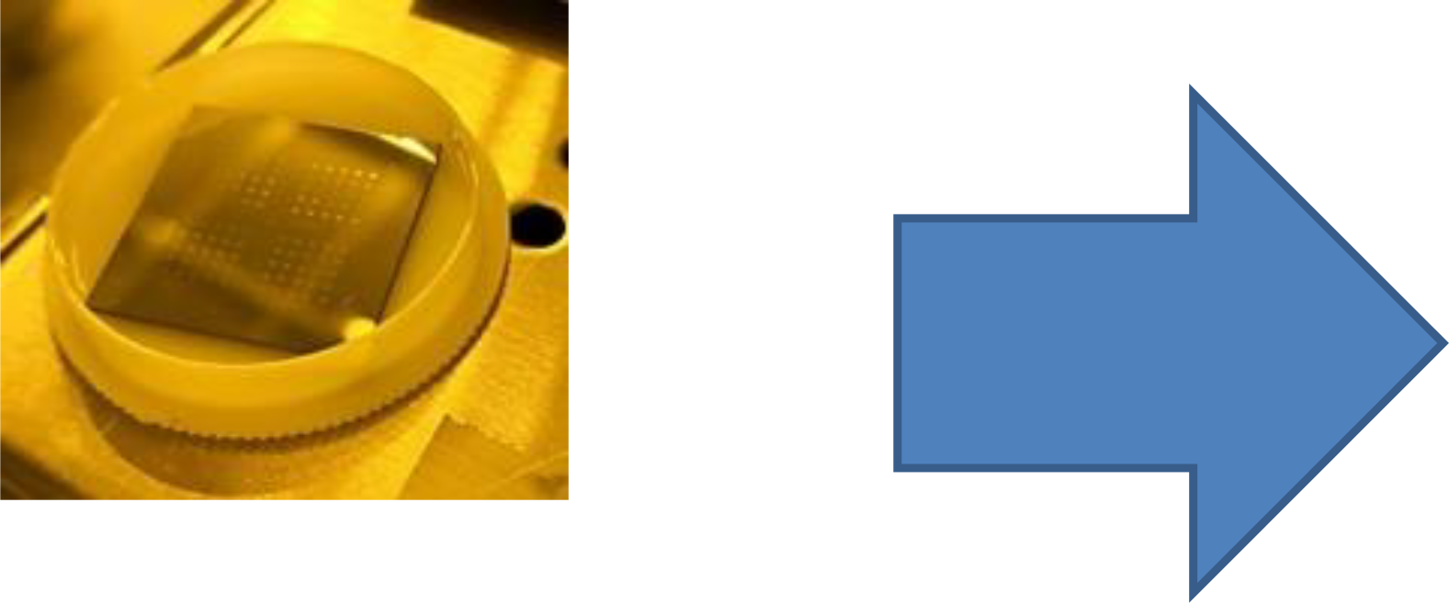  Whole breakage goes through subsequent process | 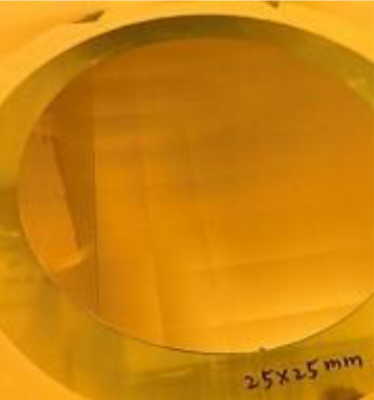  Cut into small breakage after certain process

Going through subsequent process with small breakage | Small breakage goes through subsequent process | Component is completed  <Note>Please discuss with the I-line engineer Chin-Tsai Hsu (ext. 7648) before exiting the breakage line process.

Instructions on use of breakage lines - (1)

The I-line Stepper is the primary machine for TSRI’s 6/8-inch exposure service. Although we have already provided the stage for breakage exposure service, we have to restrict the conditions for its use due to its non-standard exposure mode, which is likely to affect the primary 6/8-inch exposure service and the cleanliness of the machine.

OEM time: Tuesday and Thursday 14:00-16:00

Time for operation by yourself: Except during the office hours of 9:00-18:00 on Monday to Friday, you may use the machine.

Instructions on use of breakage lines - (2)

Thickness of breakage: must be 725 um.
Type: may be Si, compound semiconductors, glass, and LiTaO₃ ceramic materials
Size:
25*25 mm² breakage for standard OEM
Other sizes: 12*12, 20*20, 40*40mm², 50*50mm², 2”, 4”

<Note>
A breakage of the size of 12*12, 20*20 or 25*25mm ² can be coated with photoresist and developed automatically in L09, while a breakage of any other size must be coated with photoresist and developed manually. For automatic photoresist coating and development of breakage in L09, contact Engineer Chao-Hsin Hung (ext. 7573). For manual photoresist coating, contact Engineer Hung-Chun Chen (ext. 7575).

Instructions on use of breakage lines - (3)

Reticle, exposure arrangement and size:
Range of reticle layout:
3.2 X 3.2mm² (for 9 IN 1 reticle), 7.2 X 7.2 mm² (for 4 IN 1 reticle)
Exposure arrangement and size:
5 X 5 map, stepping 4.5 X 4.5 mm² (for 9 IN 1 reticle), 2 X 2 map, stepping 9 X 9 mm² (for 4 IN 1 reticle)
- The unit above is the size on a wafer.
- For all-in-one reticles, contact Engineer Ying-Ling Hong (ext. 7746).
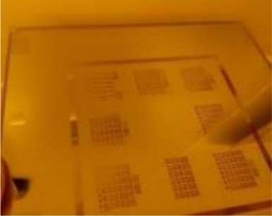  9 IN 1 reticle | 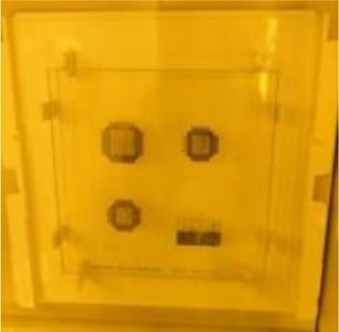  4 IN 1 reticle | 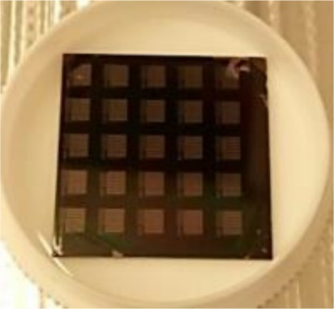  5x5 map (25mm²)  3.2x3.2 mm² exposure area  Stepping 4.5x4.5 mm² | 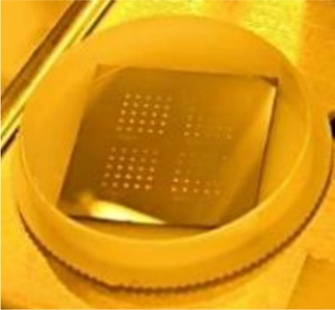  2x2 map (25mm²)  7.2x7.2 mm² exposure area  Stepping 9x9 mm²

Instructions on use of breakage lines - (4)

Resolution and alignment error:
Resolution: single line 0.35 um/single hole 0.45 um
Alignment error: misalignment 1 um
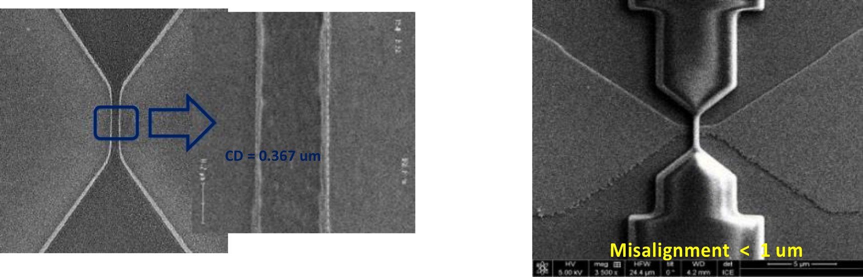
Minimum resolution:  single line 0.35 um  single hole 0.45 um |  | Reserve at least 1um for the design of layout alignment error

Instructions on use of breakage lines - (5)

Notes:
- Use a cutting machine to complete cutting breakages to be aligned.
- For non-standard wafer thickness, a dummy breakage is required (contact the engineer for more information).
- Mix-match exposure with other exposure tools is required (contact the engineers for more information).
- Exposure of special materials may be discussed with the engineer: cthsu@narlabs.org.tw (Chin-Tsai Hsu ext. 7648)

Requirements on use of breakage lines - (1)

<Notes>
A breakage must be cut flat, or the alignment service cannot be provided (except for single-layer exposure).
The back of a breakage must not be stained (e.g., marking, reverse permeation of photoresist...).
Photoresist coating on the edge of a breakage may be uneven or poorly covered, which may affect the quality near the edge.
The wafer must be cut flat, or the alignment service cannot be provided
A stained back of the wafer causes misalignment
The back of the wafer must have no markings; markings may cause defocus
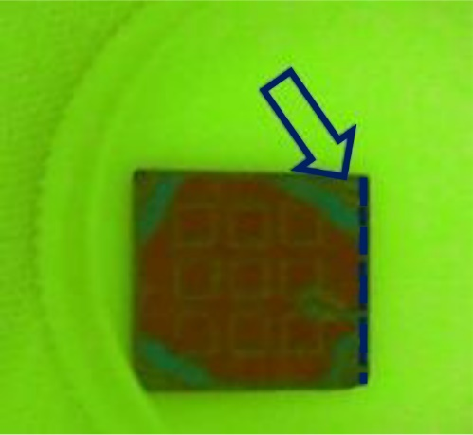 | 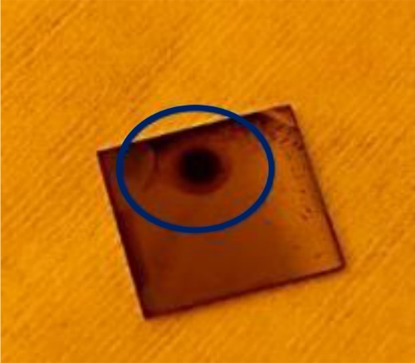 | 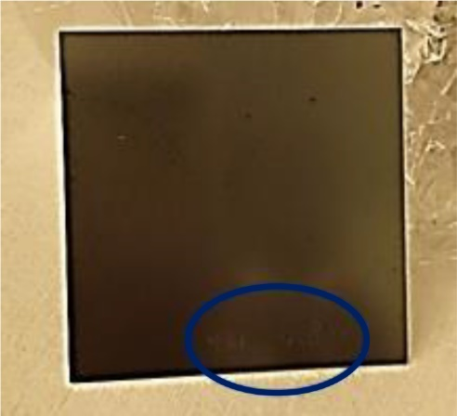 |   The corners of the back of the wafer are prone to having residual photoresists and need to be wiped clean with a dust-free cotton swab.

Requirements on use of breakage lines - (2)

Process for breakage exposure:
priming HMDS  (L09) | Manual photoresist coating | prebake  (HP 90C, 60”) | Exposure  (L05C)
P.E.B.  (HP 120C, 90”) | Development (manual)  (LOR 45”, others 70”) | H.B.  (HP 120C, 60”)

- For manual coating and development--contact Engineer Hung-Chun Chen at ext. 7575.
- A breakage of size 12*12, 20*20 or 25*25mm² can be coated and developed automatically in L09--contact Engineer Chao-Hsin Hung at ext. 7573.

Requirements on use of breakage lines – (3)

Exposure requirements:
- Only those who are qualified to use breakage lines are permitted to use jigs.
- Jigs are provided by the engineer; do not take them out of the cabinet yourself.
- All jigs must be used carefully.
- The exposure jigs have been patented. Do not take their pictures for imitation, or you will violate intellectual property rights.
- Be careful when wiping the slides, and return them to their original positions after wiping.
- Please return everything to its original position after an exposure is completed.
- Please keep the working table clean, and do not leave any wipes or vacuum tape on the table. Violation of the foregoing will be subject to penalty.

