

I-line Breakage Line-Standard Process

Chin-Tsai Hsu

Jan. 9, 2020

I-line Breakage Line-Process Specifications--(1)

Thickness of breakage: must be725 um
Type: may be Si, compound semiconductors, glass, and LiTaO₃ ceramic materials
Size: 25*25 mm² breakage for standard OEM
Reticle, exposure arrangement and size:
Range of reticle layout:
3.2 X 3.2mm² (for 9 IN 1 reticle), 7.2 X 7.2 mm² (for 4 IN 1 reticle)
Exposure arrangement and size:
5 X 5 map, stepping 4.5 X 4.5 mm² (for 9 IN 1 reticle), 2 X 2 map, stepping 9 X 9 mm² (for 4 IN 1 reticle)
Resolution and alignment error:
Resolution: single line 0.35 um/single hole 0.45 um
Alignment error: misalignment 1 um

I-line Breakage Line-Process Specifications--(2)

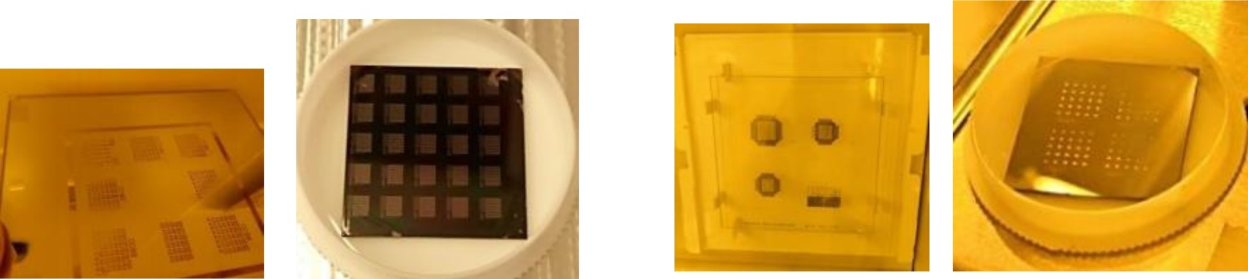
9 IN 1 reticle | 5x5 map (25 mm²)  3.2x3.2 mm² exposure area  Stepping 4.5x4.5 mm² |  | 4 IN 1 reticle |  | 2x2 map (25 mm²)  7.2x7.2 mm² exposure area  Stepping 9x9 mm²
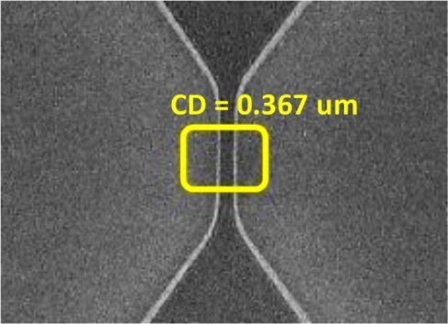  Minimum resolution:  single line 0.35 um  single hole 0.45 um |  | 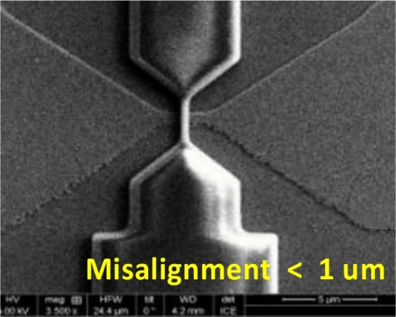  Reserve at least 1 um for the design of layout alignment error

