Introduction of Focused Electron Beam System

Instrument no.: L18
Instrument name: Focused Electron Beam System
Storage location: Class 10 Photo Room
Model: FEI Helios 1200+
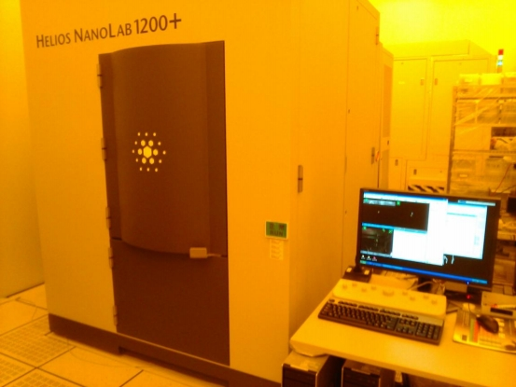

The functions are described as follows:
This instrument features three main functions:
- It utilizes the excellent resolving power of electron beam for electron beam induced deposition of platinum or carbon, and traces patterns to produce hard masks for subsequent resistance to etching. It can create a nano-structured aligner for prototyping.
- Its gun, combined with an ion beam, can be used to cut a section directly on the sample and observe the section with an electron beam, making it a good tool for failure analysis.
- The high-voltage ion beam can cut sections on both sides to make a TEM sample and, combined with the low-voltage ion beam technology for sample cleaning, can produce an excellent TEM sample smaller than 100nm with low-amorphization damage.

The main specifications are described as follows:
Electron beam specifications
Resolving power | 1nm @ 15kV SE  1.4nm @ 1kV SE
Accelerating voltage | (SEM) 1-30kV
Electron emission source | Thermal field emission
Range of magnification for observation | (SEM) 55x to 500kx
Ion beam specifications
Resolving power | 4.0nm achievable@30kV
Accelerating voltage | (FIB) 2-30 kV
Ion emission source | Type: Gallium liquid metal  Life time: 1000 hours
Stability of position of ion beam irradiation | Beam shift spec.: mechanically <5μm, electrically 0.1%
Specifications of movable stage
Direction axis | At least 5-axis motorized
Specifications of movement  X, Y | Repeatability 2.5 μm  Travel ≥± 200 mm
Z | ≥ 10mm
Rotation | 360°
Tilt | -3° to 58°
Sample stage | 200-300 mm wafer
Applicable gases | Platinum Deposition  Carbon Deposition

