Focused Electron Beam System - Technical Data

Sample chamber loading time ≤5mins
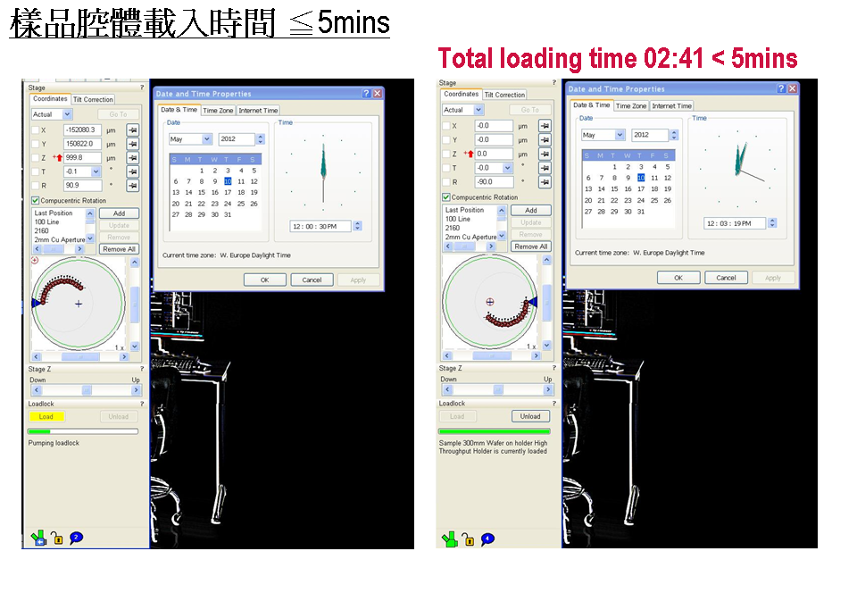
- Gas deposition power - Iso Line
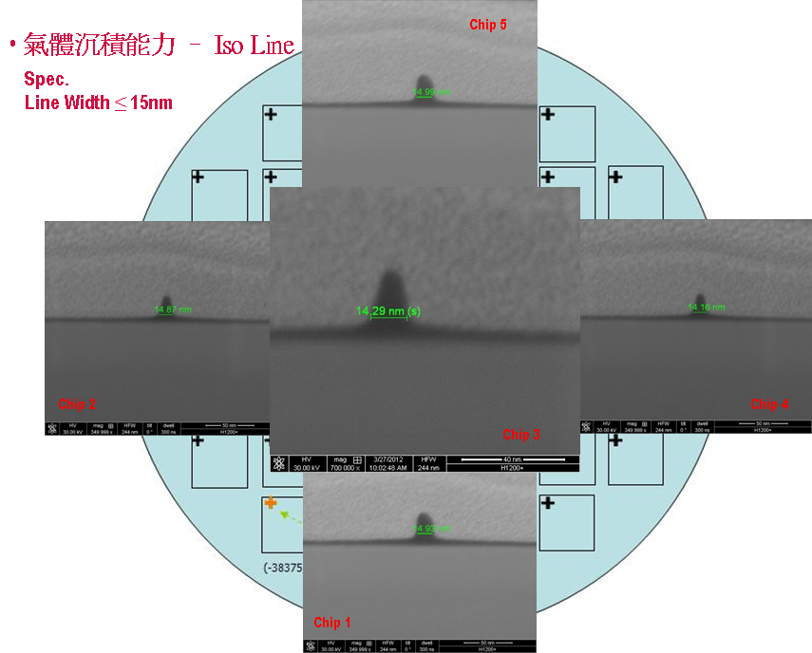

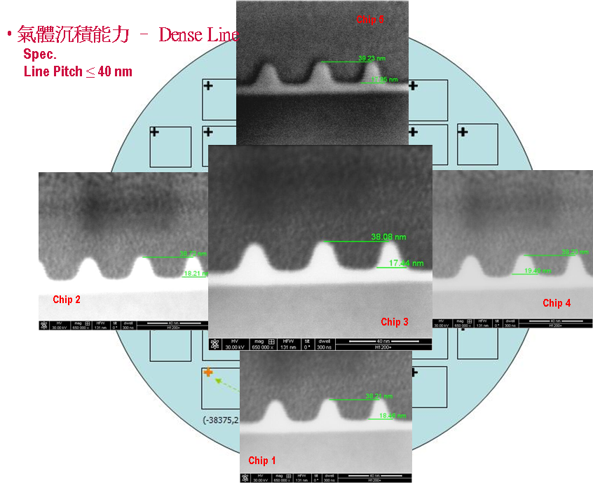
- Gas deposition power - Dense Line

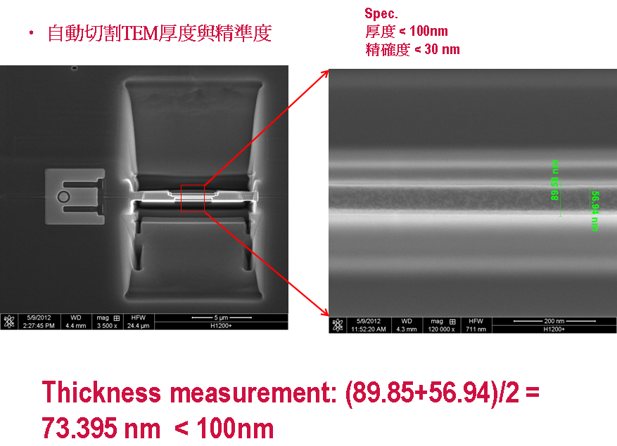
- Automatic cutting TEM thickness and accuracy
Thickness < 100 nm
Accuracy < 30 nm

