Standard Operating Procedures for Focused Electron Beam System

- Placement of the specimen:
  - Turn off E beam/I beam,
  - Click unload loadlock
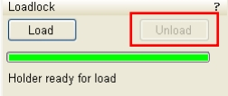
  - Open loadlock door and place the sample in, and click Load
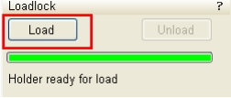
  - Check if the vacuum degree of the chamber is below 5x10⁻⁵ mbar
Completed
Not completed
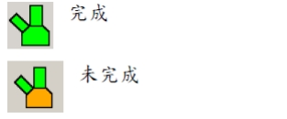

- ON/OFF of electron and ion beams
Click Wake Up to turn on E beam/I beam
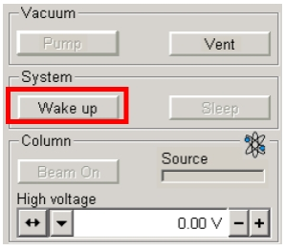

- Search for specimen/cutting point
  - Focus on and search for the sample with low-magnification SEM (mode 1)
  - Perform Z to FWD connection,
  - Set Z=4.25 mm (in SEM mode)

  - Adjust magnification to approx. 5000x (the scale bar showing 5um), and adjust the focus (Note: the stage must be moved with the mouse and the QUADE 1-3 in the navigator screen)

- Setting the eucentric height of the specimen (SEM mode)
  - The Z-axis must be moved with the mouse and the navigator screen
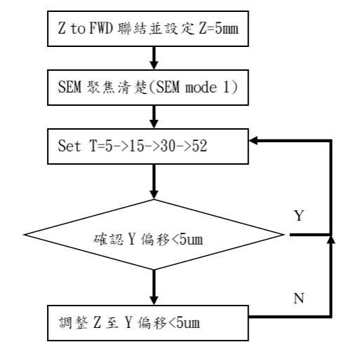
Z to FWD connection and set Z=5mm
SEM focus is clear (SEM mode 1)
Adjust Z to Y offset<5um
Check if Y offset<5um
  - Parameter settings of the coordinates of 5 axes
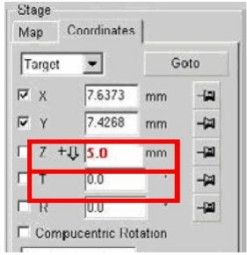

- Cutting of the specimen and coating with a Pt protective layer
  - Switch to FIB mode (select 30~50pA for beam current)
  - Select Patterning
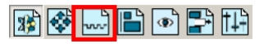
  - Select patterns, set xyz, and select material file.
  - Select appropriate I beam currents (current density must be lower than 10pA/um²)
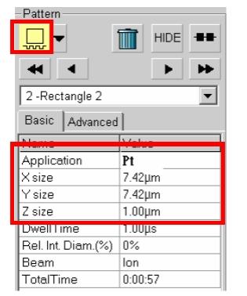
  - Heat Pt and insert the needle
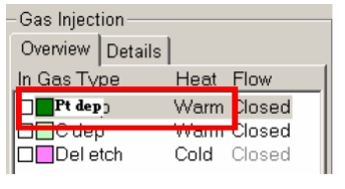
  - Run patterning
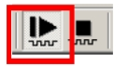
  - Run X-section
Select regular cross section-> cleaning cross section
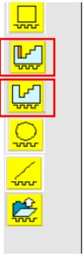

- Capturing and saving images (switching to SEM mode)
Real-time image | 
Capture single image | 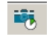
or press F2 for the default photo settings

