Variable Shaped Electron Beam Aligner
System Introduction

System Functions
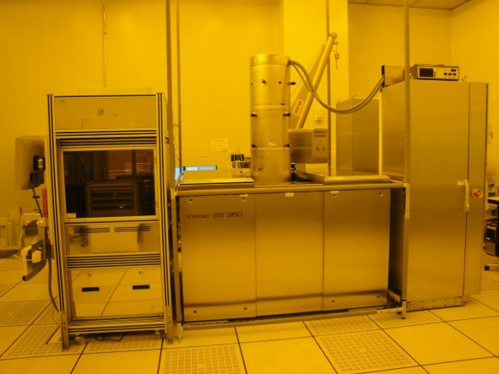
  The main function of the Variable Shaped Electron Beam Aligner is the exposure of 8-inch wafers, and its main specifications are as follows:
  Electron beam shape | VSB
  Acceleration voltage | 50 kV
  Min. address grid | 1 nm
  Current density | 15 A/cm²
  Substrate size | 200 mm wafer
  Min. feature size | < 50 nm

Instrument Location
Nano Electronics Building
Clean Room 100 (photo room) and the sub fab below it
Photolithography Area 1
Developer storage area
Chemical box
Cooling water vapor
Temperature and humidity control
Temperature control
Photolithography Area 2
Main part of process
Main part of TRACK process
Developer storage area
Temperature and humidity control
Temperature control
Chemical box
Cooling water vapor
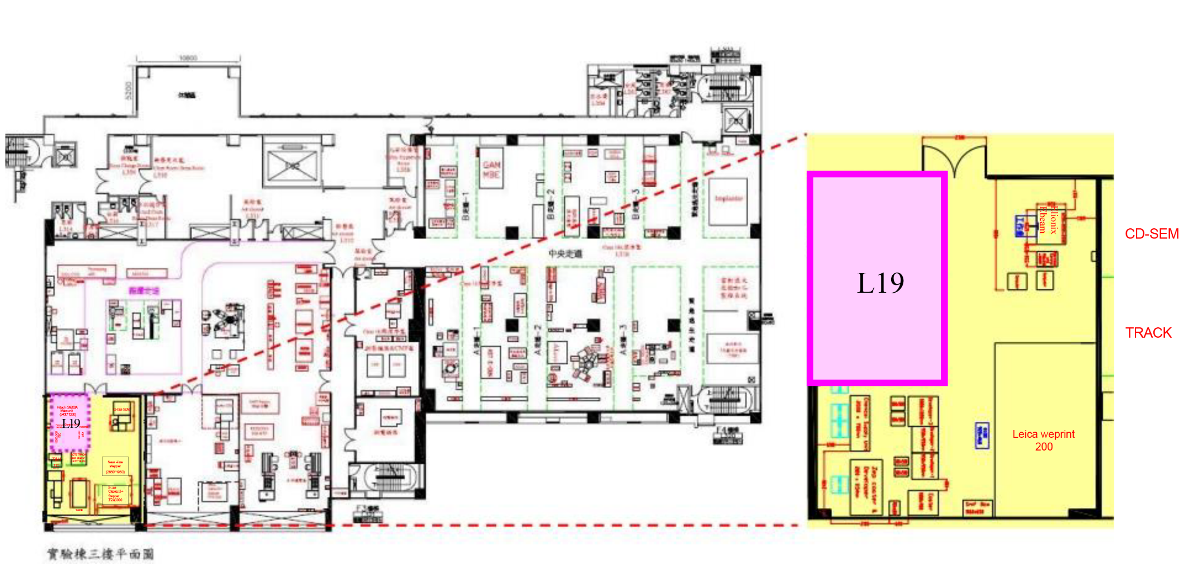

Equipment Overview

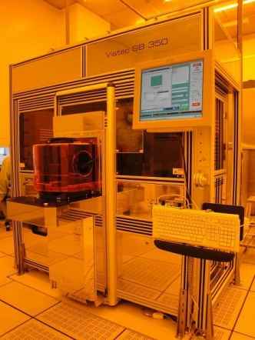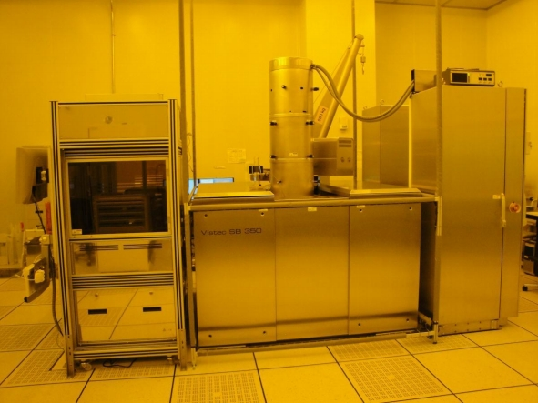
Transfer system
Exposure system
Control system
Transfer system-front
Load/Unload port

Emergency Stop Button-EMO

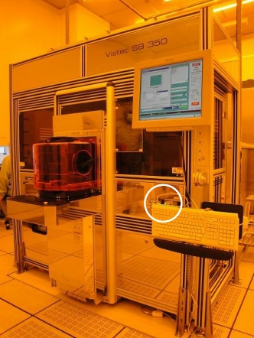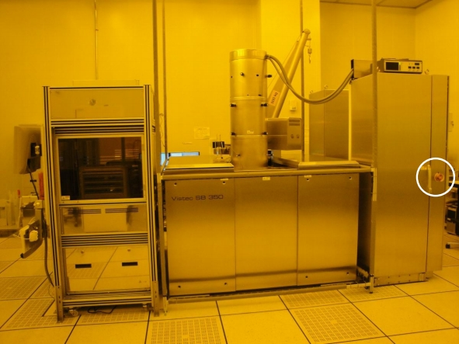
Transfer system-front
Control system-side

Services

- Exposure of 8-inch wafers

- Equipment used:
- L17 Photoresist Coating and Development System

END

