Variable Shaped Electron Beam Aligner - Technical Data

Item | Specification | TestResults
Resolution | 50 nm | V 47.43nm/H 45.36nm
Line width accuracy | 30 nm | 1.6 nm / 5.0 nm
Line width uniformity | 20 nm | V 9nm / H 8nm
Edge roughness | 15 nm | V 4.52nm/3.70nm H 7.03nm/6.52 nm
Multi-layer alignment accuracy | 40 nm | X 17nm/Y 15nm

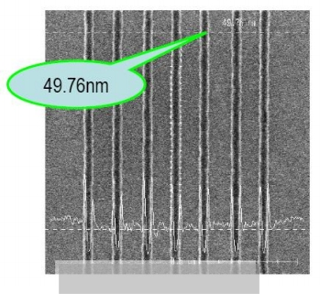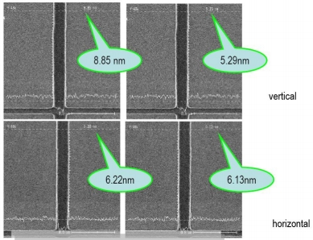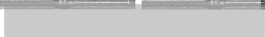
Edge roughness ≤ 15 nm photoresist line
Resolution ≤ 50 nm photoresist line

