Variable Shaped Electron Beam Aligner
Standard Process

NEB resist process sequence
aim: ~380nm resist thickness

- Prime | HMDS 90°C
- Coating | 4400 rpm 30”
- Softbake | 110°C 120”
- Exposure | Base Dose 16µC/cm²
- Post Exposure Bake | 105°C 120”
- Development | AD-10 2.38% TMAH 60” puddle
- Rinse | Di-Water
- Hardbake | 110°C 120”
  - Track ACT8 recipe
- COT-NEB
- DEV-NEB

100 nm line  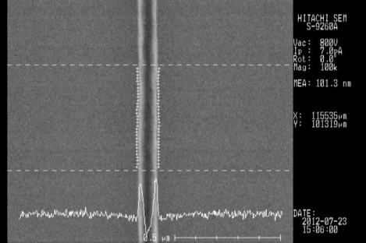  101.3 nm iso @12µC/cm² | 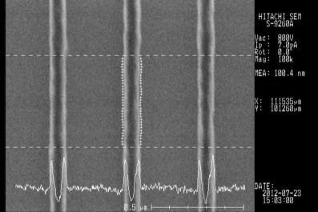  101.7 nm L/S=1:3 @11.2µC/cm²
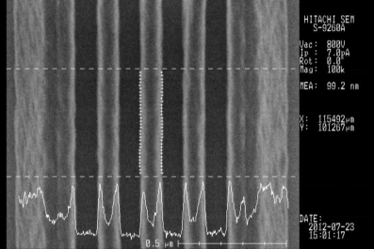
Collapse L/S=1:1 @12µC/cm²

CAN resist process sequence
aim: ~100nm resist thickness

- Prime | HMDS 90°C
- Coating | 1500 rpm 30”
- Softbake | 110°C 90”
- Exposure | Base Dose 80µC/cm²
- Post Exposure Bake | 110°C 60”
- Development | AD-10 2.38% TMAH 30” puddle
- Rinse | Di-Water
- Hardbake | 110°C 60”
  - Track ACT8 recipe
- COT-CAN
- DEV-CAN

50 nm line  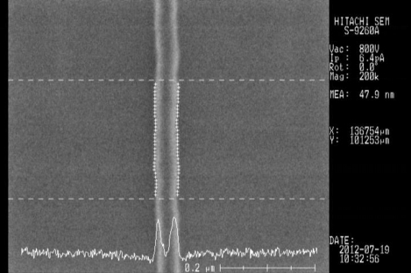  47.9 nm iso @80µC/cm² | 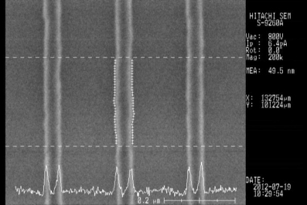  49.5 nm L/S=1:3 @76µC/cm²
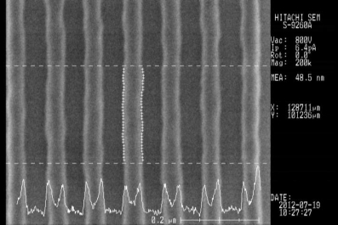
48.5 nm L/S=1:1 @72µC/cm²

Chips placement on 8” wafer (standard layout)

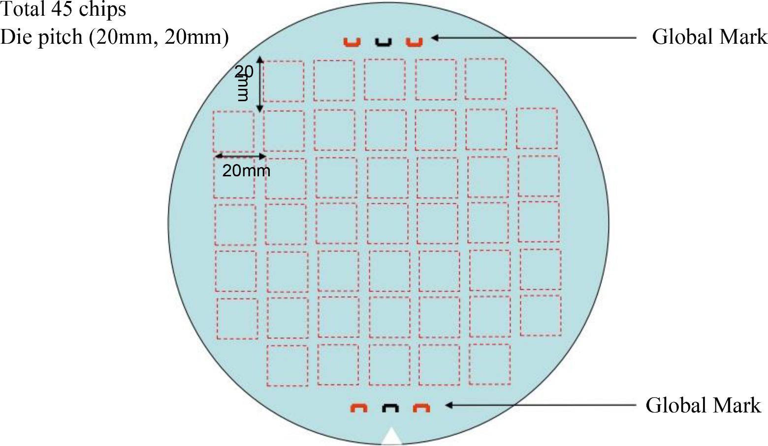

Chip mark arrangement in the chip



