Mask Process Machine

TL-0605S

Automatic Mode



Techno-Lead Japan Co., Ltd.

[Auto Mode Operate]

- Utility
Check air/N2/vent.
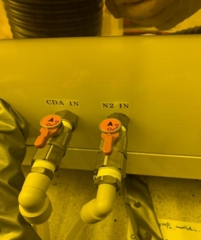

- Power On
Open ELCB1 in the electronic box.
Touch the side of the panel to press Power (In).
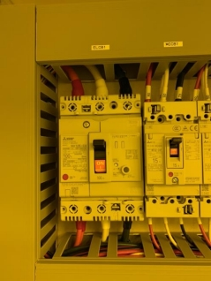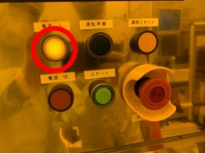

Check the temperature of each hot plate.
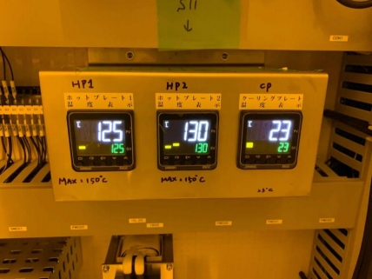

- Mode Select
Touch the screen on “Title Screen” to move to “MENU” ↓
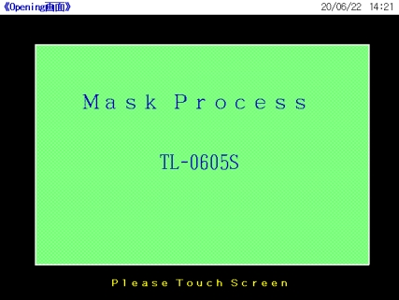

Press “Auto” button.
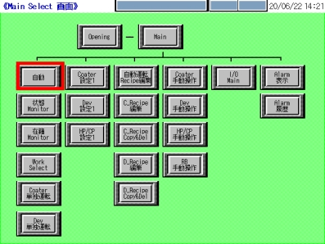

- place the cassette.
According to the reticle size.
①Change the reticle size to the required setting manually.
※When placing the cassette, make sure to fix the bottom of the cassette to the top of the stand until they are secure.
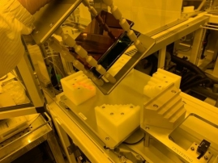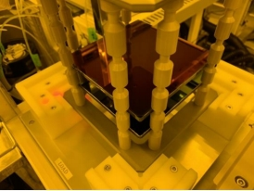

After the cassette is placed, press LD/ULD START button.
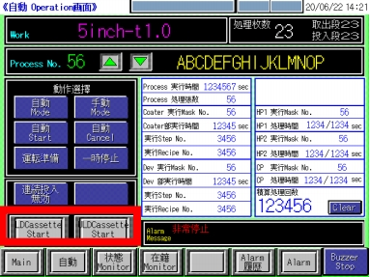

- Check the recipe number and set the recipe number to run.
Set the number of reticles and the recipe respectively. Check the recipe number again before operation.
※Check the reticle size.
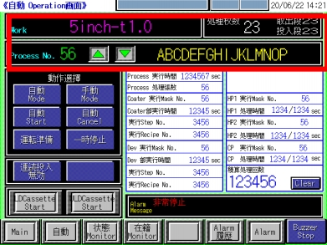

- Set to Homing.
※The home point of the robotic arm must be set manually. The home point of the robotic arm must be set under manual mode.
Under Main, select RB for manual operation to run Robot Homing.
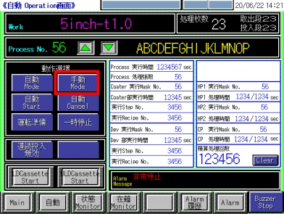
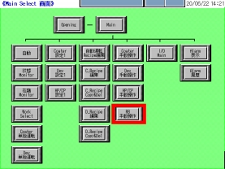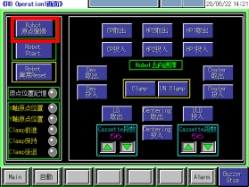

Then, switch back to Auto Mode and press the Run Ready button, and the machine will start to perform homing of each unit.
The Start button will start to blink when you finish homing setting.
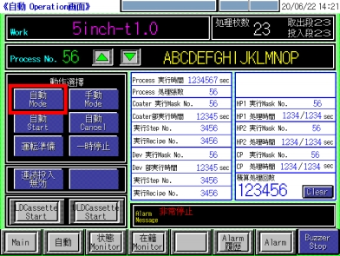
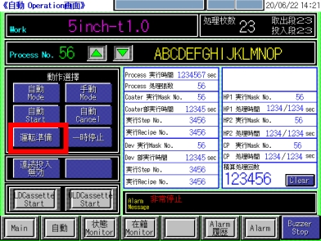

- Mode Selection
Press Auto Mode button on the “Auto Operation Screen” to switch to automatic mode.
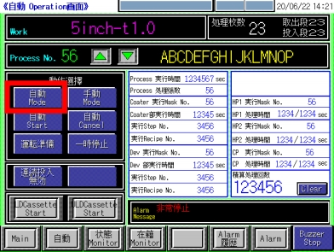

- Start Automatic Mode
Check if automatic operation can be started, and then press the touch screen to complete the preparation for automatic start.
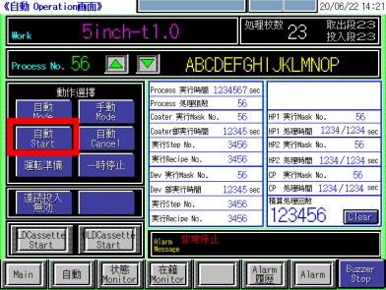

- Start Automatic Operation
The “Start” button blinks when everything is ready.
Press Auto Start button to display the final check screen.
After the final check is completed, the machine is ready to run.


