

Introduction of L22 High-speed Mass-produced Optical Exposure System
(248 Scanner Introduction)

Engineer: Tsai-Ming Huang

Last Edit: Apr. 14, 2023

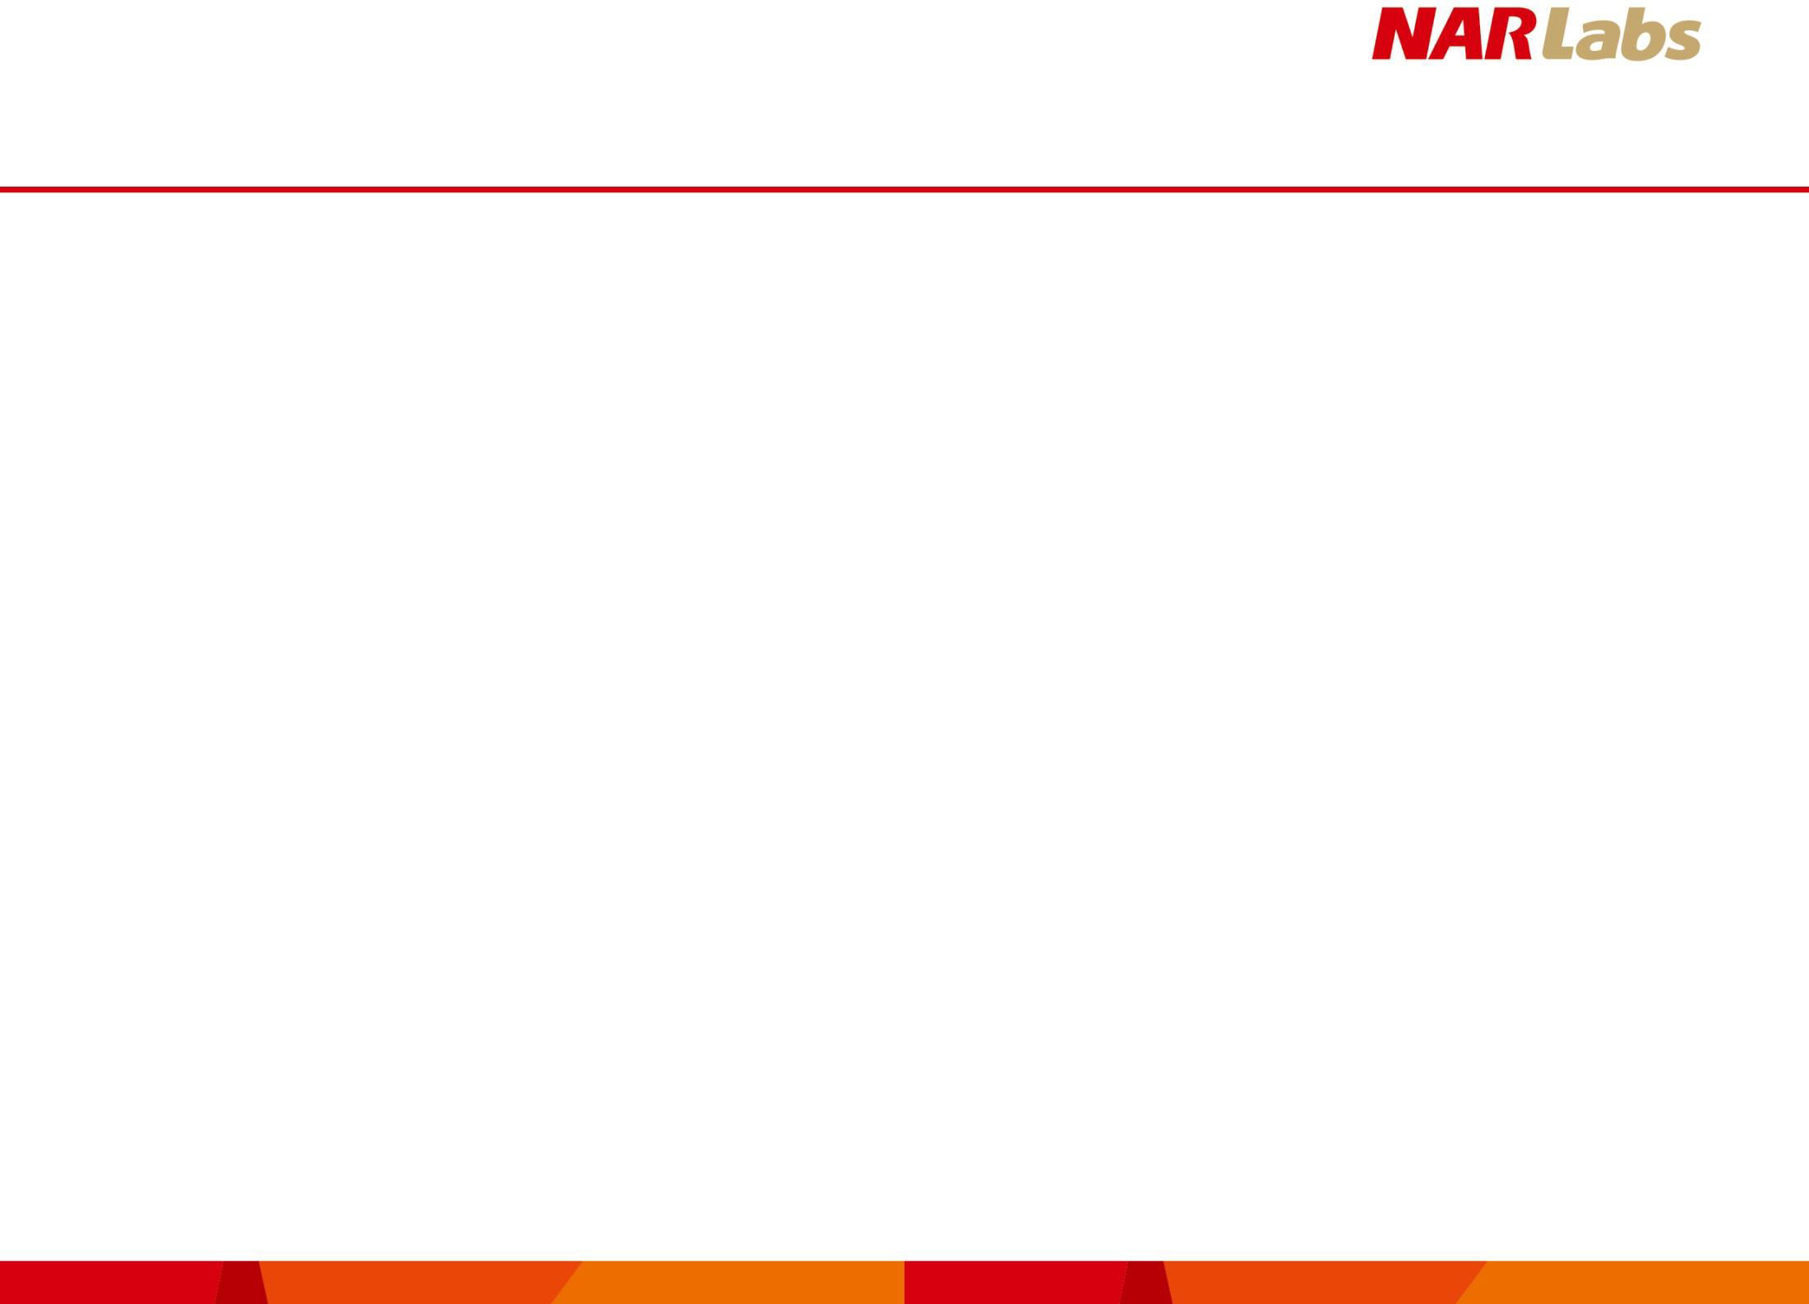
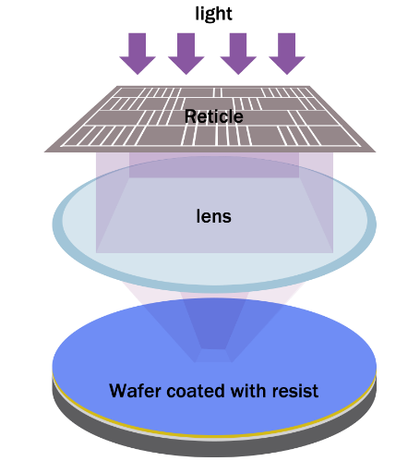
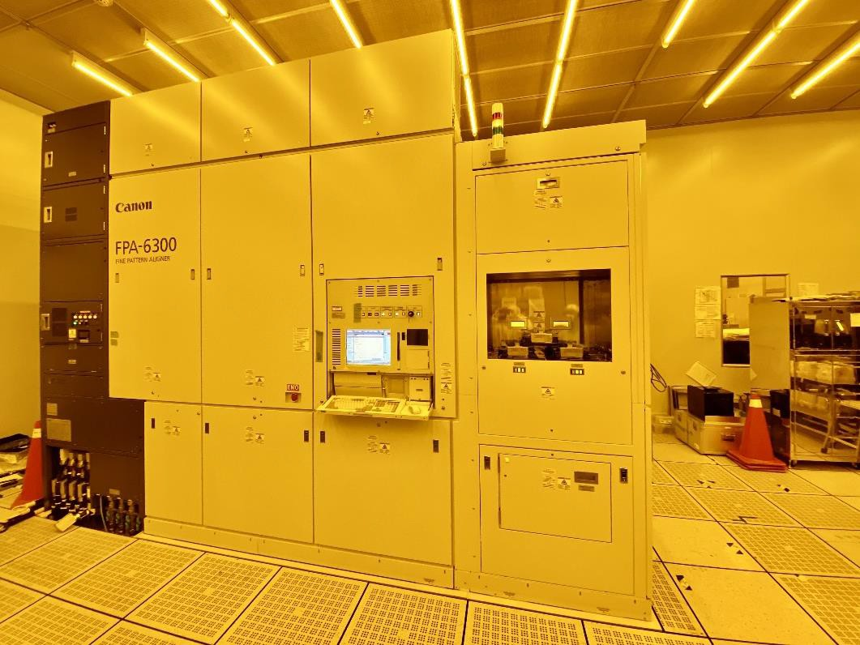
The 248 Scanner Introduction

The Lithography Process | The KrF (248 nm) DUV Scanner in TSRI: FPA-6300ES6a

- Circuit patterns are transferred from the reticle to a wafer using an
aligner.
- Exposure equipment with better resolution can transfer circuits with smaller line width to a wafer. As a result, more components can be placed on the wafer per unit area, generating more functions and better performance for a single chip.
- TSRI introduced Canon FPA-6300ES6a, which utilizes a sophisticated stage control technology, an improved alignment system and a more advanced temperature and deformation control system for more precise control of exposure offset. The optical projection system with an NA (numerical aperture) of up to 0.86 provides good resolution and exposes smaller line widths (110 nm).
Specifications
Model type | KrF (248 nm) DUV Scanner
Wafer size | 200 mm
Numerical aperture (NA) | 0.50-0.86
Resolution | ≤ 110 nm

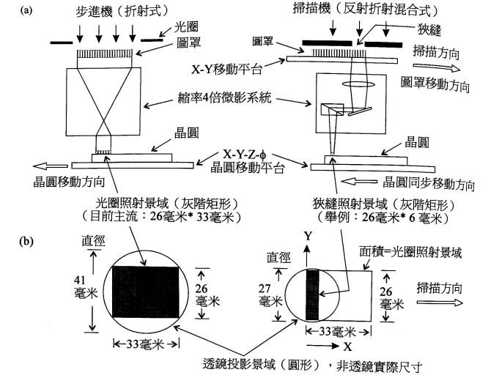
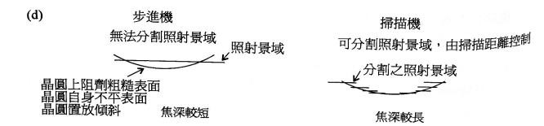
Scanner vs Stepper

i-Line Stepper
248 Scanner
  - Advantages:
- The scanner requires smaller and more easily made lenses with better quality and less image aberration.
Larger depth of focus
Photoresist on the rough surface of wafer
Uneven surface of wafer
Wafer placed in tilted position
Shot field
Stepper
Unable to split the shot field
Split shot field
Scanner
Able to split the shot field, controlled by scanning distance
Lens projection field (circle), not actual size of lens
Stepper (refractive)
Aperture
Reticle
Reticle
Scanner (reflective-refractive)
Slit
Scanning direction
Reticle moving direction
Wafer
Wafer synchronous moving direction
Wafer moving stage
Wafer
Lithography system with 4x reduction
X-Y moving direction
Wafer moving direction
Slit shot field (gray scale rectangle)
(Example: 26mm*6mm)
Aperture shot field (gray scale rectangle)
(Current: 26mm*33mm)
Smaller depth of focus
Area=Aperture shot field
Scanning direction
26mm
Diameter
Diameter
33mm
27mm
33mm
26mm
41mm
- The scanner is capable of adjusting the focused position while exposing, resulting in a larger depth of field for the process.

- Nanometer Technology for Semiconductor, by Wen-an Loong

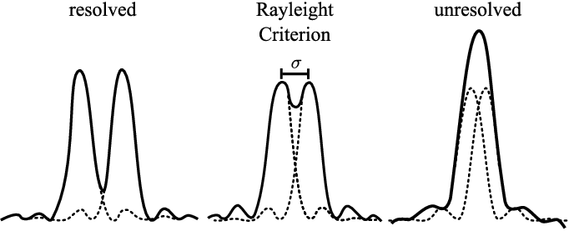
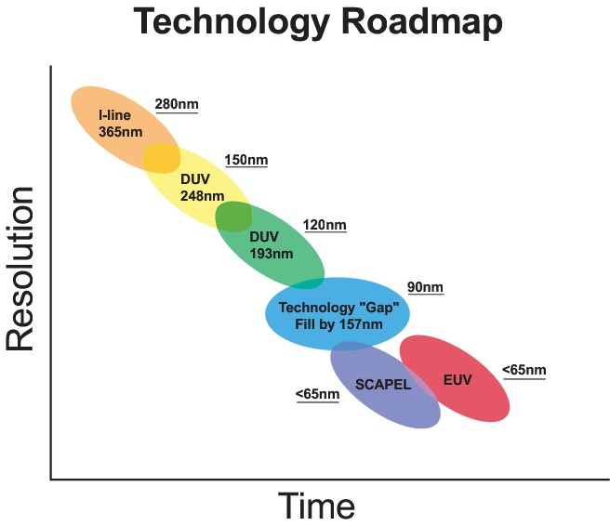
248 (DUV, KrF) vs 365 (i-line)

- Compared to the 365 nm i-line, the 248 nm DUV KrF using a shorter wavelength has better resolution.
R (resolution)= K₁λ/NA
K1: Integrated parameter of process
λ: Wavelength
NA: Numerical aperture

- Light with a wavelength of 248 nm is produced by a krypton fluoride (KrF) excimer laser, so 248 is sometimes referred to as KrF.

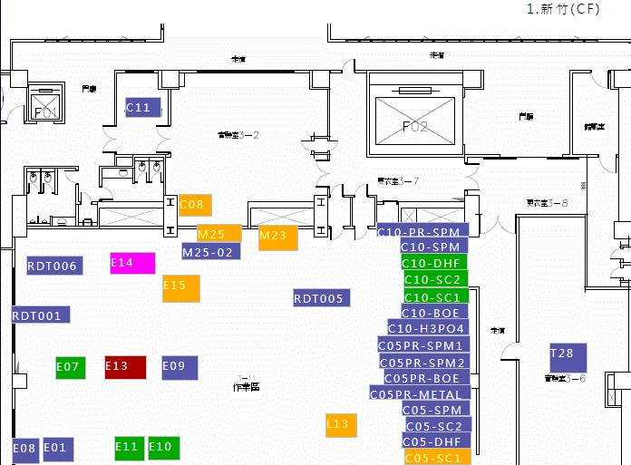
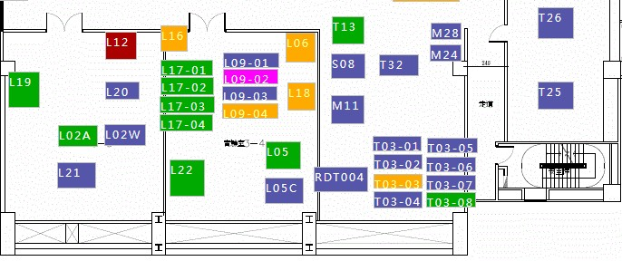
Location of 248 Scanner (L22)

Entrance to Class 100 Clean Room

L17

L22

Photo Room

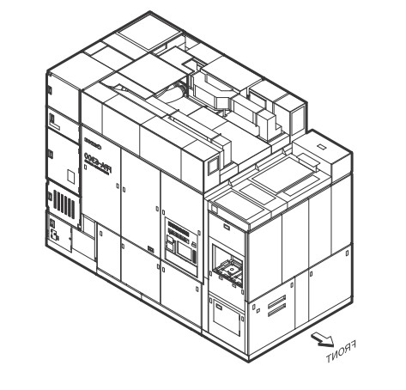
Appearance of 248 Scanner (L22)

Foup load port
248 laser
Reticle
Wafer

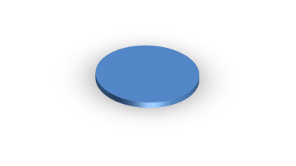
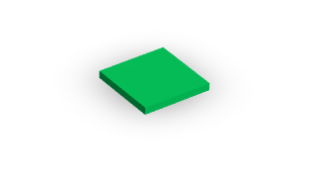
From the KrF excimer laser device located in the sub-fab

Reticle load port
Control panel

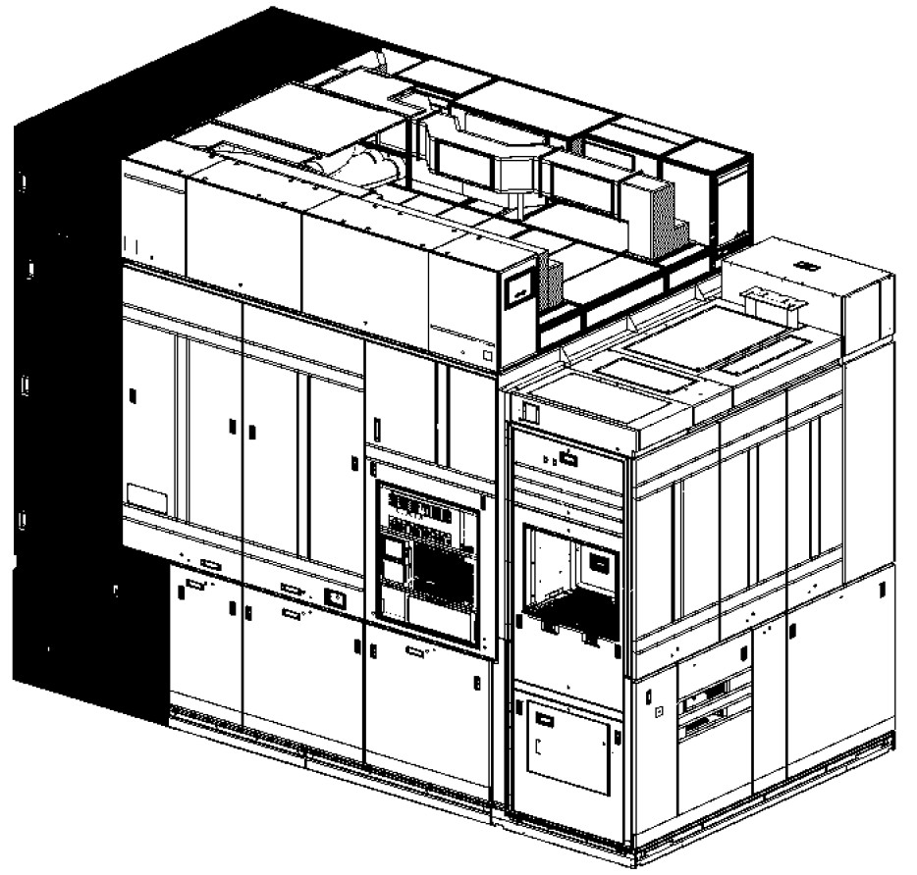
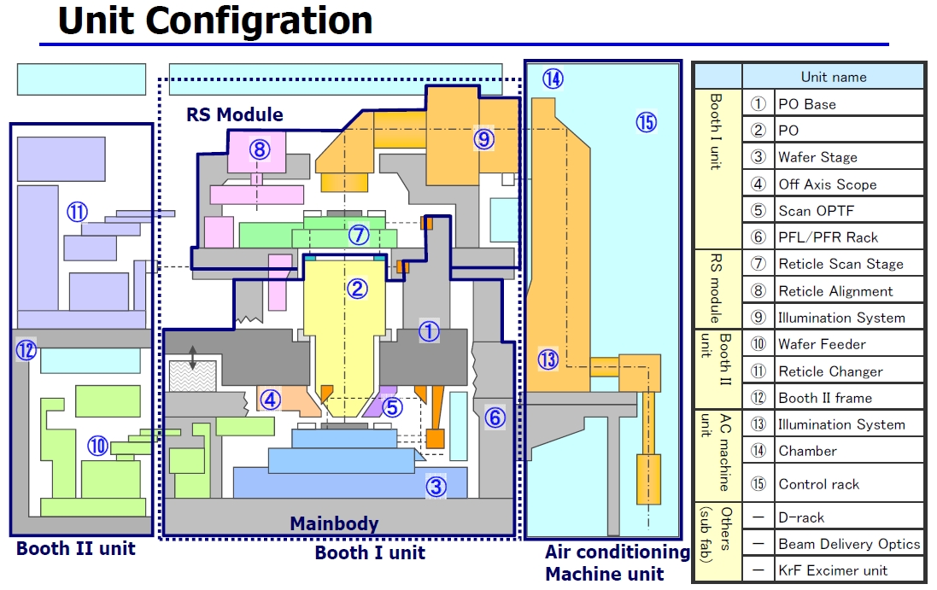
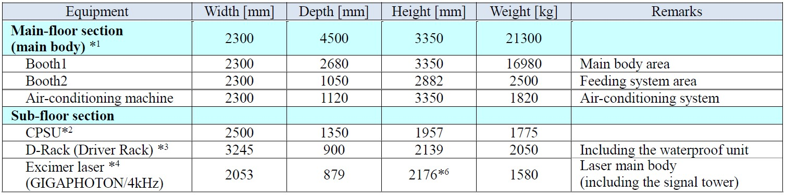
Details of 248 Scanner (L22) (Main Fab)

Main Body


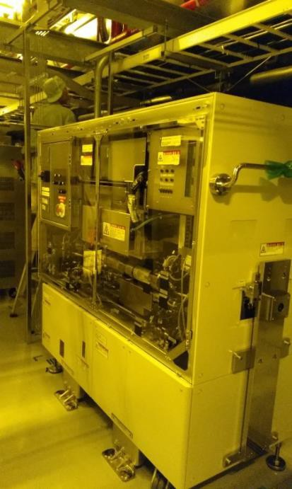
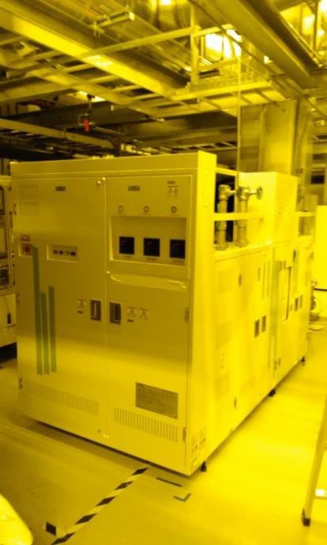
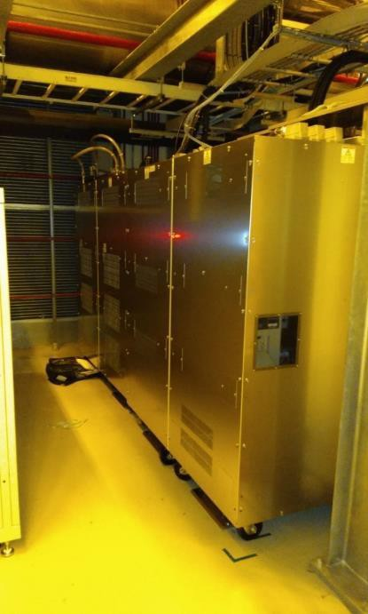
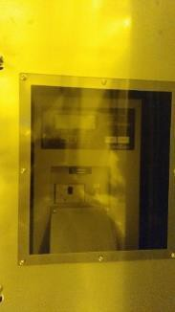
Details of 248 Scanner (L22) (Sub Fab)

Giga Laser CPSU D-Rack

F47

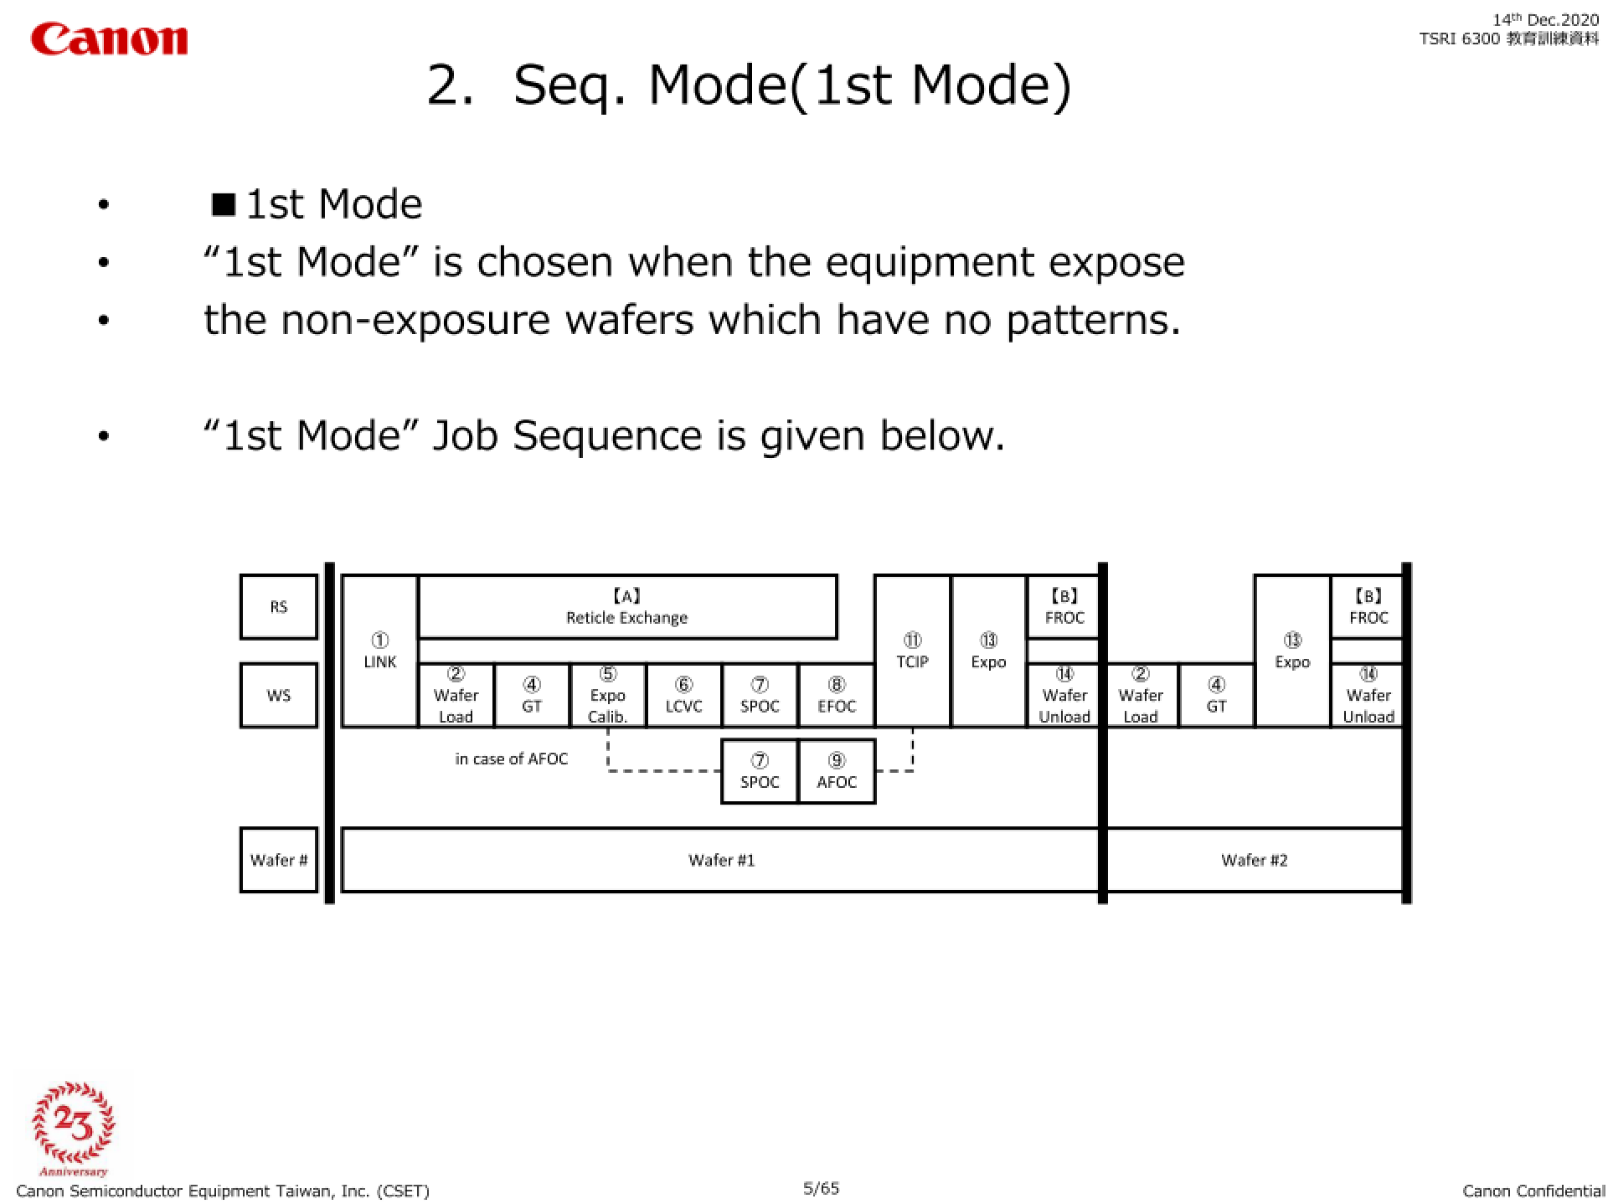

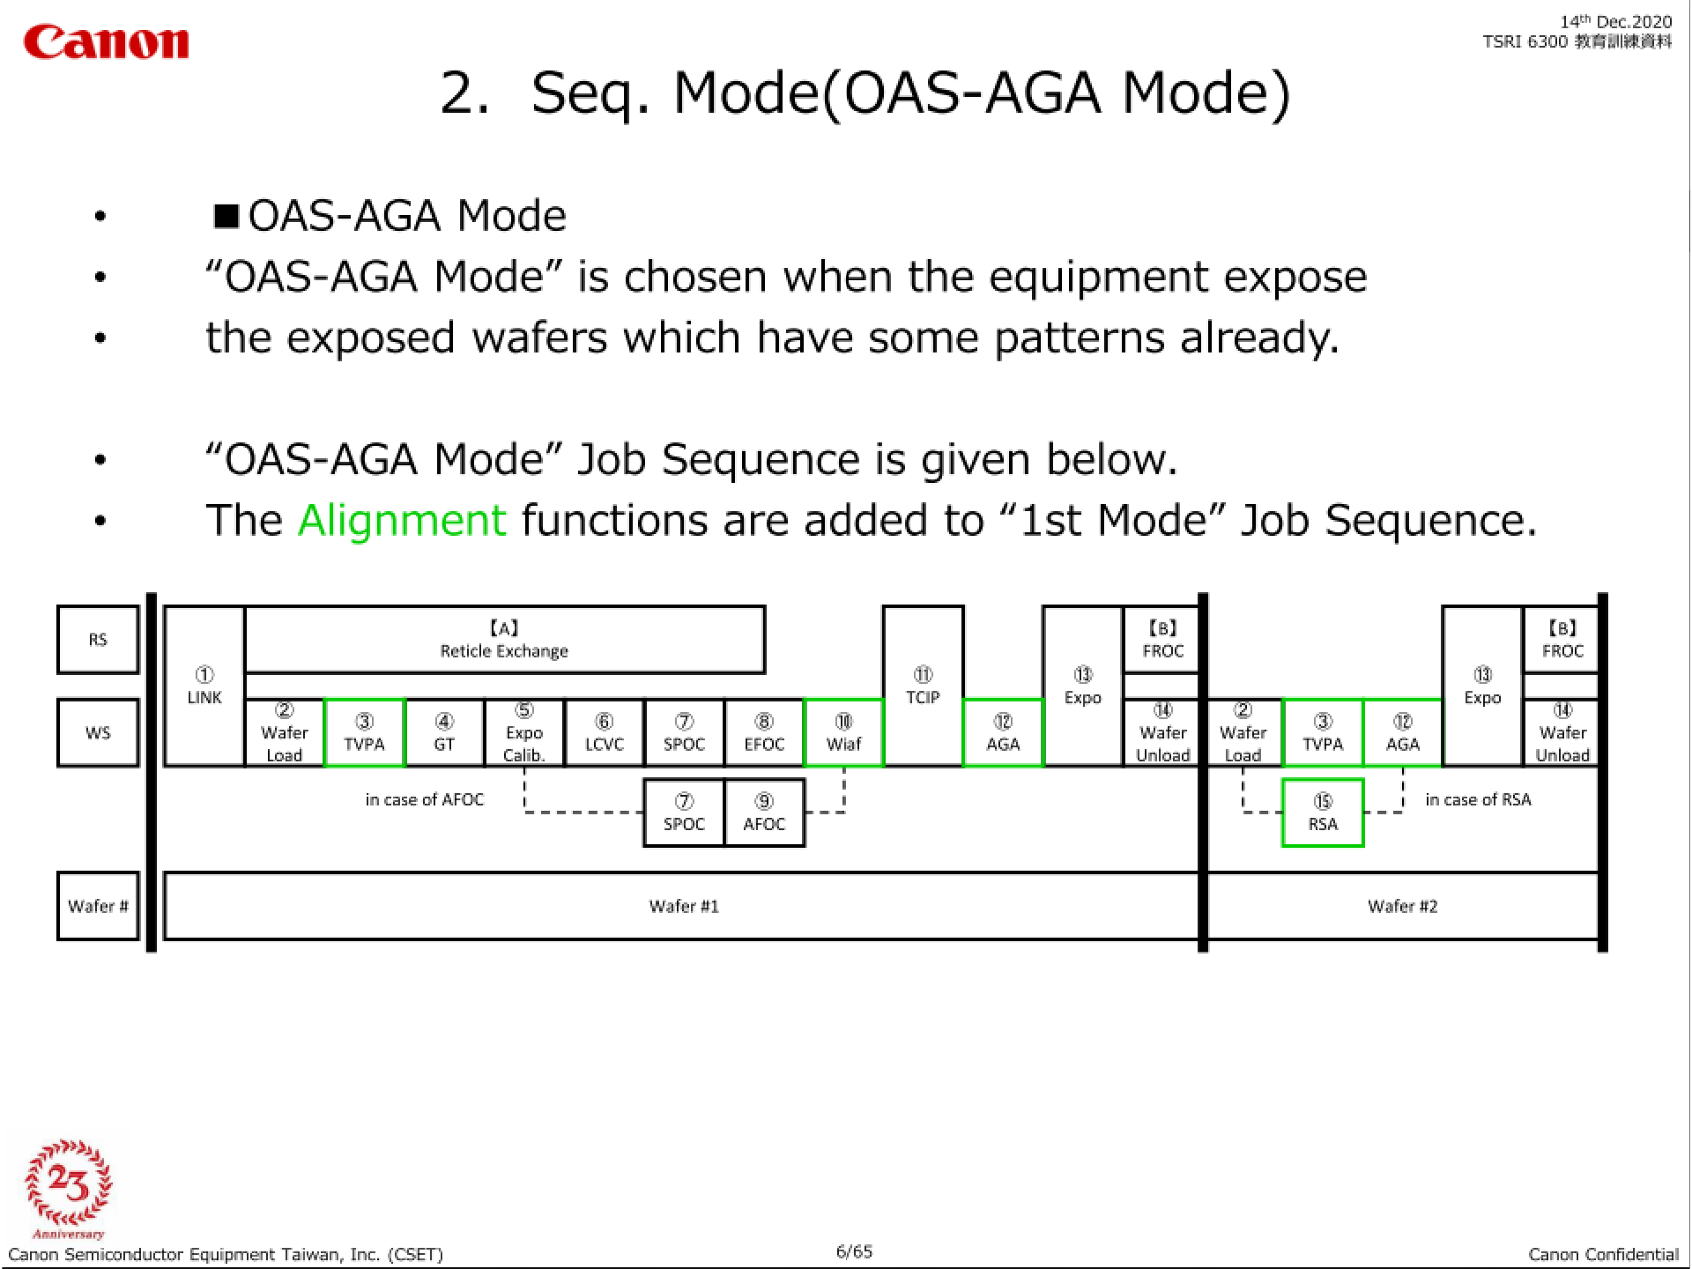

End

