

L22 High-speed Mass-produced Optical Exposure System

Technical Data

(248 Scanner Technology Data)

Responsible engineer: Tsai-Ming Huang
Engineer: Tsai-Ming Huang

Last Edit: Aug. 16, 2022

GKR-5201A Resolution
- Substrate: Double-side polished silicon wafer
- Photoresist: GKR-5201A (3160Å)
- Reticle: Binary Mask
- Line width design Line/Space: 110/110 nm
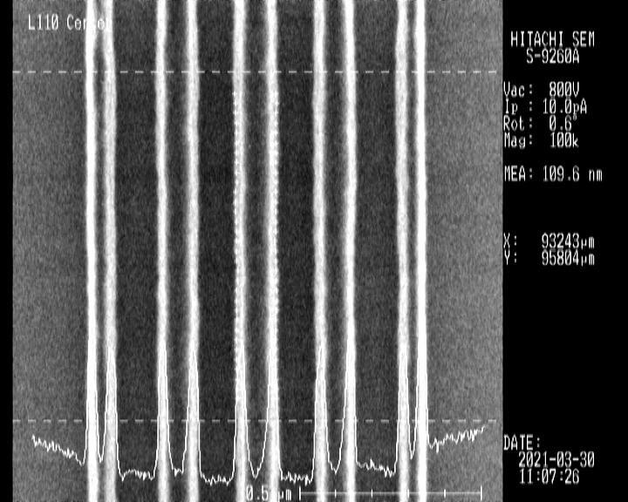
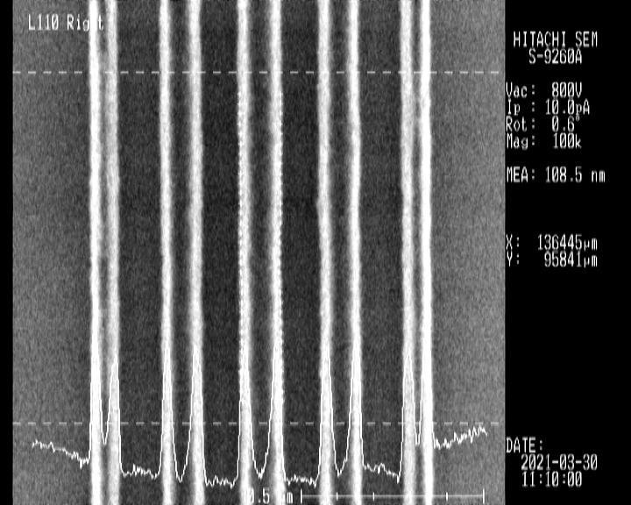
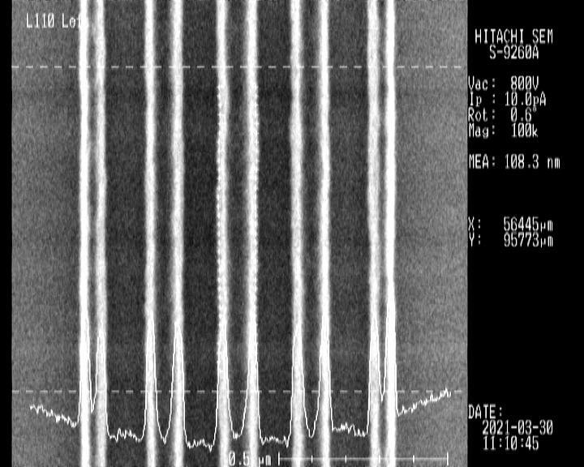
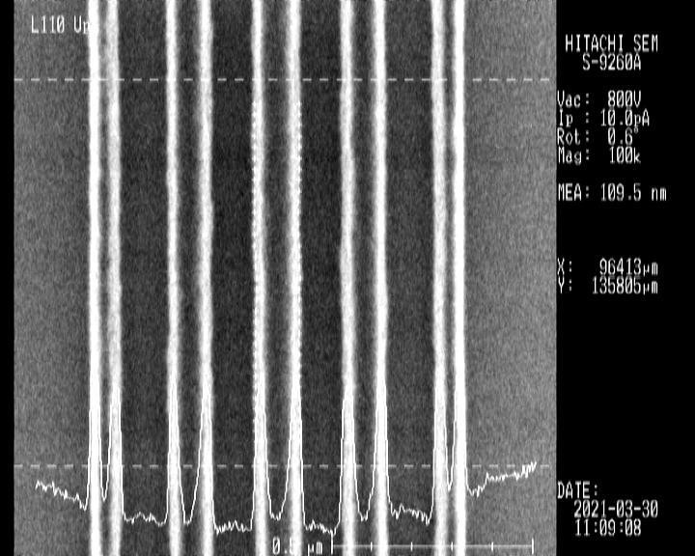
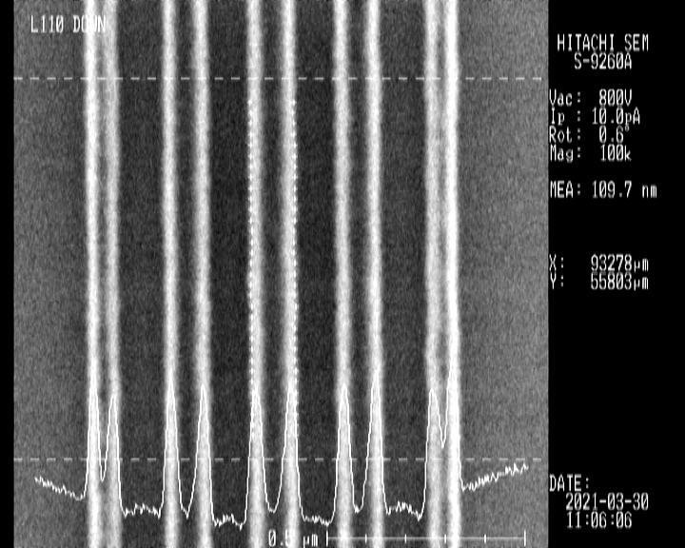

Location | Linewidth (nm)
Center | 109.6
Left | 108.3
Right | 108.5
Up | 109.5
Down | 109.7

TDUR-P6159 Resolution
- Substrate: Double-side polished silicon wafer
- Photoresist: TDUR-P6159 (8000Å/20000Å)
- Reticle: Binary Mask

248 | P6159
PR Thickness (A) | 8000 |  | 20000
Resolution | Line/Space:  0.25 um | Hole/Pillar:  0.35 um | Line/Space: 0.8 um  Dense Hole/Pillar: 1 um
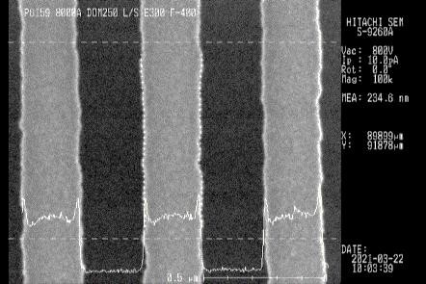
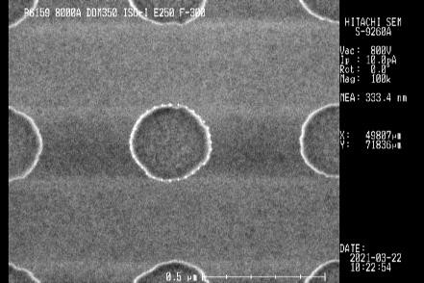
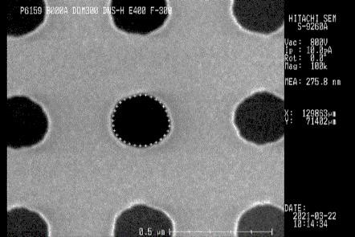
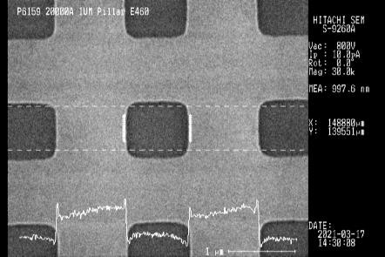
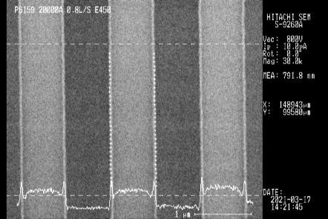
L/S
Hole
Pillar
L/S
Pillar

