RAITH Voyager Electron Beam Lithography System

The Voyager Electron Beam Lithography System is a Gaussian beam machine manufactured by RAITH of Germany, and has been available for use at TSRI since March 2023. The machine is currently located in the photo room of Class 100 Clean Room.
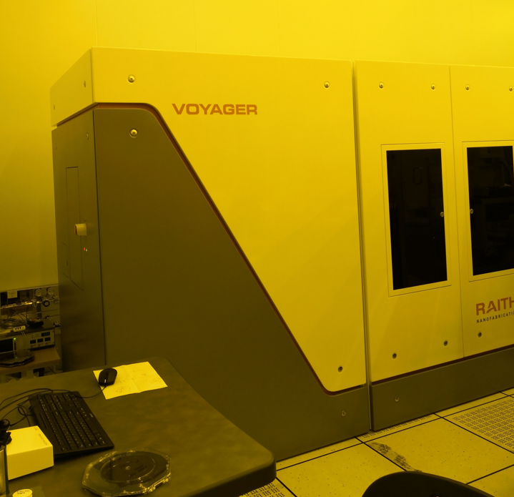

The Voyager Electron Beam Lithography System currently provides the service of self-exposure of breakages, with sample sizes ranging from 1cm to 10cm. A breakage sample can be in any form (we suggest it be cut by a cutting machine), but the use of magnetic materials for exposure is strictly prohibited. The picture below shows the holder where a sample is placed.
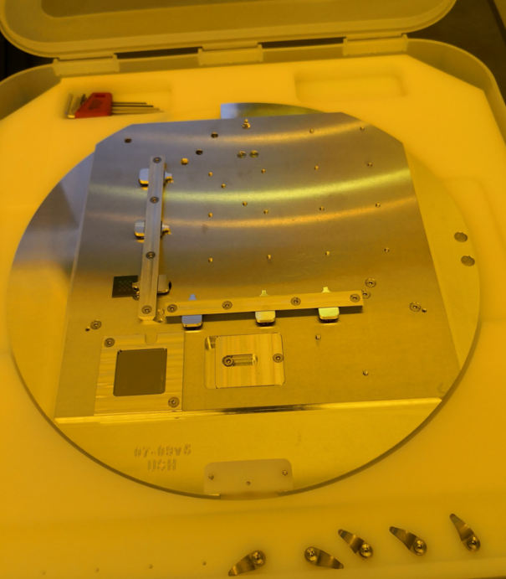

Specifications of the Machine
The service specifications of TSRI’s RAITH Voyager Electron Beam Lithography System are described as follows:
- Accelerating voltage: 50keV
- Write field: 500um
- Beam current: 300 pA
- Exposed area: max. 100mm (4inch), min. 10 mm.
- Resolution: 8 nm (isolated lines), 40 nm (periodic patterns)
- Field stitching: < 20 nm @100 μm write field
- Overlay accuracy: < 20 nm @100 μm write field
- Dose control: ≥ 20ns (5ns minimum dwell time increment)
- Mark shape: any shape and kind (etching depth > 0.2 um )
- EPC software: nanoPECs

