Introduction to RAITH Voyager Electron Beam Lithography System

The TSRI’s RAITH Voyager Electron Beam Lithography System provides services for exposures of up to 100mm (4 inches) and at least 10mm. A sample can be cut automatically by machine or manually. The cut surface must be flat and vertical. The following is an overview of the relevant parts of the process:

Resist Coating and Development
The TSRI provides two types of resist: TOK P015 positive resist (400 nm thickness) and Sumitomo NEB negative resist (400 nm thickness). The L09 Track provides automatic resist coating and development for 12, 20, 25 and 40mm breakages, but the L09 machine may only be used when a breakage must be cut by machine. If a breakage is cut manually, it may only be coated with T12 and developed manually, and cannot be processed with L09.

Breakage Exposure Stage
There are two methods of breakage exposure: exposure for the whole process is completed with the RAITH Voyager Electron Beam Lithography System, or for the key layers with the Voyager Electron Beam Lithography System, while the Zero Layer and the remaining layers are exposed with the I-line stepper using the mix-matching exposure technique. Since the Voyager Electron Beam Lithography System has a very slow exposure speed, it is recommended that exposure be performed using the mix-matching technique to increase its effectiveness.
The TSRI has been providing services for many years since it developed a mix-matching exposure technique in 2017, using the I-line stepper (FPA 3000 I5+) as the core in combination with the existing E-beam writer (WEPRIN 200 or SB350). The RAITH Voyager Electron Beam Lithography System is based on the previous mix-matching exposure technique, where the I-line stepper is used to create the Zero Layer, and then the Voyager Electron Beam Lithography System and the I-line stepper completes exposure respectively according to their own alignment marks.

Overview of Process Information
This machine has been available at the TSRI since 2023. We also use NEB resist and 150nm dense line as the basis for process monitoring. We have obtained the following exposure results based on stepping 10nm and 20nm respectively:
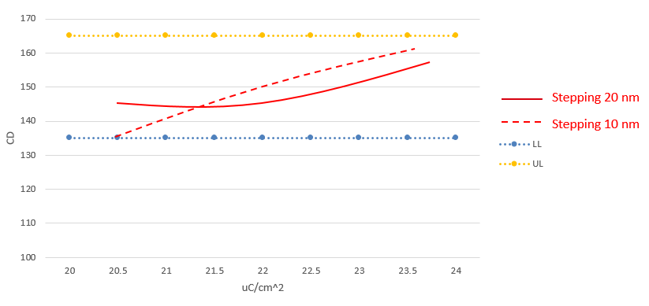
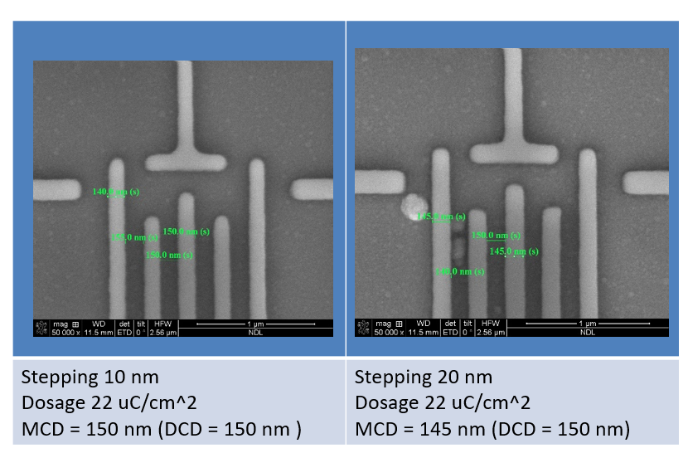

We also refer to other information, as follows:
Single line resolution: 9.94 nm
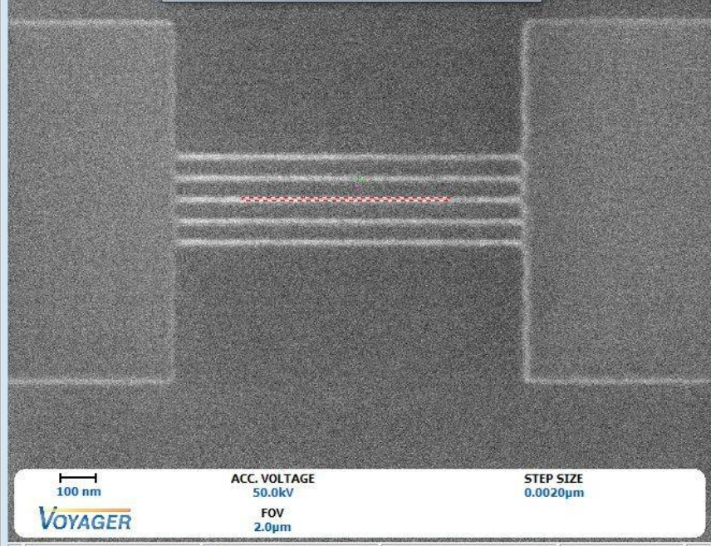

Grating resolution: 20 nm grating


