Canon FPA-3000i5⁺ Stepper

The FPA-3000 i5⁺ is a high productivity mix-and-match Stepper. Its wide-field lens with improved NA variability makes it an excellent investment. This extensively field-proven veteran of the Canon Stepper line-up has been a best-selling product since its release in 1996.

Features
- High resolution, wide-field lens, extra NA variability, plus reticle options.
- High alignment accuracy for CMP processes. Two off-axis methods in addition to Canon's original technology.
- High throughput features include a six-axis non-contact FLAT (Fast Linear Air-guided Tilting) stage and on-the-fly smoothing focus.
- Designed for high CoO and efficient operation which is achieved through common parameters for main-body structure, operation and maintenance. For example, by partnering with the E-beam Stepper the i5+ delivers truly optimized mix-and-match lithography.

Specifications

FPA-3000i5+ | I-line (365nm) Stepper
Resolution | 0.35 micron (dense lines)
NA | 0.63 – 0.45 (Automatically Variable)
Reticle Size | 5-inch
Reduction Ratio | 5:1
Field Size | 20mm x 20mm
Overlay Accuracy | /Mean/ + 3 sigma ≤ 45nm
Throughput | 100 wph (200mm)

Introduction to X-Y Exposure Stage System
The aligner used in the current lithography process is mainly composed of an optical projection system and an X-Y exposure stage. The optical projection system determines the resolution limit of the aligner on the resist layer, while the X-Y stage affects the relevant parameters of alignment by the aligner, further affecting the capacity for and quality of products. Currently, a stepper with a high NA and a short wavelength (up to the DUV range) is able to keep a line width of 100 nm or less, and the ensuing challenge lies in the alignment limit of a line width below 100 nm (3σ=10 nm). With respect to an advanced aligner, there are clear specifications and testing methods for the stepping accuracy, stepping scaling, stepping repeatability, rotation compensation and tilt compensation of the exposure stage.

Introduction to X-Y Stage System
The exposure stage is an air-bearing stage that employs an air-bearing system and a linear motor to move on the X, Y and θ-Z axes to achieve high-speed, high-accuracy positioning and transfer of wafers. It consists of two systems: (1) a drive system, and (2) a position detection system.
The drive system is controlled by a linear motor that outputs current values from the X-Y exposure stage’s exclusive printed circuit board to calculate the distance traveled by the motor-driven stage moving to a specific position. The position detection system consists of a photo switch sensor and a laser interferometer. The photo switch sensor shuts out light as the stage is driven to a specific position to determine the relative origin and limit of the stage, while the laser interferometer calculates the real-time positions of the stage during travel and deflection based on the interference pattern generated by the optical path difference between the laser beam and the light reflected from a bar mirror on the stage. The helium-neon laser beam is split by a beam splitter into three beams, which are directed to the laser heads of the X-axis, Y-axis and θ-angle respectively, with each of the three beams interfering with the light reflected from the bar mirror on the stage to accurately determine the relative positions of the laser head and the stage through calculation (see Fig. 1). The beam splitter in the figure splits a beam from the laser head to three interferometers. An interferometer generates interference using the optical path difference between the incident light and the light passing through the bar mirror, and the resulting light is directed into the PCB using optical fibers for measurement and calculation. The whole stage movement coordinate system and its range are shown in Fig. 2; the moving range of the X-axis is between ±115mm, and the moving range of the Y-axis is between -190mm and +115mm, while the relative origin is at (-9.5, -165).
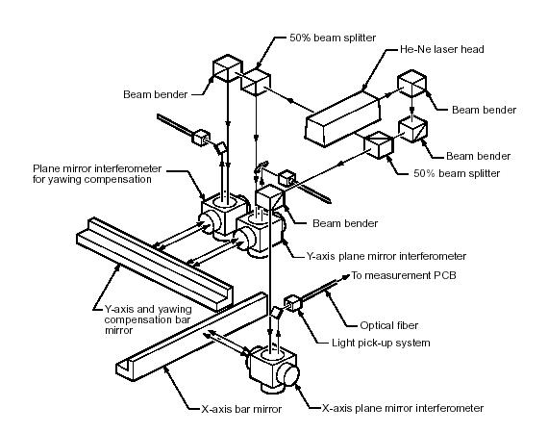
Fig. 1. Drive system of the stepper

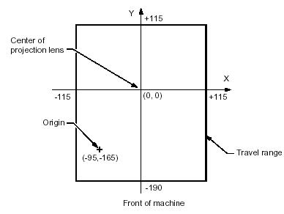
Fig. 2. Stage movement coordinate system and its range

Effects of X-Y Stage Errors
The X-Y stage is controlled by the sophisticsated drive and positioning system mentioned above, with many variables. The main source of error is a small error in the geometric angle between the laser interferometer and the stage, resulting in inaccuracy in the result of interferometric calculation, which is generally referred to as ABBE parameters, and can be categorized into the following parameters for the evaluation of the stage’s performance: (1) stepping accuracy, (2) stepping repeatability, (3) stepping scaling, (4) rotation compensation, and (5) tilt compensation.
Stepping accuracy is used to evaluate whether the stage’s stepping distance equals the set value for the same exposure; poor stepping accuracy may result in an irregular error. Such an error will cause unexpected overlapping of patterns on the same layer, or make it impossible for alignment on the next layer. In Fig. 3, the solid line indicates normal stepping, while the dotted line is the result of poor stepping accuracy.

Fig. 3. The solid line indicates normal stepping, while the dotted line indicates poor stepping accuracy.

Stepping repeatability is used to evaluate the repeatability of the stepping distance for each exposure. Poor stepping repeatability may cause a regular error in multi-layered alignment, leading to poor alignment efficiency and affecting quality. In Figure 4, the solid line indicates the pattern of the previous layer, while the dotted line is the result of poor stepping repeatability.

Fig. 4. The solid line indicates the pattern of the previous layer, while the dotted line indicates poor stepping repeatability.

Stepping scaling is used to evaluate whether there is any enlargement or contraction of the step distance during the same exposure; poor scaling may result in a regular enlargement of the pattern’s offset. In Fig. 5, the solid line indicates the normal pattern, while the dotted line indicates the enlarged pattern caused by poor scaling. Fig. 5 shows that the difference between the center of the normal pattern and that in the case of poor scaling is increasing, despite the stepping distance remaining the same.

Fig. 5. The solid line indicates the normal pattern, while the dotted line indicates the enlarged pattern caused by poor scaling.

Rotation compensation is used to evaluate whether the stage’s stepping pattern has rotated, and poor rotation compensation will lead to the result in Fig. 6. The cause of rotation is related to whether the reticle has rotated, so such compensation is often the cause and effect of reticle rotation compensation. In Fig. 6, the solid line indicates the normal pattern, while the dotted line is the result of poor rotation compensation.

Fig. 6. The solid line indicates the normal pattern, while the dotted line indicates poor rotation compensation.

Tilt compensation is used to evaluate whether the stage is parallel to the exposure area. If not, the orthogonality of its projection on the stage will be affected, resulting in an uneven focus. In Fig. 7, the solid line indicates the normal pattern, while the dotted line is the result of poor tilt compensation.

Fig. 7. The solid line indicates the normal pattern, while the dotted line indicates poor tilt compensation.

Causes of X-Y Stage Errors
The occurrence of any of the errors in the previous section will definitely lead to decreased alignment efficiency, the cause of which is related to calculations by the laser interferometer on the stage (referred to as ABBE parameters). In the following section, our I-line stepper and its exposure stage platform are used as an example to introduce various ABBE parameters and the causes of their resulting errors. The relationship between the laser interferometer and the stage is as follows: the interferometer consists of three laser heads X, Y and Y Yaw, each of which interferes with the light reflected from the bar mirror to calculate the positions of X, Y and θ respectively (see Fig. 8).
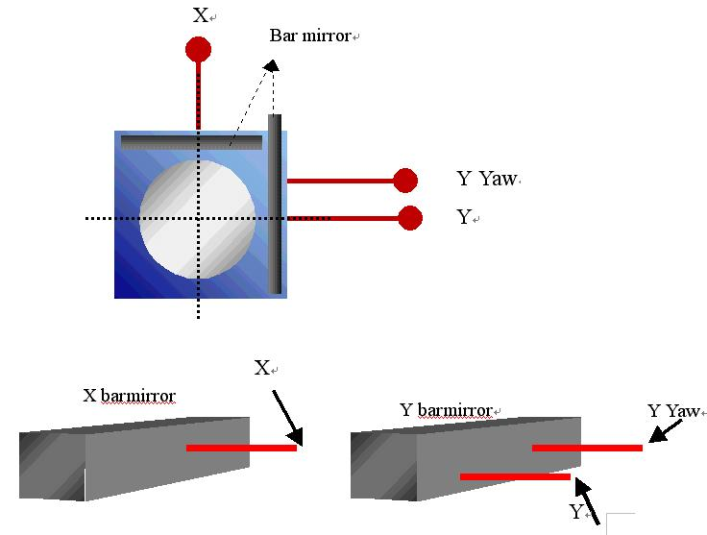
Fig. 8. Principles of function of an interferometer

The parameter A of ABBE is used to compensate for the inaccuracy of the calculated position caused by a small height difference (A) between the position of the reflective light from an incident laser beam hitting the bar mirror and the actual exposure area when the stage is driven tilted. Such compensation can be expressed by the following equation.
Δ = A x sin ( Tilt ) + X {1/cos ( Tilt ) - 1} ≒ A x Tilt
The stage will perform die-by-die tilt compensation during an exposure, and it will cause the above small error of AxTilt when tilt compensation occurs. Therefore, it is necessary to calculate the compensation value in advance for the laser interferometer to correct the error. An error caused by the parameter A of ABBE is the main factor affecting stepping accuracy. In Fig. 9, black indicates the correct position, and red is the result of poor compensation of the parameter A of ABBE.
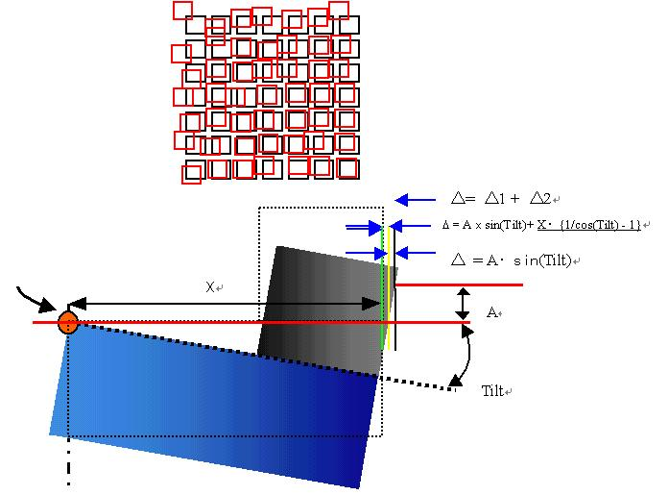
Fig. 9. Black indicates the correct position, and red indicates poor compensation of the parameter A of ABBE.

The parameter B of ABBE is used to compensate for a small error in calculation caused by a difference of B angle (rad) between different positions (X) when the incident angle of the laser beam is not parallel to the stage, expressed by the equation Δ = B × X × Tilt. An error caused by the parameter B of ABBE is the main factor affecting stepping scaling. In Fig. 10, the red area indicates the correct position, while the light-blue area is the result of poor compensation of the parameter B of ABBE.
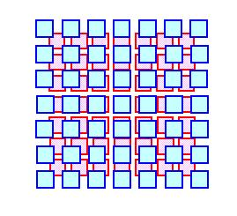
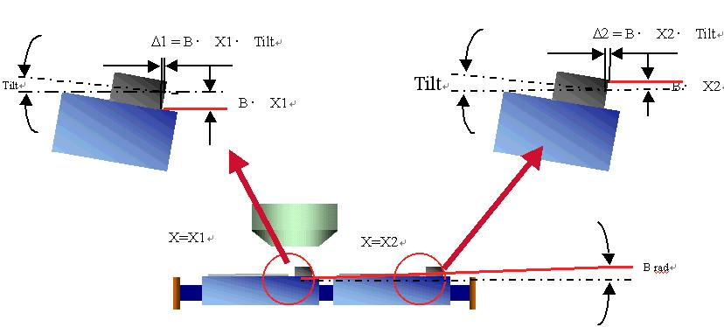
Fig. 10. The red area indicates the correct position, while the light-blue area indicates poor compensation of the parameter B of ABBE.

The parameters C and D of ABBE are used to compensate for rotational errors at the left and right ends of a wafer caused by the X and Y components (D and C) of the angle between the incident Y Yaw laser beam hitting the bar mirror and the Y laser beam. θ deflection of the stage is based on ΔY, the result of Y and Y Yaw laser beams, divided by the distance between Y and Y Yaw (42mm). If there is no good parallelism between Y and Y Yaw, there will naturally be a rotational error caused by ΔY when the stage moves to the left and right ends (see Fig. 11), as expressed by the following equation: Δθ  = Y ( C + D θ) / 42mm.
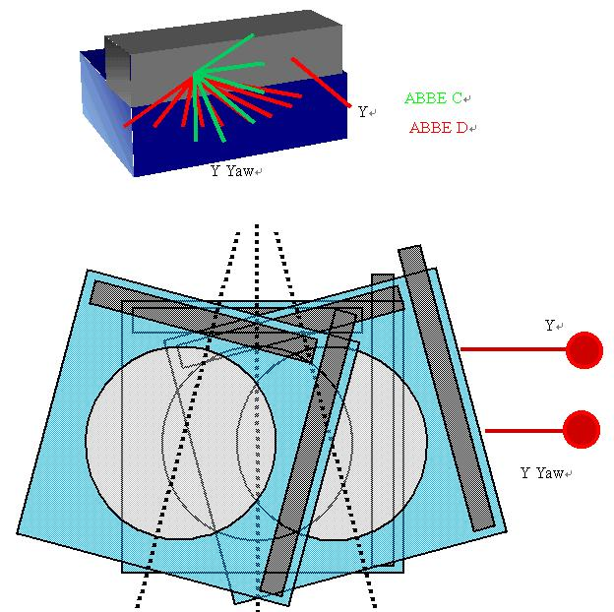
Fig. 11. Parameters C and D of ABBE

The parameter E of ABBE is used to compensate for a height difference between the incident positions of the Y and Y Yaw laser beams. Such difference will cause a measurement error for Yaw when the stage is tilted on the Y axis. When the parameter E of ABBE is not properly compensated for, the measurement θ of the Yaw axis will have an error in a fixed proportion to the tilt of the platform. Such an error occurs in the wafer rotation compensation of X and Y, and also in the chip/shot rotation compensation (see Fig. 12), as expressed by the following equation.
ΔLyaw = tilt*height displacement Δθ = Δ Lyaw/42mm
ABBE E = Height Disp. / 42mm X 100 (%)
=  Δθ/ Tilt X 100 (%)
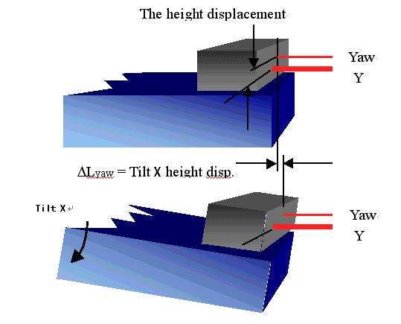
Fig. 12. Parameter E of ABBE

The parameter G of ABBE is used to compensate for a measurement error in Y Yaw during rotation of the stage caused by deviation of the incident position of the Y laser beam from that of the Y Yaw laser beam. If the parameter G of ABBE is not properly compensated for, the Y-axis offset and wafer rotation will be fixed in proportion to the overall stage rotation (see Fig. 13).
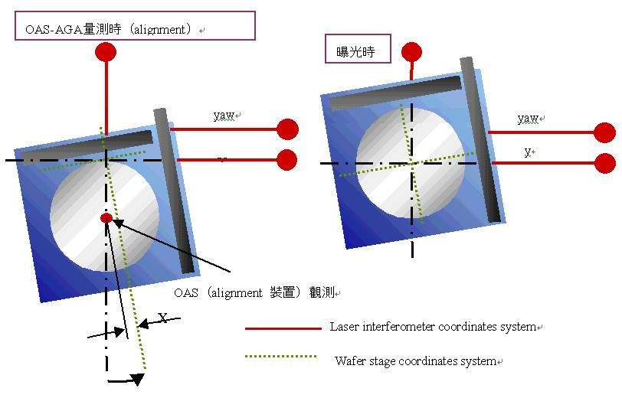
Fig. 13. Parameter G of ABBE

The parameter H of ABBE is used to compensate for an error caused by displacement between the lens center and the rotation center (the intersection of the interfering laser beams X and Y). If the parameter H of ABBE is not properly compensated for, the overlay alignment in the X and Y directions will lead to an offset in a fixed proportion to the stage rotation (see Fig. 14), as expressed by the following equation.
Shift - X = Hy*wafer total rotation
Shift - Y = Hx*wafer total rotation
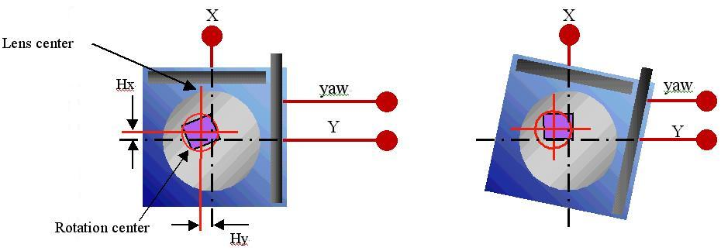
Fig. 14. Parameter H of ABBE

Verification of X-Y Stage Errors
After understanding the effects and causes of stage errors, we introduce how to design an exposure process to verify the stepping accuracy, stepping scaling, stepping repeatability, rotation compensation, tilt compensation and other parameters of the I-line stepper’s stage. Verification of the stage’s performance requires the use of a standard testing reticle, which includes 25 areas with a variety of testing patterns for alignment, usually using a box-in-box structure. The exposure process for verification mostly consists of an exposure of the first layer and an exposure of the second layer through forced displacement of the stage to create a box-in-box structure, with different testing criteria for step-by-step verification.
Verification of the stage’s stepping accuracy is also known as N-step verification. The process is designed with a stepping distance of 12.5mm between X and Y, and a distance of ±7.7mm between the top and bottom edges and between the left and right edges of the reticle (each die is 15.4mm x 15.4mm), which will result in a box-in-box structure generated from the X2 and Y2 positions on the edges (see Fig. 15).
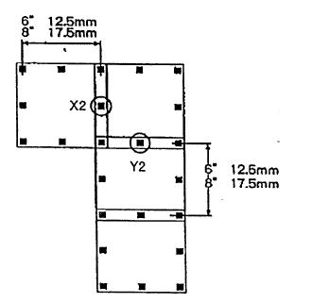
Box-in-box structure
dx =∣Distance from the left solid line to the left dotted line - Distance from the right solid line to the right dotted line∣/2

dx =∣Distance from the top solid line to the top dotted line - Distance from the bottom solid line to the bottom dotted line∣/2
Fig. 15. Box-in-box structure for verification of the stepping accuracy of the stage

We then measure the dx and dy of the box-in-box structure of each X2 and Y2 to calculate the 3σ value, which represents the stepping accuracy of the X and Y axes, and its specification on the I-line stepper must conform to the following: the 3σ of dx ≤ 20nm and the 3σ of dy ≤ 20nm.
The verification process for the stepping repeatability of the stage consists of the use of a 32 shot layout (see Fig. 16) to expose one layer and require the stage to move to the Y axis by 0.348 μm, which will result in a box-in-box structure generated from the C3 position in the shot center. Then, the dx and dy of the box-in-box structure of each C3 are measured to calculate the 3σ value, which represents stepping repeatability, and its standard specification must conform to the following: the 3σ of dx ≤30nm and the 3σ of dy ≤30nm.
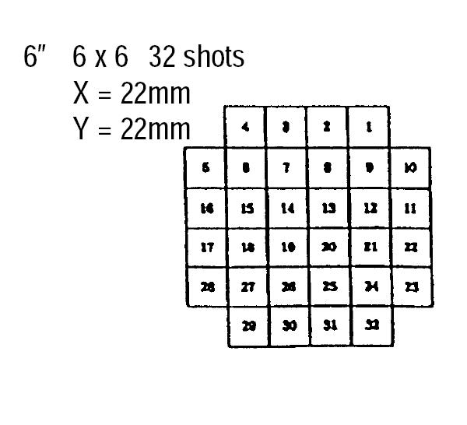
Fig. 16. Structure for verification of the stepping repeatability of the stage

The verification process for the stepping scaling of the stage requires a standard wafer, which is a wafer with a standard 32 shot layout exposed by a calibrated machine. The standard wafer is used for the machine’s alignment system to measure the BL1 mark of the C3 position of each shot for the purpose of determining the center of each shot and measuring whether the distance of each shot center is enlarged. Since the shot distance of the standard wafer is a fixed value, the enlargement value of a center whose distance is measured to have been enlarged is caused by movement of the stage. The enlargement value can be calculated to obtain the enlargement ratio, and its standard specification must conform to ±0.5ppm.
Rotation compensation is related to reticle and stage rotations, and there are two processes for the verification of stage rotation (SRC) and the verification of reticle rotation (RR). In Fig. 17, RR and SRC have different sources of error, despite the fact that their effects are actually the same.
RR
SRC
Fig. 17. Reticle rotation and stage rotation

The verification process for reticle rotation adopts exposure step distances of 17.5mm for the X axis and 5mm for the Y axis, as well as a left-right distance of ±10.1mm and a top-bottom distance of ±4mm for the reticle (the die size is 20.2mm x 8mm), with 5x6 rows, to obtain a box-in-box structure of the X2 position (see Fig. 18).
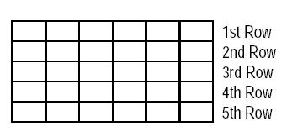
Fig. 18. Pattern designed for the verification of reticle rotation

An exposure is set to pause at the first shot of each row. When an exposure is executed at the first shot of each row, the machine will pause and forcibly displace the position of the reticle, and then it will re-align the reticle and continue to execute the exposure. After the exposure completes developing, we will obtain a box-in-box structure with 5x4 shots and 20 overlapping areas. We measure the average value of dy of the box-in-box structure at the X2 position in the same row, and then divide the average value of the five rows by 17.5mm to obtain the amount of reticle rotation. Finally, these values are stored in the machine parameters, which will be corrected by the machine during each exposure through rotation of the reticle by a fixed amount.
The verification of stage rotation uses a set of marks on the reticle and the stage to be read by the iA scope of the machine to obtain the rotation amount. First, the reticle is aligned with I-line’s light source (see the FRA marks in Fig. 19), and the stage is driven to the stage reference block. Then, the iA scope will read the mark on the reticle and the mark on the left side of the stage reference block for measurement, followed by movement of the stage to the mark on the right side of the block for measurement. Since the positions of the marks on the left and right sides of the stage reference block are fixed, the dy value obtained from measurement is divided by the distance between the marks on the left and right sides of the stage reference block to acquire the rotation amount (see Fig. 20).
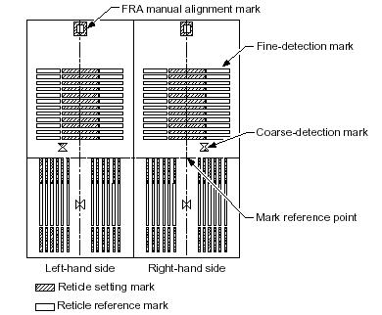
Fig. 19. FRA marks

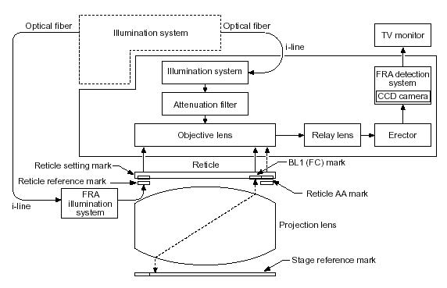
Fig. 20. Method of the verification of stage rotation

Stage tilt will cause poor orthogonality. Similar to the case of stage scaling, the method for testing orthogonality requires a standard wafer, which is used for the machine’s alignment system to measure the BL1 mark of the C3 position of each shot for the purpose of determining the center of each shot. Since the shot orthogonality of the standard wafer is 90°, the amount of deflection of any orthogonality measured to have included such amount is caused by tilt movement of the stage, and its standard specification must conform to ±0.5ppm.
Here we introduce the principles and method for correction of alignment offset, the most critical part of the stepper technology. These high-precision and preparatory actions can ensure the quality of the process. In addition to machine failure, other external factors such as vibration, unstable current, air pollution, humidity, temperature difference and uneven wafer, can cause poor quality of the process. As the critical line width of lithography moves below 100nm, the tolerance of stage error has almost reached its physical limit, and multi-layered alignment is bound to become the biggest enemy of the quality of lithography module production. We hope that by understanding the causes and methods of verification of stage errors mentioned above, readers will be able to quickly determine the source of error in the event of any multi-layered alignment error, and then troubleshoot and correct the error in order to enhance the competitiveness of manufacturers.

Introduction to Reticle Stage System and Chip Pre-alignment System

Reticle stage system: It is installed on the tube of the main lens, and its main functions include carrying the reticle and aligning the reticle with the reticle stage reference mark. The following is an introduction to the functions of its units.

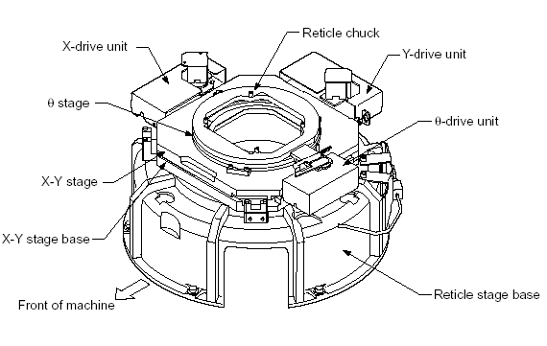

- Reticle chuck: Utilizing vacuum suction to hold the reticle.
- θ stage and θ drive unit: Driving the reticle to move in the θ direction.
- X-Y stage and X-Y drive unit: Driving the reticle to move in the X-Y direction.
- X-Y stage base: The X-Y stage and X-Y drive unit are installed on this base.
- Reticle stage base: Installed on the tube of the main lens to support the X-Y stage base.
- The reticle reference marks are located on the X-Y stage of the reticle, for the X and Y directions respectively. When the reticle enters the X-Y stage, the system will use the iA detector for alignment (fine reticle alignment on the reticle with the reticle reference marks).

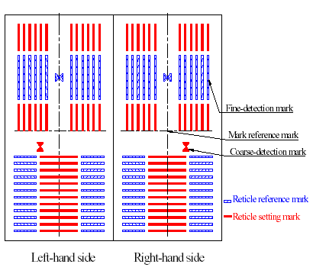

Off-axis TV pre-alignment system: The TVPA detects the PA (pre-alignment) mark on the wafer and processes the image. When the image is within an identifiable range, the next alignment process, AGA (advance global alignment), starts. The TVPA uses a halogen lamp off-axis (non TTL) to directly illuminate the PA mark on the wafer, and then directly acquires the image with an OA (off-axis) detector for image processing.
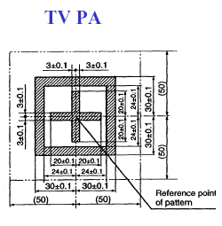
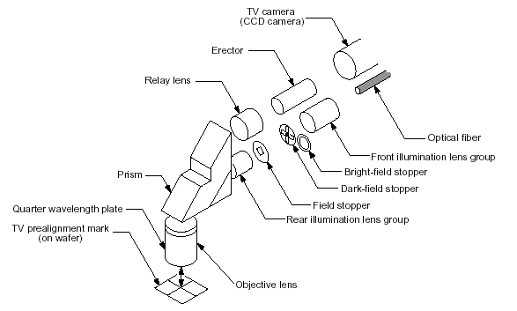
Mark
Diagram of TVPA detector

Introduction to Illumination System

Illumination system: The i5+ illumination system is designed to achieve better imaging and greater depth of focus than previous machines. It features a larger mercury lamp capacity of no less than 2kW for usability. This illumination system has six features:
- Integrated optical system: Using an ellipsoidal mirror and a fly eye to achieve optimal uniform intensity of illumination.
- I-line light source extraction: A band-pass filter and a band-reflective mirror are used to purify and extract the 365nm wavelength.
- Flexible illumination range: The illumination range is controlled by a mask.
- Highly accurate dose control: Highly accurate shutter and light integrator.
- Multiple exposure modes: Automatically changing the corresponding stopper, input lens and first zoom lens.
- Automatic compensation for uniform intensity of illumination: Moving 2nd zoom lens, software compensation, and OAI mode unit.
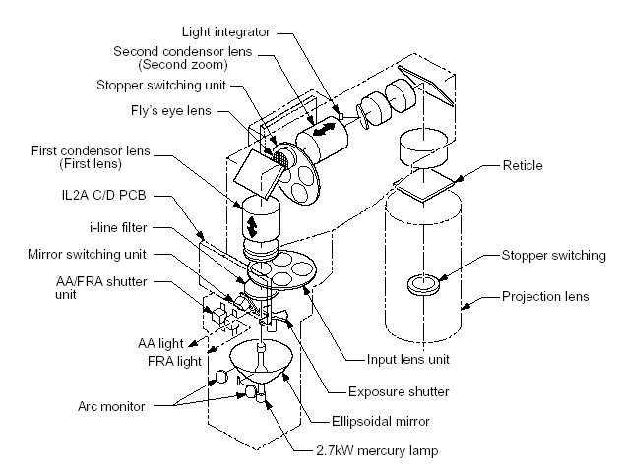
Diagram of the illumination system

The following is an introduction to the functions of its units:
- Ultra high-voltage mercury lamp: An ultra high-voltage mercury lamp of at least 20kW.
- Ellipsoidal mirror: Effectively collecting light emitted by the mercury lamp.
- Light base position adjusting unit: Controlling mechanical knobs in the X, Y and Z directions to achieve optimal illumination and uniform intensity.
- Arc monitor: The light from the mercury lamp is projected as an arc image through a pinhole, making it easy to understand the direction and position for adjustment when adjusting the position of the light base.
- Mirror switching unit: Switched off during an exposure, and switched on during AA or FRA to direct the I-line light out.
- AA/FRA shutter unit: The I-line light directed from the mirror switching unit is split here. The shutter opens to AA during AA and to FRA during FRA.
- Exposure shutter: The shutter blades rotate and stop to block light or allow light to pass through, thereby controlling the duration of exposure.
- I-line filter: Extracting a wavelength of 365nm from the light reflected from the ellipsoidal mirror.
- Input lens: Combined with the stopper when different illumination modes such as SIA and SIB are required.
- First zoom lens: Focusing the light reflected from the ellipsoidal mirror on the fly eye lens, with the angle changeable through an illumination mode.
- Fly eye lens: A lens consisting of multiple small focusing lenses used to ensure uniformity of the illuminating light.
- Stopper switching unit: Switched automatically during the OAI mode to combine with the input lens to form OAI.
- Second zoom lens: Used to compensate for decreased uniformity caused by the OAI illumination mode.
- Light integrator: Measuring and integrating the exposure dose, and measuring the exposure uniformity according to the exposure intensity.
- Mask unit: Moving four masks to control the size of the illuminated area.

Introduction to Alignment System

There are two types of alignment systems on the I-line stepper: a reticle alignment system and a multi-layered wafer alignment system. The reticle alignment system is an accurate reticle positioning system that uses the iA detector for alignment of the stage reference mark with the reticle mark, referred to as FRA (fine reticle alignment). The wafer alignment system uses the B/C detector to detect the AA (advance alignment) mark on the wafer for positioning with a non-exposure light source, which is an He-Ne laser or a halogen lamp (B2). Different alignment light sources are used for substrates with different reflectivities, and the σ-size of an alignment light source may be selected to obtain the pattern of an alignment mark with a different contrast.
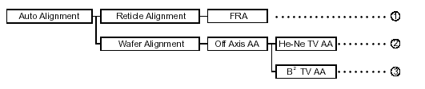
Diagram of the alignment system

The alignment system includes three detectors, iA, B and C. The iA detector is mainly used to obtain the FRA image, using the I-line light source to directly illuminate the reticle and the reticle stage to obtain the alignment pattern. The B/C detector is used to obtain the image and position of the AA mark, with an He-Ne laser or a halogen lamp as its alignment light source. The off-axis alignment detector is a detector used to obtain the TVPA image, with a halogen lamp as its alignment light source.

Pattern of FRA alignment
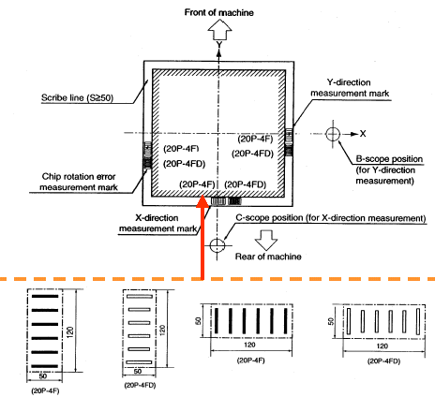
Positions and pattern of AA marks (20P-4F)

