TSRI I-line Stepper Exposure Stage-Introduction

There are three types of TSRI’s I-line stepper (FPA 3000 I5+) exposure service stages: whole breakage (Stage 1), breakage (Stage 2), and whole breakage-breakage mix-matching (Stage 3) exposures. These three types of exposure stages are further categorized into single I-line machine exposure and mix-matching exposure techniques (see figure below).
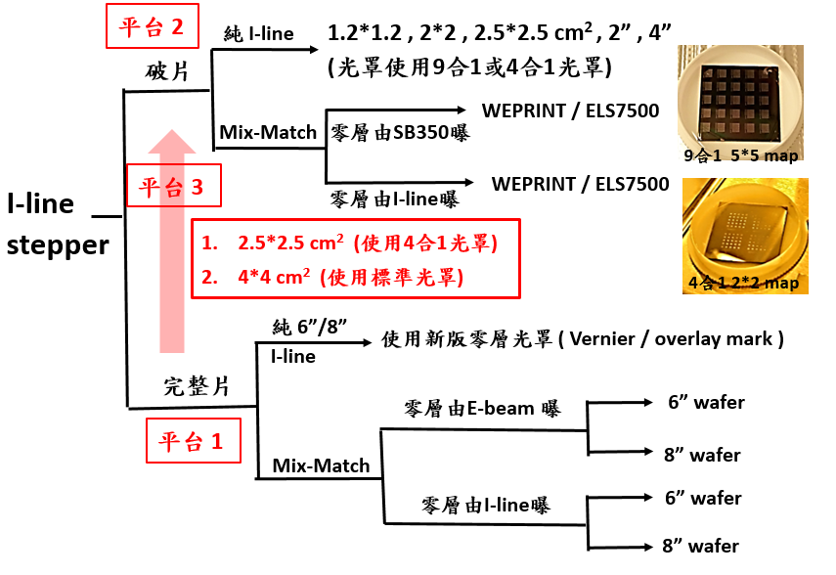
Stage 2
Stage 3
Stage 1
Breakage
Whole breakage
Pure 6”/8”
Pure I-line
Zero layer is exposed by SB350
Zero layer is exposed by I-line
(using 9-in-1 or 4-in-1 reticle)
Using new zero-layer reticle (Vernier/overlay mark)
Zero layer is exposed by E-beam
Zero layer is exposed by I-line
4-in-1 2*2 map
9-in-1 5*5 map
1. 2*2, 2.5*2.5 cm² (using 4-in-1 reticle)
2. 4*4 cm² (using standard reticle)
Fig.: Types of TSRI’s I-line stepper exposure service stages

Whole Breakage Exposure Stage
TSRI’s I-line stepper (FPA 3000 I5⁺) currently provides 6” and 8” wafer exposure (conversion every 2 weeks) services. The current misalignment spec during each conversion: (/Mean/+3σ) ⇒ X < 45 nm, Y < 100 nm, and the measurement value is shown in the left figure below. The misalignment measurement values between conversions are shown in the right figure below.
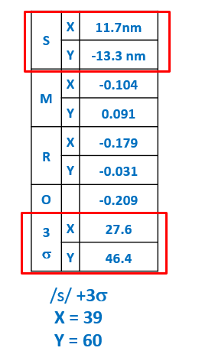 | 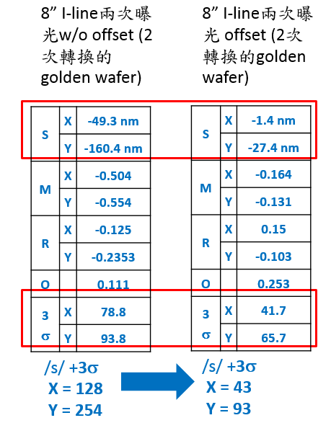  8” I-line is twice exposed w/o offset (golden wafer converted twice)  8” I-line is twice exposed offset (golden wafer converted twice)
Fig.: 6/8-inch I-line stepper - current misalignment measurement value during conversion | Fig.: 6/8-inch I-line stepper - misalignment measurement values between conversions

In addition, we also provide a mix-matching exposure technique with the I-line stepper as its core. This technical stage uses the I-line stepper to expose the zero layer and large line width layers, and the key layers (e.g., gate) are exposed with a high-resolution E-beam writer.
Process steps: First, use I-line to make a zero-layer mark, and then use the zero-layer mark as an alignment mark to make other patterns to confirm the misalignment result.
Through the above method, we obtain the result of 6” I-line start mix-matching exposure (/Mean/+3σ) ⇒ X: 190 - 260nm, Y: 130 - 200nm (see left figure below). And the result of E-beam start mix-matching exposure (/Mean/+3σ): No value compensation: ⇒ X~450 nm, Y~580 nm; with value compensation: ⇒ X~210 nm, Y~390 nm (see right figure below).
Comparing the results of mix-matching exposure measurement, we find the I-line start mix-matching exposure to be better.

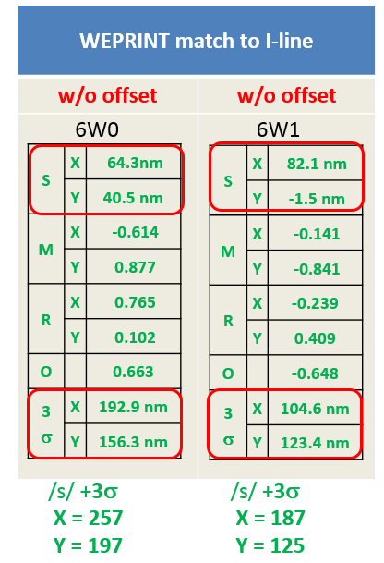 | 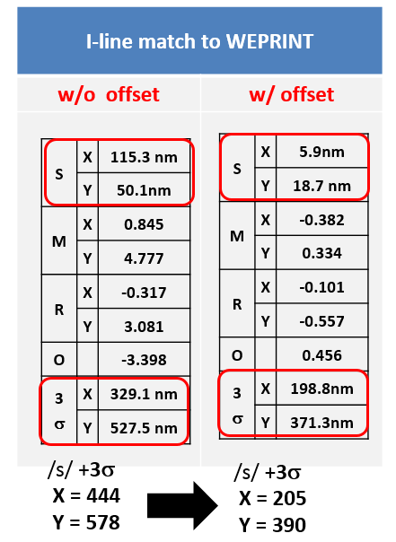
Fig.: 6” I-line start mix-match exposure - misalignment measurement values | Fig.: 6” E-line start mix-match exposure - misalignment measurement values

Result of 8” I-line start mix-matching exposure (/Mean/+3σ) ⇒ X: 50 - 60nm; Y: 90 - 130nm (see left figure below). And the result of E-beam start mix-matching exposure (/Mean/+3σ): No value compensation: ⇒ X~390 nm, Y~450 nm; with value compensation: ⇒ X~110 nm, Y~130 nm (see right figure below).
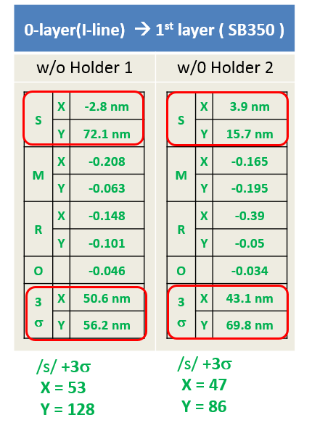 | 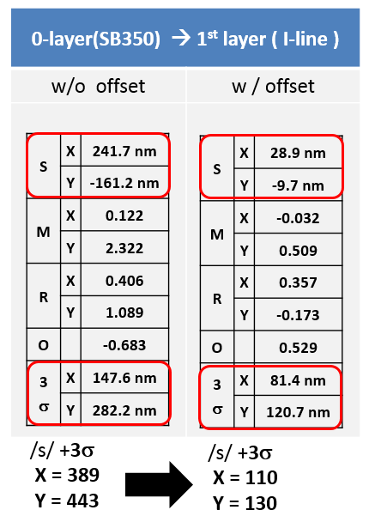
Fig.: 8” I-line start mix-match exposure - misalignment measurement values | Fig.: 8” E-line start mix-match exposure - misalignment measurement values

Breakage Exposure Stage
In 2018, TSRI began to provide the only high-resolution, high-capacity and high-alignment breakage exposure service stage based on mass-produced steppers around the world. This stage not only provides pure I-line stepper breakage exposure service, but also combines a breakage mix-matching exposure technique with the I-line stepper as its core.
TSRI’s pure I-line stepper breakage stage provides exposure service with a resolution of 400 nm and misalignment < 1 um (see left figure below). With parameter value compensation, the misalignment specification can be less than 0.5 um (see right figure below).
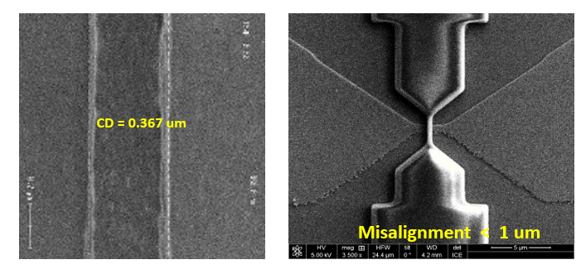 | 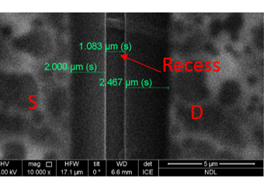
Fig.: Pure I-line breakage exposure, with resolution > 400 nm and misalignment < 1 um. | Fig.: recess S is designed as 2um. After parameter value compensation, the exposure alignment error is < 100 nm.

In addition, the exposure materials for this stage are no longer limited to Si wafers, and we are able to provide exposure services for a wider range of materials (see figure below).
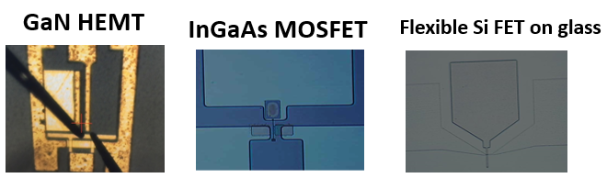
Fig.: Exposure of I-line breakages of various non-Si materials.

In 2019, using the I-line stepper as the core together in combination with a high-resolution E-beam writer, TSRI completed a mix-matching breakage exposure technique. This technique is able to reduce resolution to below 100 nm.
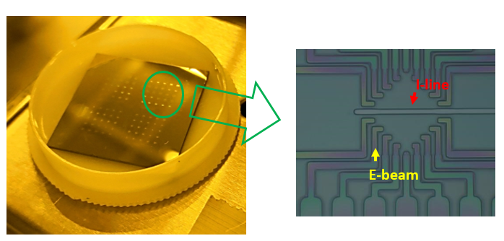 | 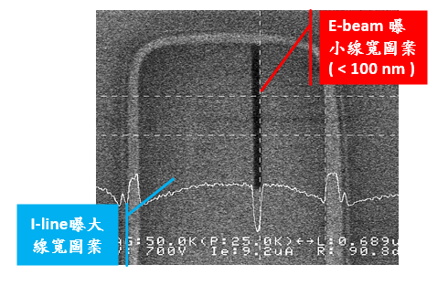  E-beam exposes a small line width pattern (<100 nm)  I-line exposes a large line width pattern
Fig.: I-line/E-beam mix-matching breakage exposure, misalignment < 1 um | Fig.: Mix-matching breakage exposure. E-beam is able to expose patterns below 100nm

Whole Breakage-Breakage Mix-matching Exposure Stage
This stage combines the whole breakage and breakage exposure techniques. It initially exposes a whole breakage. After a certain process, the whole breakage is cut into breakages with a machine, and then the component is completed in a breakage form.


