Machine Name: | Laser marker
Machine No.: | CF-M11
Draft Dept.: | Operations Division
Draft Date: | 2006/08/15

Document Revision History
NO | Issue Date | Revision application No. | Revised Content | Revised Page | Version
01 | 2006/09/01 | ------ | First draft | ----- | 01
02
03
04
05
06
07
08

Approved by | Reviewed by | Drafted by

- Purpose:
Define Laser marker practices to ensure operation quality.
- Scope:
Applicable to Laser marker
- Rights and Responsibilities:
- Organization responsibilities: The engineer is responsible for the drafting and revision of specifications.
- Qualified operator: Operators passing Laser marker system evaluation.
- Definition of terms:
No
- Relevant Documents:
Specification of Laser Marker SL473D2 (No. 828-322424 1st edition)
- Notes:
- This machine is for marking on brand-new non-coated 6” wafer. For marking on special substrates, please contact the engineer.
- Only 6INCH-3 (large font) and 6INCH-2 (small font) marking files are available for marking. Other files are for machine inspection/test.
- DO NOT open the cover when the machine is operating!
- During machine operation, if any accident happens, please record all details in the usage log and contact the engineer or leave a voice message.
- Standard Operating Procedure:
  - Check if the machine can operate normally.
- Check if the machine status is in green card (in operation), as shown in the image below.
- Check if the cooling water is 30~35°C.
- Check if there is any anomaly recorded in the usage log. The user must check all aforementioned items before starting the marking system. For any anomaly,
- please call the responsible engineer immediately.

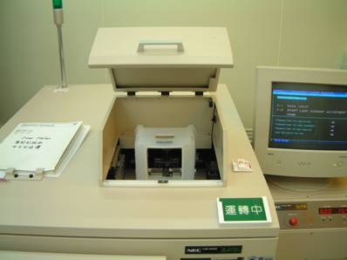

  - How to place the wafer for marking correctly
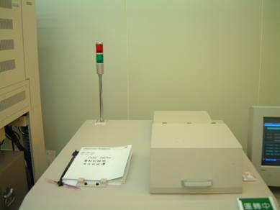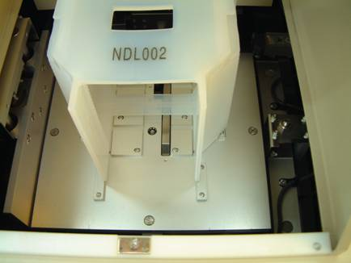
Align Holder to the position point and the bottom to the middle of the metal bar. Please note incorrect loading may lead to transfer error.

    - As shown in the image above, align Holder to the position point and the bottom pin to the middle of the metal bar.
    - Follow the image above to put the wafer for marking into Holder (no need to align the edge) correctly and check if the wafer quantity is correct.
    - How to use the marking program
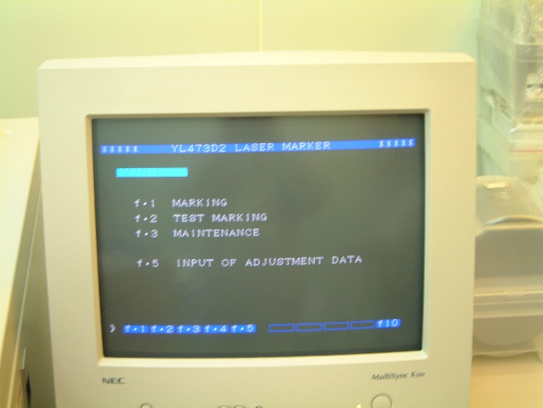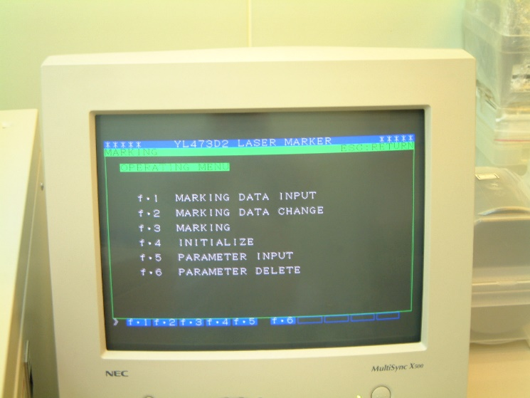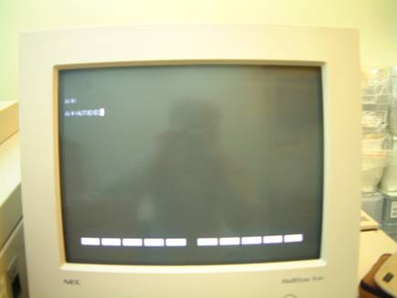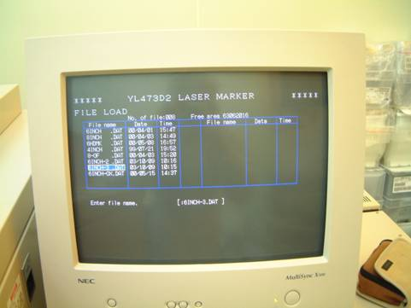
- After swiping the card, enter AUTOEXEC to activate the marking program
- Select the marking file [6INCH-3 (large font) or 6INCH-2 (small font)]
- Press F1 to access Marking menu

- Then press F1 to access Enter marking data
    - After swiping the card, enter AUTOEXEC under DOS and press Enter to access Main marking directory.
    - Select marking font size: [ 6INCH-3 ] or [ 6INCH-2 ]. Other files are not available for use. Press [ Enter ] to run after selecting the desired font size.
    - After access the program, press [ F1 ] to Marking function menu.
    - From Marking function menu, press [ F1 ] to access Marking settings.

  - How to use the marking program
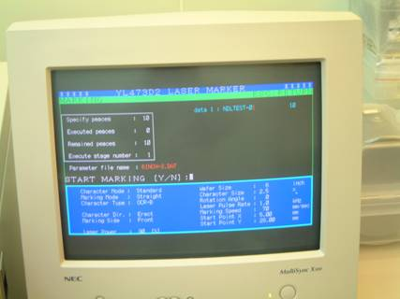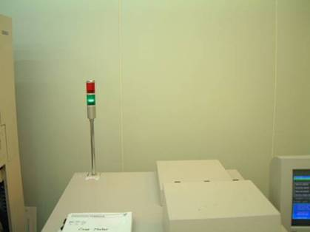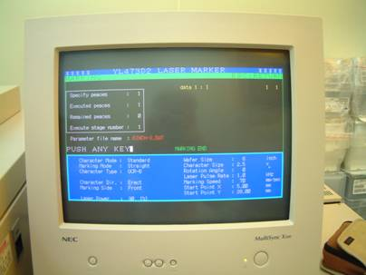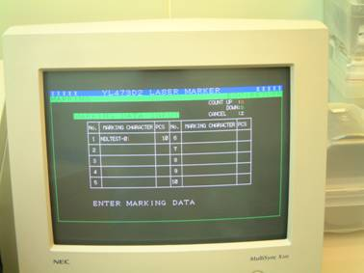

5. Enter the marking data and quantity (incremental-shift a, decremental-shift b, cancel-shift z)
6. Then press ESC to access this screen. Before pressing Yes, please check if the marking code and quantity are correct
7. After marking, a MARKING END will appear on the screen and the green light will light up. You may open the cover to change or take out the wafer
    - Enter the marking name and quantity. Make sure the quantity in Holder is identical to the entered value.
    - Press [ ESC ] to exit this setting screen. Check if the data entered at the top right corner is correct and then press Yes to start marking.
    - During machine operation, make sure it is not unattended. When “MARKING END” appears on the screen and the green light lights up, press [ Enter ] to take out the marked wafer.
  - How to use the marking program
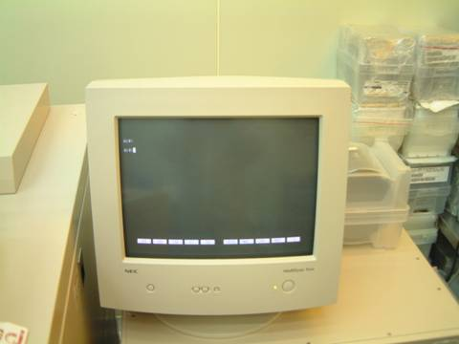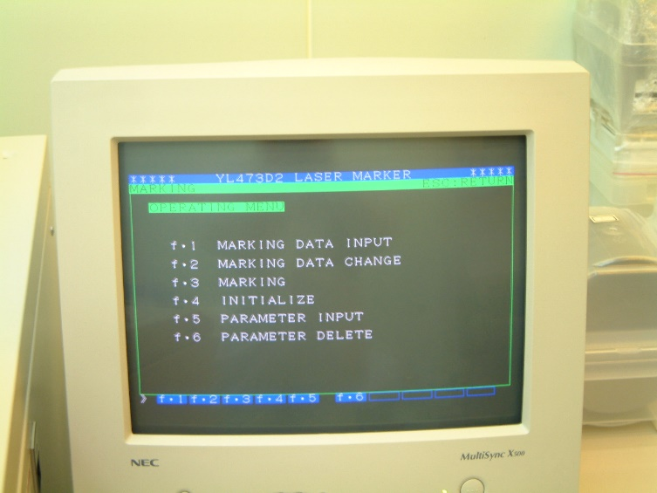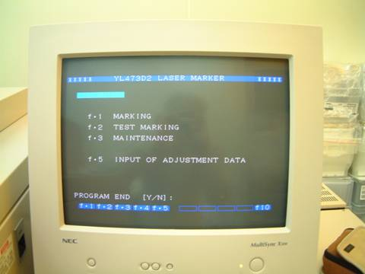
8. Press any key to return to this screen. Press F1 to enter data or ESC to return to the upper layer
9. Then press F10 to end the marking program
10. Lastly, make sure to return to DOS directory to prevent malfunction resulted from touching any key by accident.
    - Press [ ESC ] to return to Home screen, press [ F10 ] to end the marking program and return to DOS directory.
    - Make sure to record detailed usage status in the log.
    - After the operation is completed, swipe the card to turn off the screen.
- Reference forms and attachments:
- S4-NL01A Machine evaluation list.
- S4-NL01B Machine checklist.
- S4-NL01C Machine usage log.
- S4-NL02A Anomaly handling form.
- S4-NL04B Machine management card.

