Machine Name: | N&K1500 Film Thickness Measurement System
Machine No.: | CF-M23
Prepared by: | Lithography and Mask Division
Issue Date: | Sep. 8, 2021

Document Issue and Revision History
NO. | Issue Date | Revision Application No. | Issued/Revised Content | Revised Page | Version
01 | Nov. 1, 2013 | 102-DC21 | First issue | ----- | 01
02 | Nov. 1, 2021 |  | Issue of ver. 1.1 | ----- | 1.1
03
04
05
06
07
08

Approved by | Reviewed by | Prepared by

- Purpose:
Defining the operational standards of the N&K1500 Film Thickness Measurement System to ensure the quality of its operation.

- Scope:
Applicable to the N&K1500 Film Thickness Measurement System.

- Responsibilities:
  - Organizational responsibilities: The engineer is responsible for the drafting and revision of standards.
  - Personnel qualified for execution: Personnel who have passed the test for the N&K1500 Film Thickness Measurement System.

- Definition of Terms:
None.

- Related Documents:
None.

- Standard Operating Procedures:
  - Enter MES to swipe card to start up the machine.
  - Place the 8-inch baseline wafer into the stage.
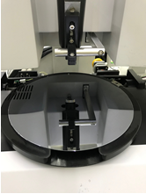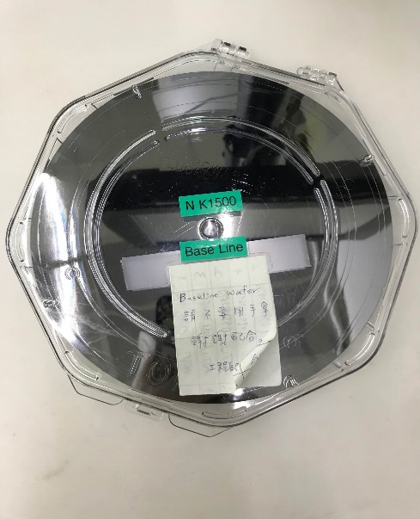

  - Turn on vacuum.
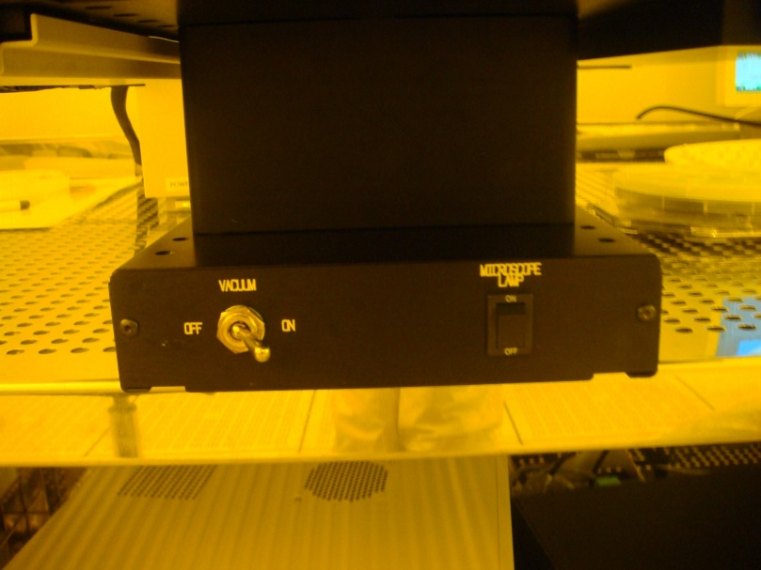

  - In Library, select Size as 8 inch (stage size) and click associate.
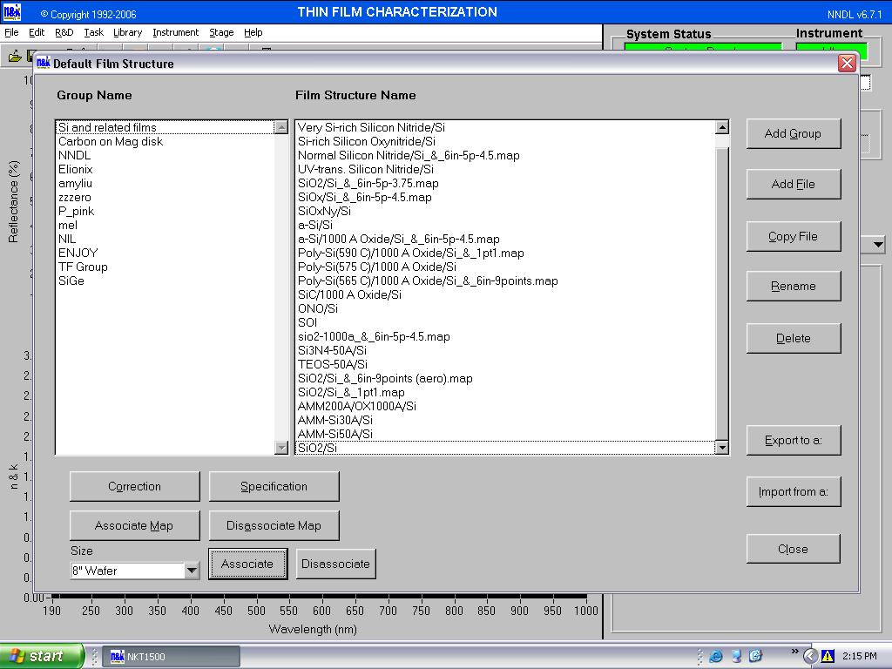

  - Check if the option of 8” is ticked under Mapping.
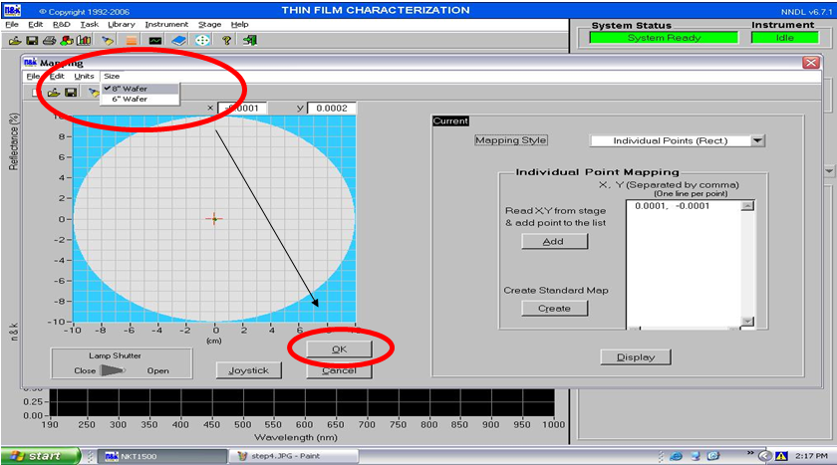

  - Execute Baseline.
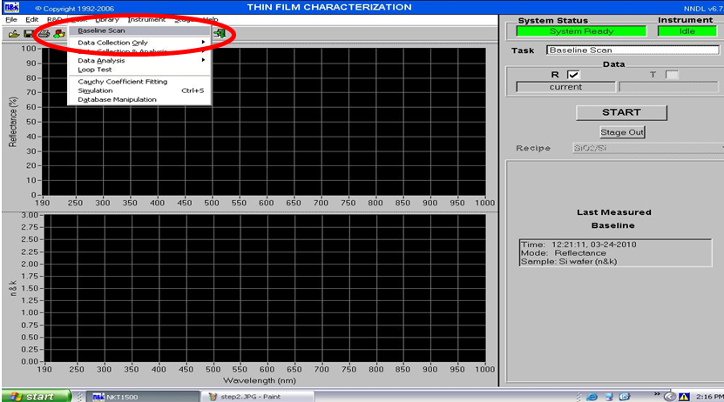

  - The baseline total value must be less than or equal to 0.20% to be acceptable.
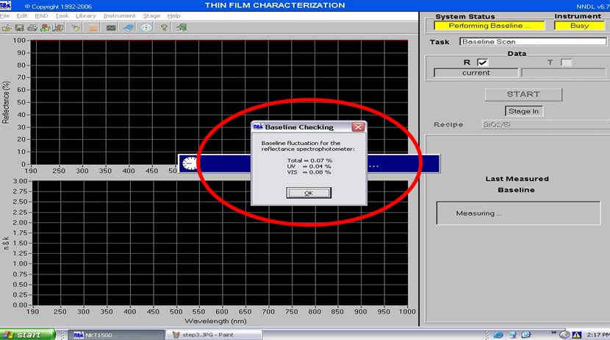

  - Remove the baseline wafer and place the wafer to be measured.
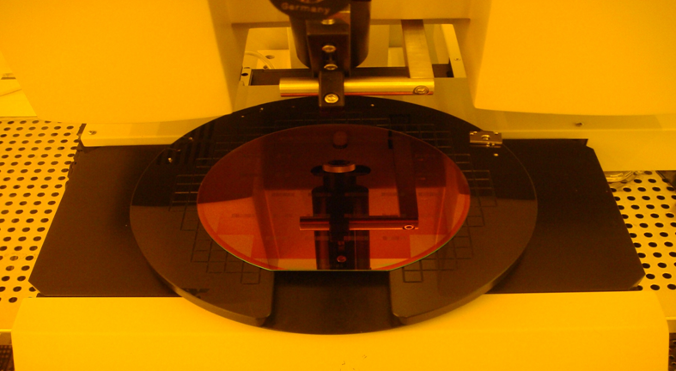

  - Use mapping to select the location to be measured.
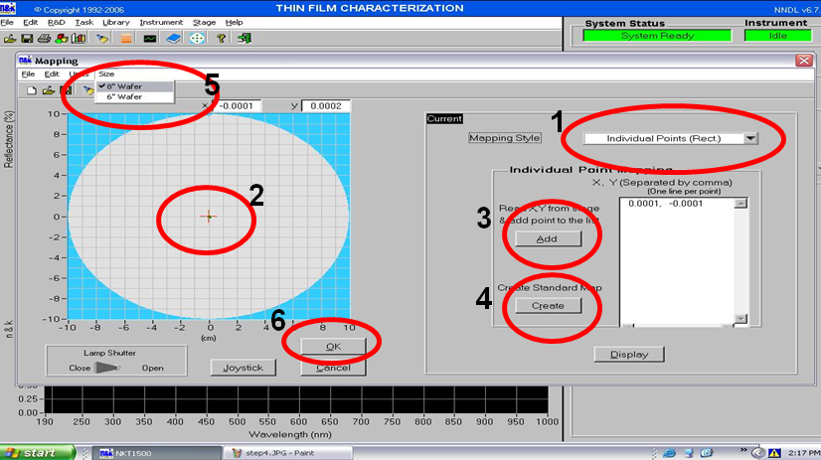

  - To enter the film structure, use the RD method or the built-in program in Library.
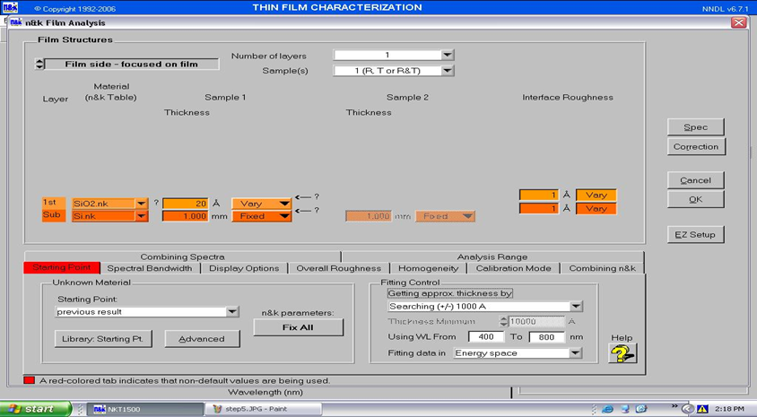

  - Data collection and analysis.
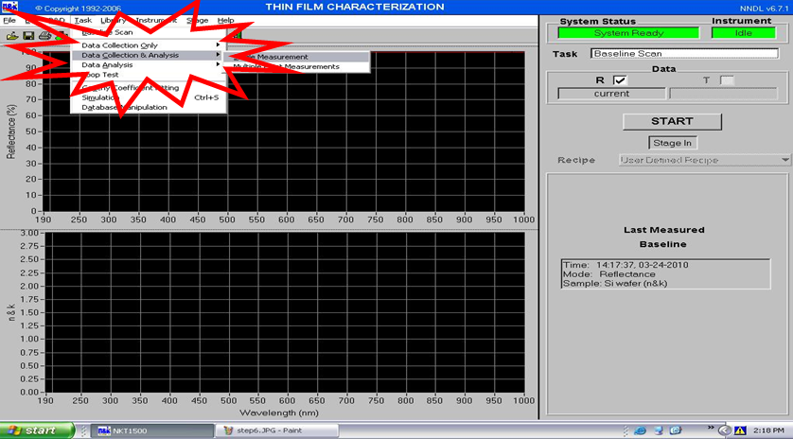

  - Select Single Measurement or Multiple Point Measurement, and click START.
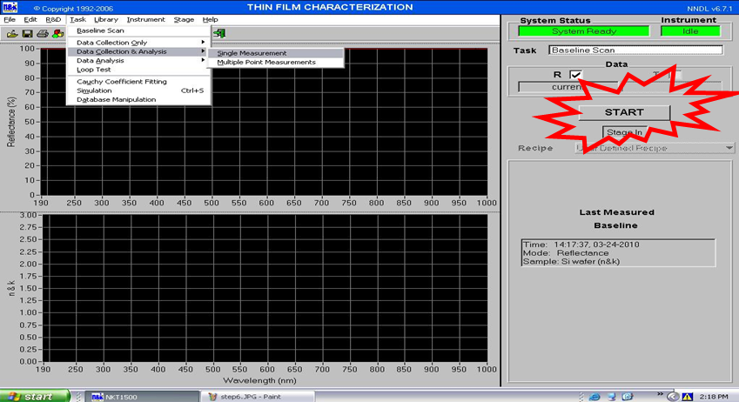

  - After keying in data information, click “ok”.
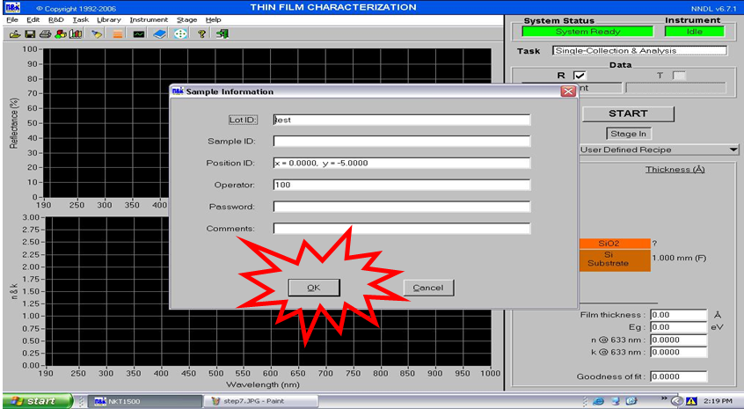

  - Click NO, as there is no need to save the file.
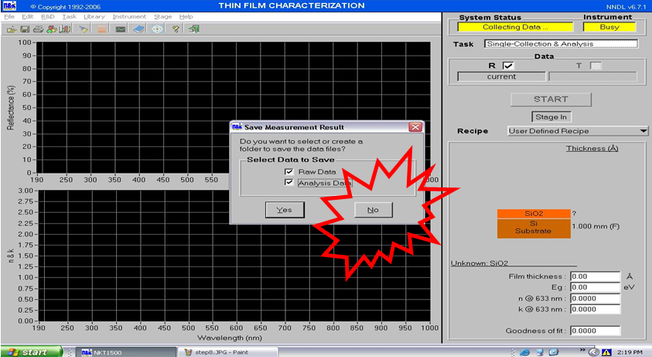

  - The goodness of fit after measurement must be at least 0.98 for the measurement data to be accurate.
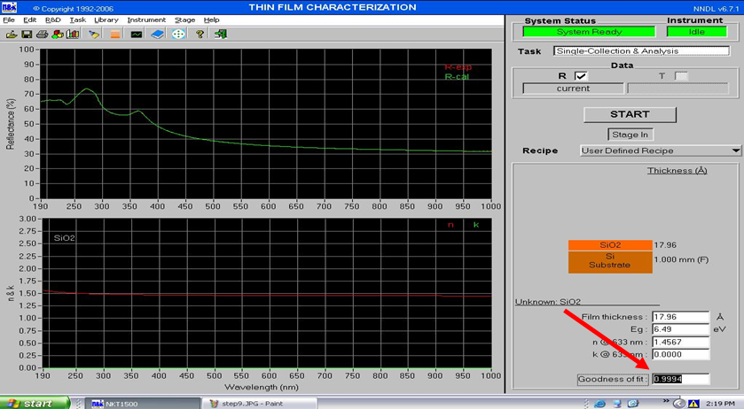

  - Assuming multiple points are measured, click the icon for statistics.
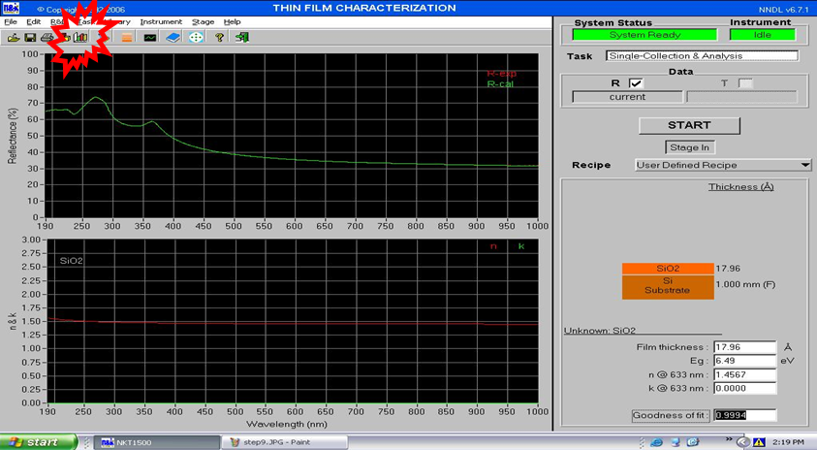

  - You can check the data of multiple points.
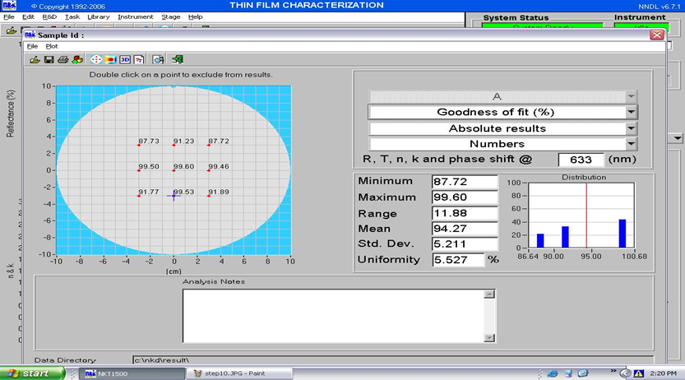

- Applicable Forms and Attachments:
  - Equipment Evaluation Checklist S4-NL01A
  - Equipment Inspection Checklist S4-NL01B
  - Equipment Use Log Sheet S4-NL01C
  - Form for Irregularities and Their Correction and Prevention S4-NL02A
  - Instrument and Equipment Management Card S4-NL04B

