Document Title: | Equipment Operational Standards (CF-M24 Surface Contamination Analyzer)
Document No.: | Q3-NL04
Prepared by: | Lithography and Mask Division
Issue Date: | Sep. 20, 2007

Document Issue and Revision History
Version | Prepared by | Effective Date | Approval No. | Description of Revision/Amendment | Revised Page
1.0 | Si-Ching Liu | Oct. 1, 2007 |  | First issue | 01
1.1 | Hsin-I Peng | Jul. 1, 2012 |  | Change to the name of the department preparing the document | All
03
04
05
06
07
08

- Purpose:
Defining the operational standards of the TOPCON Surface Contamination Analyzer to ensure the quality of its operation.

- Scope:
Applicable to the TOPCON Surface Contamination Analyzer.

- Responsibilities:
  - Organizational responsibilities: The engineer is responsible for the drafting and revision of standards.
  - Personnel qualified for execution: Personnel who have passed the test for the TOPCON Surface Contamination Analyzer.

- Definition of Terms:
No

- Related Documents:
TOPCON WM-7 Operator’s Manual.

- Standard Operating Procedures:
  - Check whether the equipment is operating normally. If yes, the equipment condition sign will indicate “Normal” (green).
  - Check the use and operation log sheet to make sure the previous use is normal.
  - Use the MES system to start up the machine.
  - Use only 6- or 8-inch wafers.
  - Place the specimens to be scanned in the designated cassette (be sure to use a vacuum pen, not a clamp, to pick up and place the chips. ) Place the H-bar face down on the holder.
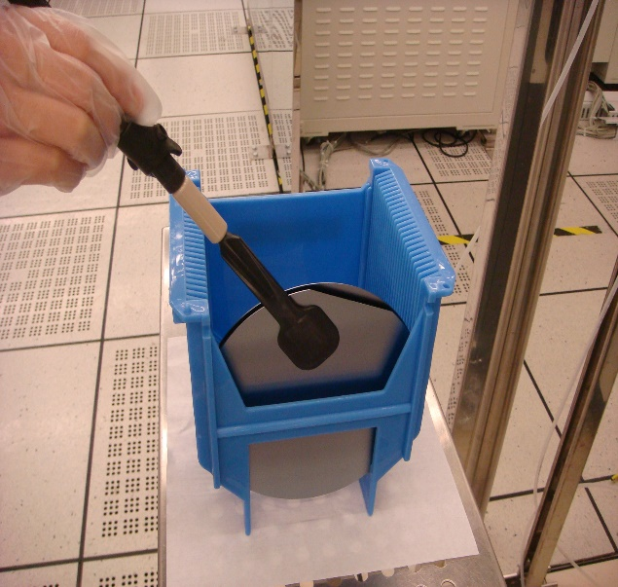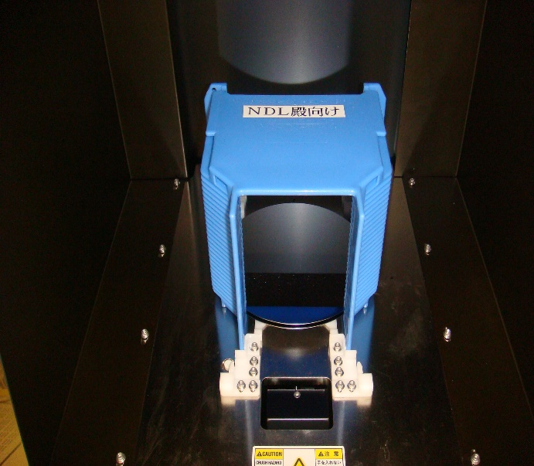

  - Enter Windows and select “shortcut to wm7.exe”.

  - Enter “shortcut to wm7.exe” and key in the password.

  - After keying in the password, the machine will perform initialization and will sound an alarm when it is finished.

  - Select “MEASURE(Group/Machine)”.

  - Select “SlotSel,RecipeSelect”.

  - When the wafer mapping location table appears (as shown below), select the wafer slot number to be measured, and click on the slot number box to the right of the wafer to select the program.

  - Select “Bare Si”

  - The program is selected as follows: G1 is scanning the particle with the smallest size, followed by G2, G3 and G4.

  - For example, to scan the smallest particle for the 6-inch wafer, select “6inch G1” and click “Data Set” to complete selection of the program.

  - The screen will return to the mapping screen (the program will be listed next to the selected chip, and you can check it again), and click “Start” to start scanning.

  - The figure below shows the result of scanning.

  - Make sure to fill in the operation log sheet and log out of the MES system after use.

- Applicable Forms and Attachments:
  - Equipment Evaluation Checklist S4-NL01A
  - Equipment Inspection Checklist S4-NL01B
  - Equipment Use Log Sheet S4-NL01C
  - Form for Irregularities and Their Correction and Prevention S4-NL02A
  - Instrument and Equipment Management Card S4-NL04B

