M2000 Ellipsometric Thickness Gauge
System Introduction

Agenda

- System Introduction
- Principles of Ellipsometer
- Measurement and Analysis

System Introduction

- Band range of measurement: 193 nm - 1690 nm (e.v. * nm =1240)
- Light source: XLS-100 type
- 30W D2 (Deuterium) for UV/VIS, with a lifetime of approx. 1500 hours
- 5W QTH (Quartz Tungsten Halogen) for VIS/IR, with a lifetime of approx. 2000 hours
- Spot size: 0.3mm-5mm
- Scan angle: 45°-75° with probe, 45°-90° without probe
- Polarizer (Analyzer): A combination of two prisms that converts the light source into single-direction light (P & S)
- Sample size: Max. an 8-inch wafer, min. a 1x1 cm breakage
- Detector by CCD
Analyzer  Detector  Source  Polarizer  Sample | 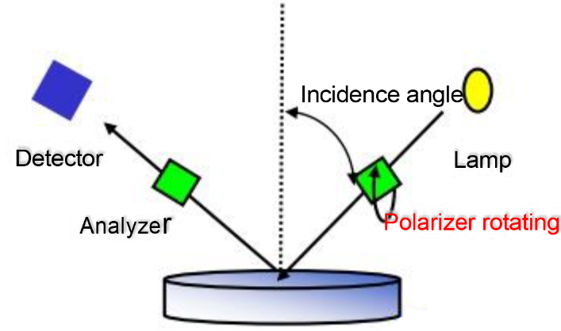

Available spectral range: 193nm-1690nm (UV/VIS/NIR) with 690 wavelengths
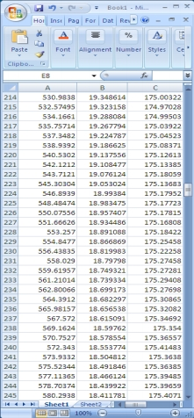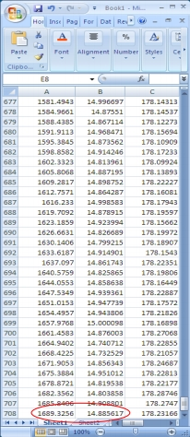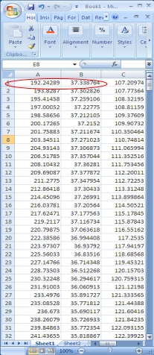
Spectral range: 192.24289 - 1689.3256 nm with a resolution of 708 wavelengths
IR: 1689.3256- 1685.8406 nm =3.485 < 3.7nm
VIS: 580.2938-578.70374 nm= 1.58646 < 2.17nm
UV: 241.43655-239.84863 nm=1.58792 < 2nm.

Spot size is 0.3-5mm

Standard spot size: 3-5mm, can be further reduced to 0.3mm through focusing accessories (spot size varies with different wavelengths)
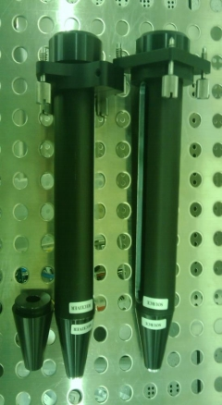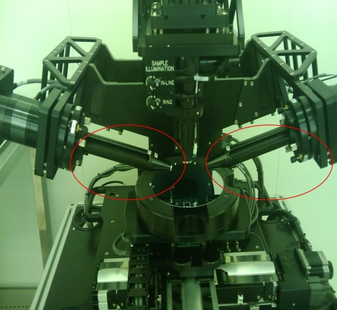
Focusing accessories | Installed on the system

Measuring angle: Computer automatically adjusts the angle, changing between 45° and 90°.

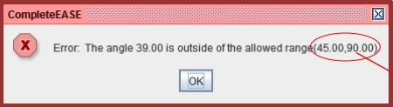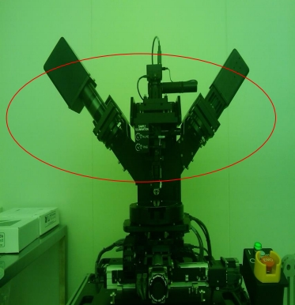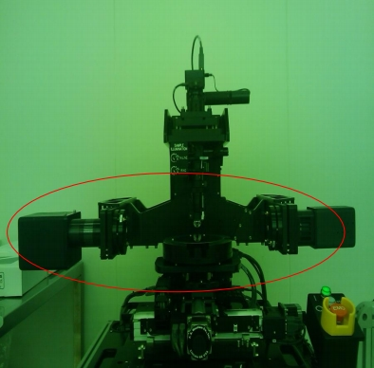
45°
90°
The set angle is 39°, but the system reminds you that only 45-90° is allowed.

200mm program-controlled XY translation stage (this stage must be able to measure wafers up to 200mm)
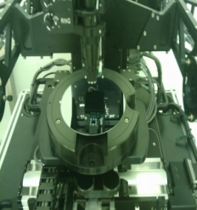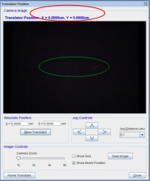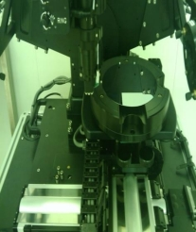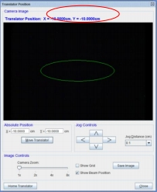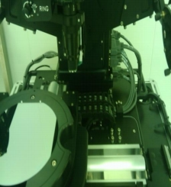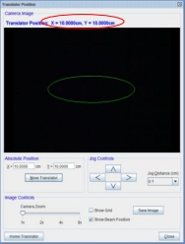
Home position X=0 Y=0
Moved to position X = -10cm Y = -10cm
Moved to position X=10cm Y=10cm
Movable range of X and Y is -10~10cm (200mm)

Principles of Ellipsometer

Light is reflected from the surface of a sample at a non-zero angle of incidence, leading to a change in the polarization state due to the thickness of the sample and its reaction to light (absorption or transparency) (resulting in changed phase and amplitude). Such method of measurement is known as ellipsometric measurement.

- For each wavelength, we acquire two independent parameters during measurement.
- ψ and ∆ (Phase change ∆ has very high sensitivity within a 10nm film)
- Absolute measurement:
- We do not need any reference parameters.
- Non-destructive and indirect measurement technique:
- The N, K and T of the sample cannot be acquired directly.
- Use the modular formula to describe the physical parameters of the sample to acquire N, K and T.
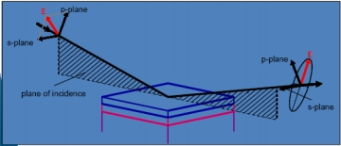

Principles of Ellipsometer

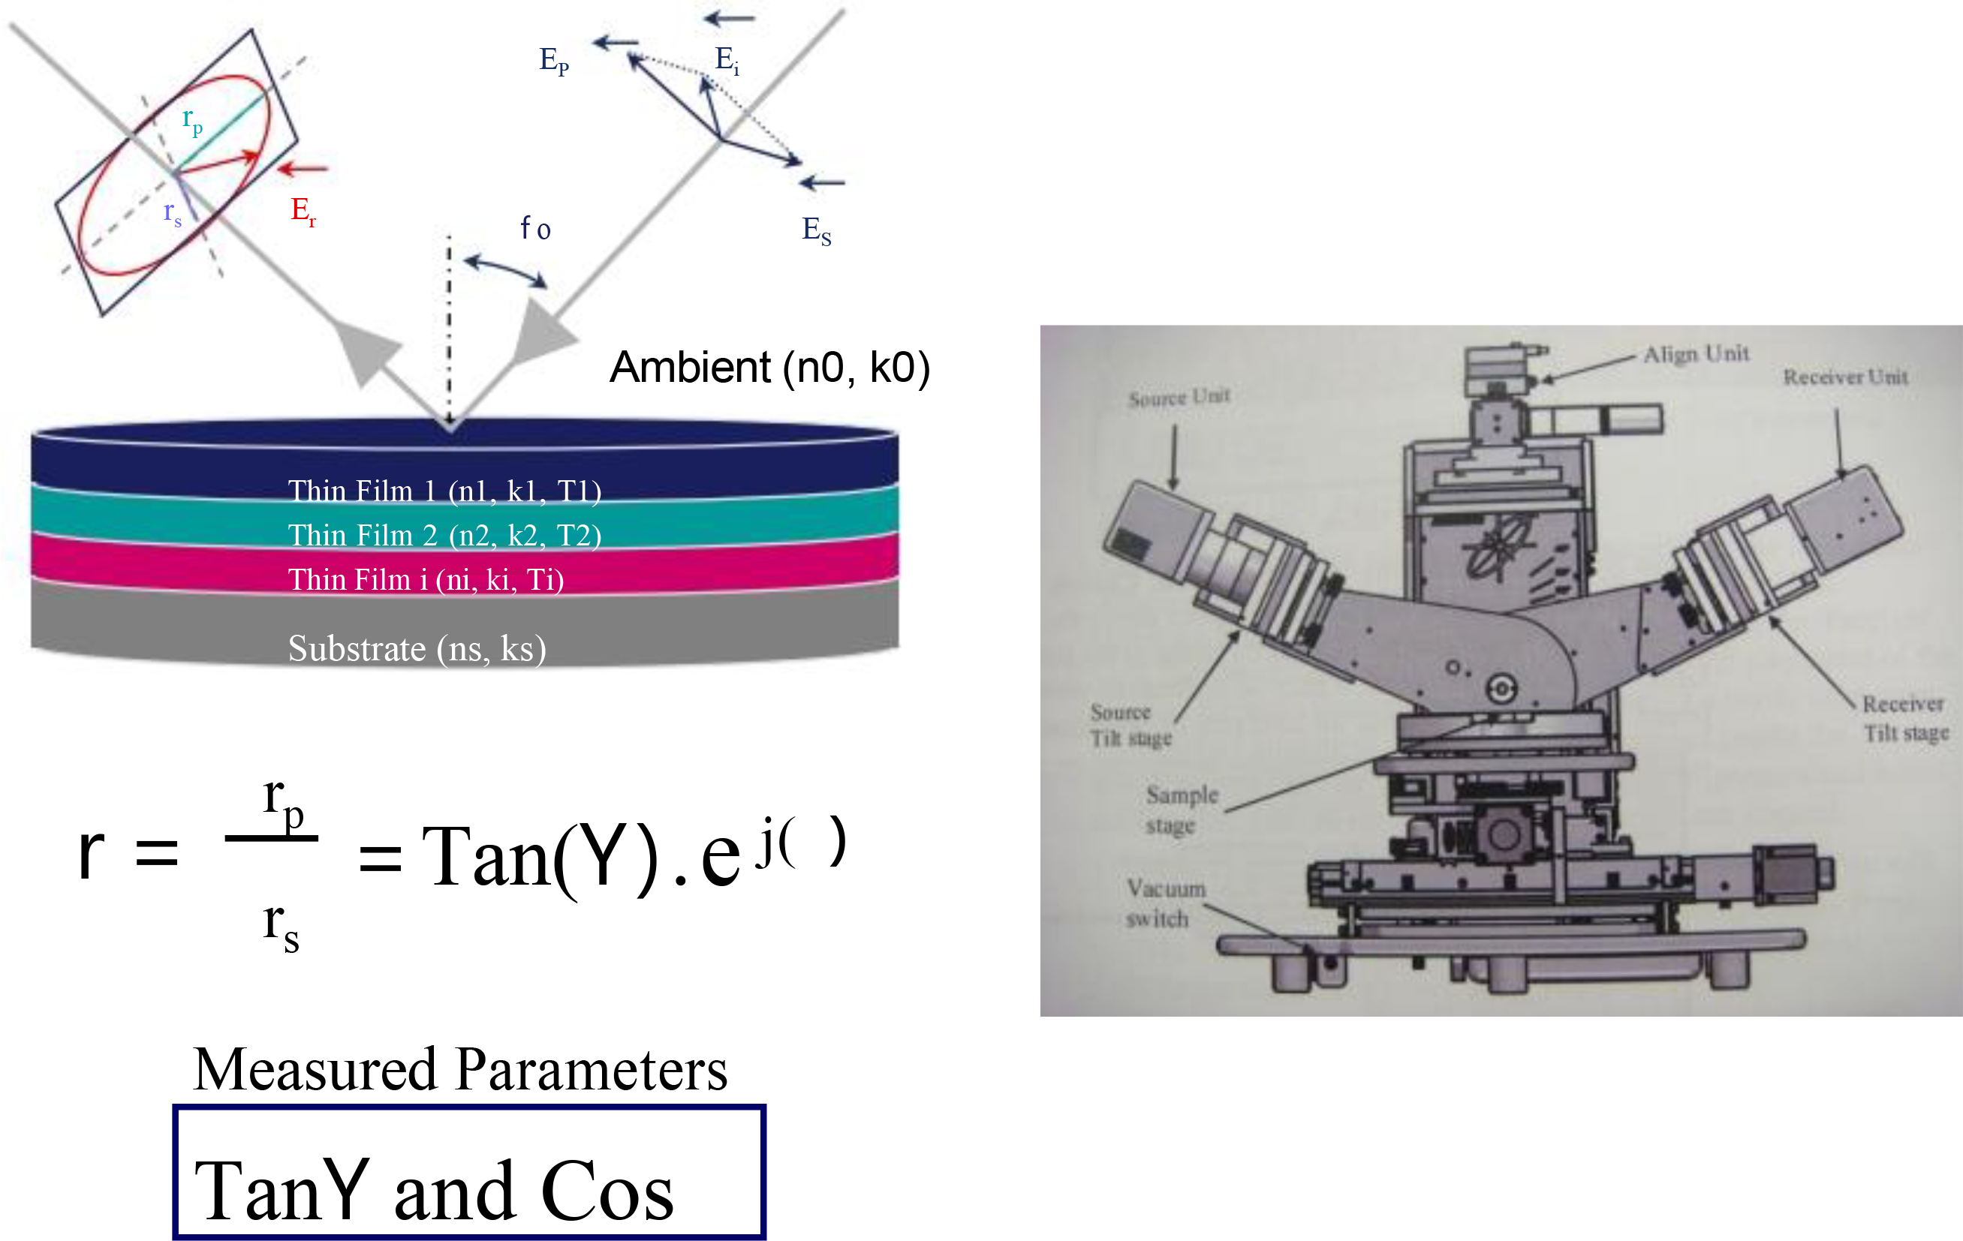

Measurement and Analysis

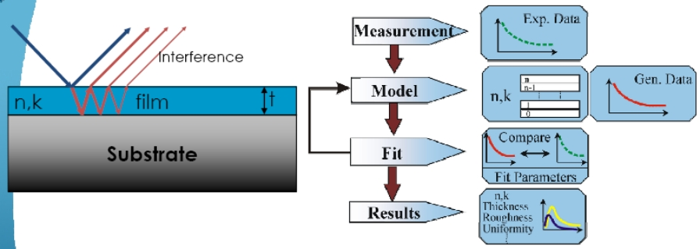

Measurement and Analysis
55A SiO₂ (Dry Oxide) deposited in Vertical furnace at 980 °C
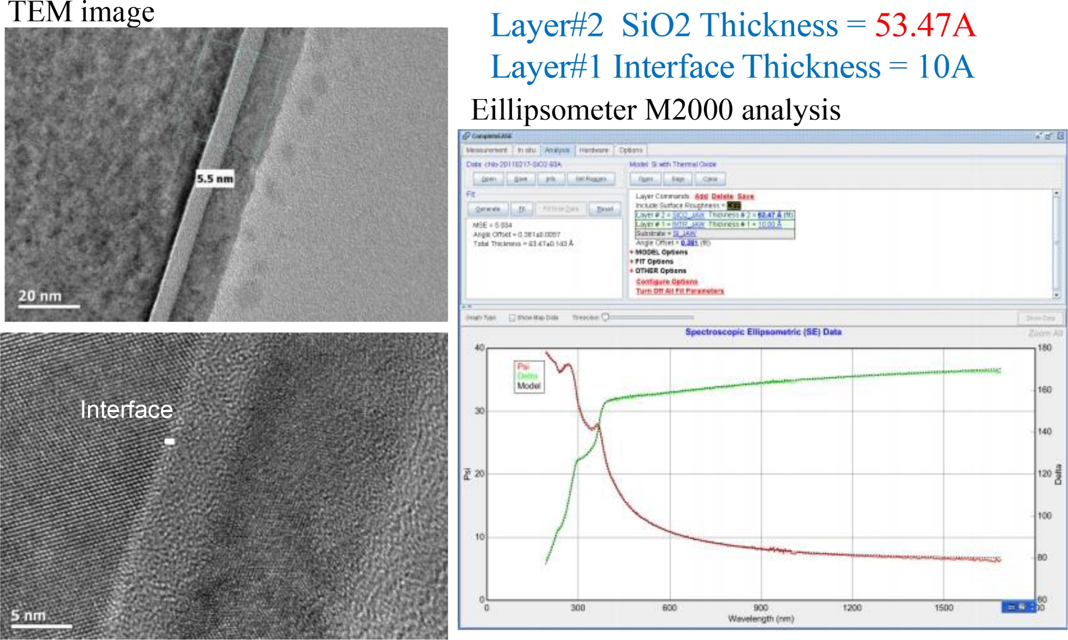

Measurement and Analysis
33A SiO₂ measurement data


