TXRT Equipment
(TXRF Equipment)



User manual

Kowa Thermo Technologies & Products Co., Ltd.

Version history

Version No. | Date of revision | Revision page | Revised content
Ver. 1.00C | 2013/11/25 |  | The 1st ver. in Chinese (Chinese, simple version/out-of-the-box)

Contents
Version history 2
Contents 3
Chapter 1 Safety first 5
1.1 During KTRX operation, please press EMO button immediately when emergencies occur (as shown below) 5
1.2 Or you can try to turn off the power of following components or interrupt X-ray output. 6
1.2.1 Turn off vacuum pumpor X-ray output: 6
1.2.2 Turn off water chiller. 6
Chapter 2 7
2.1 Power on and run initialization 7
2.1.1 Power on 7
2.1.2 Run K-TRX application 7
2.1.3 Run machine initialization 7
2.2 After the initialization, the screen below will appear on MS Windows. 10
2.2.1 Define carrier and job 10
2.2.2 Select Recipe 12
2.3 Start to measure wafers 13
2.4 During the measurement, click Monitor at the bottom of the screen to check dynamic data 13
2.5 After the measurement, the wafer will be returned to the cassette automatically. Press Unlock key next to LoadPort to take out the cassette. 13
Chapter 3 Select/Read the measurement data 14
3.1 Select the measurement data 14
3.1.1 Access Home screen and select Results 14
3.1.2 Then select Data List tab on Results screen 14
3.2 Read the measurement data 15
3.2.1 Read the measurement data 15
Chapter 4 Dynamic display of measurement status 18
4.1 Dynamic display of measurement status 18
4.1.1 Select Monitor in Home screen 18
Chapter 5 Edit recipe 20
5.1 Recipe 20
5.1.1 Recipe structure 21
5.1.2 Edit Process recipe 21
Chapter 5 Edit Recipe 19

- Safety first
  - During KTRX operation, please press EMO button immediately when emergencies occur (as shown below)
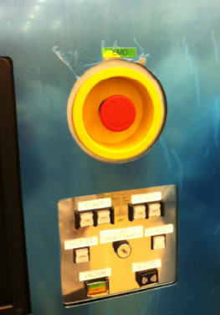
FYI.
- An emergency varies by the operator
- After pressing EMO, it is necessary to POWER ON again for initialization
- In general conditions, it is not necessary to press EMO

There are 3 EMO buttons, in the front and at the back of K-TRX (as shown below)
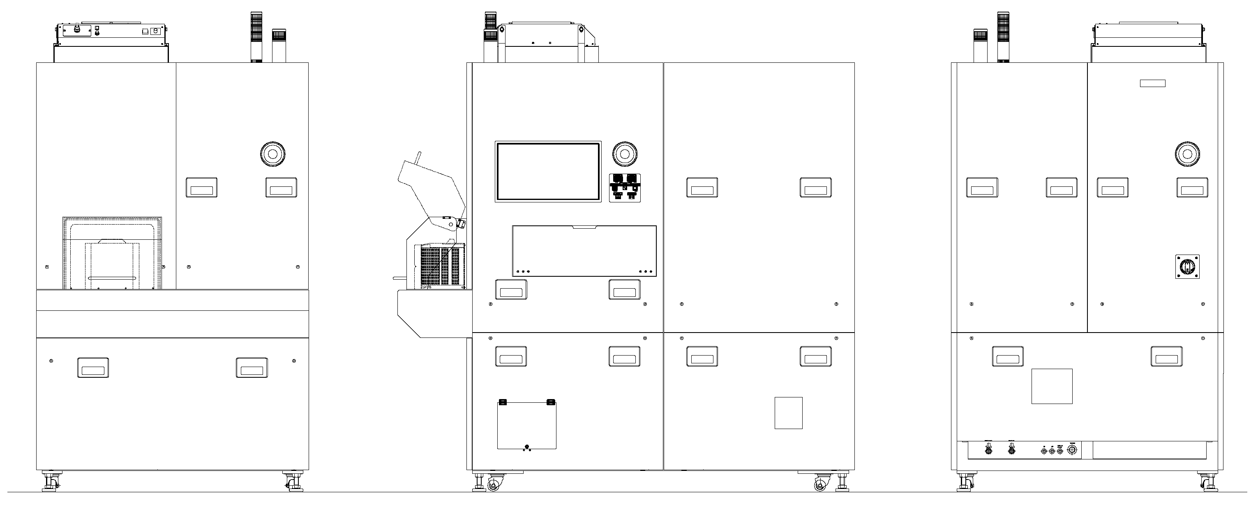
Rear view
Front view
Right side view

  - Or you can try to turn off the power of following components or interrupt X-ray output.
    - Turn off vacuum pumpor X-ray output:
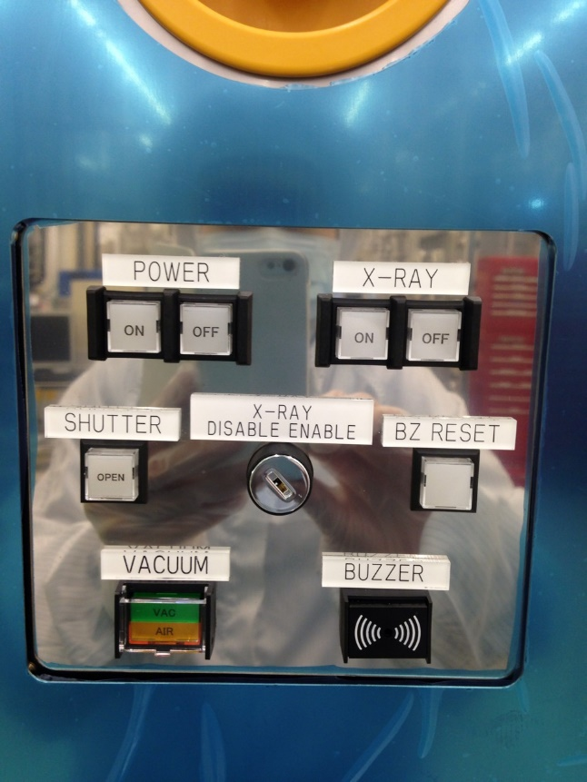
    - Turn off water chiller.
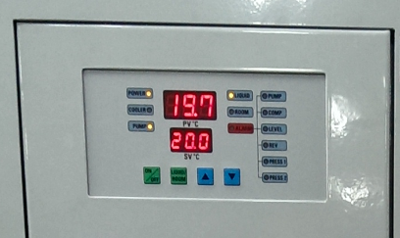
[Water chiller is installed outside the clean booth]

  - Power on and run initialization
    - Power on
Power ON: Power ON
Power OFF: Power OFF

X-Ray ON: X-RAY ON (constant ON)
X-Ray OFF: X-ray OFF (constant ON)

Shutter OPEN: X-RAY shutter open (constant ON)
X-RAY Enable/Disable:
X-RAY safety switch OPEN/CLOSE
BZ RESET: Turn off buzzer

VACUUM/VAC: | Vacuum OK (constant ON)
 | Vacuum running (blinking)
VACUUM/AIR: | Atmosphere status OK (constant ON)
 | From vacuum to atmosphere (blinking)

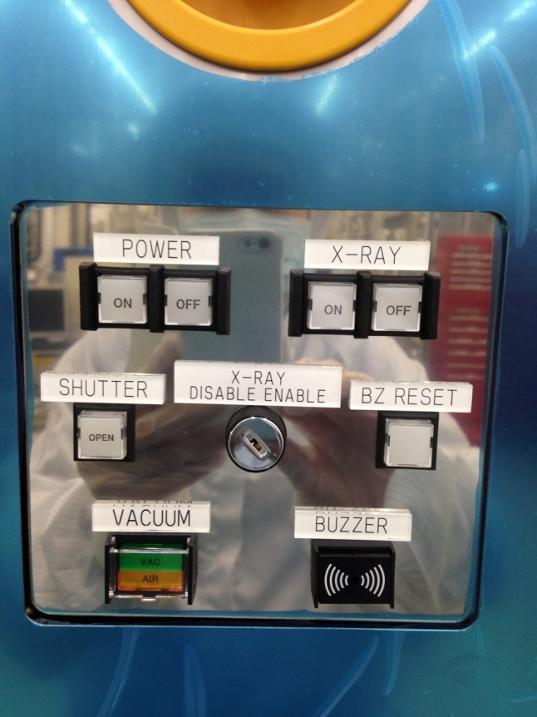

    - Run K-TRX application
Double-click K-TRX on Windows desktop and enter User and password.
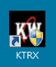
    - Run machine initialization
(It is only necessary to run initialization once, after the machine is rebooted. There is no need to run initialization under normal operation)
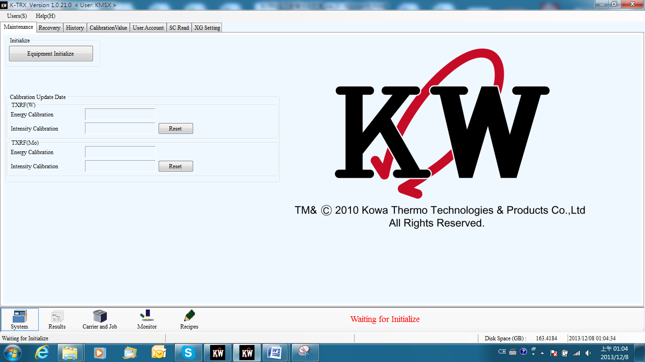

Start screen is as shown below
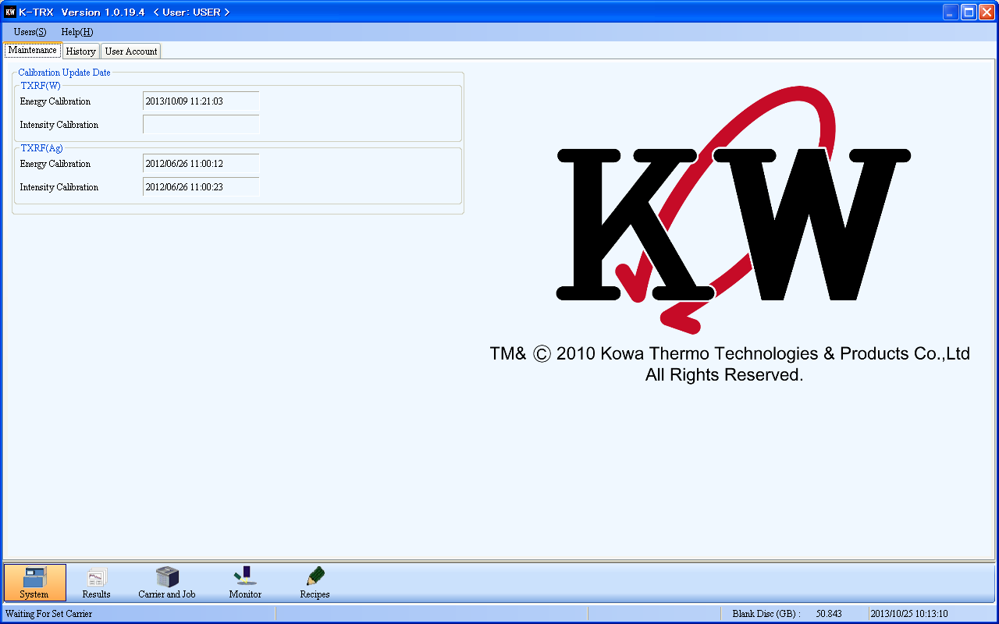

The default setting of Users is Operator (other options include Administrator and Engineer)
Permissions of Operator include:
- Read the data of measurement results
- Select recipes and measure wafers
- Log out the Operator account
- No permission to change recipes or disable K-TRX application.

Permissions of Engineer include:
- All Operator permissions
- Permission to K-TRX maintenance
- Allowed to change recipes or disable K-TRX application.

Permissions of Administrator include:
- All Operator permissions
- All Engineer permissions
- Highest level of change permissions

  - After the initialization, the screen below will appear on MS Windows.

    - Define carrier and job
Here, a carrier includes open cassette and wafers inside. And a job refers to define how to measure wafers. Press “Carrier and Job” to access the screen below.

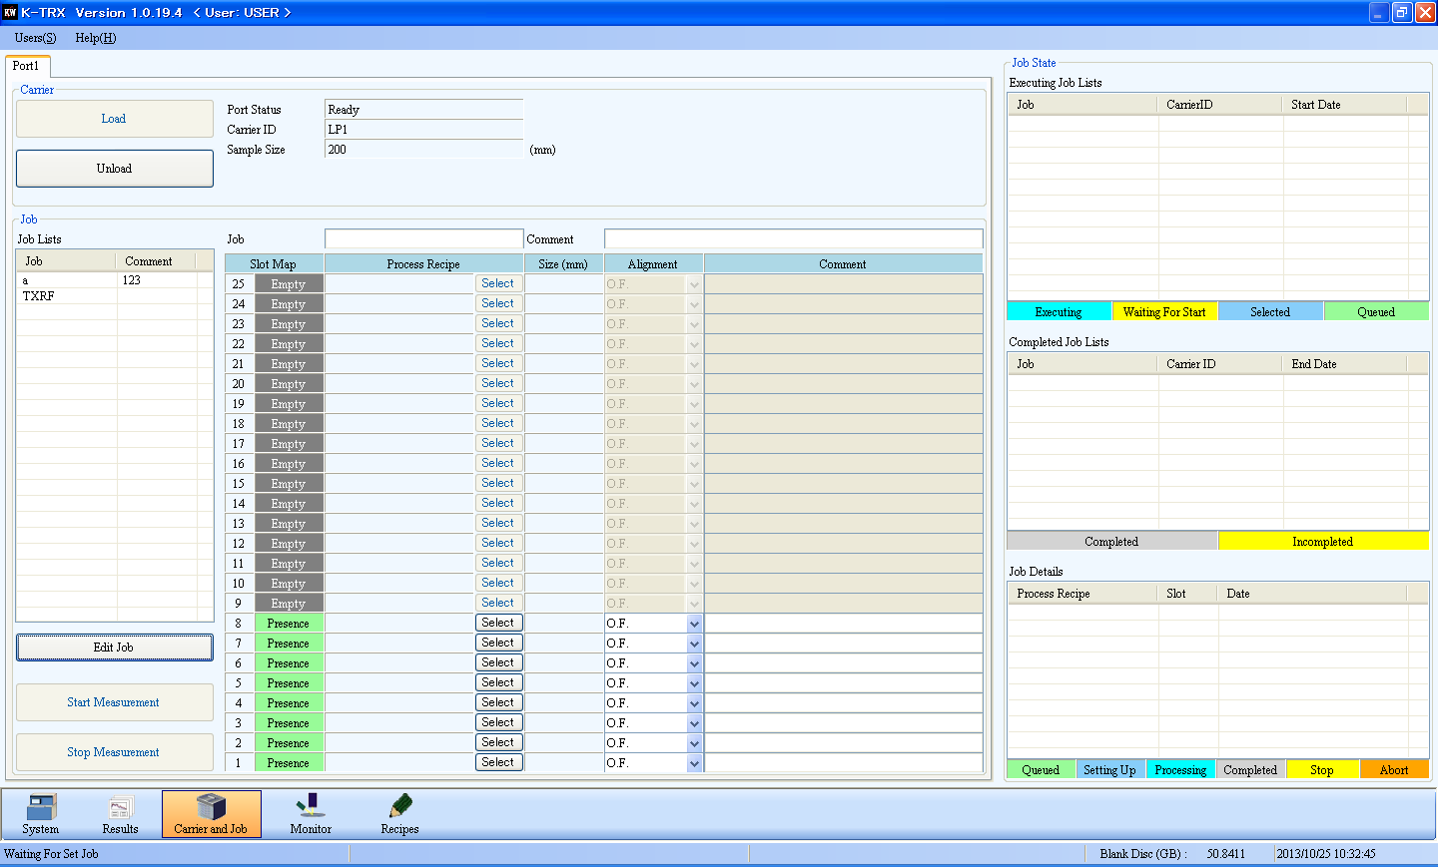
Job part
Port part
Select the tab of port number
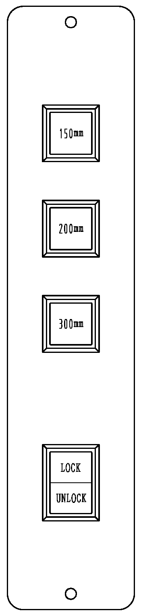
- Press UNLOCK button (2 in the right image) to open cassette cover.
2
1
- Place wafers for measurement in the cassette (no slant allowed), put on Load port and press Lock button (2 in the right image). At this time, the system will display the cassette size (1 in the right image).
- Select Port 1 on the left top corner (this machine only has Port 1).
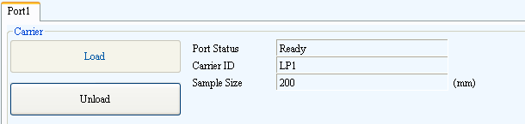
a
b
- Press Load (a in the image above) and Robot will start to scan wafers in the cassette to acquire wafer slot mapping. Empty refers to no wafer and Presence means the wafer is in the slot.
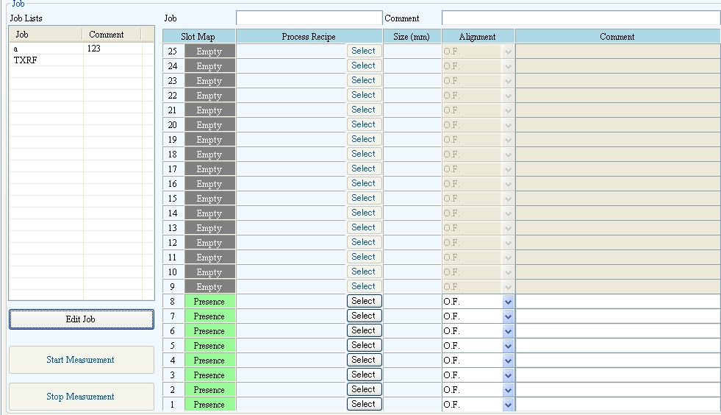
2
3
4
1
No wafer
Wafer in slot

    - Select Recipe
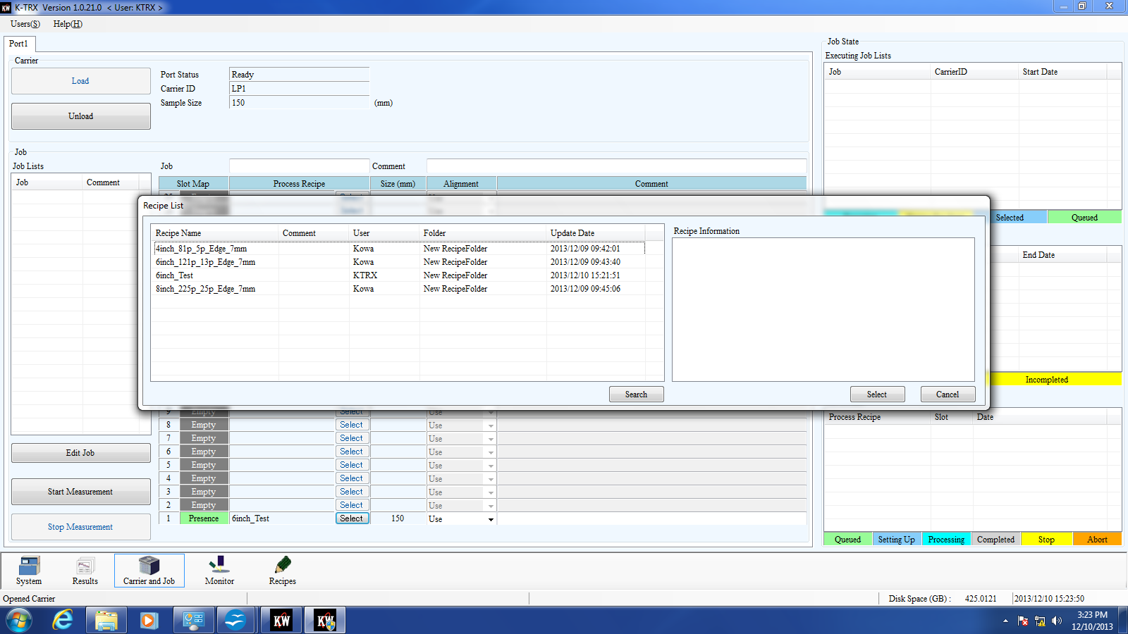
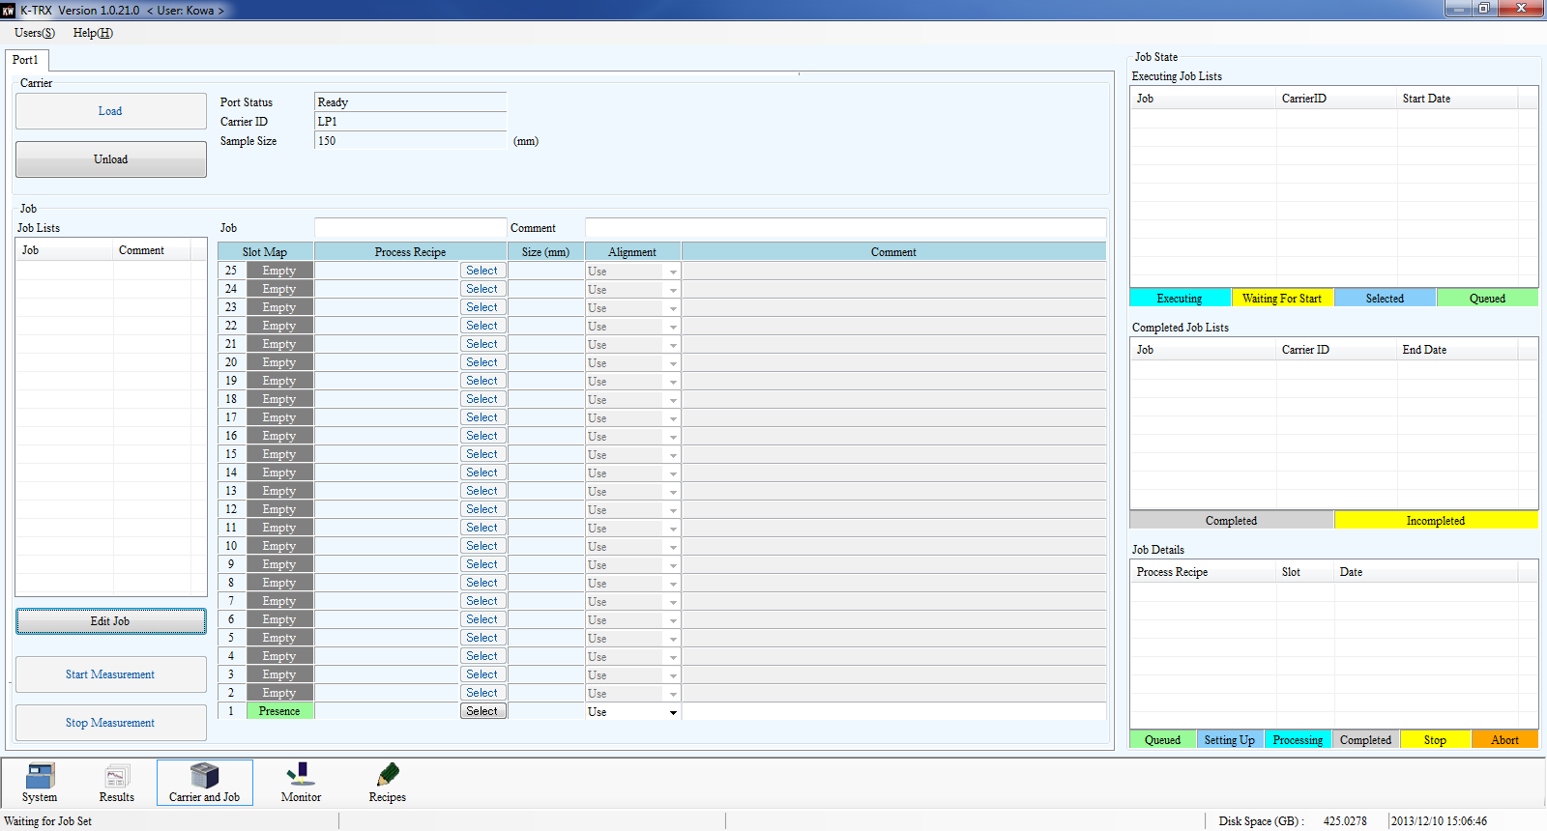
Press Select to select Recipe
Press Select to select Recipe
Select Recipe

  - Start to measure wafers
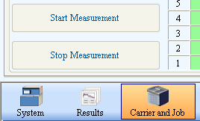
a
b
- Select Start Measurement to start measuring wafers
- To interrupt the measurement, select Stop Measurement
  - During the measurement, click Monitor at the bottom of the screen to check dynamic data
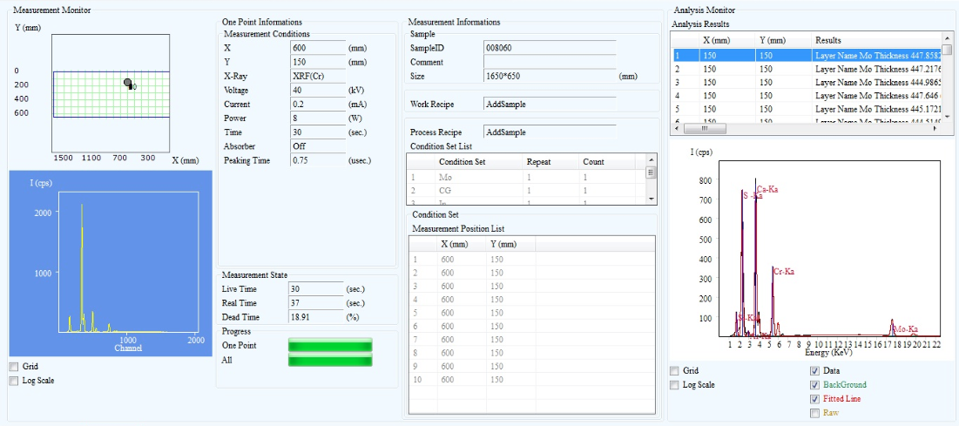
  - After the measurement, the wafer will be returned to the cassette automatically. Press Unlock key next to LoadPort to take out the cassette.

Unlock
- Select/Read the measurement data
  - Select the measurement data
    - Access Home screen and select Results

    - Then select Data List tab on Results screen
- Or select 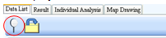Filter measurement data from Data List
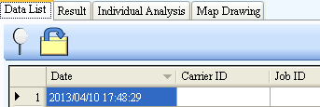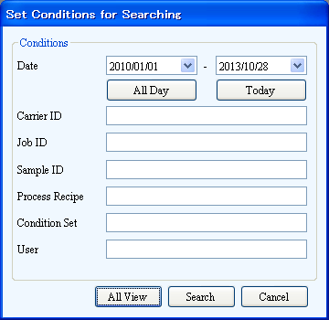
Enter filter condition
Date, Carrier ID, …
Select Search
- Or select 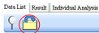Filter measurement data from Data List
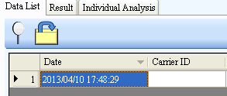
- Single-click right button to select the measurement data filtered out
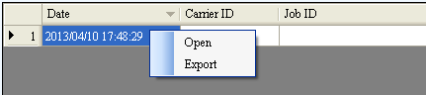
- Open
- or export to a certain folder
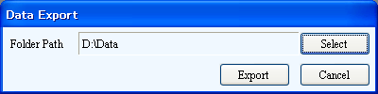

  - Read the measurement data
    - Read the measurement data
- In Home screen, select Results and then OPEN (a in the following image) to open the measurement data
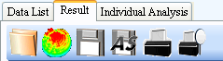
a) b) c) d) e) f)
No. | Function | Description
a | Open | Open a mapping file. (filename extension: . xmd)
b | Draw Mapping | Display the mapping file in 3D
c | Save | Save the changed mapping file to overwrite the old file.
d | Save as a new file | Save as a new mapping file
e | Print | Print the mapping file
f | Print preview | Preview the mapping file for printing

- Measurement data including coordinates, measurement date/time, intensity and concentration of contamination elements, etc. will be displayed in the list.
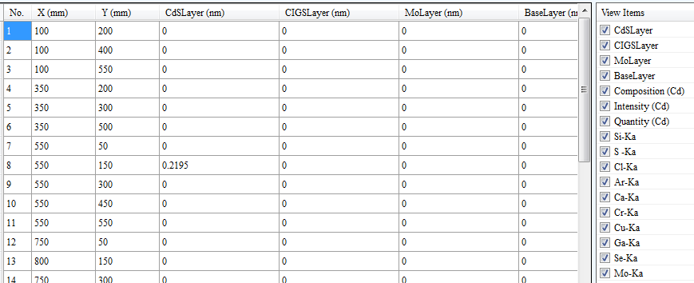
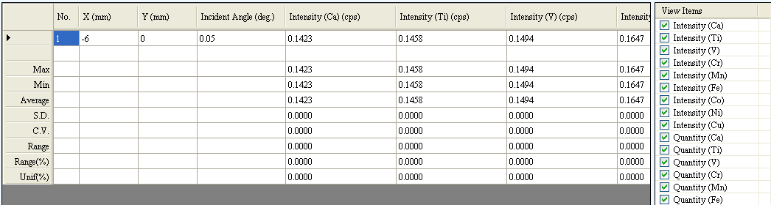
Coordinate points
Contamination element analysis
Select the element for analysis
Statistics of each coordinate: Max, Min, Average, …, Range, …

- The user can also view detailed data of each point
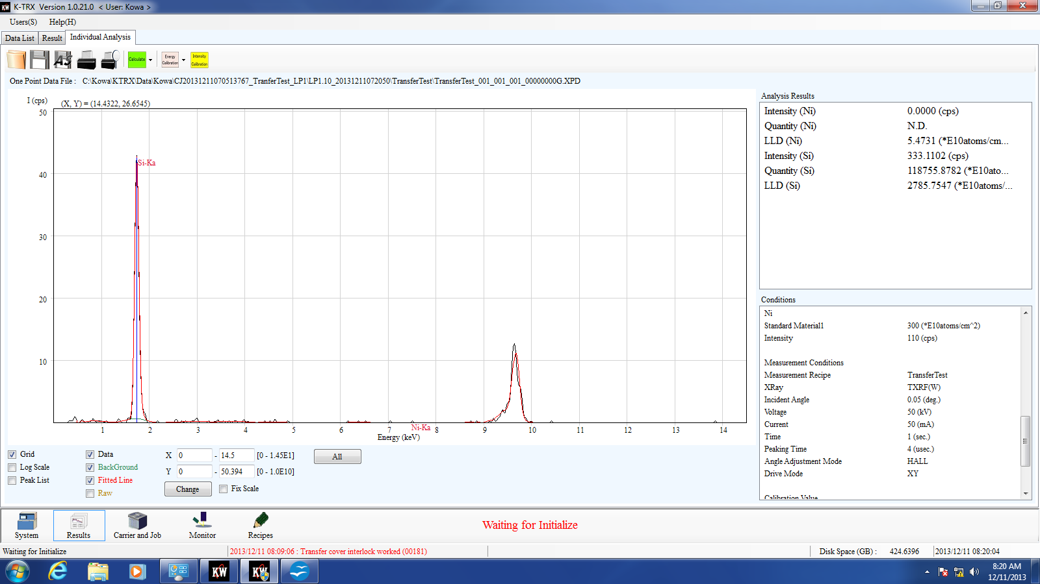
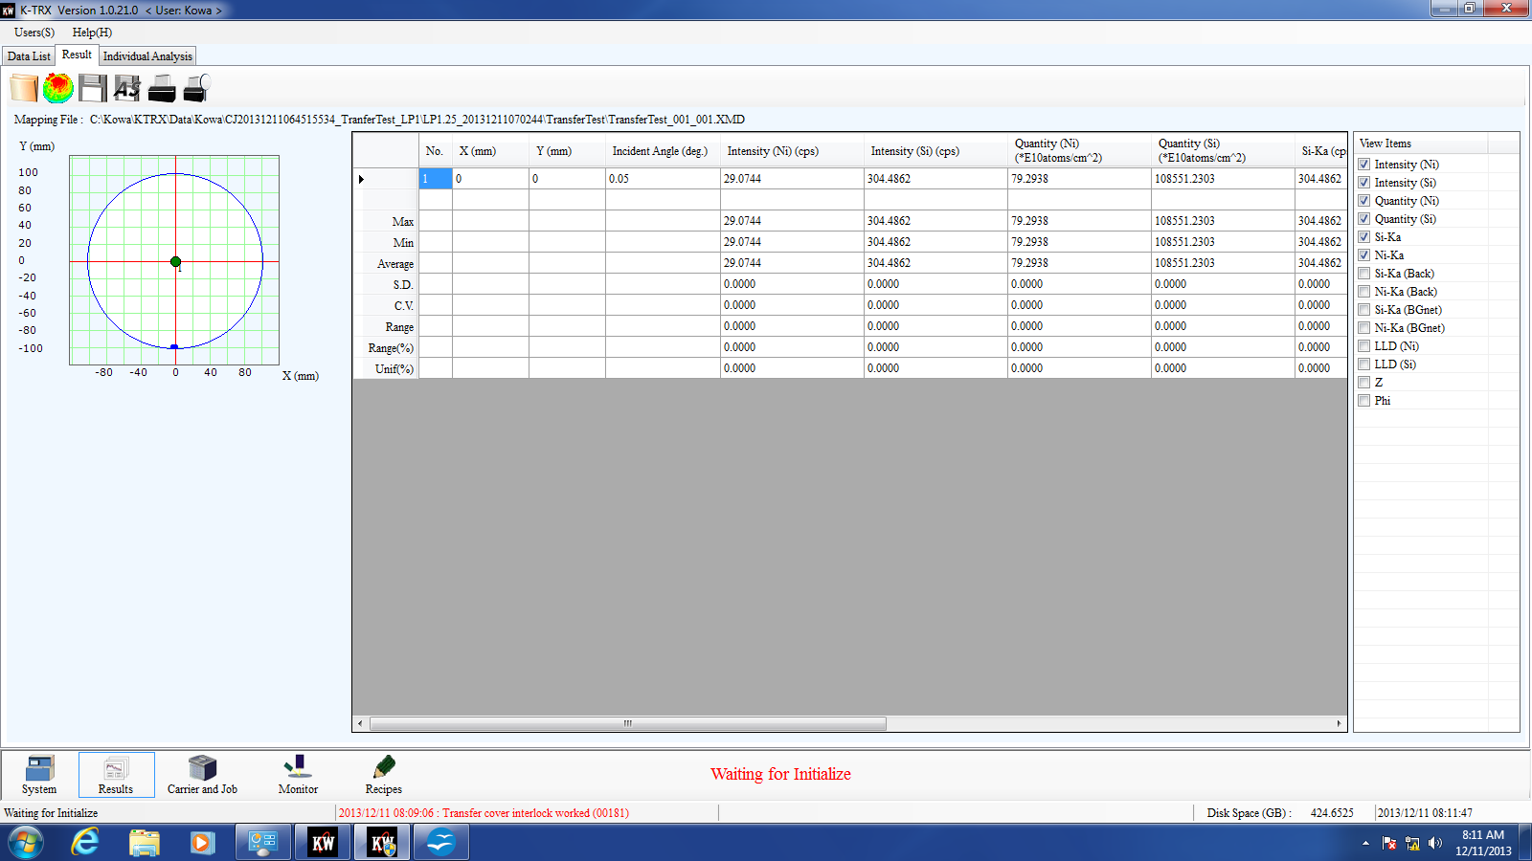
Double click the point

- Dynamic display of measurement status
  - Dynamic display of measurement status
    - Select Monitor in Home screen
- a Select the image below aa.) (Measurement) Dynamic measurement display
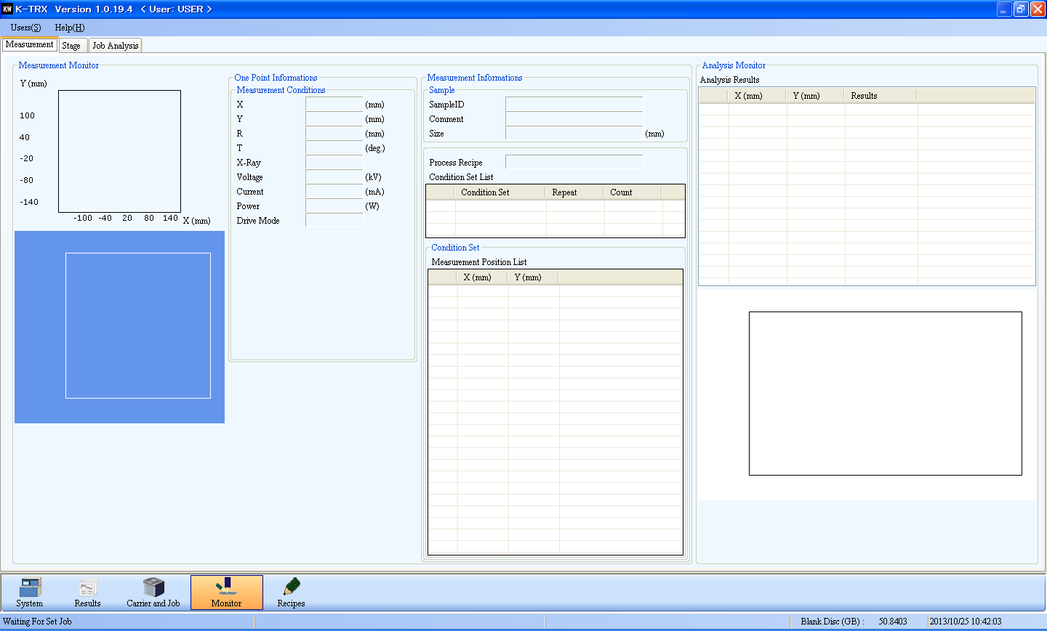
Target, KV, mA, measurement time, etc.
aa

Point under measurement
Coordinates of the point for measurement
Dynamic graph
Completed measurement
Corresponding graph
WAFER data
Recipe data
Progress of dynamic measurement 2
Progress of dynamic measurement 1

- Select the image below bb.) (Stage) Display dynamic wafer position
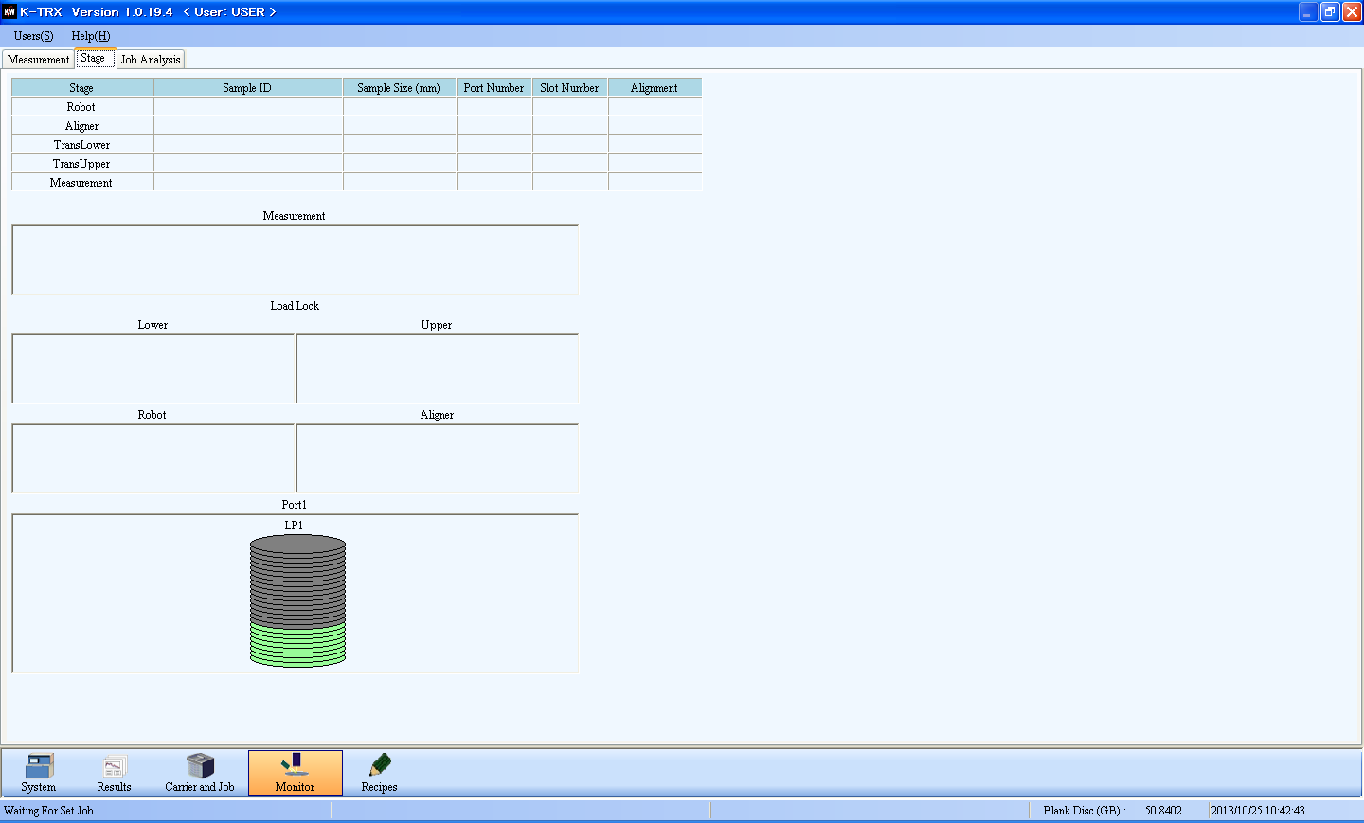
bb
Wafer data, transferred data
Data of dynamic wafer position

- Edit recipe
  - Recipe
Select Recipe in Home screen
Operator is only permitted to review Recipe. Only users in a role above Operator can edit Recipe
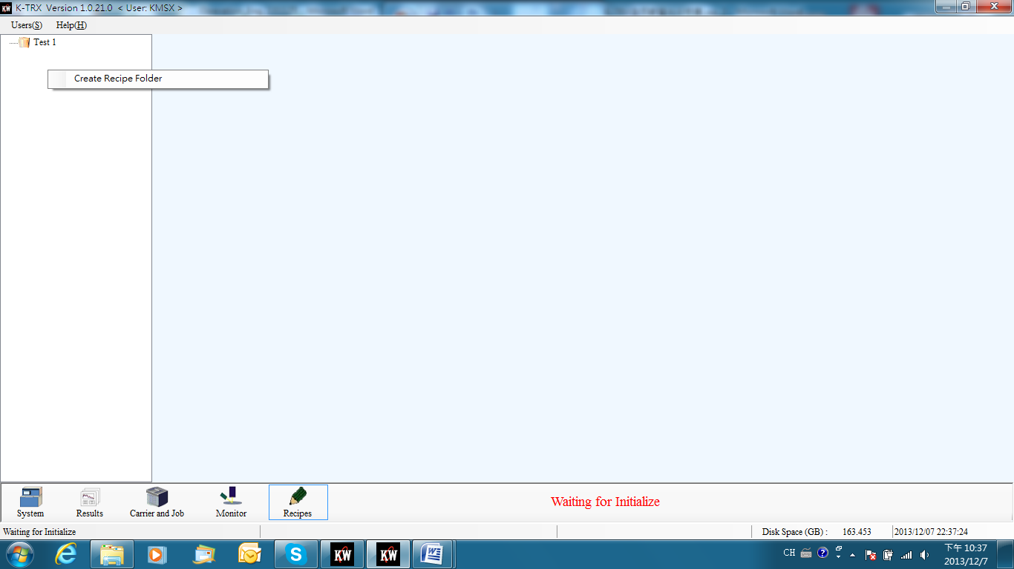

    - Recipe structure
Recipe tree is as below:
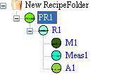
Process recipe
Condition Set
Position map
Analysis recipe
Measurement recipe

Each process recipe contains one or more condition sets and each condition set includes position map, measurement map and analysis recipe.
    - Edit Process recipe
- Recipe Folder
Right-click to create Recipe folder. The user can change Folder name after it is created

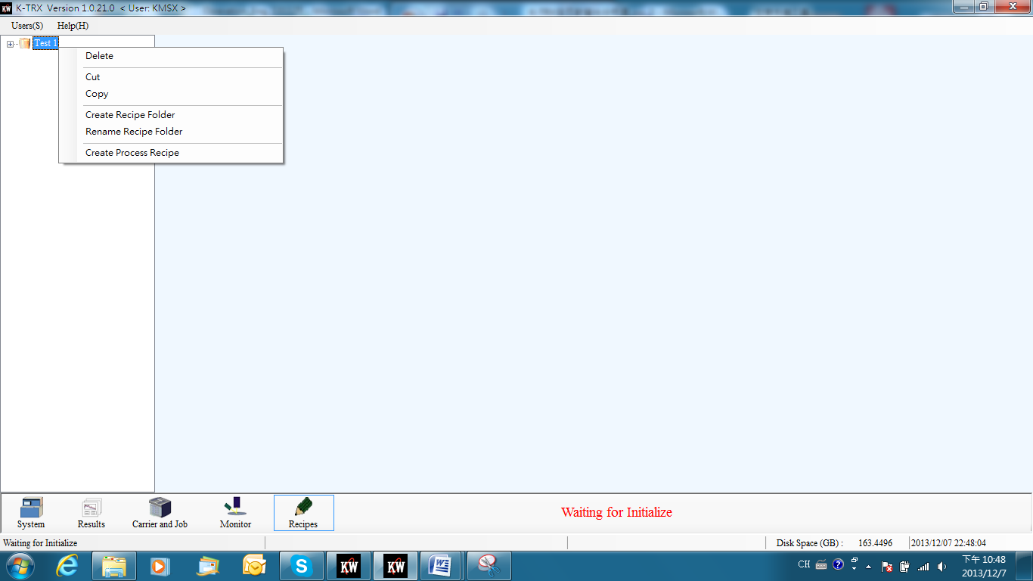
Right-click to create Process recipe under Recipe folder.
- Process Recipe – Position Map
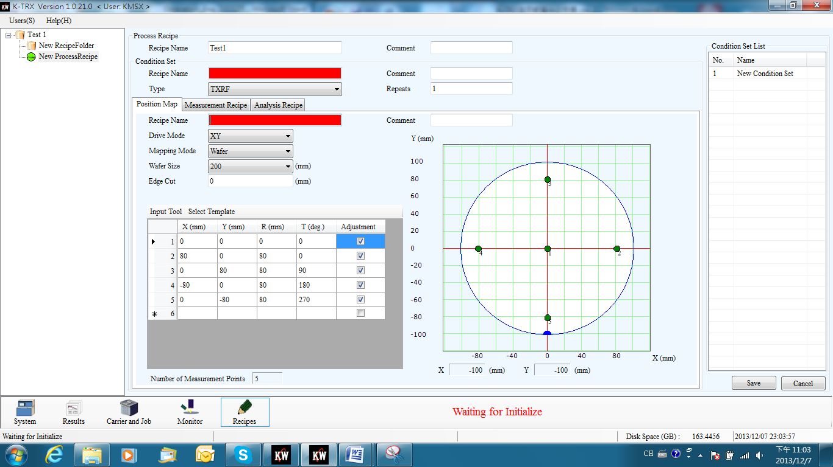
(e.g.) After creating Recipe folder (Test 1), right-click to create Process recipe under Recipe folder and then enter Process Recipe Name, Condition Set Name, Position Map, etc.
- Process Recipe – Measurement Recipe
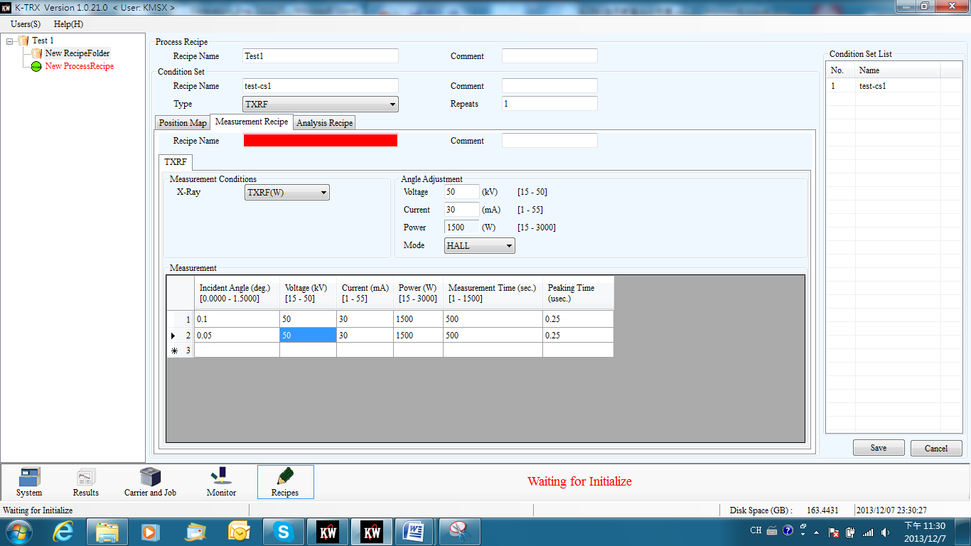
Enter Incident Angle, KV, mA, Measuring Time, Peaking Time, etc.
- Process Recipe –Analysis Recipe
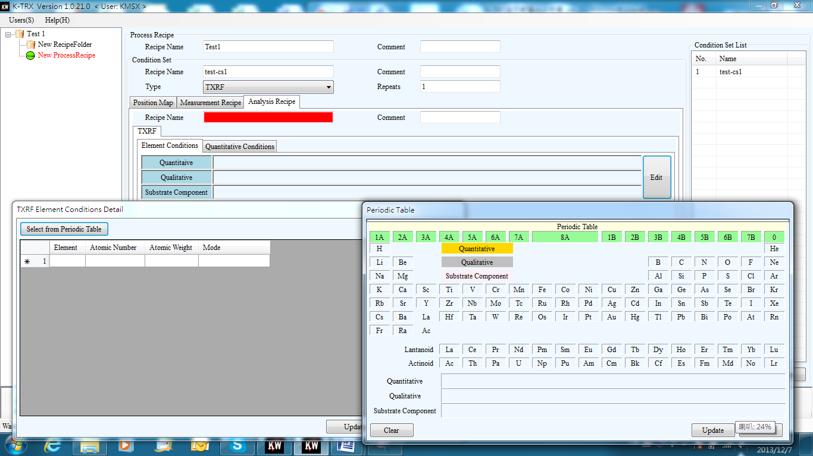
aa.) Enter Analysis Recipe name,
bb.) Click Edit to select the element for analysis
cc.) Click Select from Periodic Table
dd.) Select the element for analysis from Periodic table
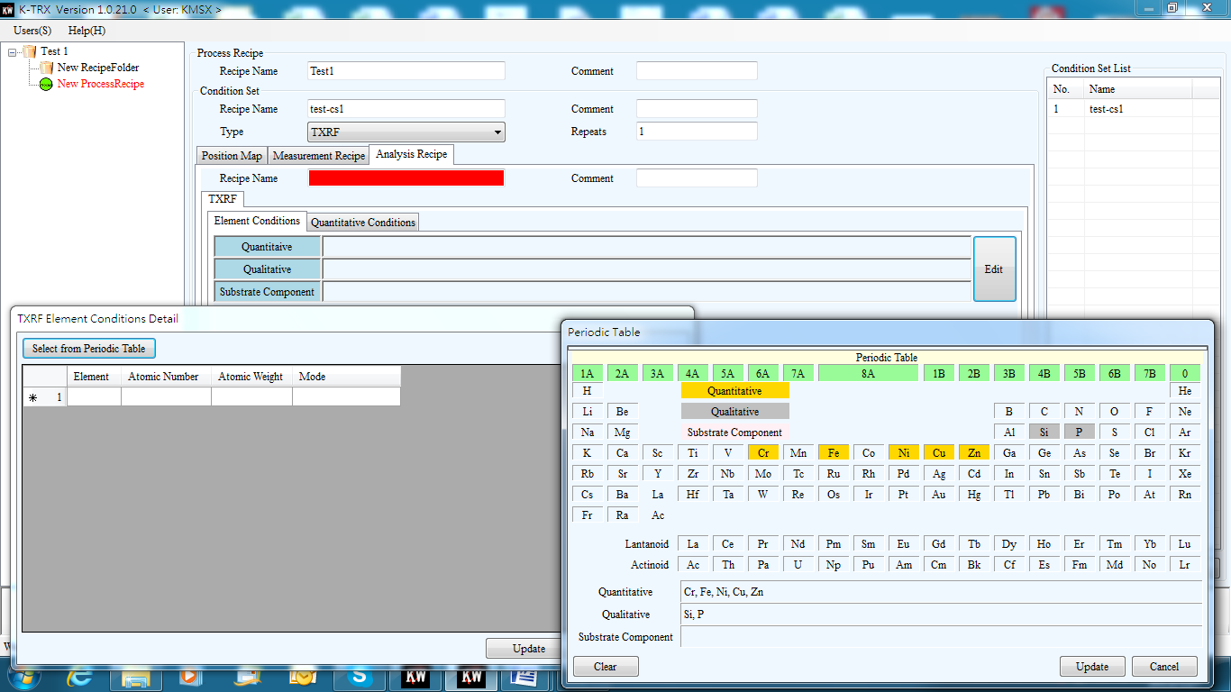
ff.) Press Update to complete selecting the element for analysis
ee.) Select the element for analysis. The gray background refers to qualify the element and the yellow background means qualify and quantify the elements.

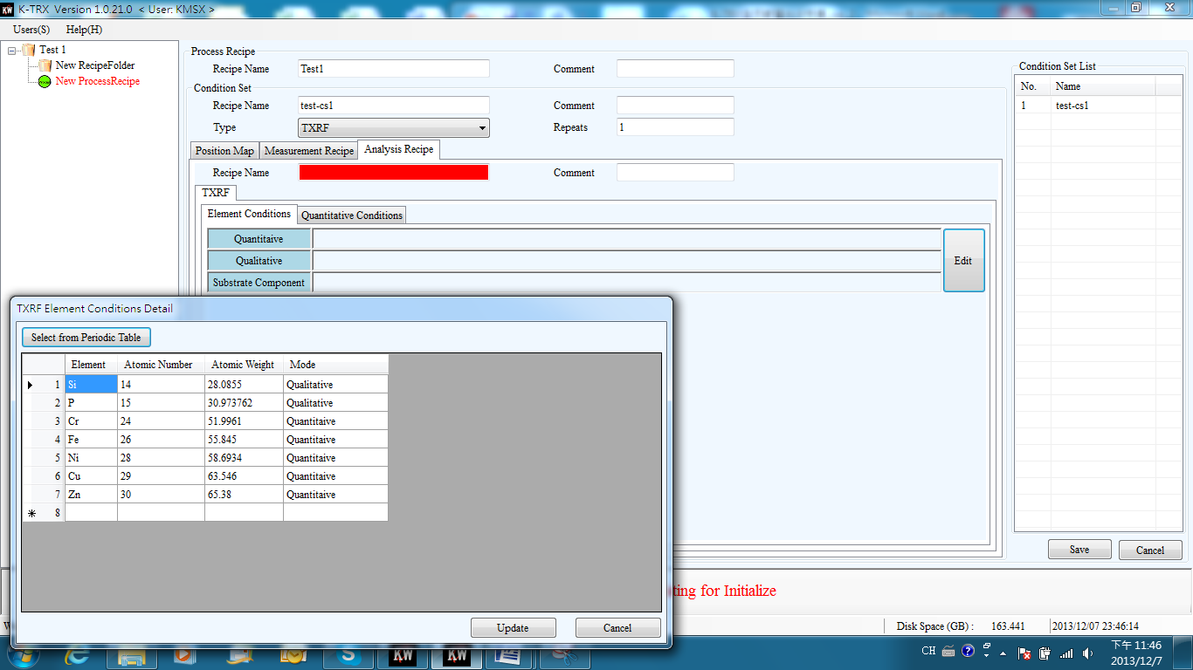
gg.) Press Update to complete selecting the element for analysis
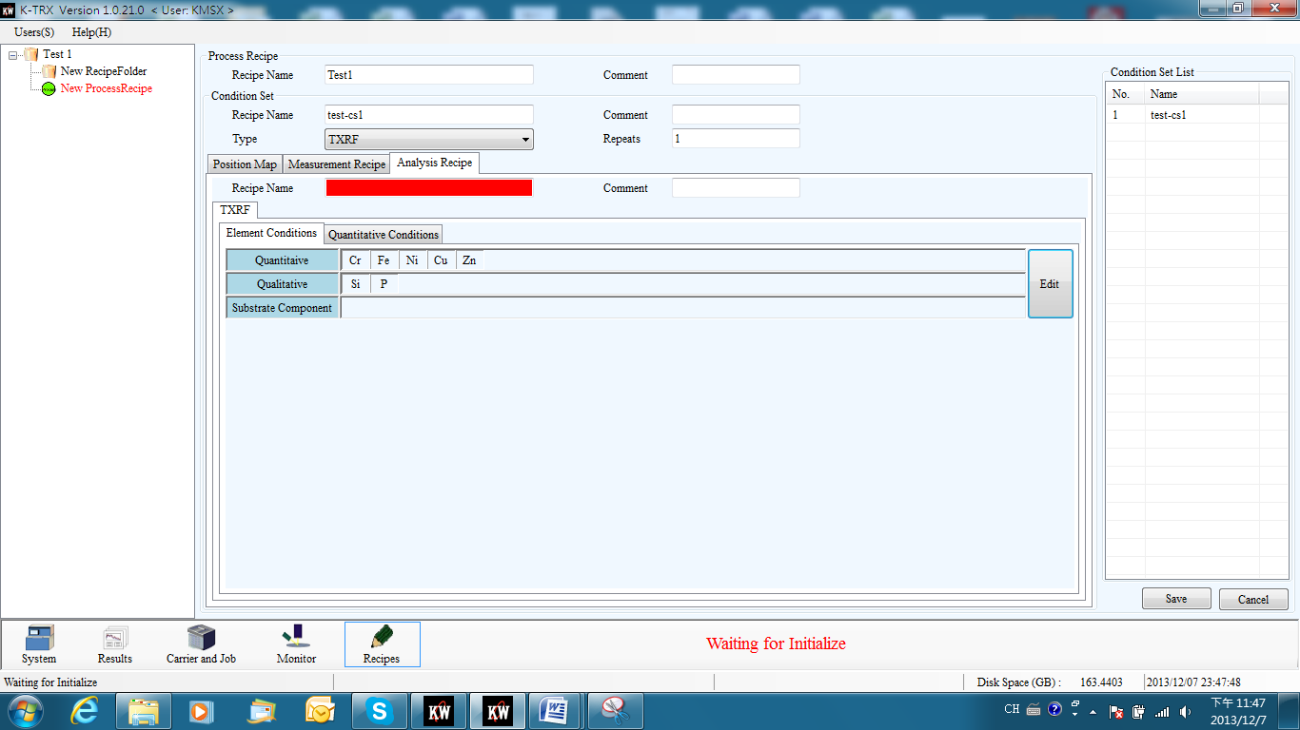
hh.) Press Save to complete editing Analysis Recipe element

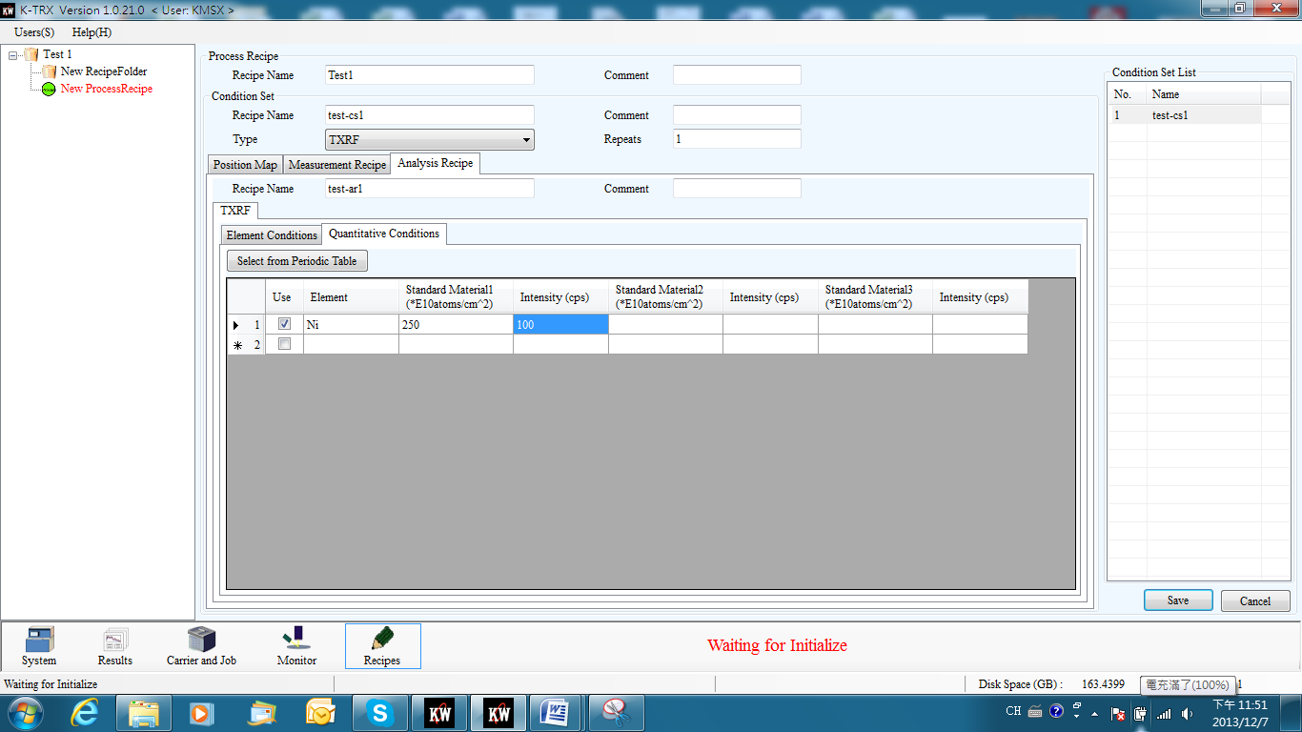
ii.) Press Quant. Cond. for quantitative reference element edit
jj.) Select quantitative reference element (Ni) and enter the intensity and reference concentration of this element
kk.) Press Save to complete editing Process Recipe
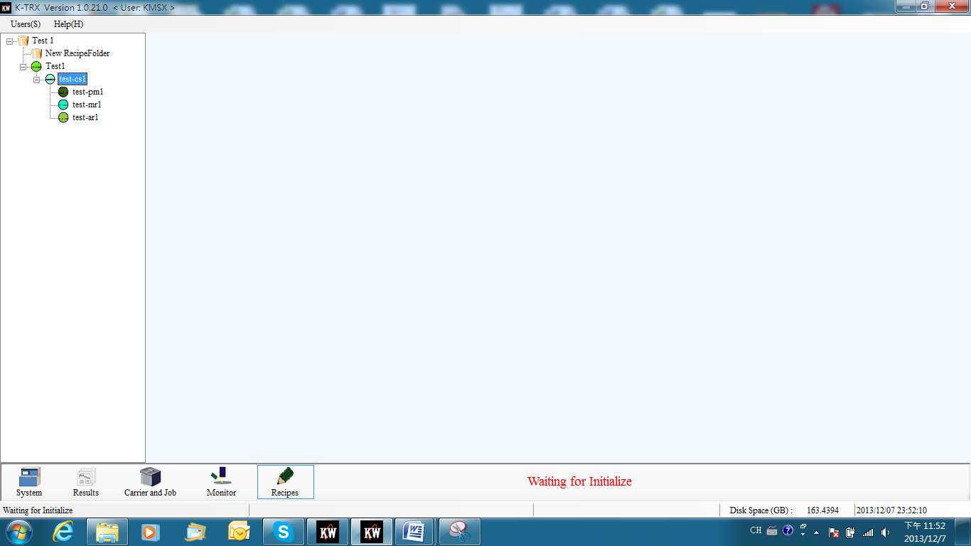
ll.) Data including position mapping recipe, measuring recipe and analysis recipe will be displayed on the left after the user completes editing Process Recipe.

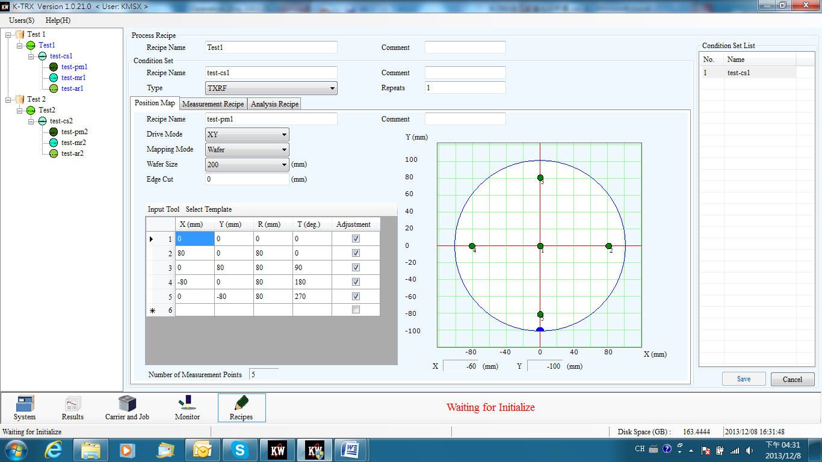

--- The END ---

