Ion Implantation System
S.O.P.

Step 1. [Sign-On Screen]
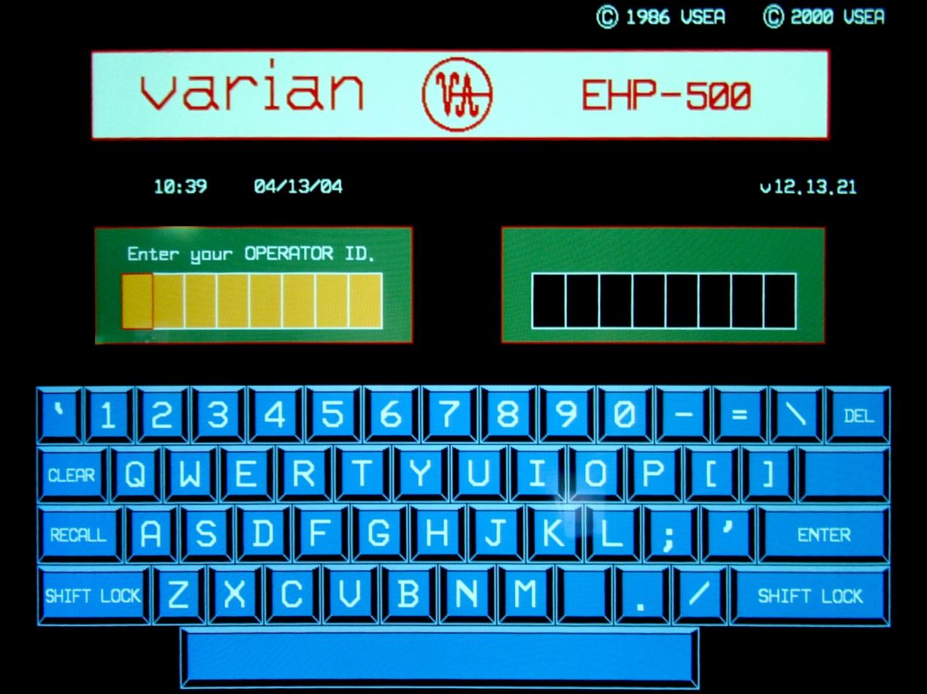
- The operator uses the displayed keyboard to enter ID & PASSWORD. (When ID or PWD has been keyed in, the [ENTER] key is used to enter the code.)
The operator uses the keyboard on screen to enter ID and password. (After entering ID or password, press [ENTER].)
Step 2. [Mode Menu]
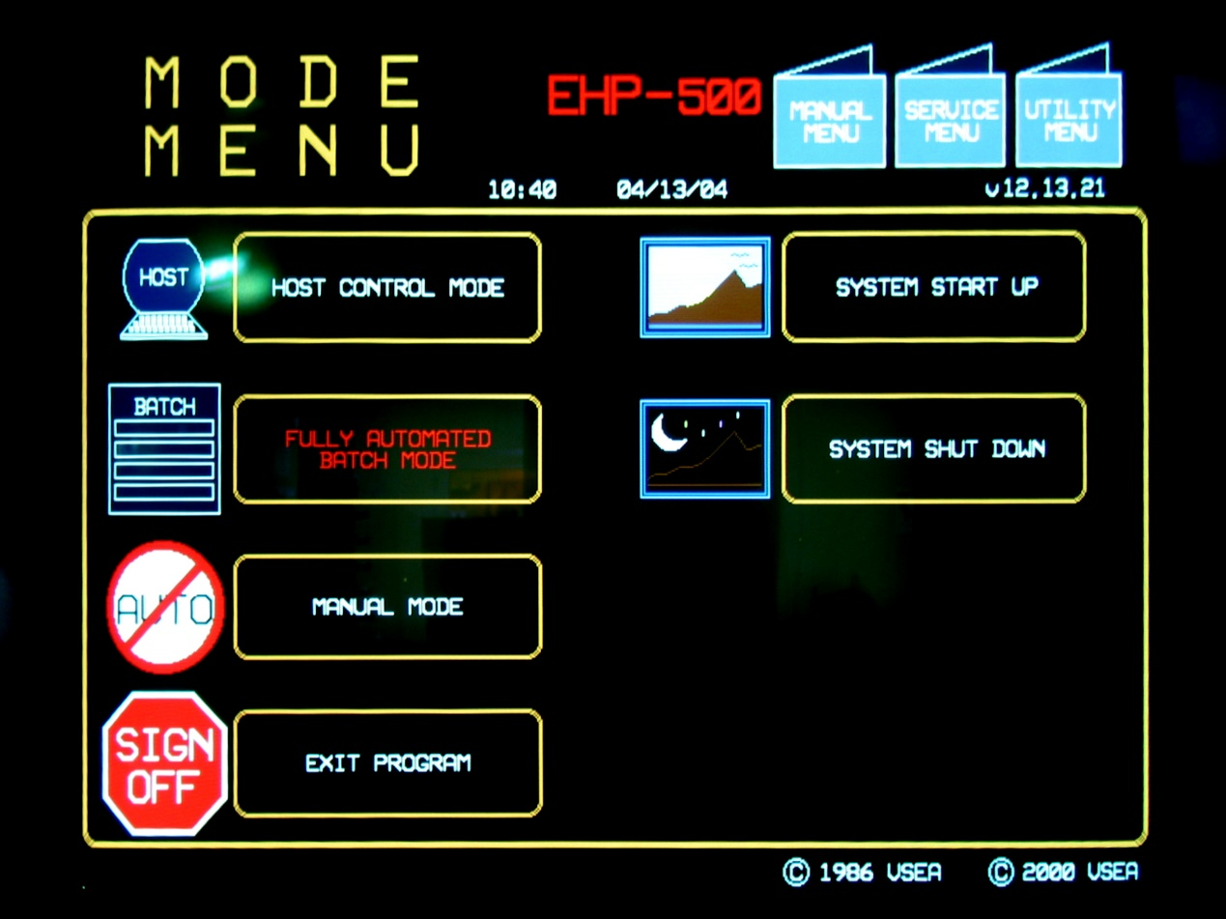
3.
1.
- Touch the [SYSTEM START UP] to automatically check the system status.
Press [SYSTEM START UP] for automatic system status check.

- Wait for the system auto-check. Once the routine is finished, the system will return to the same screen (Mode Menu Screen).
Wait for system auto-check. After the check is completed, the system will return to the same screen (Mode menu screen)

- Touch the [FULLY AUTOMATED BATCH MODE] button on the Mode Menu Screen.
Press [FULLY AUTOMATED BATCH MODE] button on Mode menu screen.
Step 3. [Batch Status]
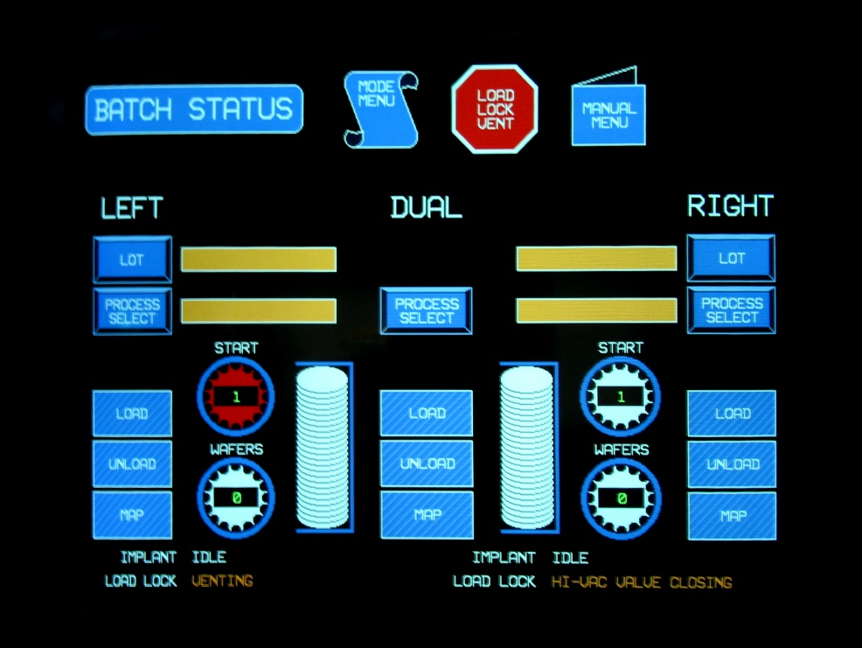
- System will vent the dual side load-lock chamber, open the door and tip the cassette holder out.
The system will vent the dual side load-lock chamber, open the door and tip the cassette holder out.
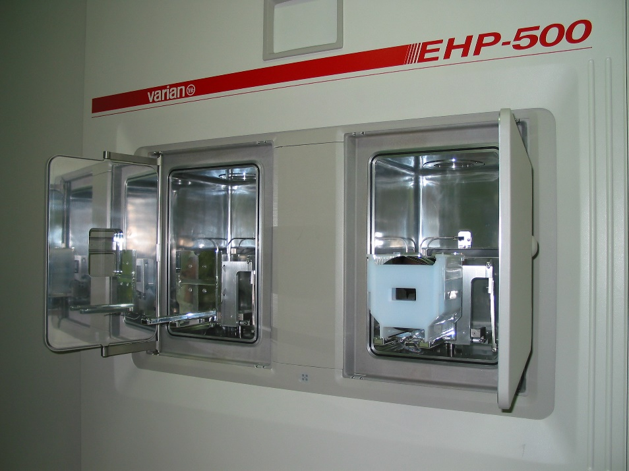
- Put the wafer cassette on. Touching the [LOAD] icon for either side will bring a newly loaded cassette into the load-lock chamber, close the door, begin pumping the chamber, and MAP the cassette.
Put on the cassette. Press any [LOAD] icon to move in the new wafer cassette, close the door, start pumping and MAP the cassette.
Step 4. [Batch Status]
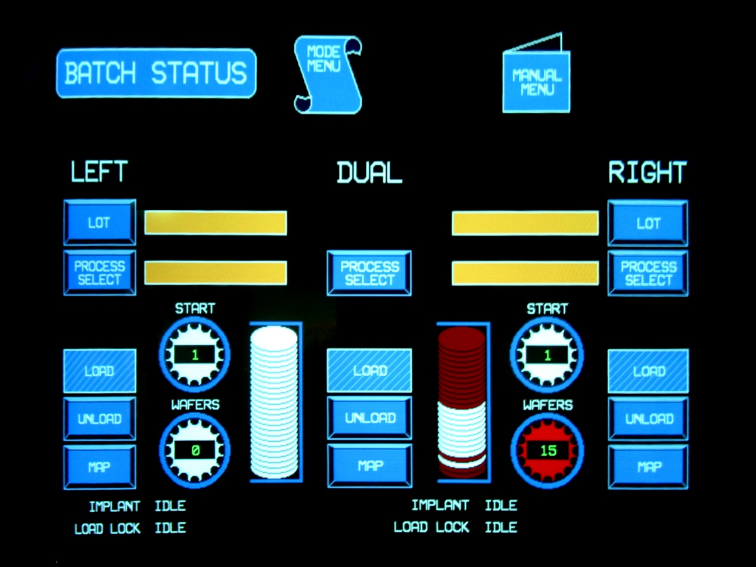
- Touch [PROCESS SELECT] to select recipe.
Press [PROCESS SELECT] to select recipe.

Step 5. [Recipe Index]
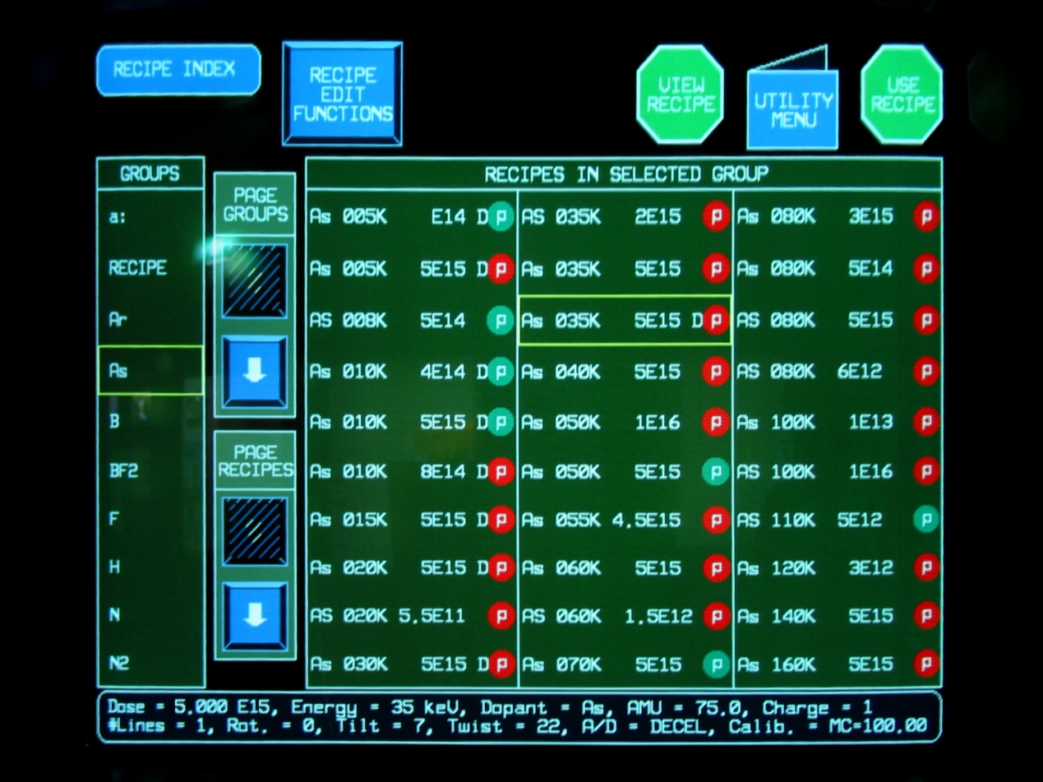
2.
3.
1.
- Select the recipe group.
Select the recipe group.
- Select the required recipe.
Select the required recipe.
- Touch the [USE RECIPE] icon to load the selected recipe.
Press [USE RECIPE] to load the select recipe.
Step 6.
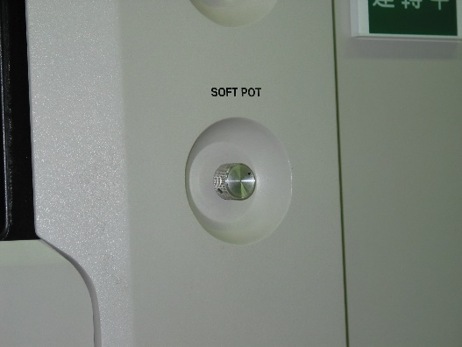
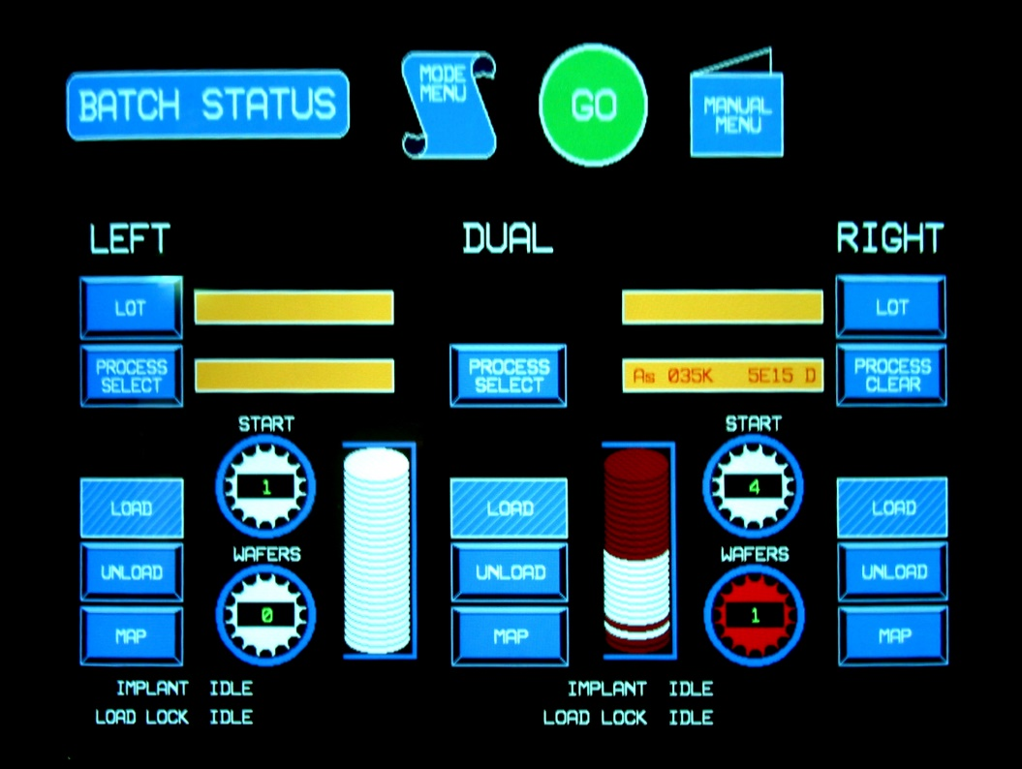
2.
1.

- Select the [START] and [WAFERS] icons and co-operate with SOFT POT to identify which wafers to implant.
Select [START] and [WAFERS] icons and set with SOFT POT to set the wafer for implantation.
- Final check! If selections are all right, touch the [GO] button. The system will start auto-tune, then implant.
Final check! Make sure all settings are correct. Press [GO]. The system will start auto-tune and implant.
Step 7.

- When the implant is finished, take the wafer cassette off, and then touch the [LOAD] icon.
After the implantation is completed, take out the cassette and press [LOAD] icon.
- Return to Mode Menu Screen, select [SYSTEM SHUT DOWN] (or [SIGN OFF]).
Return to Mode Menu screen and select [SYSTEM SHUT DOWN] (or [SIGN OFF]).

