Horizontal furnace
Technical information

- Principles of each horizontal furnace
  - LPCVD Poly Si
  - LPCVD Nitride
  - LPCVD TEOS Oxide
  - LPCVD Dope-AMM
  - APCVD Wet Oxide
  - APCVD Dry Oxide
  - APCVD N⁺ Anneal
  - APCVD P⁺Anneal
  - APCVD Drive In
  - APCVD H₂-SINTER
- Charge sources affecting the electrical property of thermal oxide layer
- Annealing

Principles of each horizontal furnace
Quartz tube is heated by thermal section III. Make sure the transfer speed is stable when sending wafers in and out of the furnace to avoid broken wafers due to the thermal stress resulting from significant temperature change.
Main factors affecting the thin film deposition rate include temperature, pressure and gas flow.
Thin film deposition process: Nucleation→Grain growth→Coalescence→Filling of channels→Film growth.

[LPCVD Poly Si] Pressure 350mTorr
Poly-Si，temperature 620°C, film thickness 200~10,000Å; α-Si, temperature 560°C, film thickness 200~10,000Å
Polysilicon is a high-purity silicon consisting of single crystals of silicon grains with various crystal orientations. It’s a high-purity silicon between single silicon and amorphous silicon.
In polysilicon, single crystal grains are separated by the 2D defects-grain boundary. Various line defects and point defects in the boundary make impurities diffuse faster through the boundary than inside the grain. Based on this, we select poly-Si and change its electronic performance by doping to acquire the “silicon” necessary for the process.
Polysilicon deposited by LPCVD contains high resistivity and can be used on resistors in IC design. The resistivity of heavily-doped polysilicon can be lowered to 500~1200μΩ-cm and make it an ideal conductive material for IC components, such as the gate metal layer. Trench structure can also be filled with LPCVD polysilicon as a capacitor in DRAM or for isolation between different components. Amorphous silicon is mainly used in TFT channels.

【LPCVD Nitride】
Temperature 780°C, pressure 350mTorr and film thickness 30~10,000Å
- A dielectric material which is applied to the etching mask of oxide layer.
- Difficult to be penetrated by oxygen and can be used as the field oxide. Serves as the masking layer to prevent oxidation on a wafer’s active area. Also known as the famous LOCOS process (local oxidation of silicon).
- Excellent in blocking alkali metal ions, difficult to be penetrated by moisture and can be used as passivation.
Because the deposition temperature of LPCVD Nitride is too high, Nitride is deposited by PECVD for passivation layer application. The deposition equation of PEVCD Nitride is as below:

【LPCVD Nitride】
Temperature 780°C, pressure 350mTorr and film thickness 30~10,000Å
The property of LPCVD Nitride film is a tensile stress above 10¹⁰dyne/cm². It is recommended to deposit a film within a certain range to avoid cracks.
Nitride deposited by PEVCD is free of this concern and we can control ion bombardment on deposited films by tuning RF power to lower the tensile stress of SiN_{x} films.

Characteristics | LPCVD | PECVD
Deposition temperature (°C) | 650-800 | 250-400
Operating pressure (mTorr) | 100-1000 | 1000-5000
Main ingredients | Si₃N₄ | SiN_{x}:H
Density (g/cm³) | 2.8-3.1 | 2.3-3.2
Refractive index | 2.0 | 1.9-2.1
Dielectric constant | 6-7 | 6-9
Stress (dyne/cm²) | >10¹⁰ (tensile) | +2x10⁹-5x10⁹

[LPCVD TEOS Oxide]
Temperature 700°C, pressure 350mTorr and film thickness 30~10,000Å
TEOS (Tetra-Ethyl-Ortho-Silicate) is liquid under room temperature and normal pressure. When used, it is necessary to be heated correctly to increase its saturated vapor pressure (around 40°C~70°C, NDL 60°C).
LPCVD TEOS Oxide offers excellent step coverage and has been massively adopted by the semiconductor industry, such as spacer deposition (2500Å). And interpoly dielectrics (IPD), including the barrier layer under BPSG, intermetal dielectrics (IMD) and passivation (5500Å).

[LPCVD TEOS Oxide]
Temperature 700°C, pressure 350mTorr and film thickness 30~10,000Å
SiO₂ is widely used in VLSI, from the first mask of MOS fabrication.
But in the first stages of CMOS component fabrication, most oxide dielectric layers are produced by thermal oxidation.
After metal deposition, oxide will be deposited by PECVD with a rated temperature under 400°C.

Characteristics | LPCVD | PECVD
Deposition temperature (°C) | 650~750 | 300~400
Operating pressure (mTorr) | 100~1000 | 1000~5000
Ingredients | SiO₂ | SiO₂:H
Density (g/cm³) | 2.2 | 2.3
Refractive index | 1.43~1.46 | 1.47~1.5
Dielectric constant | 4.0 | 4.1~4.9
BOE (100:1) rate (Å/min) | 30 | 400
Stress (dyne/cm²) | 1~3x10⁹ | -(1~5x10⁹)

[LPCVD Dope-AMM]
Temperature 560°C, pressure 350mTorr and film thickness 200~10,000Å
Dope-AMM adds a doped gas source to the reaction gas while growing polysilicon to grow n-type or p-type polysilicon directly.
This method is quite direct, but film thickness control, dopant uniformity and deposition rate vary by the dopant amount. Generally, doping B₂H₆ to grow p-type polysilicon can lead to an increased deposition rate and a reduction in the rate of PH₃ and AsH₃ for growing n-type.
This will also lead to the change of grain size and orientation. Another thing to keep in mind is that during/before annealing, it is necessary to cover an oxide layer on the surface to prevent the dopant from diffusing outward. High-temperature annealing can be ignored if the resistance is low enough.

[APCVD Wet Oxide]
Temperature 980°C and film thickness 300~10,000Å
The ratio between injected oxygen and hydrogen is 1.3~1.5, must be < 2. A higher furnace temperature can prevent a hydrogen explosion resulting from the accumulation of unreacted hydrogen. In hydrogen ignition, the gas is injected into a high-temperature torch (in quartz). The temperature of the torch should be above 650°C and maintained between 350°C~850°C after ignition.
When a very thick oxide layer is necessary and the requirement of electronic performance is not high, dry oxidation can save the required process time due to a faster oxidation rate. Main applications include field oxide (5500Å) of LOCOS and sacrificial oxide.
After a silicon oxidation, N₂O or NH₃ gas is used for “Nitridation” of SiO₂ to decrease the quantity of incomplete bonds on SiO₂ layer to improve the electronic performance of SiO₂ layer. Adding a small amount of fluorine in SiO₂ can also improve some characteristics of SiO₂ layers grown by conventional thermal oxidation.

[APCVD Dry Oxide]
Temperature 800°C or 900°C and film thickness 30~800Å
SiO₂ grown by dry oxidation has better electronic performance of oxide layer. If the required electronic performance of SiO₂ layer is not high or a thick layer is not necessary, dry oxidation can be applied to grow SiO₂. Such as gate oxide and pad oxide (300Å).
The impurity or charge can change Vt of MOSFET switch, lower its breakdown voltage and reduce “time-dependent dielectric breakdown (TDDB)” related to reliability (i.e. shortened service life). Therefore, when growing a gate oxide, it is necessary to avoid unnecessary change of electronic performance.

[APCVD N⁺ Anneal]
Temperature 400°C~1100°C
[APCVD P⁺Anneal]
Temperature 600°C~950°C
After placing the annealed material under high temperature for a while, use the heat to empower atoms to rearrange lattice to lower defect density in the material. Main defects include grain boundary, dislocation, various point defects, etc.
Semiconductor materials are one of the applications of electronic components. As long as the stress applied to the material or film does not lead to wafer warpage or film peeling, the strength can be ignored. However, the material defect or structure can affect its electronic performance. The main purpose of annealing in the semiconductor process is to restore or improve the electronic performance of material. Main annealing processes include post-ion implantation annealing, metal silicide annealing, etc.
N⁺ annealing refers to dope Group V elements (As, P); P⁺ annealing means to dope Group III elements (B).

[APCVD Drive In]
Drive-In: 1100°C
Drive-in: A 1700Å oxide is formed on the surface and ions are driven in to a depth of 2μm~3μm to form N well or P well after 4~6 hours under 1100°C

[APCVD H₂-SINTER]
Temperature 300°C~700°C
After coating aluminum, the poor contact between aluminum and silicon will increase the resistance of metal wiring.
Inject 5% H₂/N₂ (or the isotope of hydrogen D₂) at 400°C for 30 minutes to fill unsaturated bonds，and result in better contact between aluminum and silicon.

Charge sources affecting the electrical property of thermal oxide layer
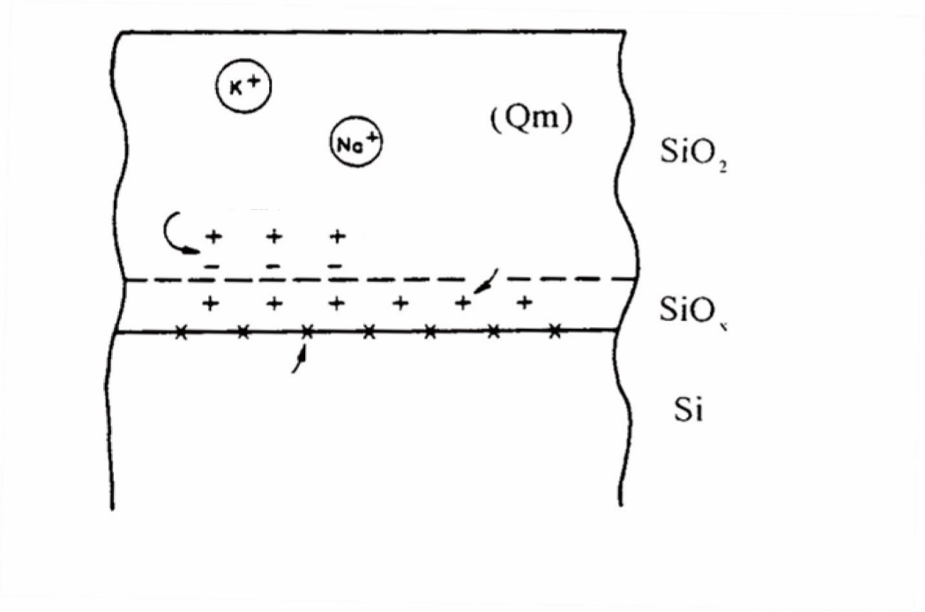
Mobile ion charge
Oxide trapped charge
Fixed oxide charge
Interface state
The relative positions of 4 main charges in the oxide layer
- Interface state
(Interface state)

- Fixed oxide charge
(Fixed Oxide Charge)

- Oxide trapped charge
(Oxide Trapped Charge)

- Mobile ion charge
(Mobile Ion Charge)

Charge sources affecting the electrical property of thermal oxide layer

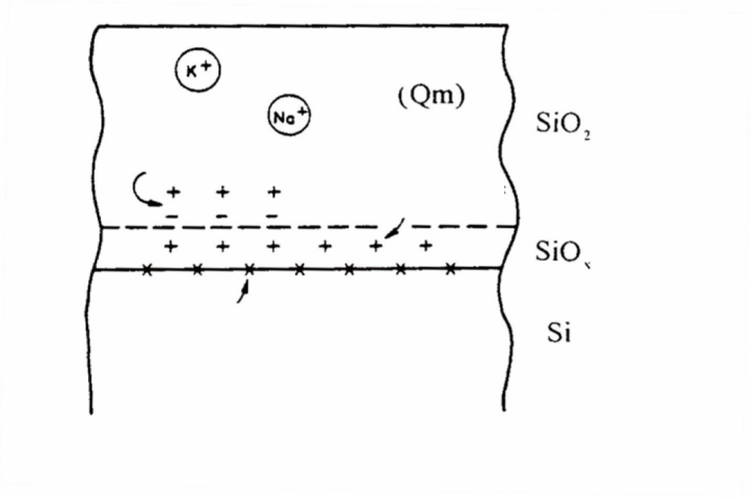
Mobile ion charge
Oxide trapped charge
Fixed oxide charge
Interface state
The relative positions of 4 main charges in the oxide layer
- Interface state
Cause: The charge generated by the discontinuity between Si and SiO₂ interfaces and unsaturated bonds.
Solution: Apply suitable annealing or use a silicon wafer substrate with low resistance <100> to decrease the charge density.
- Fixed oxide charge
Cause: Not far away from Si-SiO₂ interface and in the transition region of Si and SiO₂. The main cause is process control.
Solution: Adjust the oxidation process or apply annealing to mitigate the impact.

- Oxide trapped charge
Cause: No specific distribution. It is mainly generated when electron or electron hole is captured by impurities or unsaturated bonds in the oxide layer during MOS operation.
Solution: Apply suitable annealing to reduce unsaturated bonds and defect density.
- Mobile ion charge
Cause: Main sources of these metal impurities include quartz in the furnace, process gas, impurities in photoresists, etc.
Solution: Alkali-metal impurities like sodium and potassium can be captured by adding HCl to the reaction gas in silicon oxide process; alkali metal ions in SiO₂ can be neutralized by Cl. However, HCl is strongly corrosive and it is recommended to use chlorine-containing compounds that are less corrosive and toxic, like TCA (trichloroethane), to replace HCl. As TCA is a known carcinogen, it is replaced by Trans-LC now.
Trans-LC: Dichloroethene
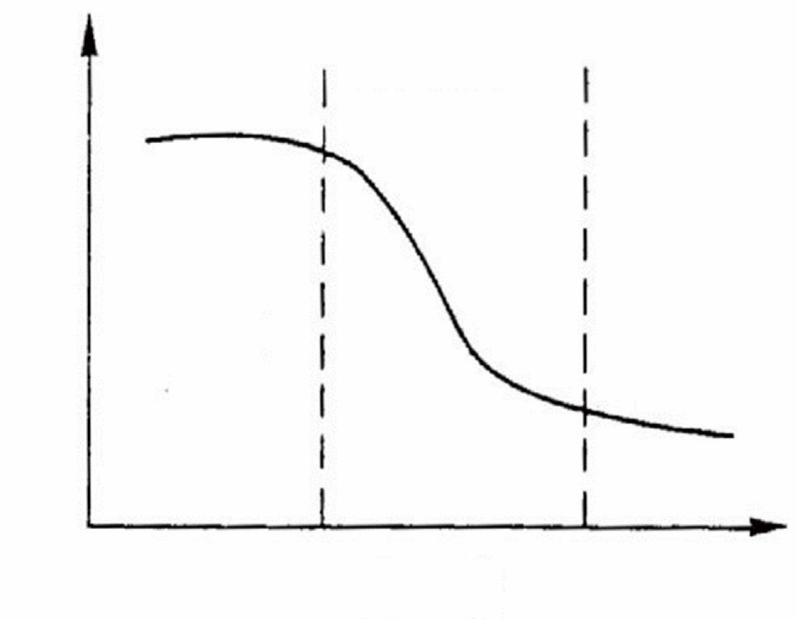
Recrystallization zone
Hardness
Temperature
Recovery zone
Grain
Growth zone

Annealing is a widely used material processing technology in smelting. This technology uses heat to eliminate the internal stress generated in the object. The applied energy will increase the vibration and diffusion of lattice atom and defects in the object and rearrange atoms. The object will recrystallize as defects are eliminated, even becoming a single crystal. The process can be divided into three stages based on the temperature: (1) Recovery, (2) Recrystallization and (3) Grain Growth.

- Recovery:
When the annealing temperature is low, the energy provided by heat is only sufficient to rearrange defects (like dislocations) to a more stable status, but cannot change the grain structure. So it can only slightly relieve the internal stress and does not significantly affect mechanical properties of the object.
- Recrystallization:
Increase the annealing temperature to rearrange atoms to mitigate defects in the object and form dislocation-free grains. After recrystallization, the internal stress will be significantly relieved as the density of dislocation and defect lowers.
(*Material hardness is an indicator of internal stress. )
- Grain Growth:
If the temperature further rises and offers sufficient energy to grains formed through recrystallization to solve the in-between surface energy, grains will start to grow by using small grains.
As defects like grain boundary disappear (grain boundary of small grains will disappear and combine as the grain grows), the internal stress will be further relieved. The time the whole annealing process takes depends on the temperature. The higher the temperature is, the less annealing time is required.
The purpose of annealing process is to eliminate defects caused by internal stress or implants to rearrange the structure of object. In VLSI semiconductor processes, annealing is mainly applied to steps requiring material structure rearrangement, such as silicide annealing and annealing repair of post-ion implantation.

