Technical information of Vertical furnace
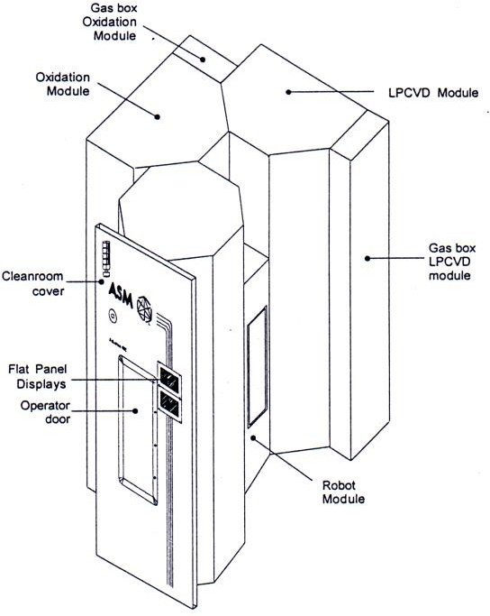

- Overview
  - A-400
A-400, a modular furnace, is designed to process silicon wafers, such as parts of semiconductor component manufacturing.
A-400 consists of the following parts:
- Work-In-Progress (WIP) station
- Robot section
- Reactor module (two or three)
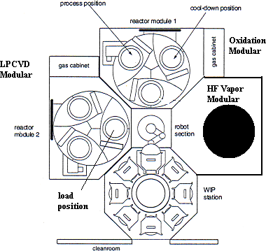

WIP Station
The WIP station consists of set a carousel set: there are 3 layers on the Carousel and each can carry 8 boats (each boat can carry up to 25 wafers).
The WIP station can carry up to 24 boats (up to 600 wafers).
For operation in the Carousel, please access from the operation door installed on the side of the WIP.

Robot Section
The Robot isolates the WIP and Reactor module by an airtight door [only opens when loading/unloading].
The Robot transfer the wafer from WIP to Reactor boat load position.

Reactor Module
The Reactor module is a small device consisting of a reactor tube, boat elevator, 3 boat position carousels and all electronic and air supply system components supporting this module.
Reactor carousel accessories provide the position of up to 3 quartz boats. When the Carousel turns, the boat will be moved to one of the 3 positions.
- Load position: Compared to Robot position, this position is for loading wafers.
- Process position: When a Boat moves underneath the Reactor tube, it will be lifted by the Boat elevator to enter the process tube.
- Cooldown position: When the process ends, the Boat elevator lowers the Boat and turns to this position to cool down wafers in the Boat (around 15 minutes) to prevent broken wafers caused by overheating when transferring.
The gas system is designed with a special structure to be integrated into the module cabinet or included in the gas cabinet and installed on the side of the Reactor module. The pumping system, provided by ASM, supports low pressure processes.

Process
A-400 is capable of the following processes:
Atmospheric Processes | Low Pressure Processes
- Dry/Wet Oxide | - Poly Silicon

Key features
    - Modular design
A-400 supports up to 3 Reactor modules and is integrated to a single WIP station and Robot section. This design features:
- “Cassette-to-cassette” process in a clean and oxygenated environment with very few dust particles.
- The process executes independent wafer operation.
- All wafers are transferred by the central robot.
- Smallest footprint in a cleanroom.
- Additional modules can be added to a single Reactor system when necessary.
- When Robot and WIP are unchanged, the module can be changed to support different processes.
- Common components and standard module configuration achieve simple maintenance and system affinity.
- Spare components of each module can be used interchangeably.
    - Process cluster
- 2 modules can run the same process to increase productivity.
- Each module can run different processes.
- Each module can complete 2 different processes in an orderly fashion.
    - Controls of surroundings
In A-400, any module and area can independently purge to repetitively cycle filtered air. N2 purge is introduced to the system to decrease oxygen content.
Installed between the Robot and module, the airtight door will only open during loading/unloading and when the oxygen content in the system falls in the specified range.
Make sure any module is under a controllable environment as well as preventing cross contamination between each module.
    - Central robot operation
The robot section comprises a Genmark Gencobot IV robot to stably transfer wafers between the WIP station and Reactor section.
The robot section comes with an optical self-calibration mechanism to eliminate the possibility of generating dust particles when transferring wafers. This mechanism also realizes the least regular maintenance time.
    - Automation
Wafer operation and process order are controlled by the Robot and Logistics controllers.
Also, most operation and maintenance tasks can be automatically operated by a single button.
A-400 provides an automated standard mode. When the system is idle, the empty Boat will be loaded to the process Tube. The tube door closes and Standby recipe is activated.

Selectivity
    - Wafer operation/Transfer selectivity
Standard Mechanical Interface (SMIF) device
The SMIF device is connected to the SMIF pod and WIP carousel installed on the side of the cleanroom to transfer wafers and boats.
Tube to Tube
Allow the user to transfer wafers from one Reactor module to other modules to process wafers in an orderly fashion.
    - Gas/Pumping system selectivity
N2 purge
N2 purge inlets repeatedly cycle air among the WIP, Robot and Reactor modules.
The high flow of N2 rapidly decreases oxygen content to reduce the oxidation on the wafer surface.
O2 analyzers are installed in each module to monitor oxygen content in real-time.
Pressure control - N2 inlet or throttle valve
Pressure regulation is achieved either by the N2 inlet between the Blower and pump or by using the throttle valve and pressure controller.
Gas cabinet
The gas system in A-400 is installed in the Reactor module.
    - Control interface options
A-400 comes with the following interfaces:
Flat Panel Display (FPD)
The FPD is a small touch screen allowing users to operate A-400.
Generally, the FPD is installed on the hanging door.
Separate FPDs are installed in other positions for quick accessibility.
Micro System Controller (MSC II)
The MSC II is a computer controller providing all FPD functions
The MSC II also provides data to log into the hard disc.
The MSC II allows the user to review historical trends and report system events.
MSC II Control Stations
The MSC II Control Station is a computer controller replacing the FPD and serves as A-400 controller.
The control station is connected to the MSC II supervisor through the LAN.
Remote Host Control (RHC)
The combination of RHC packaging and MSC II allow the user to control remotely and record as necessary.
Support SECS I and I communication standardization.
Production Control System (PCS)
The PCS is a batch-oriented function interface between the operator and A-400 controller.
The PCS provide a user-friendly interface to minimize operator time to perform a task, such as downloading a recipe and table.

Safety
A-400 is built with high standards to ensure personal and equipment safety.
Personal safety
Personal safety features include:
- Easy accessibility of Emergency off (EMO) button.
Press the EMO button to completely shut down the system.
- The motion-stop button stops the movement of all Carousels (WIP station and Reactor module), and the Robot and Boat elevator.
- The design of the gas system ensures no reaction gas flows when the power is off.
- When the operator needs to access the system to move any component, Interlock can prevent errors.
- When an obstacle is detected, the operation door and isolation door will stop immediately and open again.
- When the operation door is open, the WIP carousel will not rotate.
- The interlock panel consists of a set comprising a switch, the electronic power of the Interlock, external control and reaction gas.
Product and equipment safety

Production and equipment safety features include:
- Reactor overheat protection; when the temperature of a heating component or cooling water system exceeds the preset value, power to the heating component will be turned off.
- Extended Interlock of external flare system includes flare detection and H₂/O₂ ratio interlock.
- A pressure interlock (generally set as 2 torr) protects the reaction gas flow in the LPCVD system.
- Compressed air and N2 flow interlock process gases.
- Process interlock at Recipe stage:
- Alarms
- Aborts
- Visible and audible alarms:
- Direction indicator lights on the WIP cabinet allow the operator to simply and quickly check system status.
- A recipe-activated alarm can be programmed to 2 audible sounds.

Easy maintenance

It is possible to access computer operation or the maintenance area for A-400 maintenance.

Features include:
- All doors on top of each module allow the operator to access all equipment.
- The maintenance door provides easy accessibility to the boat/plug quartzware check and placement.
- The glass door allows fast visual inspection.
- The hoisting mechanism includes lifting reactor combination.
- On the cooling water circuit, there is flexible tubing connecting the reactor flanges and water-cooled reactor. A quick connector is available on the jacket.
- The robot requires less maintenance.
- Introduction of Reactor module
  - Dry/Wet Oxidation

Dry Oxidation
      - Gases used:
N2: 1-20slm
O2; 1.5-15slm
N2O: 1-10slm
Trans-LC
      - Process temperature: 800~1000°C
      - Thickness: 25-350Å
      - Process description:
        - SiO2 grown by dry oxidation offers better oxide layer electronic performance.
Therefore, as long as the required electronic performance of SiO2 is high or the required thickness is not too thick, generally dry oxidation is applied to grow SiO2.
Gate oxide is one of the samples.
        - In a silicon oxidation reaction, N2O gas is used for “Nitridation” of SiO2 to decrease the quantity of incomplete bonds on SiO2 to improve the electronic performance of the SiO2 layer. Adding a small amount of fluorine in SiO2 can also improve some characteristics of SiO2 layers grown by conventional thermal oxidation.

Wet Oxidation
      - Gases used:
H₂: 1-15slm
O₂: 1.5-15slm
      - Process temperature: 900~1100°C
      - Thickness: 350-10000Å
      - Process description:
        - When a thick oxide layer is necessary while the requirement of oxide layer electronic performance is not high, wet oxidation can be an ideal choice. A faster rate of oxidation can save the required process time; the main applications of wet oxidation include the growth of field oxide.
        - A higher furnace temperature can effectively prevent the accumulation of incompletely reacted hydrogen to prevent a hydrogen explosion.
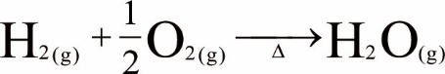
  - Poly/In-Situ Deposition

Poly Deposition
      - Gases used:
N2: 1-5slm
SiH4: 1slm
      - Process temperature: 550~650°C
      - Thickness: 500-5000Å
      - Process description:
Polysilicon is a high-purity silicon consisting of single crystals of silicon grains of various crystal orientations. To put it simply, it’s a high-purity silicon between single silicon and amorphous silicon. Among this, single crystal grains in poly-silicon are separated by the 2D defects-grain boundary. Various line defects and point defects in the boundary make impurities diffuse faster through the boundary than inside the grain. Based on this, we select poly-Si to change its electronic performance by doping and acquire the “silicon” necessary for the process.
Polysilicon deposited by LPCVD has high resistivity. And this makes it perfect for resistors in IC design. The resistivity of heavily-doped polysilicon can be lowered to 500~1200μΩ-cm and make it an ideal conductive material for IC components. In addition to these two features, the Trench structure can be filled in by LPCVD polysilicon as a capacitor in DRAM or for isolation between different components.
In current commercialized VLSI process, polysilicon is deposited by LPCVD, by dissociating silane (SiH4) after heating.
The required polysilicon layer is deposited by the formula shown below.

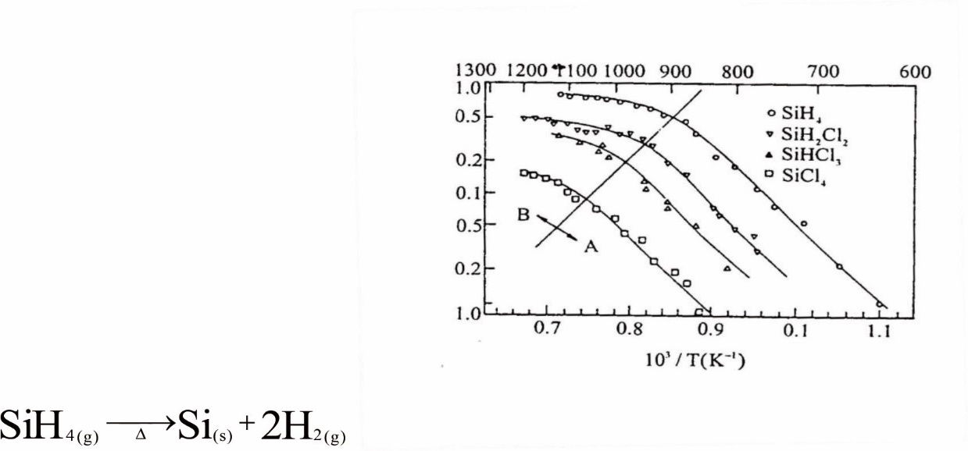
Figure This graph shows the relationship between film deposition temperature and deposition rate when using reaction gases like SiH₄^{[5]}
Temperature (ºC)
Growth rate (µm/min)
The graph above shows a reciprocal curve of reaction rate vs. temperature, based on the formula. When the reaction temperature applied to the aforementioned formula is under 575°C, the silicon deposition acquired will be in amorphous silicon.
When the temperature is between 575°C ~ 650°C, then the polysilicon reaction will occur. The higher the temperature is, the more noticeable the crystallinity will be. Basically, when the reaction temperature of polysilicon deposition based on the aforementioned formula is too high, the reaction tends to be performed by homogeneous nucleation and leads to a less ideal deposition uniformity. Contrarily, a low temperature can cause low deposition rate.
Therefore, in commercial applications, the temperature is controlled between 600°C~650°C, with a pressure between 0.3 ~ 0.6Torr. In this operation section, the deposition reaction rate is controlled by the concentration of SiH4, or the so-called partial pressure.

In-Situ Deposition
      - Gases used:
N2: 1-5slm
SiH4: 1slm
PH3: 200sccm
      - Process temperature: 550~575°C
      - Thickness: 500-5000Å
      - Process description:
In-situ doping adds a dopant gas source directly to the reaction gas while growing polysilicon to grow n-type or p-type polysilicon.
This method is quite direct, but film thickness control, dopant uniformity and deposition rate vary by the dopant amount. Generally, doping B₂H₆ to grow p-type polysilicon can lead to an increased deposition rate and a reduced rate of PH₃ and AsH₃ for n-type polysilicon. This will also lead to the change of grain size and orientation. Another thing to keep in mind is that during/before annealing, it is necessary to cover an oxide layer on the surface to prevent the dopant from diffusing outward. High-temperature annealing can be skipped if the resistance is low enough.

