Document Title: | System SOP (CF-T13 Vertical furnace)
Document No.: | Q3-NL04
Draft Dept.: | Film etching division
Draft Date: | 2019-02-15

Document Revision History

Version | Edited by | Effective date | Approve document No. | Revision/change description | Revised Page
1.0 | Chen-Jung Wu | 2019-02-20 | IS108006 | New release | ---

- Purpose:
Define the operating specifications of Vertical furnace to ensure operation quality.
- Scope:
Applicable to Vertical furnace.
- Rights and Responsibilities:
- Organization responsibilities: The engineer is responsible for the drafting and revision of specifications.
- Qualified operator: Operators passing the Vertical furnace evaluation test.
- Definition of terms:
None.
- Relevant Documents:
Vertical furnace manual.

- SOP:
- Log in MES system.
The user must log in to MES before operating the vertical furnace.
- Login:
  - Click [Login] from the function icons on the top right corner.
  - Enter the password and click [OK].
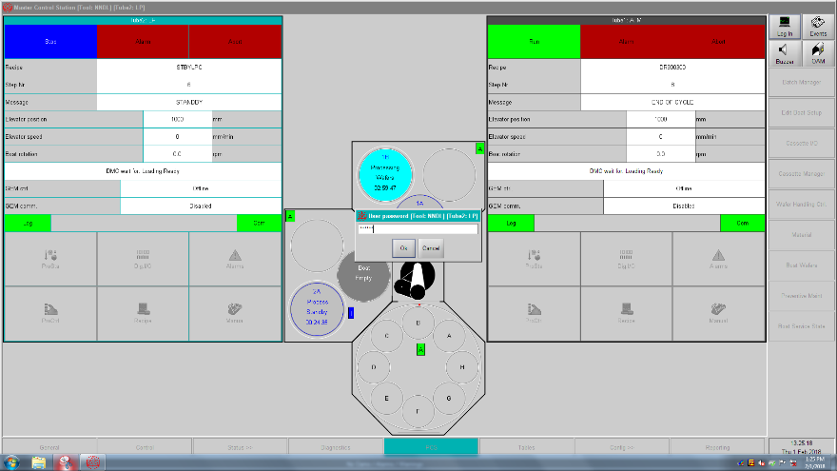
- Batch execution
- Click [Table] at the bottom of screen and [PCS Operations] on the right
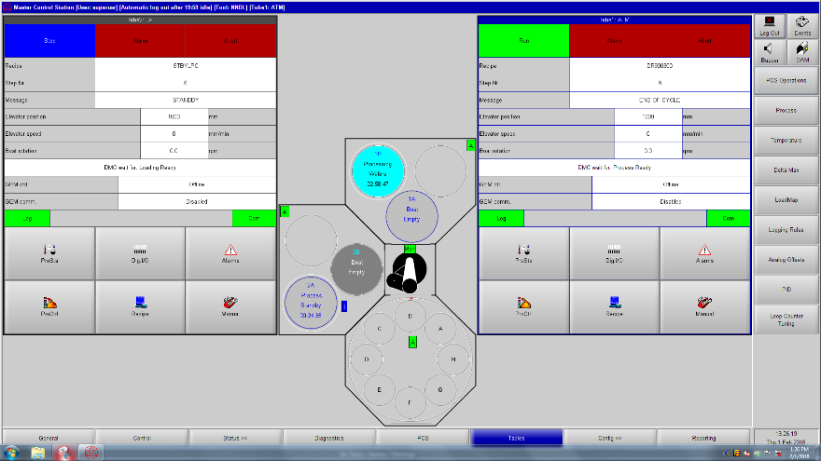
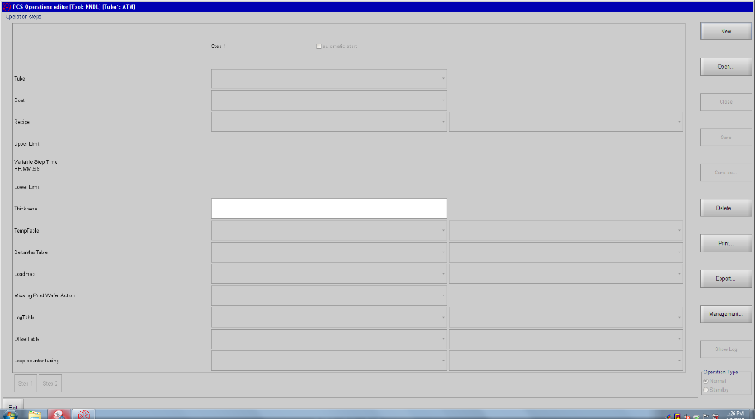
- Click [Open] on the right to display the screen below. Select Recipe name on this screen.
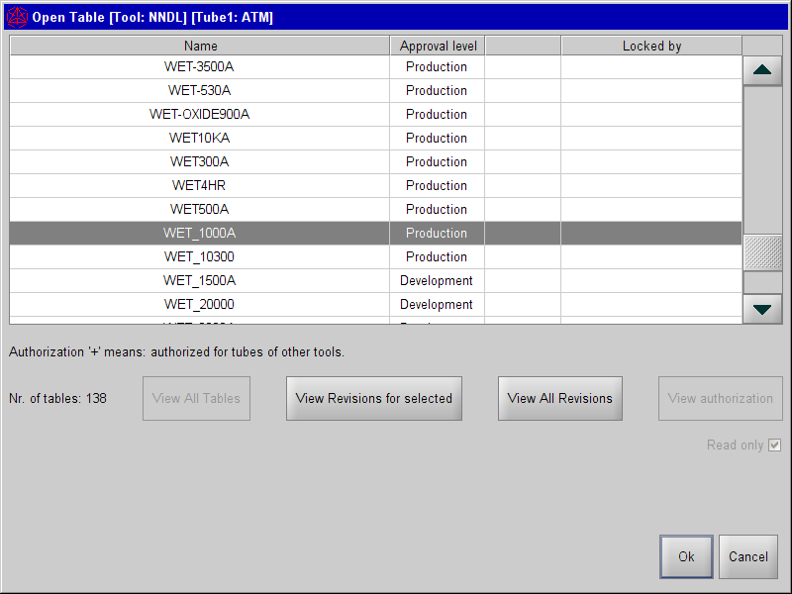
- Click [Management] to display the screen below and select Development.
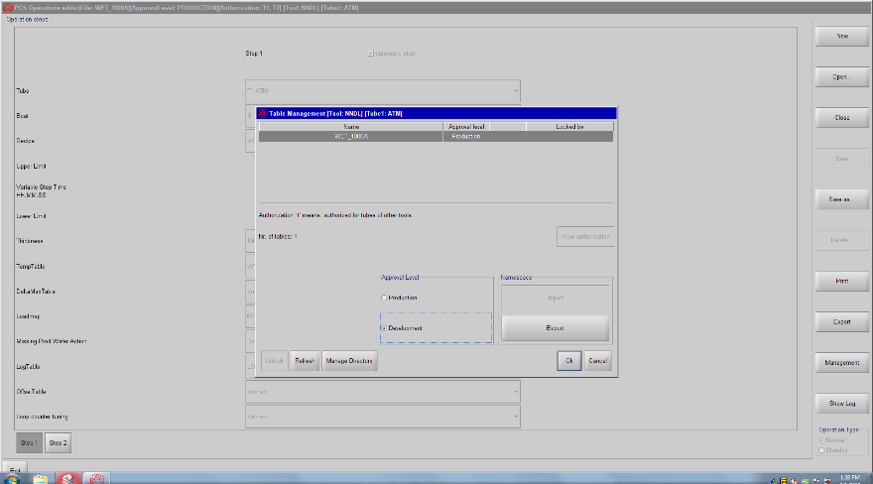
- Set Recipe content and click [Save] on the right.
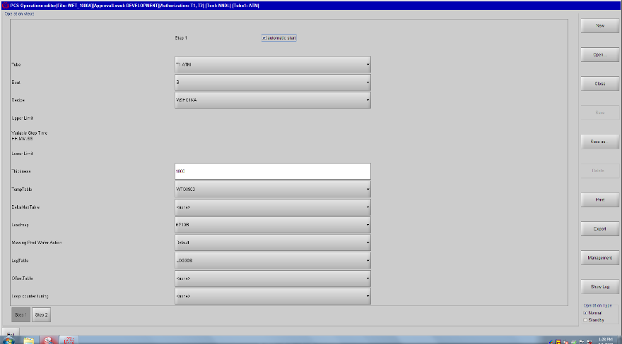
- Click [Management] and [Production] and click OK.
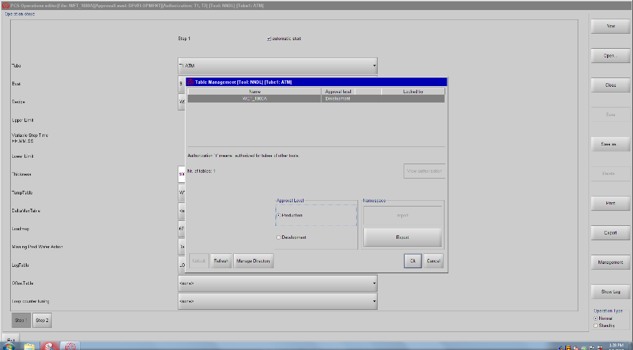
- Click [PCS] at the bottom and [Batch Manager] on the right.
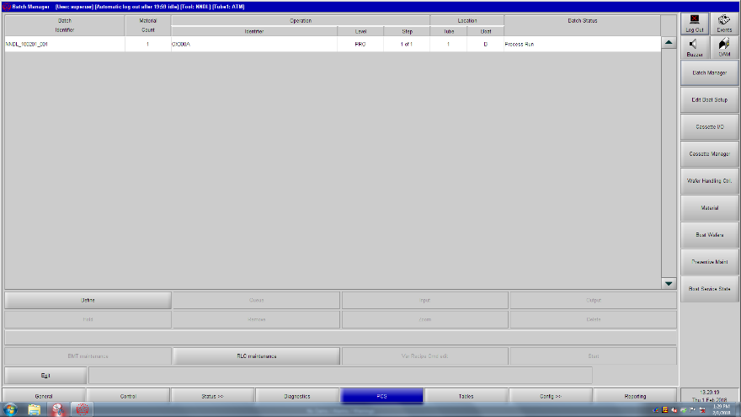
- Check the conditions and click [Define].
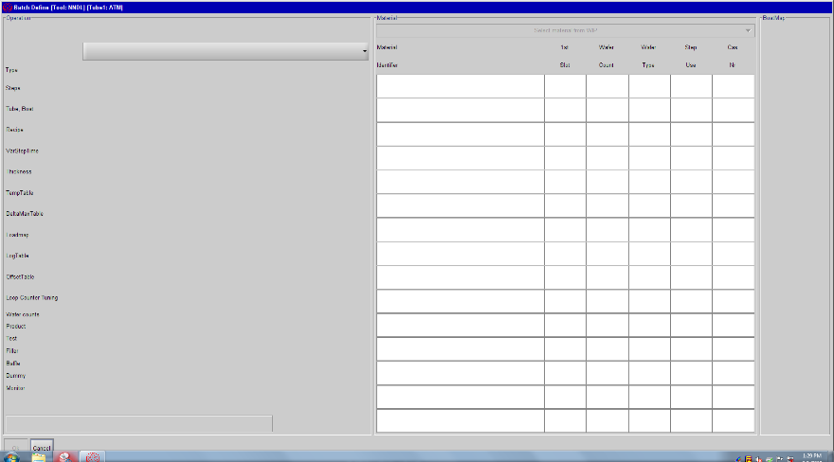
- Enter Lot identifier and click [OK].
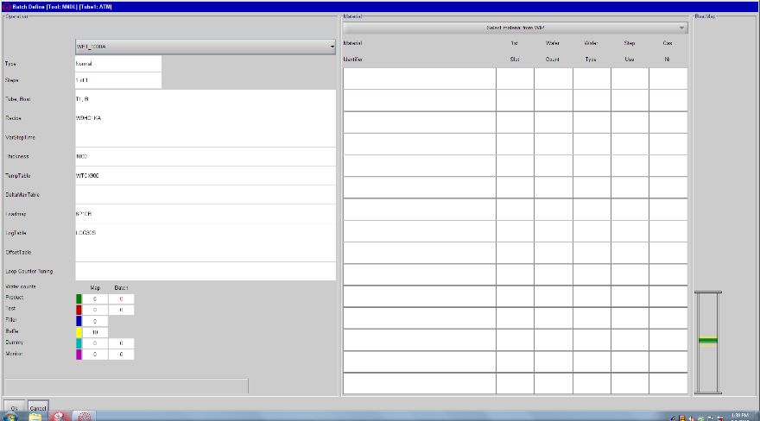
- Follow the aforementioned instructions to load the boat into the system to run the process.
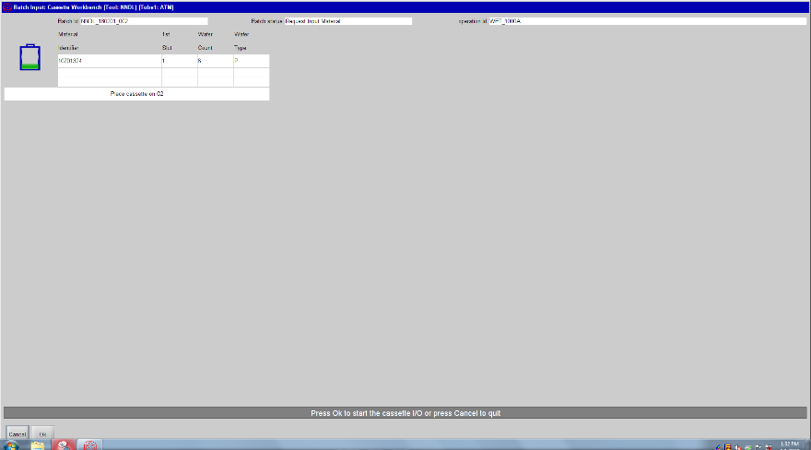

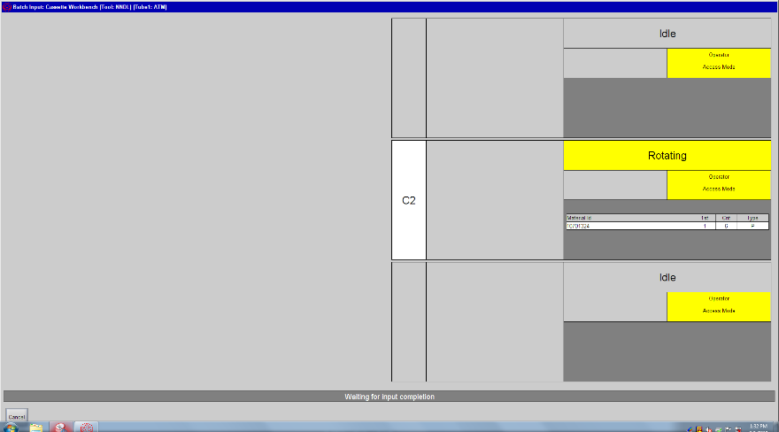

- Log out from the MES system.
- Reference forms and attachments:
- Q4-NL02 Machine management card
- Q4-NL03 Machine evaluation checklist
- Q4-NL04 Machine checklist
- Q4-NL06 Anomaly and Preventive/ correction action list

