Document Title: | System SOP (CF-T26 Backend CVD system)
Document No.: | Q3-NL04
Draft Dept.: | Film etching division
Draft Date: | 2019-02-15

Document Revision History
Version | Edited by | Effective date | Approve document No. | Revision/change description | Revised Page
1.0 | Po-Hao Chu | 2019-02-20 | IS108006 | New release | ---

- Purpose:
Define the operating specifications of the Backend CVD system to ensure high operation quality.
- Scope:
Applicable to Backend CVD system.
- Rights and Responsibilities:
- Organization responsibilities: The process engineer is responsible for the drafting and revision of specifications.
- Equipment manager is responsible for handling anomalies to maintain normal operation.
- Qualified operator: Operators passing the Backend CVD system evaluation system test.
- Relevant Documents:
Backend CVD system Operation manual.
- SOP:
- How to edit a Recipe
- Access the Homepage and click “Applied Material Centura System 5200” on top. Enter the password first.
- USER Name: AMAT
- Password: 5989
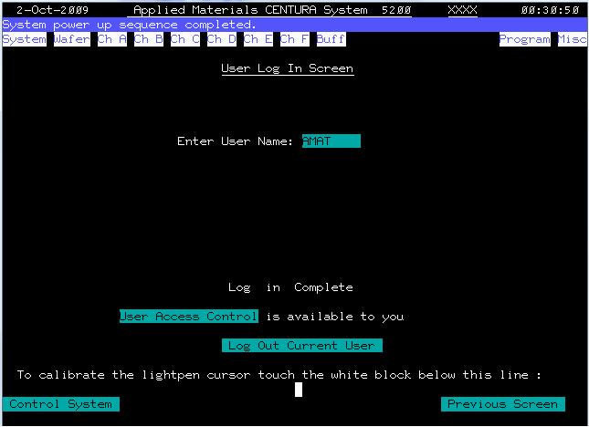
- Access the Home screen and select Program\Process Program.
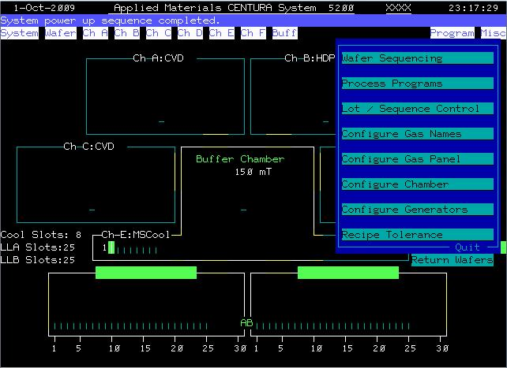

- You can see a menu displaying Recipe name on the screen.
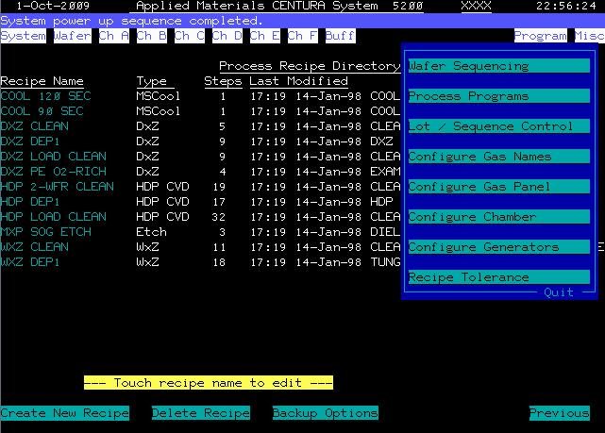

- Select a recipe to edit steps.
For example, when selecting “PE-XXX-XK” in the recipe, the user can edit and operate all green text in each step.
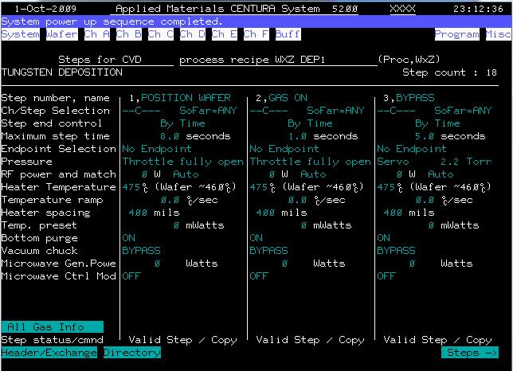
- Click “Header/Exchange” on the screen to edit the operating environment of this recipe. Remember to change “FROZEN” to “Modify” before editing.
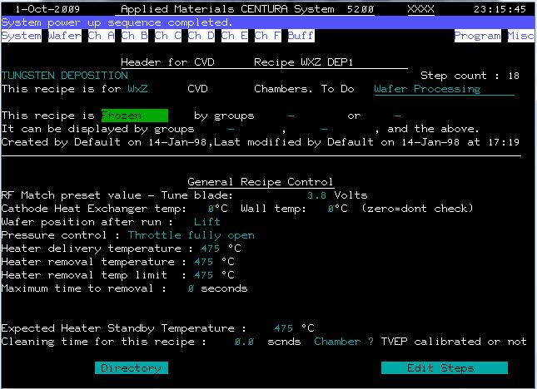

- How to edit Sequence
- Click “Program\Wafer Sequencing” on the screen
- You can see a menu displaying Sequencing name on the screen.
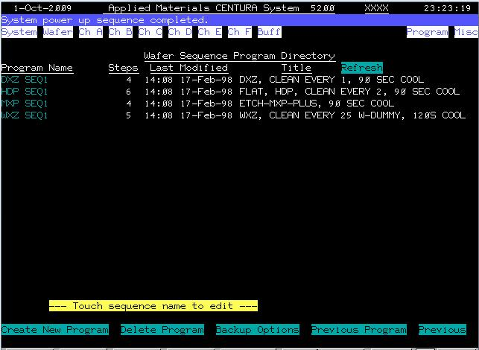
- Click any Program Name to edit the path to run the wafer. For example, when selecting “PE-XXX-XK-X”:
- Step 1 means Loadlock A or B enters the cassette
- Step 2 means the wafer enters Chamber C to run Recipe “PE-XXX-XK-X”
- Step 3 means after the process ends, the wafer exits the Chamber and then runs a clean recipe
- Step 4 means the wafer enters Chamber E to run “cool 120 SEC” for cooldown
- Step 5 means the wafer returns to the original cassette
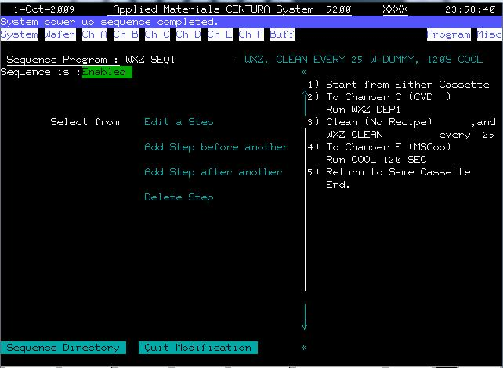

- How to edit Lot name
- Click “Program\Lot Sequence Control” on the screen
- You can see a menu displaying Lot name on the screen.
- Enter “PE-XXX-XK-X” in Add new lot name and the same text will appear on the left and a corresponding field on the right. The user then can select “PE-XXX-XK-X” Sequencing edited before.
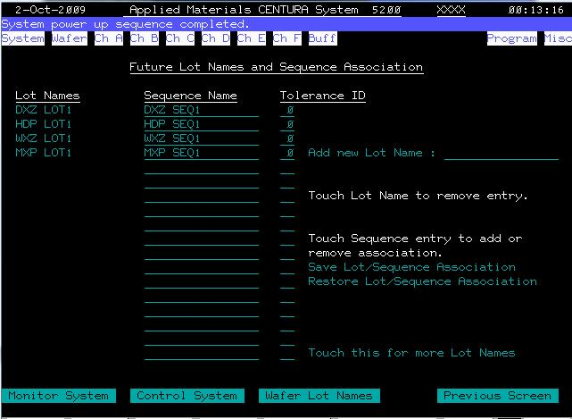
- Click “Program\Enter Lot Name For” on the screen to access the required Recipe.
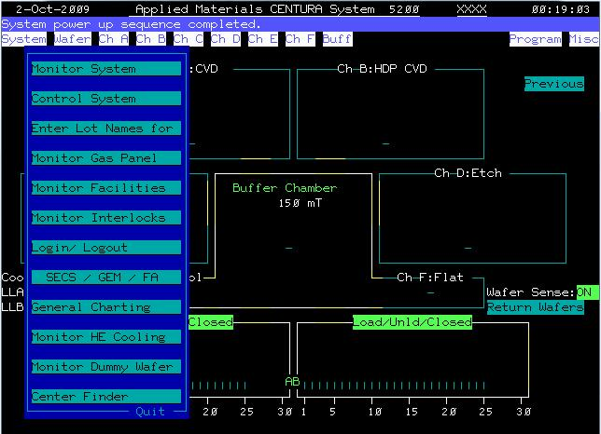
- Click any cassette; you can click Recipe according to the actual wafer position.
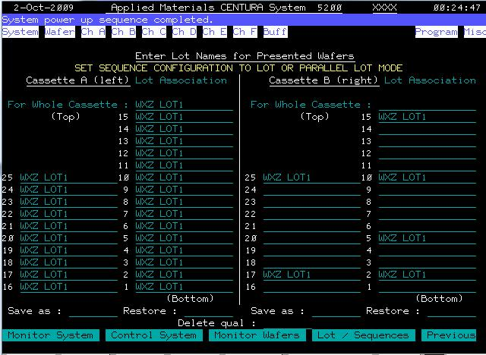

- How to load/unload
- Loading a wafer in a Cassette (A or B): when loading a wafer on Load-lock, place the Cassette in the groove and gently push outward and backward to make sure it is placed correctly.
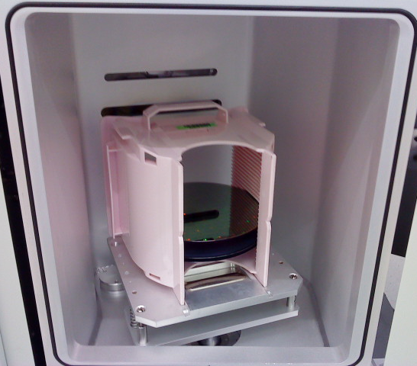
P1: When placing on Loadlock B (gently push outward and backward); place a wafer in the opposite direction when using Loadlock A.
- Select Wafer sequence to correspond to Lot name
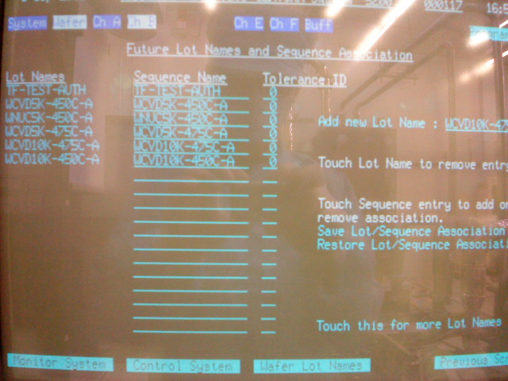
P2: Set Lot name and the corresponding Wafer sequence in the indicated field.
- And set Wafer Lot name to run on “Enter Lot Names for Presented Wafers” screen.
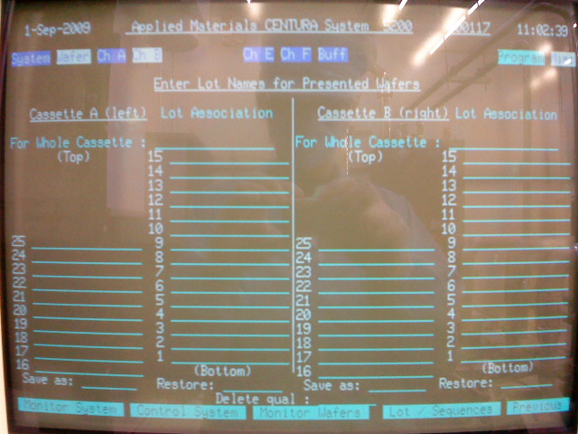
- Click “Load/Unload A or B”
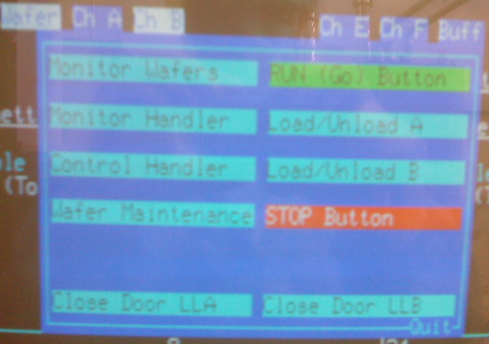
- Then click “Run (Go) Button” to start the process.

- Note:
- Please notify the person in charge of the system when an anomaly cannot be determined and solved.
- Make sure to refer to machine SOP and follow relevant regulations when using the machine.
- Reference forms and attachments:
- Q4-NL02 Machine management card
- Q4-NL03 Machine evaluation checklist
- Q4-NL04 Machine checklist
- Q4-NL06 Anomaly and Preventive/ correction action list

