Document Title: | System SOP (CF-T29 8” PVD system)
Document No.: | Q3-NL04
Draft Dept.: | Film etching division
Draft Date: | 2019-02-15

Document Revision History
Version | Edited by | Effective date | Approve document No. | Revision/change description | Revised Page
1.0 | Yun-Kai Yang | 2019-02-20 | IS108006 | New release | ---

- Purpose: Define the operating specifications of Metal PVD to ensure operation quality.
- Scope: 8” PVD system
- Rights and Responsibilities:
  - Organization responsibilities: The engineer is responsible for the drafting and revision of specifications.
  - Qualified operator: Operators passing the 8” PVD system evaluation test.
- Definition of terms: None
- Relevant documents: None
- SOP:
8” PVD system
SOP
- How to use the CTC(Cluster Tool Controlle) screen
The CTC screen is divided into multiple areas divided by frames.
2
3
4
1
The CTC screen layout
- Title panel
Located at the top of the screen and includes the function buttons commonly used for all operations, and an alarm information area. See “Fig. 3-3 Title panel” for detail of buttons.
- Navigation panel
Located at the bottom of the screen and includes the menu buttons.
Clicking on these button changes the menu button displayed on the command panel. The menu button referring to the display on the information panel turns dark gray to indicate that it is selected.
- Command panel
Located on the right side of the screen. The buttons on the command panel change according to the menu button selected on the navigation panel. The menu button referring to the display on the information panel turns grey to indicate that it is selected.
- Information panel
Located in the center of the screen, this panel displays the settings and other information specified on the navigation panel and command panel. The information panel consists of a graphical image operation area and/or text entry fields.
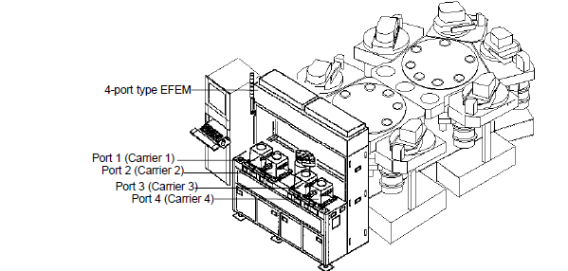
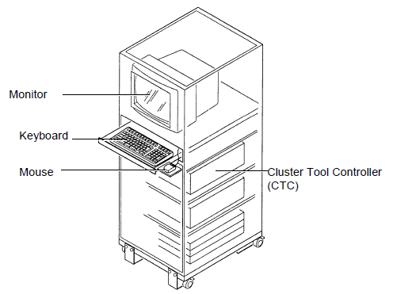

5.Title panel

- Chamber navigation area
The configuration of all modules being controlled is displayed in this chamber navigation.
Many different types of operation windows provided to the CTC screen display information specific to each module. Selecting a specific module from the chamber navigation area highlights the modules and changes the information on each operation window to that corresponding to the selected module.

- System control area
The buttons allow package operation of integrated modules at for all modules.
<SECURITY> button | Displays the [Log in/Log out] window.  Press this button to log on, log off, close and shut down. Entering a user name and password enebles operations at each security level.
<ABORT> button | Immediately stops all lot operations in progress at all modules. (*2)  Checking dialog box is displayed by the [Definition] window setting.
<STOP> button | Stops all lot processes in progress at all modules. The wafers that have been started the operation stop all processes.
<PAUSE> button | Suspends all lot operations in progress at all modules after they have proceeded to the process completion currently in progress.
<RESUME> button | Continues all the suspended lot operation.

- System status area
The current date, time, CTC softwafer version and operator name are displayed.
Date | Displayed in “YYYY/MM/DD/” or “MM/DD/YYYY” by the [Definition] window setting. (YYYY: year / MM: month / DD: day)
Time | Displayed in “HH:MM:SS”. (HH: hour / MM: minute / SS: second)
CTC version | Displays the version No. of the software.
Operator name | Displays the “Log ID” of the operator who has logged in on the [SECURITY] window. “Unknown” is displayed before “Login

- Alarm information area Displays the information of alarms given off in the system.
Provided are the <ALARMS> button to check details of alarm information and the <BUZZER OFF> button that cancels the buzzer sounded when alarm occurs.

<EVENT> button | Displays the [Event] window that displays action event log by each module unit.
<ALARMS> button | Displays the [Alarm] window that allows operators to check all alarm information currently occuring in the system.
Alarm-issue module | Displays the module in which alarm occurred. Module colors change with the level (severity) of an alarm that occurred at the time.  Red : Error  Yellow : Warning  (White : No alarm issued)
<BUZZER OFF> button | Turn off the buzzer that sounds when alarm occurs.  This button also turns off the chime sounded when the sequence of auto operation command is finished.
- Navigation panel

Menu button | Function
<Job> | Edits and stores a new lot operation or carries the lot operation already stored. Also, monitors lot processing or system state using graphics or status.
<System Setup> | Set up system by system. Executes auto operation of each system except for lot processing.
<Mainte> | Manually operates each module or each device. Also, executes and checks recovery operation from troubles and communication command-level operation.
<Recipe> | Creates and edits process conditions for lot processing, such as sequence, flow and template.  Also, sets alarm level, auto cleaning and others.
<Log History> | Checks a list of the past lot log data and details of process data. Also, compare data of wafers of each lot, creates a graph according to the result of comparison and verifies the data.
<Parameter> | Verifies and edits system configuration/definition parameters or different type of operation parameters, and backs up these parameters.
<Factory Interface> | Sets parameters related to online, and confirms the status of various status.
<MODE CHANGE> | Sets the operation mode for each module.

<Back window> button
Stores and displays the maximum of 10 windows displayed in the past.

<Favorite> button
Calls and displays the window registered in advance from the list. 10 windows can be registered in the list as optional and allows operators to call a desired window without using each button on the command panel.
The registered each users can set this function respectively.

Job
Product Monitor | Monitors the operating state of the entire system on one screen.
Lot Operation | Processes and controls lots.
Process Monitor | Displays the process status of the system.
Load Port Monitor | Monitors the status of Load Port for each Load Port.

System Setup
Auto Macro | Executes marco in multiple modules in Auto Mode.
Service Macro | Executes macro in each module in Service Mode.
Auto Menu | Executes Auto Menu in multiple modules. Parallel operation is also possible.
Service Status | Views service parameters for each module.
QC Data | Checks the QC data (film thickness).

Mainte
Module Operation | Operates in manual the device on the system for each device or unit. Semi auto is performed as well.
Module Transfer | Transfers wafers one by one.
Manual Process | Displays manual-operation menu buttons to service each device/unit in the system.
Wafer Recovery | Recovers wafers as required.
I/O Operation | Executes forcibly manual operation of module digital output (DO) and analog output (AO) and checks the real-time state of digital input/output (DI/O) and analog output/input (AI/O).
Serial Operation | Checks and manually operates, the state of device/unit of the system to use the serial communication.
Vacuum Operation | Operates vacuum system for the entire system.
EFEM Operation | Edits various operation parameters for EFEM.
Wafer Trasnfer | Trasnfers wafers between EFEM Port.
Life Test | Executes transfer and reliability tests without supplying the power according to recipe conditions.
Data Record | Displays in graphs the analog input value data according to the time elapsed.
Robot Test | Operates the robot on vacuum side by command level and checks the teaching data.
Serial Monitor | Checks the transmitting/receiving data of serial communication command.
ID Reader Test | Not supported. Performs various setting and action checking of the ID Reader.
AMHS Test | Set signals for automated material handling system (AMHS) and this system.

Recipe
Sequence | Edits the sequence of a module selected from the module navigation area.
Flow | Edits how to flow wafers to be processed through process modules (process flow).
Template | Eidts and stores lot processing parameters as a template according to multiple wafer types composing a carrier to be processed.
Alarm Level | Sets the error range according to the sequence settings.
SMC Template | Sets and edits the template used for SMC.

Log History
Logging Data | A list of the past log data and details of process data can be viewed and checked. Also, data of wafers in a lot can be graphed to compare.
Alarm | Displays a list of alarm issued in the past.
Event | Displays a list of generated events.
SMC Logging Data | Views the logging data related to the SMC processing and details of process data.

Parameter
Process Parameter | Verifies and edits process parameters.
Sequence Parameter | Sets parameters used to the semi auto movement.
Service Parameter | Sets and checks the state of monitoring devices of utilities, targets, devices, etc.
Heater Parameter | Edits setup sequence parameters for process heater and others of a module selected from the module navigation area.
Esc Parameter | Sets multiple patterns of electrostatic chuck On/Off sequences when process is in progress.
Depo Rate Parameter | Sets parameters for deposition rate for each sputteirng module.
System Parameter | Presetting the power supply type, heater type, gas line type and others controls the module according to its particular specification.
Timer | Sets the timer used in the software for menu operation and device operation.
Calibration | Not supported. Sets RF power supply calibrated data and process heater temperature calibrated data.
AI/O Max | Presets the maximum value of controllable range for each analog device.
Auto Macro Parameter | Sets auto macro of System Setup menu.
Service Macro Parameter | Sets service macro of System Setup menu.
Definition | Sets parameters related to the entire system, such as system configuration parameter.
Option | Not supported. Sets parameters for system options.
Password | Defines restrictions on windows available for operators.
Cryo Parameter | Sets parameters related to the Cryo pumping down system of the transfer module.
AMHS Parameter | Defines signals for automated material handling system (AMHS).
Transfer Parameter | Not supported. Defines the scheduler for wafer transfer control.

- Lot processing by local operation
- Carrier Setting

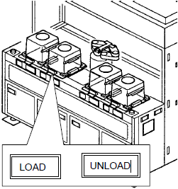

- Input the “Carrier ID”

- Edit Recipe
- Edit sequence

- Edit Flow

- Edit and Execute Lot Processing
Press the <Create Que> button on the [Lot Operation] window

- Lot Execution
Select the Job button on the navigation panel, and select the Lot Operation button on the command panel.

Press the Create Que button on the [Lot Operation] window

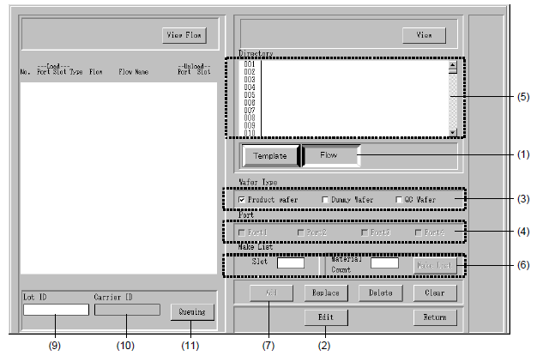
- Select the flow by the <Template/Flow> changeover button.
→ The list displayed in the [Directory] area is changed to the flow.

- Select the <Edit> button on the [Queuing (Template)] window.
→ It becomes possible to edit the template and flow.

- Select the wafer type. Select the wafer type from the among the product wafer, dummy wafer and QC wafer.

- Select the port whose carrier is set. (port1.~4.)

- Select the Flow to use from (001~250)

- Set the slot No. whose flow is set.(1.~25.)

- Select the <Add> button.
→ The flow contents selected in the [Dierctory] area is displayed in the [Template Information] area.

- Repeat the step (5), (6) and (7) and set the flow to each slot

- Move the mouse pointer to the “Lot ID”
→ The contents thus defined are dispalyed in the [Lot ID] and cursor moves to the [Carrier ID].

- Input the “Carrier ID” from the keyboard. After input, press the <Enter> key to define it.
→ The contents thus defined are displayed in the “Carrier ID”

- Reference forms and attachments:
- Q4-NL02 Machine management card
- Q4-NL03 Machine evaluation checklist
- Q4-NL04 Machine checklist
- Q4-NL06 Anomaly and Preventive/ correction action list

