Introduction of Ultra high metal and metal oxide nano-level film sputtering system

System introduction
  - System name: Ultra high vacuum metal and metal oxide nano-level film sputtering system
  - Manufacturer: Applied Materials, Inc.
  - Model: Endura® Clover™ MRAM PVD System
  - System function: Metal and metal oxide nano-level film deposition
  - System structure: (refer to Figure below)
    - Loadlock Chamber: LLA, LLB
    - Transfer Chamber: Transfer, Buffer, Ch.A, Ch.B
    - Deposition Chamber: Ch.2, Ch.3, Ch.5
    - Degas Chamber: Ch.F
    - Cryo-cooling Chamber: Ch.B
    - Oxidation Chamber: Ch.1

Function introduction
System functions:
  - Degas Chamber F: Degassing, thermal annealing
  - Deposition Chamber 2: (Quinary target chamber) CoFeB₂₅, CoFeB₂₀, CoFe, Mo, Mg
  - Deposition Chamber 5: (Quinary target chamber): Co, Pt, Ru, Ta, W
  - Deposition Chamber 3: MgO
  - Cryo-cooling Chamber B: Cooling after MgO barrier deposition
  - Chamber A: Ar cooling
  - Oxidation Chamber 1: Mg oxidation

System restrictions
  - Silicon substrates
  - The growth surface must be Si, Ge, SiO_{x} and stable solid-state metals
  - No broken wafer allowed
  - Only 8” and 12” wafers allowed
  - No photoresist allowed

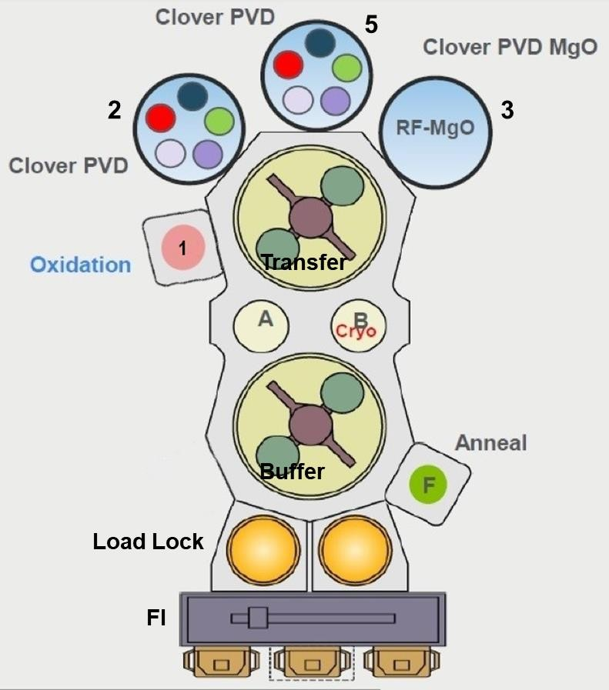
Fig. 1. System structure

