Ultra-high metal and metal oxide nano-level film sputtering system

SOP

System interface
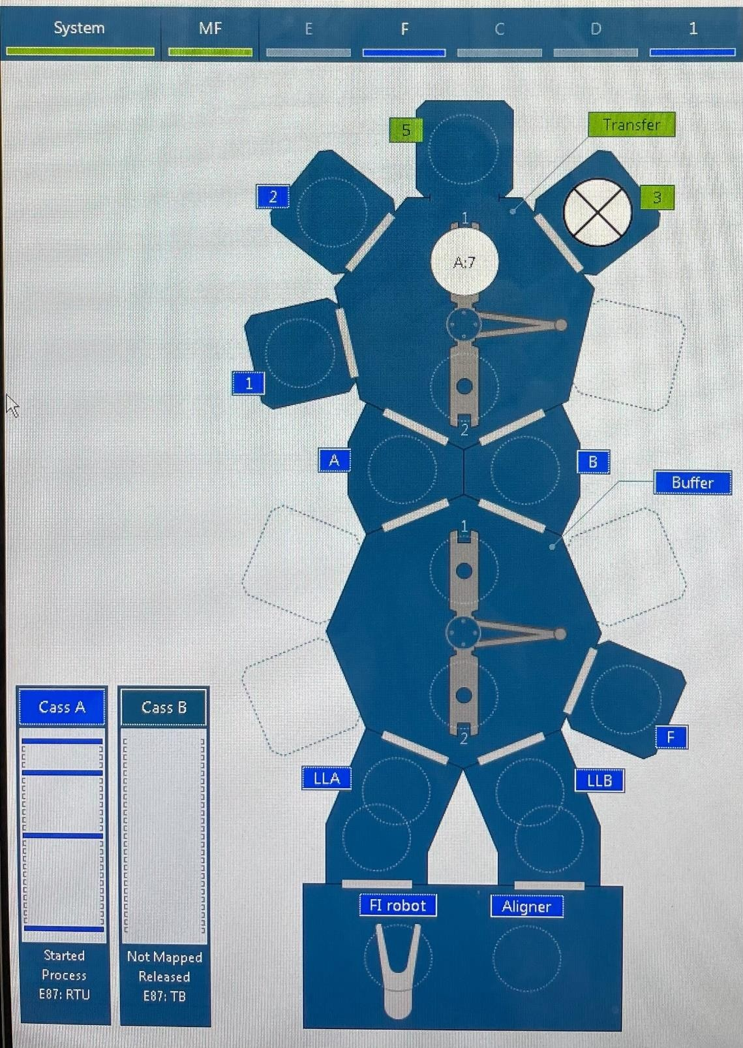
Cass A, Cass B: Load Port

FI: Factory Interface Aligner: Align 12” Notch LLA, LLB: Loadlock Buffer, Transfer: Mainframe Ch A: Pass Through
Ch B: Cryo-cooling Ch F: Degas/Anneal Ch 1: Oxidation
Ch 2: CoFeB25, CoFeB20, CoFe, Mo, Mg Ch 3: RF-MgO
Ch 5: Co, Pt, Ru, Ta, W
A chamber in blue is online, meaning the chamber is connected to system automation. A chamber in green means in process or transfer.
Wafer in process is circled in white, with cass and slot displayed

Execution interface
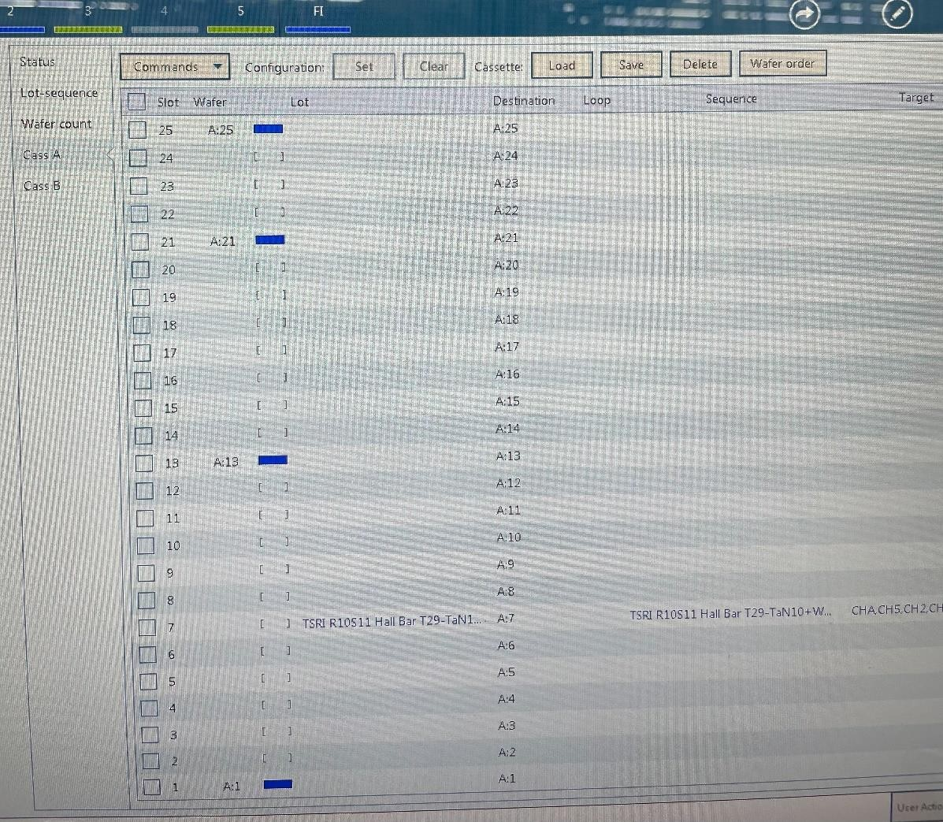
The blue block in Cass A (Slot 1~25) means there is a wafer inside.
If it is necessary to select the Lot name of a wafer in process, such as Slot 7, it is possible to correspond to the Sequence name. A sequence contains multiple recipe names. Slot 7 has already been transferred to Chamber for process, so a blue block is not displayed in Cass A.

Operation and note
- Check the system status before coating. It is recommended to set the pressure of the Deposition chamber to under 1E-08 torr.
- When coating a 8” wafer, it is necessary to record the thin film thickness for the carrier wafer. When the carrier wafer film thickness is >37500A, please recycle and purge
- When taking a wafer out from Foup, make sure to process this step in the front mask of the load port. Take the wafer with a clamp or put a 8” wafer in. DO NOT touch the front of the carrier wafer. Make sure not to place two carrier wafers in slots that are too close to each other (for example, put wafers in slot 1, 6, 11, etc.). When placing an 8” wafer, make sure that the wafer is correctly placed in the slot of the carrier wafer. No protrusion or tilt is allowed.
(Also: When placing/taking out a wafer from Foup to process in a Class 100 cleanroom, make sure to hold the carrier wafer in both hands. DO NOT use a vacuum pen (the wafer may drop). Place the carrier wafer on a cleanroom wipe after taking it out and then take an 8” wafer using a vacuum pen)
- Make sure the Foup door is securely locked. After placing on the Load port, remember to check whether the front cover protrudes again.
- DO NOT change existing Sequence and Recipe. To change conditions, please copy the standard process, add a file, change the name and then modify the content.
- Hardware settings of 8” & 12” coating (important):
  - Place an 8” operation Foup onload port A (left) and a 12” operation Foup on load port B (right).
  - Setup ➔ Sequencer ➔ “Configuration” page
    - Align wafer by default: No (8”) / Yes (12”)
    - Align wafer by default for manual transfer: No (8”) / Yes (12”)
  - MF ➔ Chamber B ➔ Put Chamber Offline ➔ Lift Calibration ➔ Pins Lift Calibration ➔ “Clamp” page ➔ Clamp Parameters
➔ Position: -4200 (8”) / -3000 (12”) ➔ Put Chamber Online
  - Ch.1, 2, 3, 5 ➔ Put Chamber Offline ➔ PVD Configuration (Ch.2, 3, 5) / Preclean APC Configuration (Ch.1) ➔ “EChuck” page ➔ Dechuck ➔
    - Dechucking Time: 60 s (8”) / 2 s (12”)
    - Dechuck Pulse: 0% (8”) / 20% (12”)
➔ Put Chamber Online
- DO NOT change other hardware parameter settings.
- Set process steps:
  - Copy the Sequence of a standard process from the Sequence Editor and rename. (DO NOT change any existing sequence)
  - Click the newly added Sequence and search for a Recipe for change.
  - Access the Recipe Editor page, copy the Recipe of a standard process and rename, like Step 1. (DO NOT change an existing Recipe)
  - Click the newly added Recipe and change process conditions as necessary, including time, power, gas flow, etc.
  - Return to the Sequence page and change to the new Recipe as necessary.
  - Check warm up recipe (target pre-coating and warm-up) in the Sequence Start Clean Recipe field.
- To avoid waste, please warm up the necessary target only.
- To warm up the same chamber, make sure of the write conditions in the same warm-up recipe. For example: If Co and Pt are in Chamber 5 and there are two recipes to grow Co and Pt, it is not allowed to write the warm-up of Co and Pt separately. The system will only select one to warm up.
- After MgO coating, it is necessary to set a periodic clean recipe. Select “RF MgO BKM Paste_”.
  - Pre-step: Set Buffer blade and transfer blade to Pull. Change to Any if cooling is not applied in the process. In Pull, wafers will be processed one by one and in Any, multiple wafers will be processed at the same time.
  - When the Sequence start clean option setting is “Evacuate+Hold”, the wafer will be loaded to system LL after warm-up. The wafer will be loaded to LL directly when the setting is “None”.
  - Make sure the recipe of chambers the wafer passes by is placed in Sequence.
  - To compare the difference between Sequence and Recipe, access Compare and then select Sequence/Recipe to compare.
  - To change the Degas temperature, access CHF to change the chamber temperature. CHF ➔ Put Chamber Offline ➔ Monitor Chamber ➔ Heater Lift ➔ Temperature ➔ Request to change to the required temperature ➔ Put Chamber Online
  - Meanwhile, in the Prestep tab in CHF recipe, it is recommended to change Expected Heater Standby Temp (degC) to 0 to apply any temperature as well as to avoid setting of the alarm.
  - Save the changed Sequence.
  - Click Lot-Sequence Association, click New and select Sequence. Lot name will be updated to the same as Sequence name. Lot name will be updated to the wafer marking if there is any.
  - Change Mode to Freeze to prevent changes and then press OK.
  - Select all slots under System ➔ Monitor wafer and then press Clear.
  - Load the Foup on the Load port of Endura PVD.
  - Click Load Pod under System ➔ Monitor wafer ➔ Cass A and the system will run auto-mapping.
  - Check the wafer, click Set from Configuration above, click Lot name to find the previously created Lot name and then click OK.
  - For wafer selection or Sequence content error after loading the pod, follow the steps below: Go to manual mode ➔ Click wafer (white box) and select Set ➔ Delete ➔ Clear lot name
  - Check if the pressure of the Deposition chamber is in a normal range. It is recommended to be under 1E-08 torr.
  - Check hardware parameters of 8” and 12” wafers, including lift calibration, e-chuck and Align wafer by default.
  - Select System ➔ Start Sequence to start the process.
  - After the process ends, select System ➔ Stop Sequence to remove the Foup.

