Introduction of S9260A In-line Electron Microscope

Instrument no.: CF-L16 | 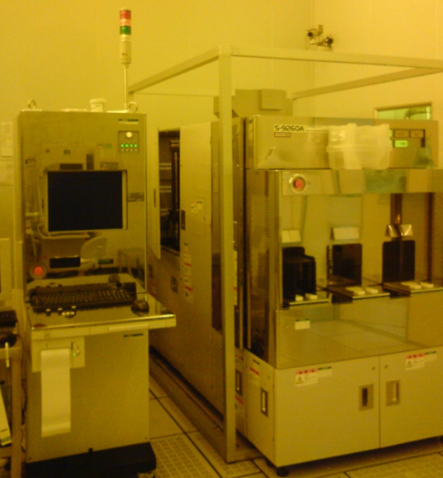
Instrument name: S9260A In-line Electron Microscope
Storage location: Class 10
Model: HITACHI S920A CD SEM

Specifications of the Machine

Item | Specifications
Specimen size | 8” wafer (SEMI or JETDA standard)
Accelerating voltage | 500-1600 V
Resolution | 3nm (800V)
Magnification | 500X to 300K X (SEM). Guarantee: 4000 X-200K X  110 X (OM)
Measurable line width | 0.1-2 um
Reliability | - 1% or 3 nm (3 sigma)
Moving range (X or Y) | 0-200 mm
Transfer mechanism | Automatic transfer  3 SMIF port (8” only)
Monitor | EWS 21″ monitor
Capacity | Max. 50 specimens/hr (5 measuring points/specimen)
Storage | Built-in hard drive  3.5″ floppy
Functions of the Machine
The S9260A In-line Electron Microscope is mainly used for measuring the line width of in-line products. It is characterized by the fact that it does not require a wafer to go through the pre-processing steps such as cutting or metal coating to observe and measure the patterns of photoresist, insulation layer and metal layer. This measuring instrument uses non-destructive testing, so that any wafer whose measurement is completed may proceed to the next step in the process.
The machine can only measure line width. Since a specimen cannot be tilted, it is not possible to observe the specimen section.

Restrictions on the Machine (Materials, Range of Parameters, etc.)
Notes:
- The specimen must be of the required size and materials: 8″ Si specimen.
- The specimen must be complete, with no missing corners or cracks.
- Due to the high vacuum in the electron gun, the specimen must not be any volatile substance or volatile during electron beam scanning.
- If the specimen contains any photoresist, it must undergo a hard bake before it is fed into the gun.
- The specimen must not contain any magnetic material.

