S9260A In-line Electron Microscope - Technical Data

Steps for Creation of a Measurement Program for S9260A In-line Electron Microscope

A measurement program for S9260 CDSEM can be created via the following steps:

- Make sure Loader Controller is in C to C, and select Slot Select in Manual Controller. Click the wafer slot number you want to load, and click Start to load the wafer into the machine.
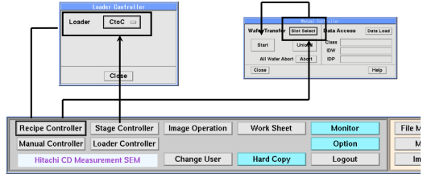

- Click FILE MANAGER at the bottom right of the main screen, and FILE MANAGER WINDOW appears.

- Click Action in CLASS Select Create
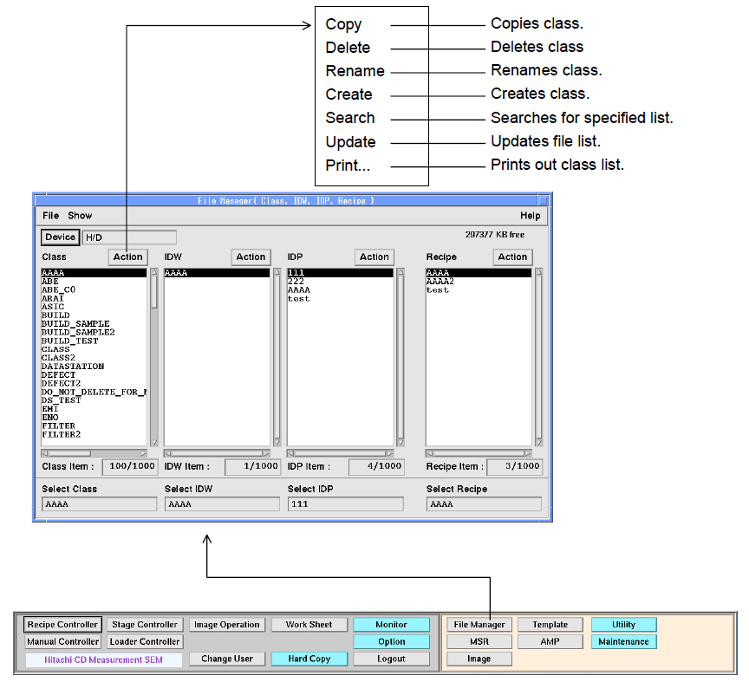

- After creating CLASS, click Action in IDW under this directory Select Create

- Input: Wafer size ⇒ 8″: 200 mm, 6″: 150 mm
Invalid area ⇒ Wafer edge blank area
Map offset ⇒ Displacement of the center of the stepper
Shot Array definition
Array X, Y: Same as the array of the stepper
Size X, Y: Same as the shot size of the stepper

- Click Create to create a wafer map.
※For any unwanted shot, you can click a shot in Auto Deletion, and then move to the wafer map on the left to click the unwanted chip, turning it gray.

- Click File Exit Save or Save as
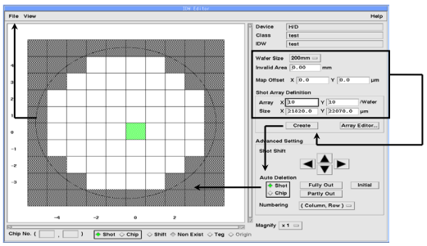

- After creating IDW, click Action in IDP under this directory Select Create

- IDP MANAGER appears, and click IDW File Load.

- Under Wafer Alignment Point Information, click Create, and AP Chip Select will appear. Select the shots in the center of the wafer close to its both sides as the alignment shots, but don't select the shots closest to both sides.
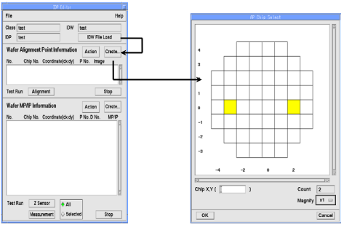

- Click OK, and AP Information File appears on the screen. Switch the screen to OM mode and click Move, and the screen moves to the shot to the left of the designated alignment point. Move the origin to be set to the center of the screen.

- Under Origin, click Reg to complete setting of the origin.

- Move the alignment pattern to be selected to the center of the screen. Under Coordinate, click Reg to complete setting of the alignment coordinates.
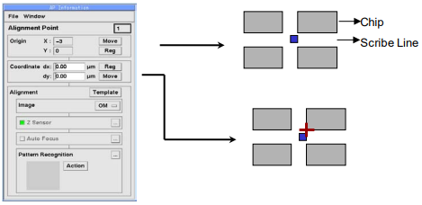

- Under Pattern Recognition, select Reg Meas PT in Action. After selecting the parameters, click OK, and a box appears on the screen. Enlarge the box to include the Alignment Mark and the more obvious edge next to it, and then click OK.
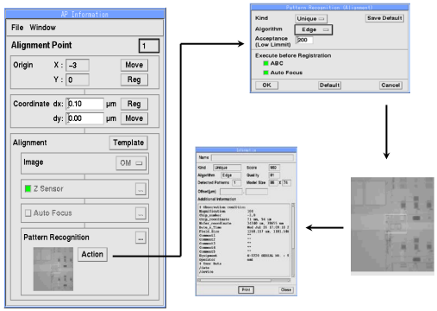

- Under Test Run, click Alignment.
A successful alignment indicates that there is no problem with pre-alignment.
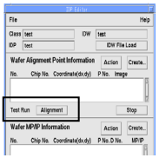

- Click Create in the Wafer MP/IP Information window The MP/IP Chip Selection window appears automatically, and click the chip you want to measure on the wafer map OK The Sequence Editor window appears automatically.
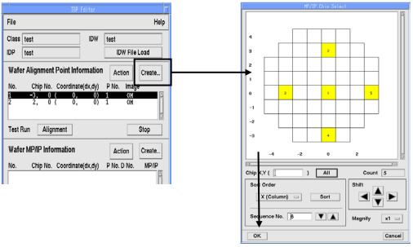

- Switch the screen to SEM Mode Move the measurement point to the center of the screen, and click Reg in Coordinate to confirm the coordinates of the measurement point.
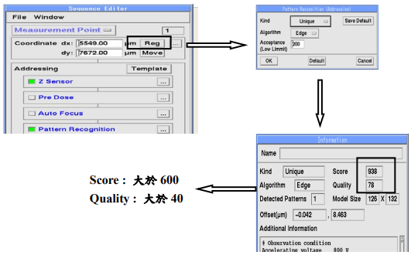
Score: > 600
Quality: > 40

- In Addressing, click Action to complete recognition of the measurement location.
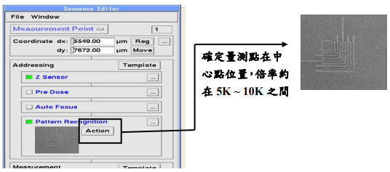
Make sure the measurement point is at the center, with about 5K~10K magnification.

- In Measurement, click Action to complete recognition of the measurement pattern.
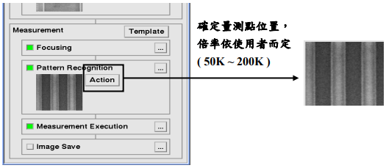
Determine the location of the measurement point, with magnification depending on the user (50K~200K).

- Under Test Run, click Measurement File Exit Save
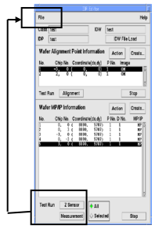

- In the FILE MANAGER window, click Action under Recipe Recipe Editor window appears automatically, and click the required CLASS/IDW/IDP, SEM Condition No., and the measured wafer no. Click Option
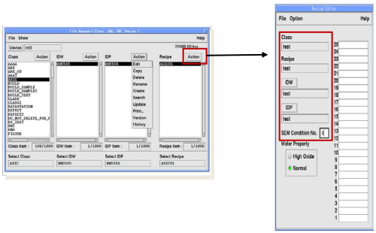

- Set the recipe conditions in the Measurement Environment window.
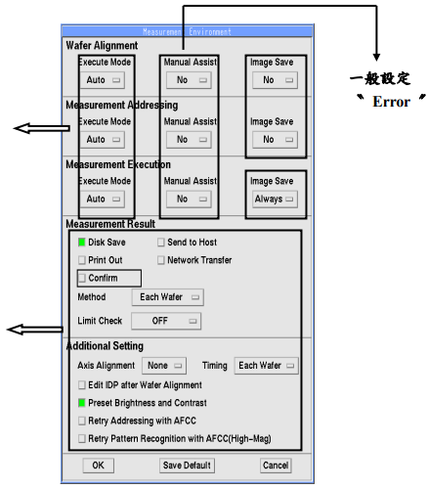
Setting by user preference
General setting “Error”
General setting “Auto”

