Machine Name: | S9260A In-line Electron Microscope
Machine No.: | CF-L16
Prepared by: | Lithography and Mask Division
Issue Date: | Jan. 15, 2018

Document Issue and Revision History
NO. | Issue Date | Revision Application No. | Issued/Revised Content | Revised Page | Version
01 | Feb. 1, 2018 | 107-DC01 | First issue | ------ | 01
02
03
04
05
06
07
08

Approved by | Reviewed by | Prepared by

- Purpose:
Defining the operational standards of S9260A In-line Electron Microscope to ensure the quality of its operation and measurement.

- Scope of Application:
Applicable to S9260A In-line Electron Microscope.

- Rights and Responsibilities:
- Organizational responsibilities: The engineer is responsible for the preparation and revision of standards.
- Personnel qualified for use: Personnel who have passed the test.

- Definition of Terms
None

- Relevant Documents:
Hitachi INSTRUCTION MANUAL CD MEASUREMENT AND EVALUATION SEM (OPERATING SECTION) (V12~)

- Standard Operating Procedures:
- Before using the machine, all personnel who have passed the test must check if machine’s condition is OK (green card: normal RUN), and complete the Machine Use Log Sheet.
- Transfer the chip to the carrier cassette for measurement (Fig. 1) and place the cassette in position, and the robotic arm will automatically detect the chip’s slot position in the cassette.
<Note>
The slot number in the port will be red when there is any irregularity such as chip stacking or skewing. Pick up the cassette and reposition the chip to the correct location.

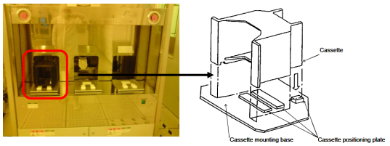
(Fig. 1)

- Click Recipe Controller, Stage Controller and Image Operation on the operating system (Fig. 2), and then click Recipe (Fig. 3). Select the port where the cassette is placed (A, B or C), and select the correct program to the slot number to be measured. Select the name of the measurement file and click Execute (Fig. 4), and the robotic arm will automatically transfer the chip to the measurement system and automatically deliver it to the measurement position.

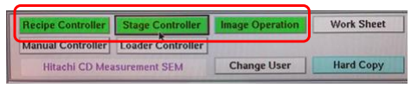
(Fig. 2)
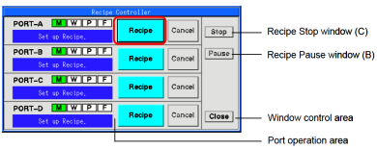
(Fig. 3)
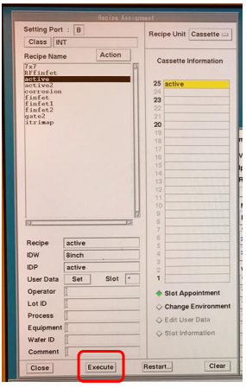
(Fig. 4)

- Switch to OM mode for alignment of the chips on the left and right (Fig. 5).
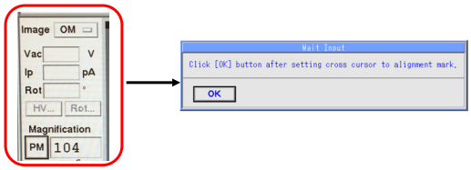
(Fig. 5)

- Find the correct pattern position, and switch to SEM mode (Fig. 6).
- After the measurement pattern is enlarged to appropriate magnification (Fig. 6), adjust Focus and Stig X,Y (Fig. 7). Click AMS, and the left and right measurement range frames appear. Move to the measurement pattern and click AMS for the measurement system to perform automatic measurement and display the measurement value on the screen (Fig. 6).
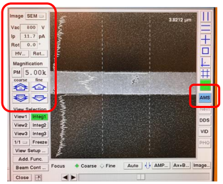
(Fig. 6)
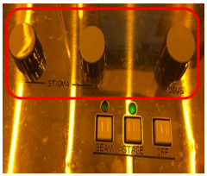
(Fig. 7)

- Storage of Measurement Data:
Turn on the computer next to the machine (user: NDL psw: 123456)
  - Click TiV me on the screen, and then click “Color Screen Icon” on the screen, and select “Analog Device-Composite Connector”.
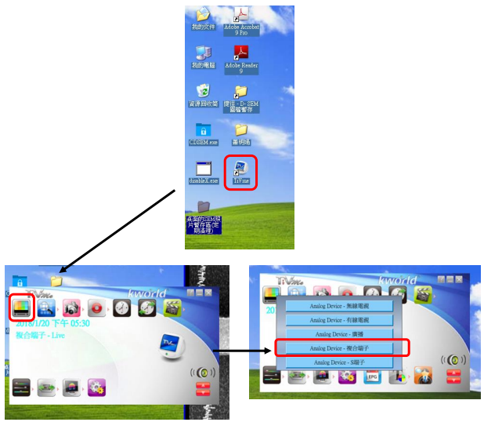
  - Now, the image on the screen is synchronized with the image on the Image Operation window on CD SEM. To take a photo, you can directly click the “camera icon” for the function of snapshot capture. To display the measurement data on the image, click VID on the Image Operation window.
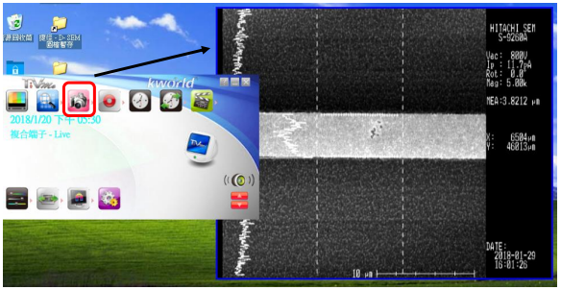
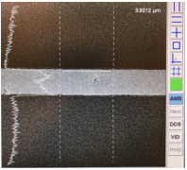 | 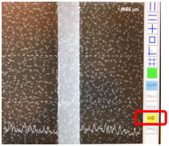
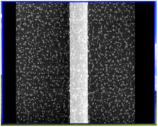 | 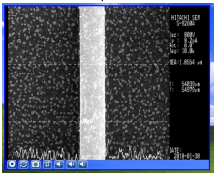
General photo mode | VID photo mode
  - Path setting: Click Snapshot Capture Setting to set the format, number and path of the saved image.
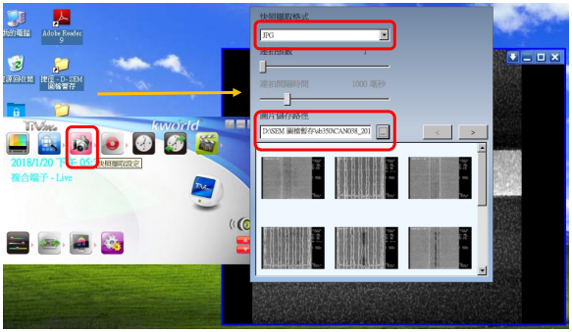

- After measurement is completed, the measurement value will appear on the operating system. If the measurement value is verified as correct, directly click STOP in the recipe controller to unload the wafer, and check if the indicator light at the loading port shows Finish (Fig. 8). You can pick up the cassette, remove the wafer and fill out the log sheet.
<Note>
Cancel the VID photo mode before unloading the wafer.
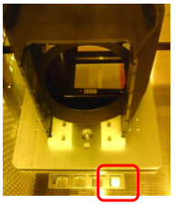
(Fig. 8)
- Applicable Forms and Attachments:
- Equipment Evaluation Checklist S4-NL01A
- Equipment Inspection Checklist S4-NL01B
- Equipment Use Log Sheet S4-NL01C
- Form for Irregularities and Their Correction and Prevention S4-NL02A
- Instrument and Equipment Management Card S4-NL04B

