PCB Design e-file
PCB Design e-file Example
PCB_DGN_EXP_EN.pdf
- If there is any problem about fill-in this document, user can download the example pdf (listed above) from the same web page.

Software information

PADS:
- Encourage users to use free PADS PCB software provided byTSRI.
- About PADS, TSRI provides template files, software consulting, e-Learning, and winter / summer vacation training courses.

Altium:
- Please use versions after 2012 (including).
- The design of version before 2012 might not be compatible with TSRI’s template, and generates too many DRC errors.
- After 2015/03, there is no update for the Altium template, please use PADS software instead.
- Please set up the Design Rules by oneself and make sure to comply with the DRC listed in TSRI’s web “PCB Fabrication - Design Rules Manual”.

Allegro:
- No template.
- Please set up the Design Rules by oneself and make sure to comply with the rules listed in TSRI’s web “PCB Fabrication - Design Rules Manual”.

Other Software:
- Not Acceptable.

[1] PCB Name and Phone no. of Applicant

PCB Identification Code#
Applicant Name
Applicant Phone No.
PCB Layout software name / version

# PCB Identification Code Naming rule:
Process Code_year batch_serial number on”PCB Fabrication Application Form”.
Ex: 4L_115E_A0001
Mark this code at “Silkscreen top” upper left corner with a frame to enclose it.

[2] Topics

Topics in English

[3] PCB Gerber Layer Naming

Refer to web”TSRI PCB Fabrication Application”4. File Upload Layer Naming and Numbering
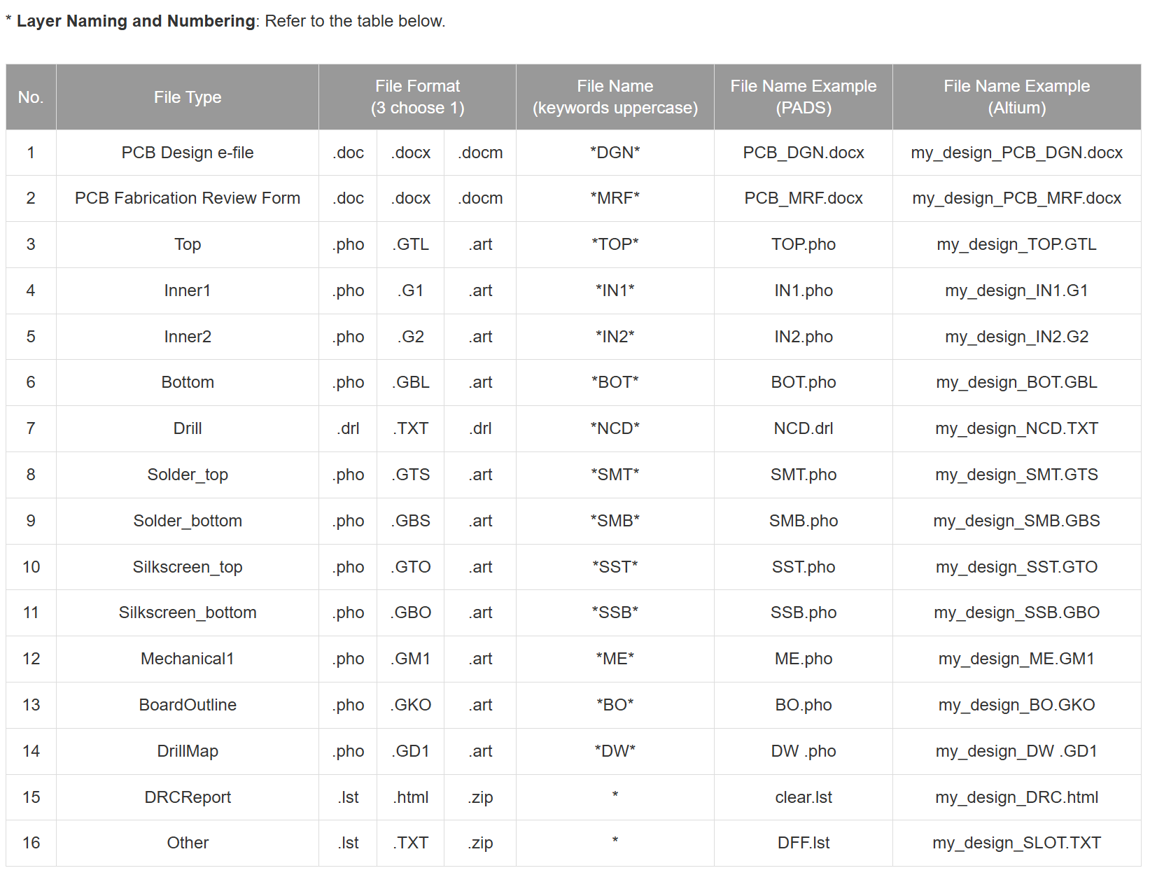
See copied figure below:

Item | Remarks
Each Layer | - Generate Gerber file separately  - Upload separately  - Record the file name in “File Name” column of the following table.
Necessary files for upload | - With *mark in “PCB Fabrication Application System”  - Except “Other”, all files are necessary files for upload.
“Other” Column | - If there is no other file, skip this column.  - Altium slot layer: uploads here.  - Altium .GG1: is not necessary.  - If there are more than 1 files, please compress them.by .zip or .7z format.

FR4 2-Layer Board / RO4003 2-Layer Board

Fill in the following table:

No. | File Type | File Format  (3 choose 1) |  |  | File Name  (keywords uppercase) | File Name
1 | PCB Design e-file | .doc | .docx | .docm | *DGN*
2 | PCB Fabrication Review Form | .doc | .docx | .docm | *MRF*
3 | Top | .pho | .GTL | .art | *TOP*
4 | Bottom | .pho | .GBL | .art | *BOT*
5 | Drill | .drl | .TXT | .drl | *NCD*
6 | Solder_top | .pho | .GTS | .art | *SMT*
7 | Solder_bottom | .pho | .GBS | .art | *SMB*
8 | Silkscreen_top | .pho | .GTO | .art | *SST*
9 | Silkscreen_bottom | .pho | .GBO | .art | *SSB*
10 | Mechanical1 | .pho | .GM1 | .art | *ME*
11 | BoardOutline | .pho | .GKO | .art | *BO*
12 | DrillMap | .pho | .GD1 | .art | *DW*
13 | DRCReport | .lst | .html | .zip | *
14 | Other | .lst | .TXT | .zip | *

FR4 4-Layer Board / RO4003 4-Layer Board

Fill in the following table:

No. | File Type | File Format  (3 choose 1) |  |  | File Name  (keywords uppercase) | File Name
1 | PCB Design e-file | .doc | .docx | .docm | *DGN*
2 | PCB Fabrication Review Form | .doc | .docx | .docm | *MRF*
3 | Top | .pho | .GTL | .art | *TOP*
4 | Inner1 | .pho | .G1 | .art | *IN1*
5 | Inner2 | .pho | .G2 | .art | *IN2*
6 | Bottom | .pho | .GBL | .art | *BOT*
7 | Drill | .drl | .TXT | .drl | *NCD*
8 | Solder_top | .pho | .GTS | .art | *SMT*
9 | Solder_bottom | .pho | .GBS | .art | *SMB*
10 | Silkscreen_top | .pho | .GTO | .art | *SST*
11 | Silkscreen_bottom | .pho | .GBO | .art | *SSB*
12 | Mechanical1 | .pho | .GM1 | .art | *ME*
13 | BoardOutline | .pho | .GKO | .art | *BO*
14 | DrillMap | .pho | .GD1 | .art | *DW*
15 | DRCReport | .lst | .html | .zip | *
16 | Other | .lst | .TXT | .zip | *

[4] Gerber Output Setup / TOP Figure
Please make sure the uploaded Gerber and Drill files are correct, and the same as those shown in the attached figures.
Altium: Open .GTL、.TXT and .GD1 files, and attach the figures separately.
PADS: Use command File > CAM > select correct Document Name > Preview (click Board or Extents), and attach the figures separately.
Other Software: Use similar method.
PCB Size (ME frame) | cm x cm
Output Units | ☐ Inches (English)
Output Units | ☐ Millimeters (Metric)
Format (I:D) | Integral (Leading) =
Format (I:D) | Decimal (Trailing) =
Coordinates | ☐ Absolute
Coordinates | ☐ Incremental
Coordinates | ☐ Not applicable
Zeros suppression | ☐ Leading Zeros suppression
Zeros suppression | ☐ Trailing Zeros suppression
Zeros suppression | ☐ None (Keeping leading and trailing zeros)
Gerber figure (Top) (Attach below.)
[5] Drill Output Setup / Figure
Output Units | ☐ Inches (English)
Output Units | ☐ Millimeters (Metric)
Format (I:D) | Integral (Leading) =
Format (I:D) | Decimal (Trailing) =
Coordinates | ☐ Absolute
Coordinates | ☐ Incremental
Coordinates | ☐ Not applicable
Zeros suppression | ☐ Leading Zeros suppression
Zeros suppression | ☐ Trailing Zeros suppression
Zeros suppression | ☐ None (Keeping leading and trailing zeros)
Drill Figure (Attach below.)
Drill Table (Attach below.)
[6] PCB DRC Verification Results Figures
No DRC error figure from software.

[7] Assembly (2D or 3D)
PADS: Use command View > PADS 3D to display the layout, and attach figure below.
PADS part height setup: Project Explorer > PCB Decals > (Select one Decal) > RMB (Right Mouse Button) > Properties Attribute > Add > Geometry. Height, or when building part Library, the setup of Attributes. After these setup, user can use command Edit > Attribute Manager > Components > Attribute > Show > Geometry. Height to verify.

