N&K Analyzer
Standard Operation Procedures
- First, open the light power (front panel) and wait for at least 15 minutes to warm up machine。
- Turn on the computer→ choose and click “filmetric.exe”。
- choose “Structure” (b)choose “Edit Structure”。
→ key in the closest film thickness(Thickness,d[Ǻ])。
→ choose“Layer#1”name → choose “Substrate” →choose desired measure item “d , n , k” →choose“OK”。
- choose “Baseline”→ Be sure “Autoscale Integration” been chosen
→ choose Reference Material: Silicon →put “Silicon reference sample” on the spot light of measure plate (upward the measure film )→ choose “OK”。
→ appear “take reflectivity dark” window→ remove “Silicon reference sample” from the measure plate →choose “OK”。
3.Finally, put “desired measure sample” on the spot light of measure plate (upward the measure film )→ choose “Measure”。
(a) choose “Display”→ choose” Thickness”→ then display chosen
measure value。
- If calculated (Red line) and measured spectra(Blue line) almost
match，the measurement is successful；if not，key in another possible value and repeat measurement step
4.After finishing measurement，remember to turn off the light power。

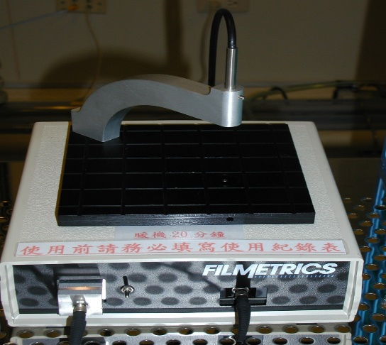
a.待量測試片位置
b.量測區域需大於
光源1x1cm以上
c.欲量測之晶圓正面朝上
打開燈源確定燈源亮起
並暖機20分鐘以上

a. The position of the sample to be measured
b. The measurement area must be at least 1x1cm larger than the light source.
c. The wafer to be measured is facing up

Turn on the light source and warm up for more than 20 minutes



Click the left mouse button 2 times
nutes

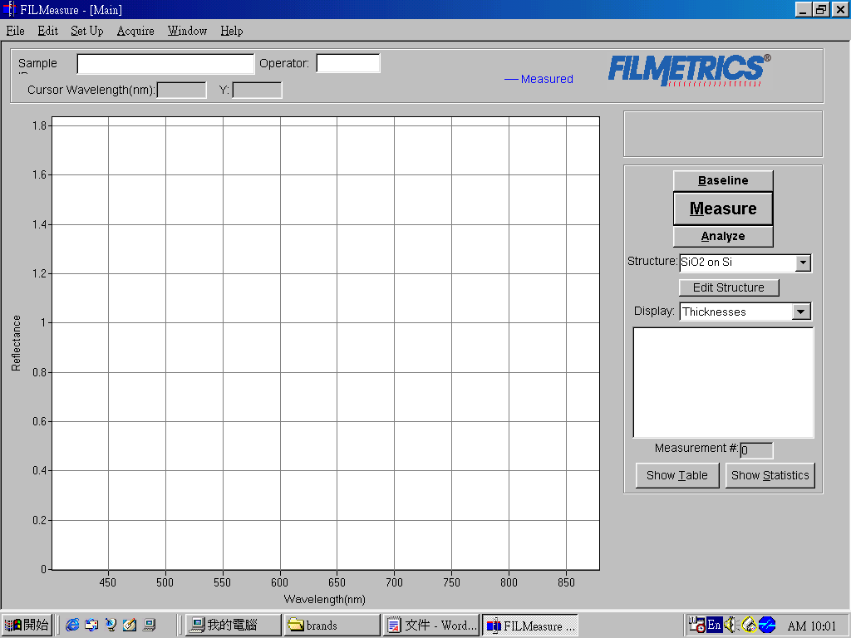
Click Baseline

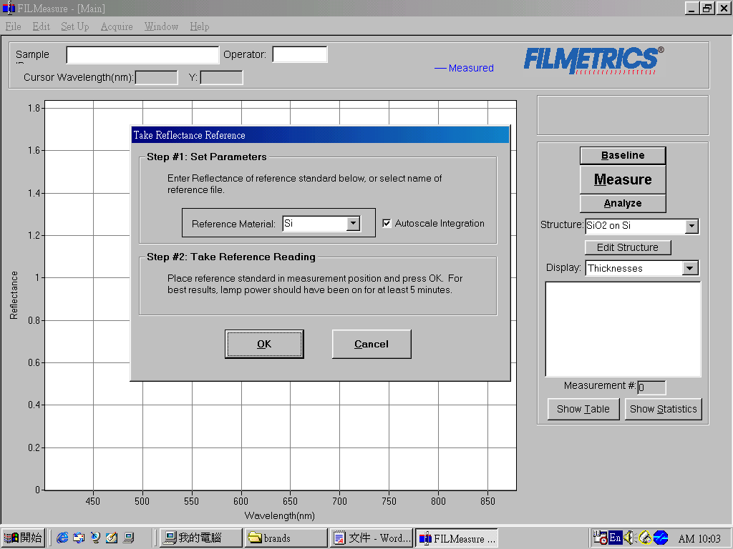
- First place the Bare Silicon
on the light source platform
2. Make sure Autoscale integration is checked
3. Click OK

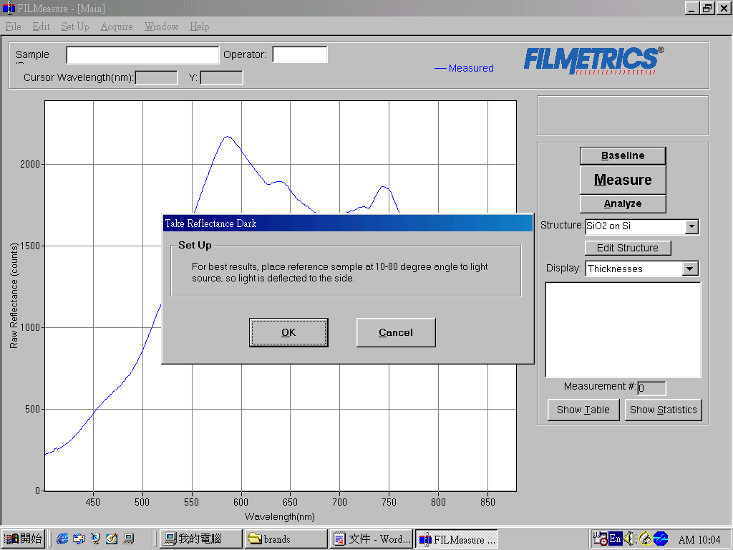
1. First remove the Bare Silicon from the light source platform
2. Then Click OK

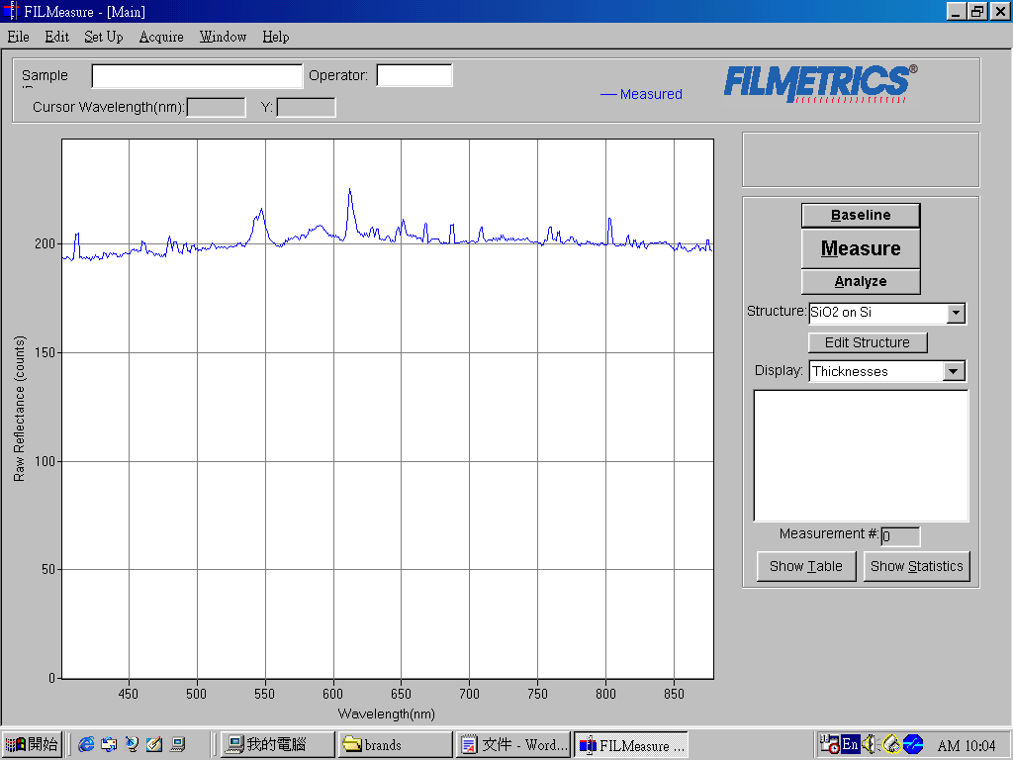
1. First place the measuring sample on the light source platform
2. Click Edit Structure

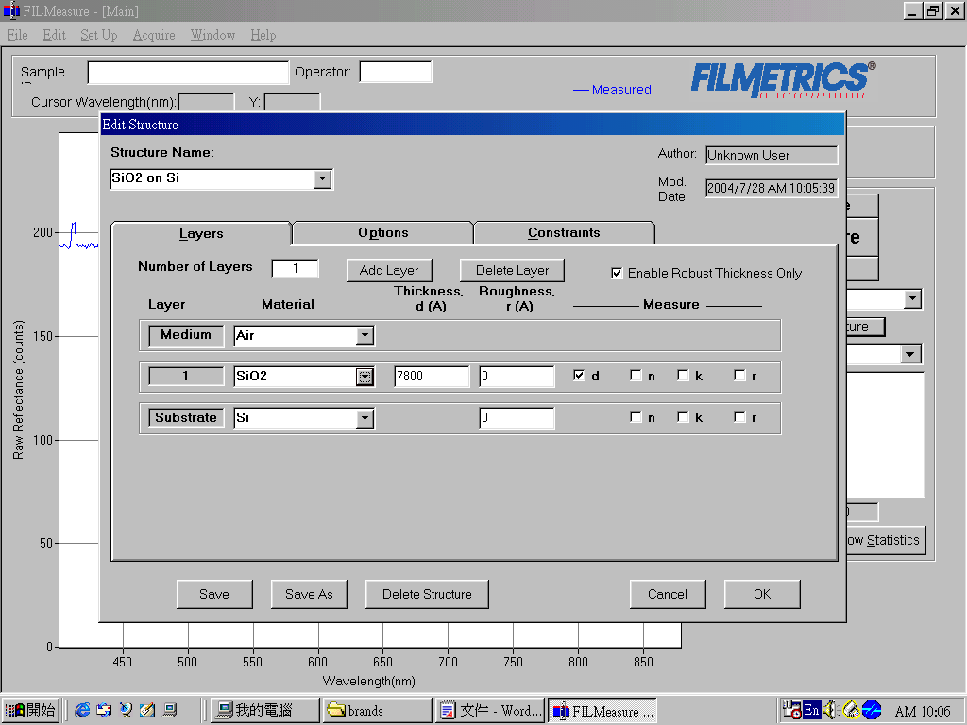
1. Enter the estimated thickness
2.d (thickness) needs to be checked
3. Click OK
Select the desired structure
of the film to be measured

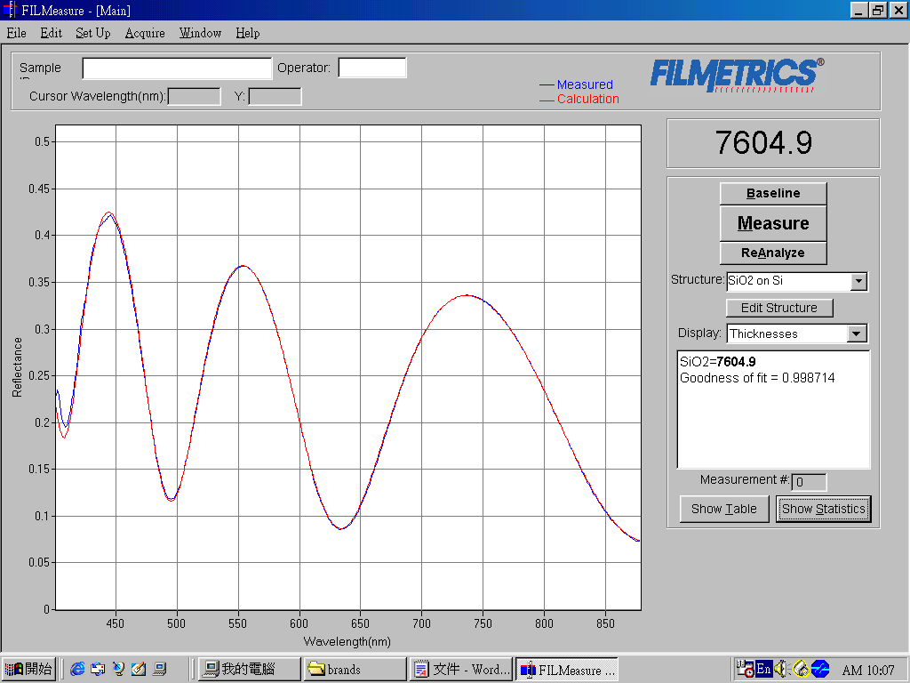
Click Measure
Thickness value is 7604.9Å
Goodness of fit closer to 1
The fitting error closer to 0
The higher the thickness accuracy
More points can be measured
Statistical results of the time

