Auto PR Coating and Baking System(Track)
Standard Operation Procedures
(1) Operation process:
1. Swipe the card to turn on the machine and log in.
2. Make sure the recipe program is turned on.
3. Put the wafer into the Cassette, do not insert it obliquely.
4. Click the recipe you want to execute and click Done.
5. After the process is over, after all the wafers are returned to the
cassette, the wafers are taken out for exposure.
6. Place the exposed wafer in the center of the chuck of the developing
machine.
7. Click the recipe you want to execute and click Done.
8. After the standby station buzzes , the process is completed and the
wafer is taken away.
9. Swipe card to log out from the machine
(2) Matters needing attention:
1. Only complete 6&8-inch wafers can be processed, and other sizes of
test wafers can not be processed.
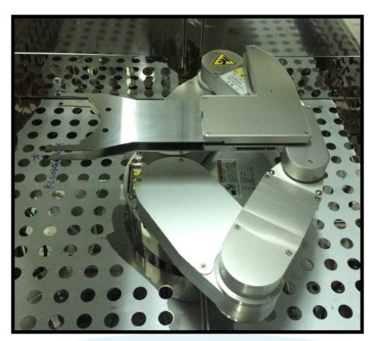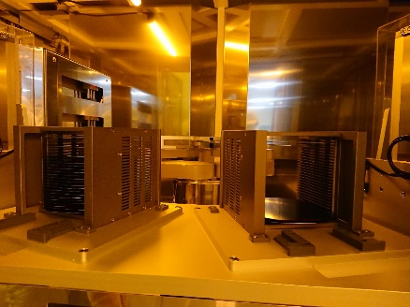
Wafer Load/Unload Cassette
Transfer Dual Robot

