Mask Aligner Exposure System
Standard Operation Procedures
I. Loading Mask
1. Check whether the machine operation notice board is in operation, if so, log in and
start the machine, log in to the student public account root password root.
2. Place the wafer to be exposed in the prealigner zone (Figure 1)
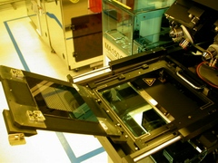
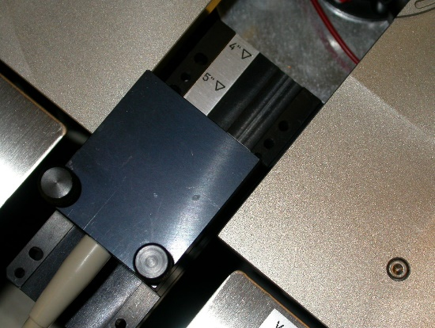
Sensor7

(Figure 1) (Figure 2)
3. Press "Mask" on the main screen, pull the holder parallel to the track tenon to fix it, then pull the handle of the holder, and turn the holder out from the inside out.
4. Put the photomask on the Holder (the brown chrome film faces up, and it becomes down when the cover is put down), and close to the left screw to determine the position of the photomask each time. (Figure 2)
5. Press "Vacuum" on the screen to suck the photomask onto the Holder, check the vacuum pressure gauge of the Aligner (>0.8bar), confirm that the photomask is sucked safely, and then cover the Holder back. (Pigure 3)
6. Push the Holder back in parallel with the tenon of the board (note the gas line, Figure 4), press "Clamping" on the screen, and press "Return".
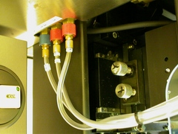
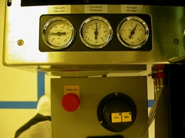

(Figure 3) (Figure 4)

II. First Mask Exposure

Select "Change Program" "List" on the main screen, select the type and thickness of the photoresist to be exposed (note Configuration 6’’ or 4’’), and then load.\

After loading, return to the upper screen to enter "Edit", enter "Mode" and select First Mask, and then edit Exposure type, exposure time and other conditions, return to the main screen after editing.

On the main screen, click SYSTEM SHORT PROGRAM Load/Un load: Prealigner and AlignStart/BreakLOAD WAFER ON PREALIGNER, TOUCH TOCONT (Place the test piece on the prealigner area, and then press the above option)

The wafer will be sent to the exposure area, and the wafer will return to the original place after exposure Unload WAFER ON PREALIGNER, TOUCH TO CONT (Take out the test piece in the prealigner area, and then press the above option to repeat) If you do not want to continue exposure, select EXIT SHORT PROGRAM to return to the main screen

