Manual Spin Coater
Standard Operation Procedures

- Turn on the Pump before use (press the [Power] button), select the appropriate
suction head (chuck), confirm that the wafer can be sucked , set step1 (low) and
step2 (high) speed value (RPM) and time (seconds), press the red start button on
the right, and turn off the Pump after use (press the [Power] key).
2. Please heat the Hot Plate before use. Please turn it off if you don’t use it for more
than 1 hour to prolong the life of the heating plate. Do not exceed the upper limit of
the operating temperature of 200 degrees. When not in use, you need to pull out
the plug.
3. When using a spin coater, in order to avoid contamination and organic liquids
flowing into the cavity, it is necessary to lay a dust-free wipe in the spin coater and
clean it after use.
4. Please clean up after use, put the used utensils back in place, and close the door of
the fume hood.
5. During use, please try to pull down the door of the fume hood so that the operation
is not affected, so as to reduce the solvent volatilization into the stagnation-free
room.
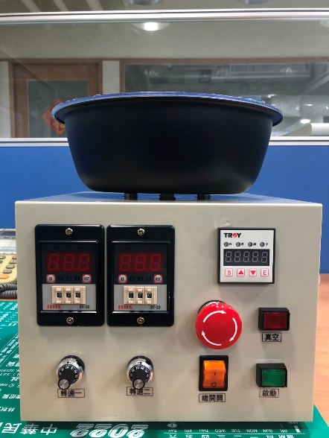
Start
Vacuum
Step 1(Low)
Step 2(High)

