Taiwan Semiconductor Research Institute
SE-023 3D Laser Microscopy
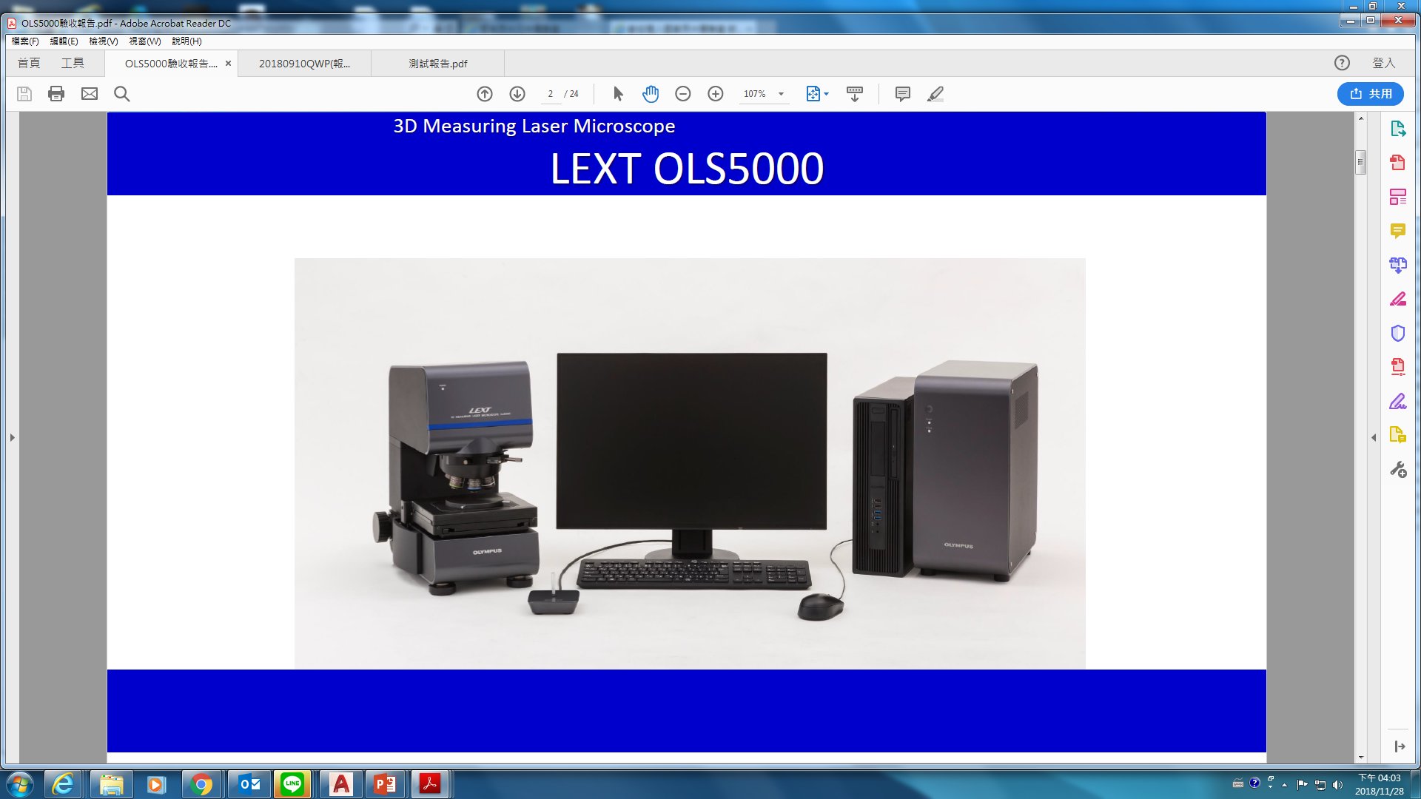
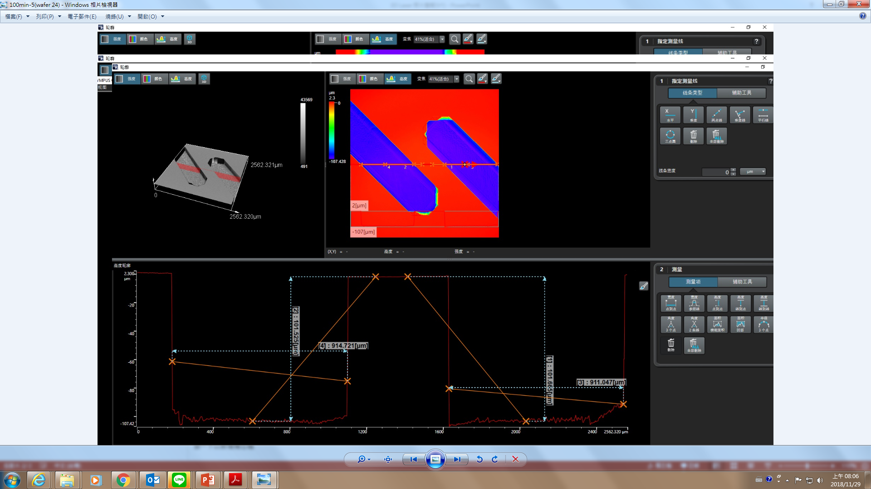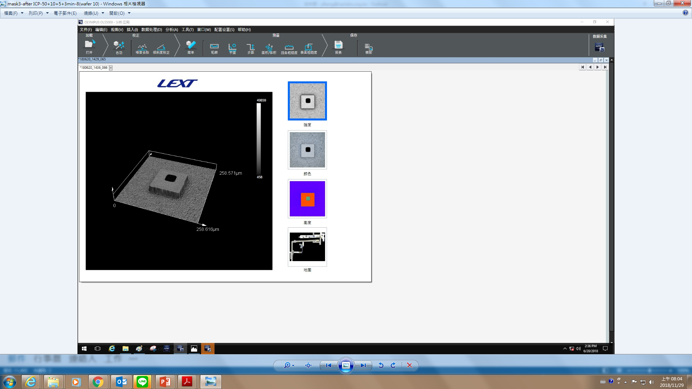

1. Model: Olympus OLS5000
2. Equipped with five sets of lenses: MPLFLN5X, MPLFLN10X, MPLAPON20XLEXT, MPLAPON50XLEXT, MPLAPON100X, of which 20x, 50x, and 100x are dedicated laser objective lenses
3. Specimen carrier: electric drive, movable stroke 100mm*100mm on XY plane
4. Operation analysis software: can control laser microscope 3D shooting, autofocus, EFI depth of field synthesis, HDR (high dynamic range contrast imaging), and size measurement

