Taiwan Semiconductor Research Institute
SE-024 Chip To Wafer Bonder
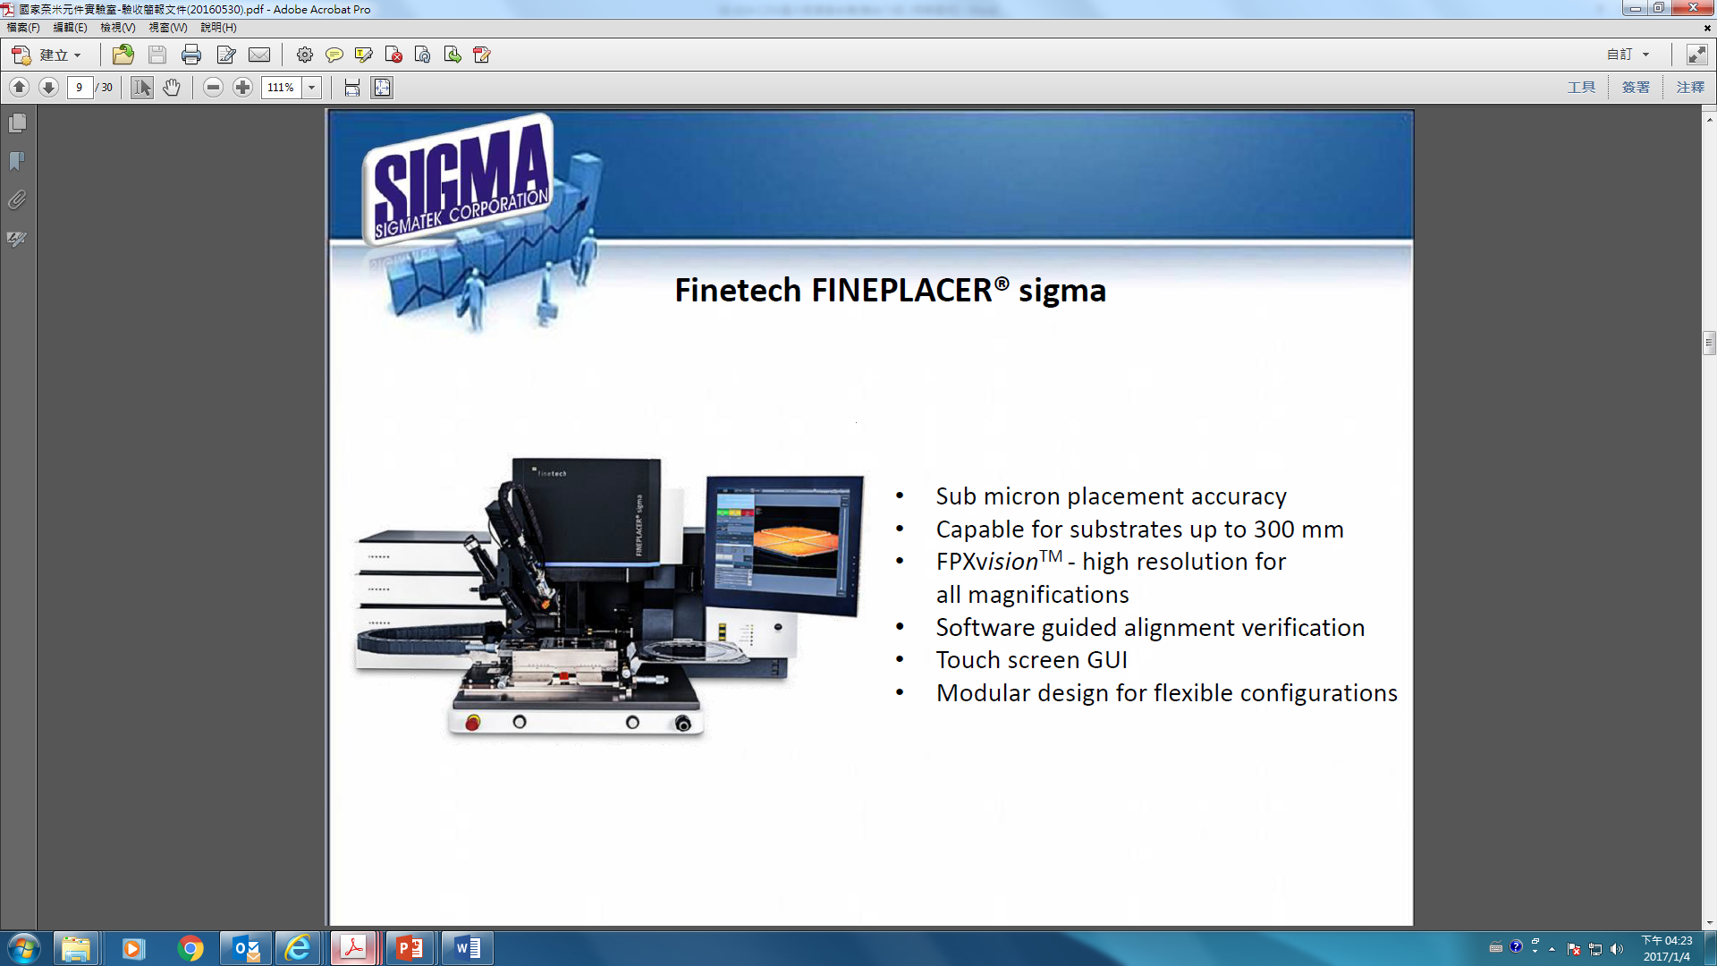
一. System introduction:
1. Equipment name: C2W wafer alignment bonding machine
2. Brand: Finetech
3. Instrument model: Fineplacer sigma
4. Equipment function: Chip to Wafer alignment bonding process
5. Wafer Size: chip size
二. Specifications:
1. A chip-sized heated nozzle head must be customized.
2. Bonding force max 500 N.
3. Temperature max: chip 400 °C & substrate 250 °C.
4. Equipped with Dispenser & Process Video Module.
5. Equipped with Die Flip & Formic Acid Module.

