Chip To Wafer Bonder
Standard Operation Procedures
(1) Operation process:
1. Swipe the card to turn on the machine and log in.
2. Make sure the recipe program is turned on.
3. Select the appropriate nozzle head and replace.
4. Place the chip joint side down on the bottom of the appropriate platform.
5. Select the created parameter name, and first execute pick up to pick up the chip onto the
suction head.
6. Then place the substrate joint surface upward on the appropriate platform position of the
bottom.
7. Then execute manual align by X.Y.ΘAxis movement to align the chip with the substrate.
8. Finally, perform the bonding conditional process, and take away the bonded pair of sample
after the process is completed.
9. Swipe the card to log out from the machine.

(2) Matters needing attention:
1. If you do not have a suitable suction nozzle, you need to customize it before use.
2. Special processes must be discussed with the person in charge of the machine before processing.
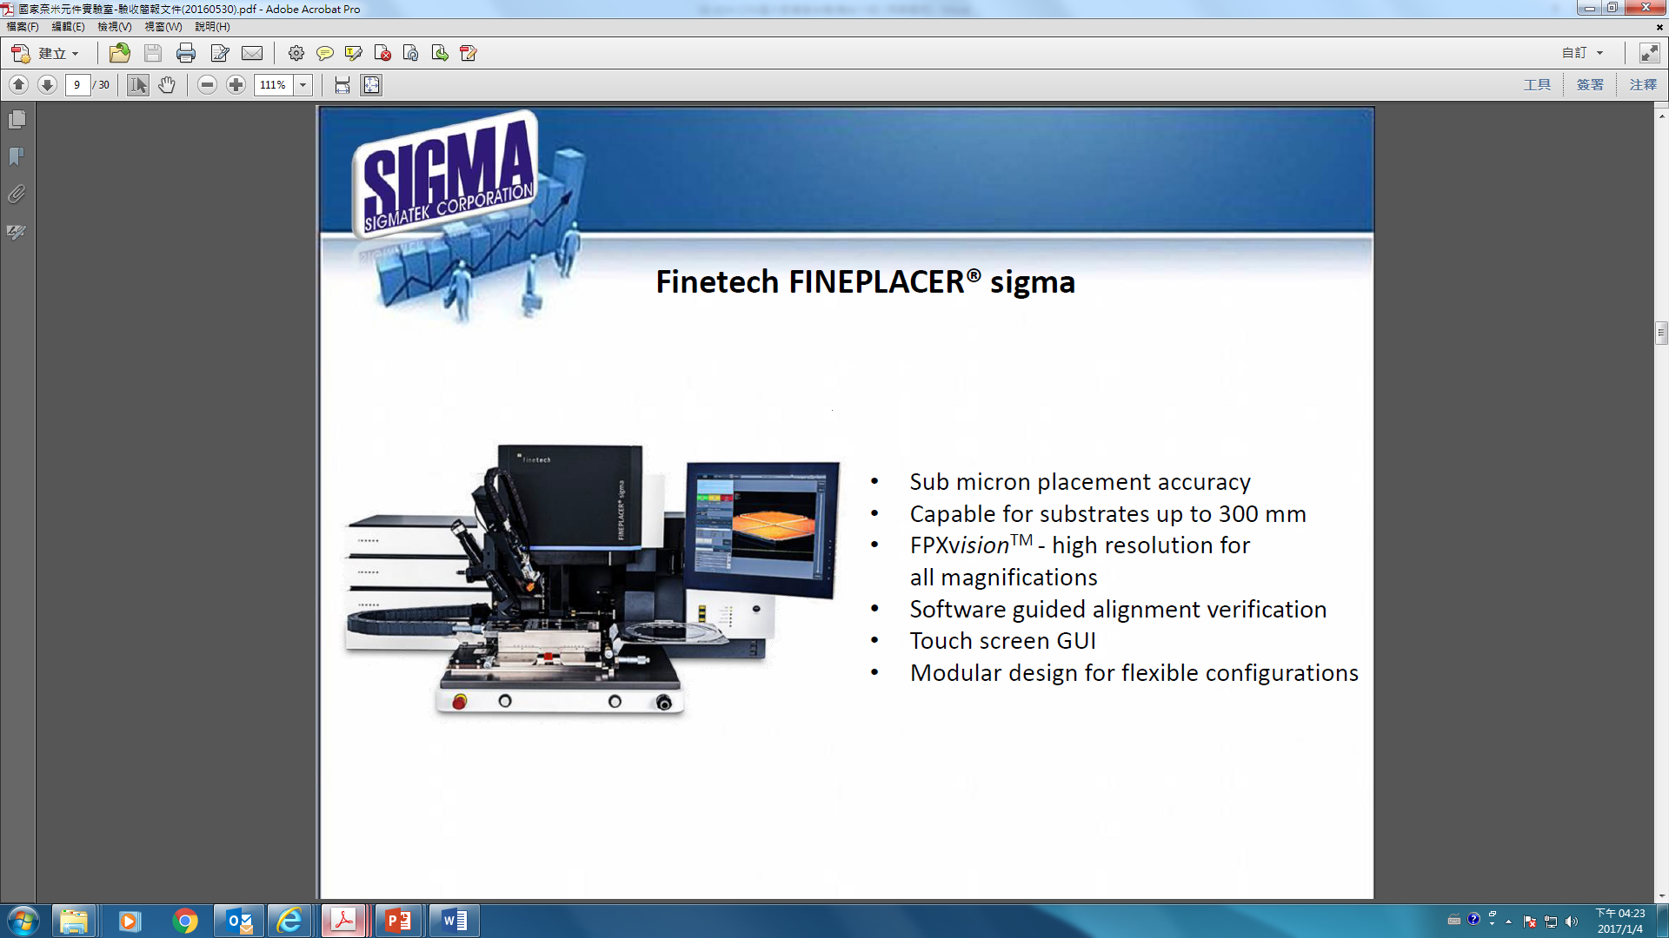
Z Axis movement
Y Axis movement
X Axis movement
Θ Axis movement

