Taiwan Semiconductor Research Institute
SE-025 Wafer To Wafer Bonder
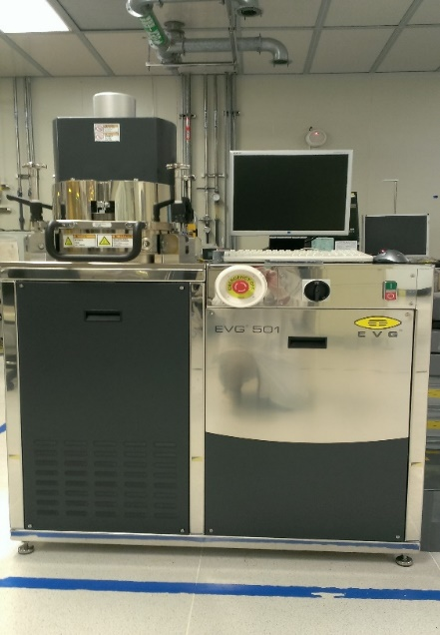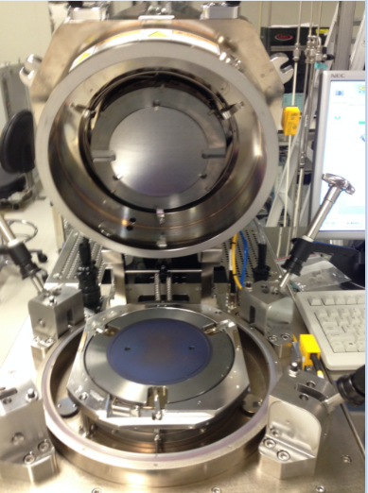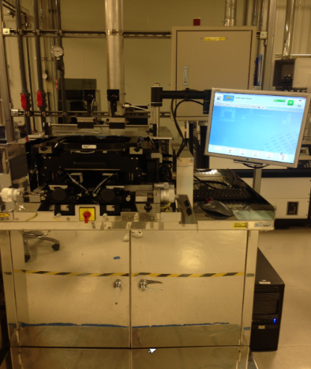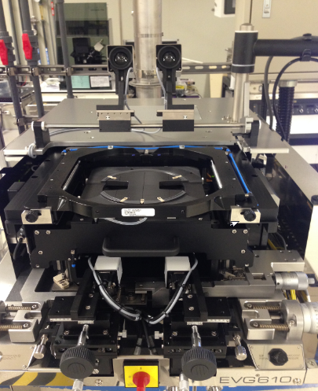
一. System introduction:
1. Equipment name: W2W wafer alignment bonding machine
2. Brand: EVG
3. Instrument model: EVG 501&610
4. Equipment function: Wafer to Wafer alignment bonding process
5. Wafer Size: 6 & 8 inches
二. Specifications:
1. The dry mechanical pump can achieve a vacuum value of about 5E-2 torr.
2. Back alignment objective lens & front IR light source & manual alignment mode.
3. Bonding force max 20kN.
4. Max temperature can reach 450 °C.
5. Cu-Cu & Sn-Sn & Glass Carrier Bonding.

