Taiwan Semiconductor Research Institute-Heterogeneous Integration and Manufacturing Division
SE-C04 UV-VIS-NIR Spectrophotometer

Standard operating procedures
1、 Start up
(1) Check the experimental record book, notice boards and announcements to confirm whether the equipment is under maintenance or has any problems.

(2) Turn on the power - the power switch is located on the right side of the body. After turning on the power, the power indicator on the top of the panel.

2、 Tuning and measurement
(1) Turn on the main unit of the machine, the power switch is located on the right side of the machine, after turning on the power, the power indicator on the top of the panel (wait until the indicator light stops blinking before turning on the computer).

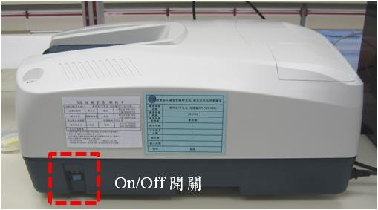
(2) Turn on the computer and log in to the student public account "UV" with the password "SEC04".

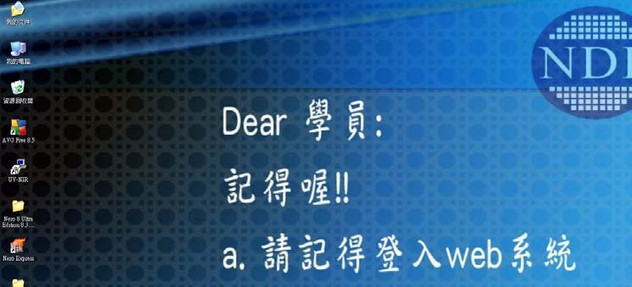(3) Select the program on the computer desktop and open the "UV-NIR" software.

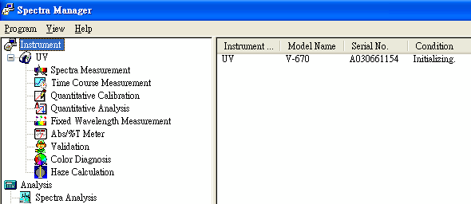(4) Open the “Spectra Measurement” program to enter the measurement screen.

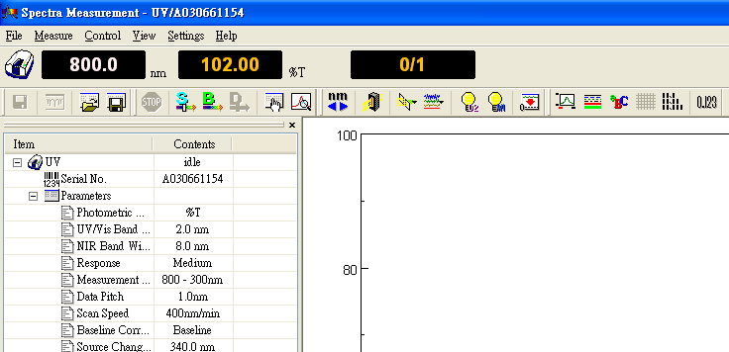(5) After entering the main program, check whether the light source (D2 & WI lamp) is turned on, if not, please restart the program. If you still have problems, please notify the engineer.

(6) Measurement parameter setting

Set the parameters of the spectrum scan，select Setting parameters

a. Select the measurement mode and basic parameter settings - 「Absorption (Abs)」、「Transmission (%T)」、「Reflection (%R)」。

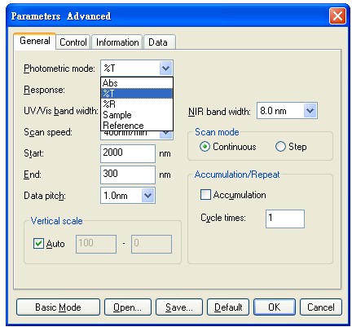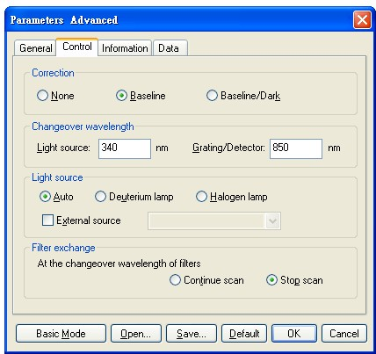b. Checking- 1. Calibration method；2. Light source switching position；3. Is the light source on

c. This setting cannot be changed, and the file access location cannot be changed without authorization.

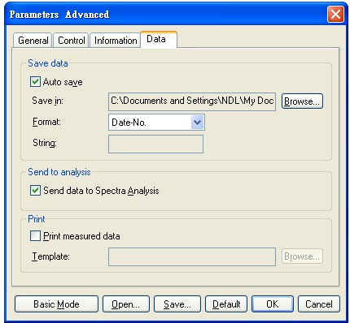

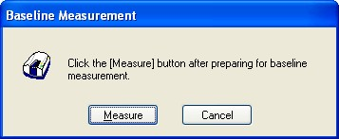(7) After the measurement parameters are set, do baseline correction before the spectrum measurement, select baseline correction, then the following screen appears.

(8) After the baseline correction is completed, put the sample to be tested into the sample slot of the host, press start scanning the spectrum.

(9) The scanned spectrum will be automatically sent to the spectrum analysis software "Spectra Analysis" for analysis.

(10) The file has two formats: program file (jws) and text file (txt), and it is recommended to save both file formats. The program file (jws) can be called by the program to judge the image, and the text file (txt) cannot be called by the program, and it is stored in the specified folder.

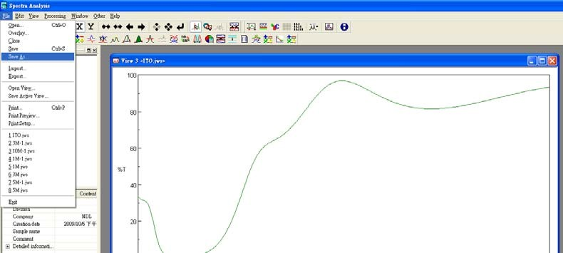a. Program file (jws) file format - Select on screen 「File」「Save as…」

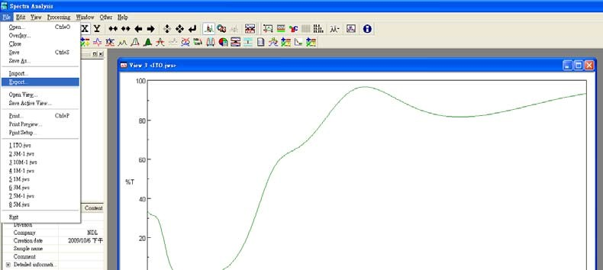b. Text file (txt) file format - Select on screen 「File」→「Export」

(11) Please remember to take out the sample after measurement, and use N2 gun to clean the accessories.

3、Shutdown process
(1) Close the "Measurement Software" and then shut down the computer.

(2) Power off the machine.

(3) Shut down the web control system.

